بسم الله الرحمن الرحيم



An-Najah National University

Faculty of Engineering

Computer Engineering Dept.

USB Electro-Kit

Final report

Project Documentation, presented as a hardware graduation project in computer engineering department

Prepared by :
- Jafar T. Hajeer ( 103 02138)
- Mohammad Sh. Khalaf
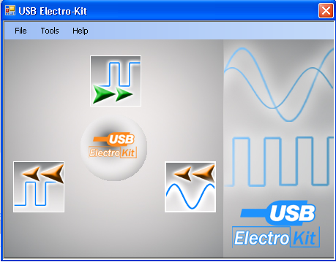

Introduction:

As a requirement to get the bachelor degree in Computer Engineering, students are required to perform a hardware graduation project.
We were free to choose a project using one of the modern technologies in computer world.

Why USB?
USB is intended to help retire all legacy varieties of serial and parallel ports. USB can connect computer peripherals such as mice, keyboards, PDAs, gamepads and joysticks, scanners, digital cameras, printers, personal media players, and flash drives. For many of those devices USB has become the standard connection method. USB is also used extensively to connect non-networked printers; USB simplifies connecting several printers to one computer. USB lock software can lock out memory devices and still allow other USB peripherals to function. USB was originally designed for personal computers, but it has become commonplace on other devices such as PDAs and video game consoles. In 2004, there were about 1 billion USB devices in the world.

So, we chosen to design a USB device, because we really wanted to learn this powerful technology that every computer peripheral is moving towards .

The First step was to implement a Windows driver for our device, this was the greatest challenge, and after about 90 days we could do it.

Then we wanted to choose an application that affects our life. So we search for a problem in our life and to try to solve it by a USB device.

Which problem?
As computer engineering student in An-Najah University, we faced a problem of lack of hardware equipment in the programmable controlled lab (microcontroller lab)
This lab in the first semester of each academic year receives the students of:
- CPU design Lab
- Microcontrollers lab.
- Additions of students form other departments.

And in the second semester of each academic year, the labs receives students of:
- Digital Logic Design Lab
- Communications and signal processing.
- Microcontrollers.
- Hardware graduation project.

So, we are saying at about 80 students in first semester and 160 students in second semester need to use the lab. But what is available is 9 benches that can only be used by one groups (group is 2 students in common, rarely it be 1, rarely it be 3).

The solution was to try to take the benefit of Microchip PIC microcontrollers and USB together to try to design at least a substitute of basic equipment available in the lab.

The most important devices are:
- Power supply: In most cases, this is just used for a fixed 5 volts power.
- Oscilloscope.
- Digital Oscilloscope
- Frequency Generator.

So, we started in the project with the aims of:
- Implementing a Windows driver for USB.
- Trying to design as most as we can from the devices mentioned above.

----------------------------------------------------------------------------------------------------------------------------------------------------------------------------------------

USB Driver:

Before entering in the details of The Driver we should specify the opportunities that we had before to reach to the correct way to make our drivers.

First, the only known drivers that used before is the HID (Human Interface Devices) and it is the first USB class that used under windows. On PCs running Windows 98 or later, applications can communicate with HIDs using the drivers built into the operating system. The device just needs to be able to function within the limits of the HID class specification which is one of the problems of this driver. The problem that we had with the HID is that not done by us. It is ready in windows. And when we want to use we will be not free to work with as we want. So we should find another way to work with.

Second, we start to read a book about USB and how it is work. This book gives the way to build the driver and also the HID driver. This book name is USB Complete (Everything You Need to Develop Custom USB Peripherals, Third Edition, Jan Axelson). This book gives us the start of entering the USB Device. During this work Microsoft made a way to make drivers for USB and name it WinUSB.

Most Importantly, WinUSB is Independent Hardware vendor. Don’t need to be as the manufacture needs as HID. This way help the developers for building their drivers that does not depending on Kernel mode. The details will be later.

The WinUSB developed by Microsoft and released before days before we reach it. It is a problem for us firstly to learn something that no one knows about. Also no one could help us in that and any information or examples on the net that could help us.

After reading half and more from the USB complete book, the thing began to become more flexible. We download a Windows Driver Tool Kit which helping us to build the driver and help us about the function that could be used in the code. Microsoft supports a new book helping building the driver.
This book is (Developing Drivers With The Microsoft Windows Driver Foundation). This book builds the basics for what we want to do and how the USB drivers work and the design of it. This makes the breakpoint of our work that all work depends on it.

Now it is the time to enter the details.

Independent hardware vendors (IHVs) who manufacture USB devices must often provide a way for applications to access the device’s features. Historically, this has meant using the Windows® Driver Model (WDM) to implement a function driver for the device and installing the driver in the device stack above system-supplied protocol drivers. The Windows Driver Foundation (WDF) is now the preferred model for USB drivers. It provides IHVs with three options for providing access to a USB device:
- Implementing a user-mode driver by using the WDF user-mode driver framework (UMDF).
- Implementing a kernel-mode driver by using the WDF kernel-mode driver framework (KMDF).
- Installing WinUsb.sys as the device’s function driver and providing an application that accesses the device by using the WinUSB API.

Kernel Mode Driver Foundation (KMDF)
- KMDF USB Support
- KMDF encapsulates PIRP formatting and sending via IoCallDriver into the WDFIOTARGET object
- WDFUSBDEVICE
  - WDF target object for configuration and control transfers
- WDFUSBINTERFACE
  - Grouping object that contains WDFUSBPIPE objects for a configured interface
- WDFUSBPIPE
  - WDF target object for non control endpoints
- A WDF target does the following for you
  - Manage target state (Started, Stopped, Removed)
  - Track sent requests and cancel them when asked
  - Manage lifetime of the request and the memory in it
    - You no longer have to worry about when to free memory or the request itself
- You can use KMDF USB functionality in both a full fledged WDF driver and in some existing WDM miniport models (e.g. NDIS-WDM)

- KMDF USB Features
- Configuration
  - Easy iteration of interfaces and endpoints
  - Select Configuration
    - Automatic (select AlternateSetting 0 for each interface)
    - Custom (driver provided settings list)
  - SelectSetting for each interface AlternateSetting
- Optional continuous reader for any IN WDFUSBPIPE
  - Can configure how many pending requests are polling
  - Automatic buffer allocation and cleanup
- Selective Suspend functionality and logic built into WDF directly

- KMDF USB DDI Examples
- Configuration
  - WdfUsbTargetDeviceSelectConfig
  - WdfUsbInterfaceSelectSetting
  - WdfUsbInterfaceGetNumConfiguredPipes
  - WdfUsbInterfaceGetConfiguredPipe
- Async I/O on WDFUSBPIPE
  - WdfUsbTargetPipeFormatRequestForRead
  - WdfUsbTargetPipeFormatRequestForWrite
- Sync I/O on WDFUSBPIPE
  - WdfUsbTargetPipeReadSynchronously
  - WdfUsbTargetPipeWriteSynchronously

The KMDF structure is in this shape:


Legend
IHV or ISV Component
Microsoft New Component
U
K
Device
Driver
WDF.SYS
Application

- What is UMDF:
- Implementation of the WDF Driver Model in User Mode
- Provides:
  - The infrastructure to run a device driver in user-mode
  - The WDF I/O Pipeline and PnP/PM State Machine
  - The core WDF objects
    - Devices, Files, Queues, Requests, I/O Targets, etc...
- UMDF and KMDF both share the WDF Model
  - So learning how to use one will apply to the other
  - But they are not source or binary compatible
    - Have similar but not identical DDIs
    - Each has additional functionality applicable to its domain


App
K
U
Device
WinUSB. DLL
WinUSB.SYS
Existing USB Stack
WinUSB – Motivation and Architecture
Motivation
Legend
IHV or ISV Component
New Microsoft Components
Existing Microsoft Components

- KERNEL Mode Driver handles
- Complex logging and I/O
- Power management
- PnP events, etc.
- USER Mode DLL exposes
- simpler USER Mode API
- Incorrect implementation leads to app hang/crash (not PC crash)
- Safer upgrade to new OS
- Solutions like HID are inefficient (need special H/W)
- IHVs don’t want to be experts in complex driver models

- WinUSB – Candidates and Statistics
- Potential candidates
  - Media Transfer Protocol (MTP) devices
  - Test and measurement devices
  - Simple sync/update utilities
  - University/independent projects
  - IAD devices
- Statistics
  - Performance
    - Able to maintain Hi-speed bus traffic at ~40MBps transfers !!!
    - <10% CPU utilized by system on 3GHz machine with 512MB RAM
  - Code development time

- When can you NOT use WinUSB?
  - Bus drivers that need to build additional stacks
in kernel
  - ISOC devices

- WinUSB – How to Write an INF?
- Selection of class/class GUIDs in Version Section of INF
  - Do NOT use Class “USB”
- Selection of Interface GUIDs in INF
  - WinUSB allows for multiple Interface GUIDS to be
simultaneously registered
  - In the HW.AddReg section, add :
HKR,,DeviceInterfaceGUIDs, 0x10000,"{058815B2-9805-47d3-B7D5-ABC464D3CA06}"
- Use Include/Needs in your INF to load the right sections
- Ensure that INF works on ALL platforms – x86, IA64, x64

- WinUSB – Advanced Features around Pipe Policies
- Policies that developers can set to modify the driver’s behavior
  - Write pipe policies:
    - SHORT_PACKET_TERMINATE (DEFAULT: false)
    - RAW_IO (DEFAULT: false)

  - Read pipe policies:
    - AUTO_CLEAR_STALL (DEFAULT: false)
    - PIPE_TRANSFER_TIMEOUT (DEFAULT: infinite)
    - IGNORE_SHORT_PACKETS (DEFAULT: false)
    - ALLOW_PARTIAL_READS (DEFAULT: true)
    - AUTO_FLUSH (DEFAULT: false)
    - RAW_IO (DEFAULT: false)
  - Power policies
    - AUTO_SUSPEND (DEFAULT: true)
    - ENABLE_WAKE (DEFAULT: false)
    - SUSPEND_DELAY (DEFAULT: 5 secs)

- Microsoft Internal Consumers
Benefits of having internal Microsoft customers…
- Identify new and complex usage situations
- Get early feedback and catch bugs faster
- Validate assumptions and see if its really simple to program to this new interface!

WinUSB
- MTP is an early adopter of WinUSB for Windows codenamed “Longhorn”
- Used internally for test and compliance tools

KMDF USB Driver Library
- WinUSB itself is based on KMDF USB support
- Sample Driver (osrusbfx2 )

- Which Model is Right for You?
- Use WinUSB and write code in User Mode…
  - If device is exclusively owned by a single specific application, and
  - If the code handling the device is entirely in application
    - E.g. Device Validation and compliance test program
- Use KMDF and write code in Kernel Mode…
  - If the driver needs to communicate with other drivers in Kernel Mode
    - E.g. smart-card reader driver, etc
  - If the device is not exclusively controlled by a single Application all the time. You may need a central entity to manage the resource
    - E.g. serial<->USB NIC
  - If the device needs ISOC support or needs to control protocol timing
very tightly
    - E.g. Conference Camera driver
  - KMDF will be made available on Windows 2000, but WinUSB may not

- KMDF USB – Used for devices whose drivers have to be in kernel mode
- WinUSB with UMDF – Used for devices where a real driver is needed. E.g.
  - Raise the level of abstraction of the device (there is a deep stack of third party added value)
  - The device is shared across multiple applications
  - Applications can recover from driver crashes or failures. Devices like cameras, cellphones, media players etc. belong to
this category

WinUsb without UMDF – Used for exclusive devices where an application has full control of the device and is high degree of knowledge about the device .

 | - WinUSB w/out UMDF | - WinUSB with UMDF | - KMDF
- Where does the IHV need to write code? | - User mode | - User mode | - Kernel mode
- Supports expose/sharing device with multiple applications | - No | - Yes | - Yes
- Supports isolation of driver from application | - No | - Yes | - No
- Supports USB Bulk, Interrupt and Control Transfers? | - Yes | - Yes | - Yes
- Supports USB ISOC Transfers? | - No | - No | - Yes
- Allows kernel mode stacks to be built on top of IHV component? | - No | - No | - Yes
- Does MS request IHV code be WHQL tested? | - Yes | - Yes | - Yes
- Common examples of devices | - USB rain gauge | - USB <-> Serial dongle | - USB NIC

Hardware Design:
Basically , the circuit is built over a Microchip Pic18F4550 microcontroller . the main feature of this uC is that it supports USB technology .
In addition, we used an oscillator crystal X20 MHz , USB connector and other connectors for input/output. This basic circuit was self-powered by USB.
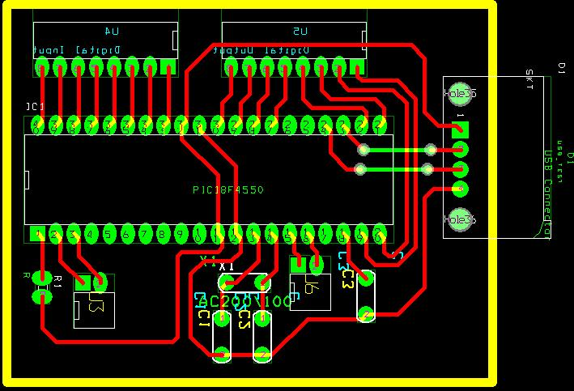
From the start, we did not want to suffer the problem of noise we lived in previous hardware courses, so from the start we moved towards the PCB technology.
Another increase was additional to be added to the circuit in order to fix the analog input signal before it enters the uC, so we used a shift –scale circuit consisting of 2 LM741 OpAmps , and a LM7660 voltage converter chip that was needed to get the negative voltage reference of the OpAmps.
The problem we faced here it that we needed a +9, -9 voltages for the references of OpAmps. This could not be achieved without an external power supply, so we needed a transformer and regulator circuit.

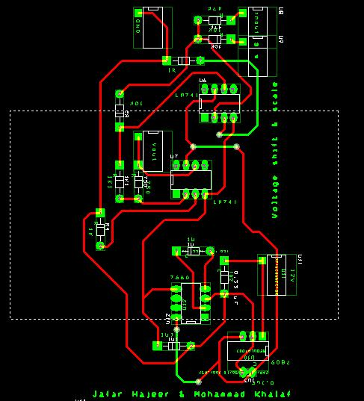

Operation:
The system was mainly consist of the following parts:
- Hardware circuit connected to PC using a USB cabple.
- PIC18F4550 firmware (code) programmed by CCS PICC software, this software was responsible to receive commands (and some times basic data) from PC and acts depending on it.
- Windows driver: was responsible to interface between PC and hardware and to allow the communication between PC application and firmware.
- Windows application: Built using Microsoft Visual C#.Net language, it include a user-friendly interface to allow easy control of system.

The system was able to perform one of three tasks at a time:
1: AnaloScope:
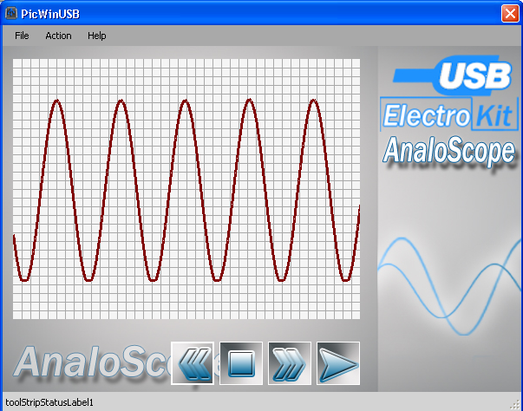
A single channel oscilloscope capable of reading at a sample rate of 74 KS/Sec, the main algorithm of its work is:
- Connection of the device to PC via a USB port is the basic requirement.
- User runs USB Electro-Kit software.
- Choose AnaloScope.
- connect input to the device and click start.
- At this time, the PC check for connection, if device not connected show error message and exit.
- if connection was good, application run s a thread responsible of requesting data ,this thread sends a control word of one byte : 010X
- uC receives the control word and reserves 8 arrays of 100 bytes ( 99 bytes data and 1 control byte) each.
- uC read ADC input for ( 99*7 = 793 ) times and store them in the array and sends the data in first array via USB to the PC.
- The thread receives the 100 byte array ,and fires another thread responsible for drawing the 100 data bytes on the screen. Then thread1 sends order again and so.
- in the uC, in the second time it receives a command, it does not read ADC again, instead it just sends the 2nd array , this process is repeated until the 8th array is sent, then it goes to step 8. (by this we can read 800 continuous readings),
- In PC side, the first thread continue requesting data until the buffer is full. This is done because drawing in C# is a lot slower than data transfer.
- When PC finishes drawing all data stored in the buffer, it re-runs the first thread.
- process is stopped either by removing the device or by running another tool of USB Electro-Kit.

Problems in AnaloScope:
- Low sampling rate: The reason was the low sampling rate of uC 's ADC (maximum is 80 Ksps) this can be solved by using a high speed external ADC.
- Delay between each 800 readings, this happens because at the time of data transfer via USB, uC can not read data from ADC. This can be solved by using an external RAM chip of size greater than the buffer, and another uC.

Digital Oscilloscope:

After finishing the work of analog oscilloscope, we moved to design one of the most important instruments in the lab, a digital oscilloscope .
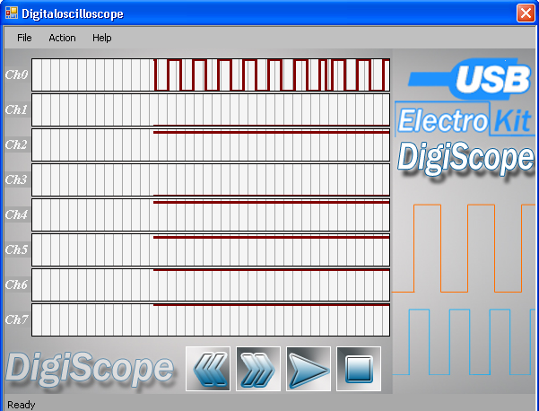
The part of the firmware is similar to that part special for analog oscilloscope, except that we here instead of reading the ADC, we read PORTD of the uC.
The process of the digital oscilloscope is done through the following steps:
- user enters the USB Electro-Kit software and chooses the Digital Oscilloscope tool.
- when clicking start button, a connection with the device over USB is established, if device is not connected, show an error message and exit.
- if the connection is established, application creates a thread that sends the control word: 0X00 to the device.
- uC reads the control word and reserves 8 –arrays each of size 100, including a 99 data bytes and a single control byte.
- uC sends first array.
- when the reading thread receives data it stores it in a shared array, starts the drawing thread and requests another packet of reading.
- uC when receives another request it does not read, it just passes array number 2 and so up to array number 8. this process supplies us with 800 continuous readings.
- when the uC has sent the 8 arrays, in the next request it goes back to read and store as in step 4.
- the sampling rate achieved is 700Ksps.
- in the drawing thread, we separate the arriving byte into 8 channels depending on arithmetic calculations, and draw each of them on its channel.
- reading thread still requests from the device until the buffer is full. Then it stops to wait the drawing thread to finish.
- when drawing thread finishes , it again resume reading thread.

Problems :
at the time we send data from the device to PC above USB, this consumes time. So a gap appears between each 800 reading and the next 800, the solution is to use a large random access memory ( Ram chip) on the device, and to use 2 uC 's one for reading and the other for writing.

Pulse Generator:
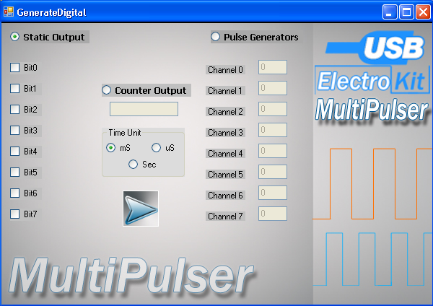
An important part of the lab equipment is the frequency generator. It generates mainly the sine and square waves ( 1channel only). But as computer engineers , in most cases we just work with the square waves ( pulses). So, we designed a multi-styled pulse generators that works in 3 modes:

  - Static output: the user may need to use the output ports as an 8-bit bus at generates any value needed with them, so he just uses the checkboxes available in the windows application to check those bits he /she wants them as ones and leaves those zeros unchecked. Once he clicks the generate button the following steps are executed:
    - Check if the device is connected successfully, else just send an error message and exit.
    - PC sends a packet consists of a control byte and a data byte, the control byte is 0X02 (op-code) and the data byte is the value of the 8- bits.
    - Device receives data and control word, and just show the data bits on port B
    - Data will still unchanged until device is disconnected or used in another mode.

  - Counter Mode: in many labs ( like digital logic design lab, we needed an input of a counter for our circuits), so the user is able to run the counter mode with the appropriate delay in unit of mSec, uSec,Sec. When the user works on counter mode the following procedure is executed
    - Check if the device is connected successfully, else show an error message and exit.
    - PC sends a packet consists of 1 control byte and 2 data bytes in the form of:
- Control: 0X03 | - Data: Delay unit | - Data: delay amount

    - device receives the packet, analyze it, and start an 8-bit variable, with initial value 0;
    - increment the variable
    - wait for delay time
    - output the variable on PORTB
    - if variable less than 255 go to 4.
    - if variable equal 255, then set its value to 0 and go to 4
    - process is only stopped by disconnecting the device or running it in another mode
  - Multi-pulser mode, in this mode, user can use the device to generate up to 8 different frequencies signals: the work is performed in the following procedure:
    - In the user form, the user find the option to decide how many channels he wants to use, by just leaving those unwanted channels as zeros
    - The user decide each channel's delay.
    - When the user clicks Generate button, the application checks if the device is connected to the PC, if not it shows and error message and exit.
    - If the device is connected, the PC sends a 10 Byte packet via USB, consists of 1 control packat and 9 data packets
0x04 | Time const. | Delay 0 | Delay1 | …. | Delay 6 | Delay 7

    - The device receives the packet, analyze it, and goes in an infinite loop with a counter, at each iteration, if the loop counter modular the delay factor of each channel is 0, it changes this channel i.e. if it's 1 it makes it 0 and vise versa
    - This process continues to infinity, unless the device is disconnected or it was used in another job.

Preferences Form:
It's clear that our application depends a lot on graphics and user interface, and because it's a matter of taste for colors and drawings, we enabled the user to modify the drawing area depending on his taste.
This is done in the following steps:
- At each time the user opens the preferences form, it loads a pref.ini file located at C:\ directory.
- if the file could not be located, the program uses the default settings.
- then the user can modify the drawing area background color, the grid lines drawing colors and widths, the data drawing line color and width.
- also the user may modify the buffer size.
- finally the user may save these preferences, so the next time the user runs DigiScope or AnaloScope, his preferences will be applied.
- also at any time, the user still have the option to go back to the default settings.

Description of Firmware:
The firmware basically starts with some constants definition:
- #define USB_HID_DEVICE FALSE //Diable HID option
- #define USB_EP1_TX_ENABLE USB_ENABLE_BULK //turn on EP1(EndPoint1) for IN bulk/interrupt transfers
- #define USB_EP1_RX_ENABLE USB_ENABLE_BULK //turn on EP1(EndPoint1) for OUT bulk/interrupt transfers
- #define USB_EP1_TX_SIZE 100 //size to allocate for the tx endpoint 1 buffer
- #define USB_EP1_RX_SIZE 10
Then
- #include <pic18_usb.h> //Microchip PIC18Fxx5x Hardware layer for CCS's PIC USB driver
- #include <PicWinUSB.h> //Descriptors and USB configuration
- #include <usb.c> //handles usb setup tokens and get descriptor reports

In the main function, we just define some variables, and call for the usb basic connection functions:
- usb_init();//initialize uc for USB work
- usb_task();//define a usb task
- usb_wait_for_enumeration();//wait until the device is enumerated from PC

then the remainder of the code is an infinite loop that at each time checks for any new commands arrived at the endpoint, if so, extract it's opcode and execute the appropriate part.
The firmware uses about 80% of the microcontroller's RAM, this because of high number of data storage arrays and variables reserved.
The Firmware was written using CCS PICC compiler.

Windows Application description:
The application is basically built over the PICWinUSBAPI class that uses all resources of the WinUSB.dll file.
All other classes at first step, create an object of picwinusbapi.cs class and use it for basic communication with the device.
Picwinusbapi.cs class uses these main functions:
- winusb_initialize() , to initialize the connection between PC application and the device
- winusb_write_pipe() to write data to usb
- winusb_read_pipe() to read data from usb

in this class we define two pipes :0X01 for sending and 0x81 for receiving.

All other files implement the usage of one specific part of the project. They are windows form contain controls for starting jobs.
In AnaloScope and DigiScope we have controls to start from device and buttons to explore data arrived. All drawing here is built over GDI+ graphics library from Microsoft.
In MultiPulser, we have loot of check boxes and text field to enable user to enter deferent frequencies of generated signals.

Problems we faced:
- In Software:
  - Windows Driver: the technology we used is so modern, to the limit that no tutorials , examples are available more than Microsoft ambiguous documentation, this also supplied us with nobody to ask when we faced problems in developing the driver.
  - C#.net application: we discovered lately that the choice of C#.net for drawing was not the best, because we knew lately that GDI+ library of Microsoft , which C# uses for it's graphics still have unsolved bugs, to the limit that at anytime an unhandled error may occur in drawing without reasons. More than that, a lot of exception are available in the user controls supplied with C#, one of it was the BrowseFolderDialog tool, which runs successfully in small software, but in large ones with lots of threading it crashes down.
- In hardware:
  - Lack of wanted chips, for example our PIC18F4550 was not available in a place nearer than the Jordanian capital, Amman. Also in our work we needed a high speed ADC, also not available except from Europe , so it needs more than a month to arrive.
  - Lack of accessories, for example USB connectors and input output connectors.

Benefits we got after execution of project:
    - team work was very successful in this course.
    - great experience for developing USB devices.
    - great experience with developing signal processing .
    - great experience in using PCB technologies.

Buffer size is determined by user in Preferences file

