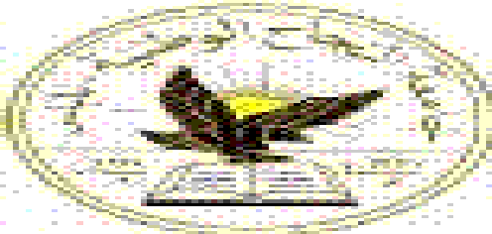

AN_Najah National University

Final Project documentation

Project Name : Document Flow in Najah University

Prepared by :

Maymoona ishtaya
Neda Omar Abd Alrazeq

Project supervisor : Dr .Raed Alqadi

Document management system

Electronic document management system is powerful ,integrated application that contains record management processes for document filing and organization ,secure storing , and easy retrieval and viewing.

Our project give this application to all employee in najah_national university in easy process that every employee can store all request in special form that are designed by use.

Our project stands for two points:

1. Ready application ( Forms)

2. Blank message

Ready form:

This application give each employee the forms that every employee need it such as vacation form ,transformation Form , Input/output form, message posting ,Alternative Course and other forms that every employee need it in najah University

Blank message:

Each employee can send any type of message that need and can send it to any employee work in the department ,can send it to multiple receiver and send this message in direct by another employee
In our application we give the option that the administrator can enter new message that the employee need it and not found we give easy step that that the administrator can add this new message easy.

Forms of our project:

Inbox details:
This form give the user the number of message that has been received and not read it when the user open this form at the first time there is small bulb will be appear when the user attention that have received new message This form appear in Fig (1)
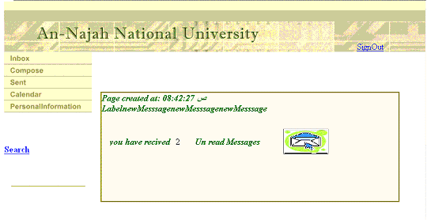

fig (1)

from this figure see that the user have two message that not read yet

Receiver Inbox:

This form give the user table of message that has been received this table give name of message, sender name, date Of Sending and you have option to delete the message easily as shown in the figure .

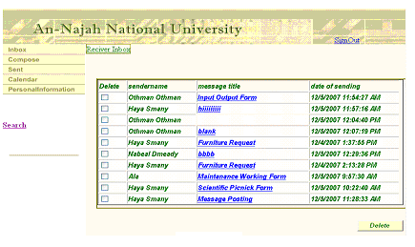

the message can be seen easily by click on the name of message to see all message and take options for forward it or reject.

Sender Inbox:

This form give the user table of message that has been sent this table give name of message, sender name, date Of Sending and you have option to delete the message easily as shown in the figure (3)
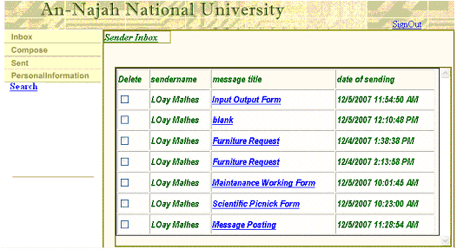

Fig(3)

The name of message is link give the user option to open this message and send it again

Add new user:

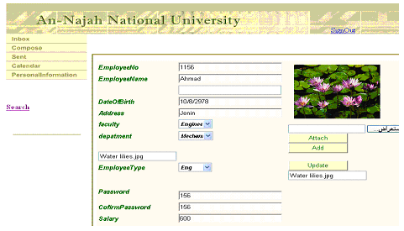
This Form give the option for the administrator for Add new user And give the permission to use this application as shown in the figure (4)

Fig(4)

Personal Information:

This form give the employee list of his information and give him option in order to update this information.
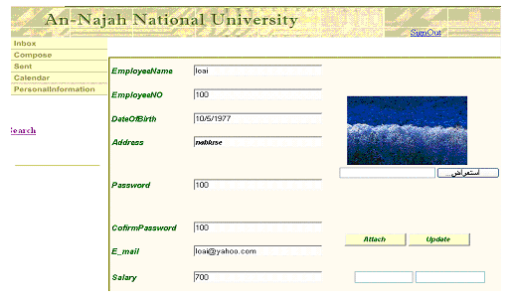

Search form:

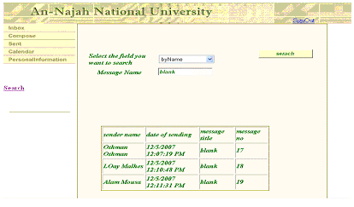
This form give the user option to make search of the messages that has been received according to message name ,sender name ,date of sending

Add New department :

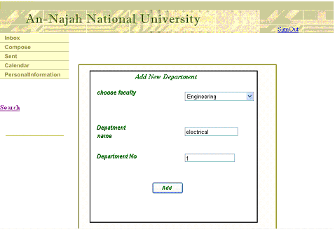
We give the option for administrator to add new option after determine the faculty name , we add drop down list to determine the faculty name the in two text box add the department name and department No as shown in the figure

Add new faculty:
The administrator can add new faculty that has been created to the university.
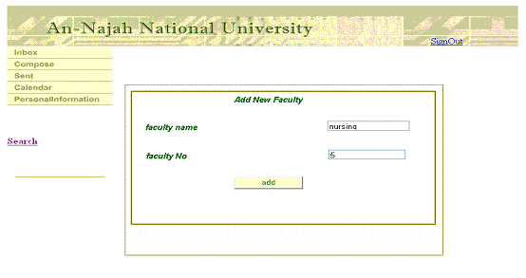

Her we will give you circle of one message in these slide:

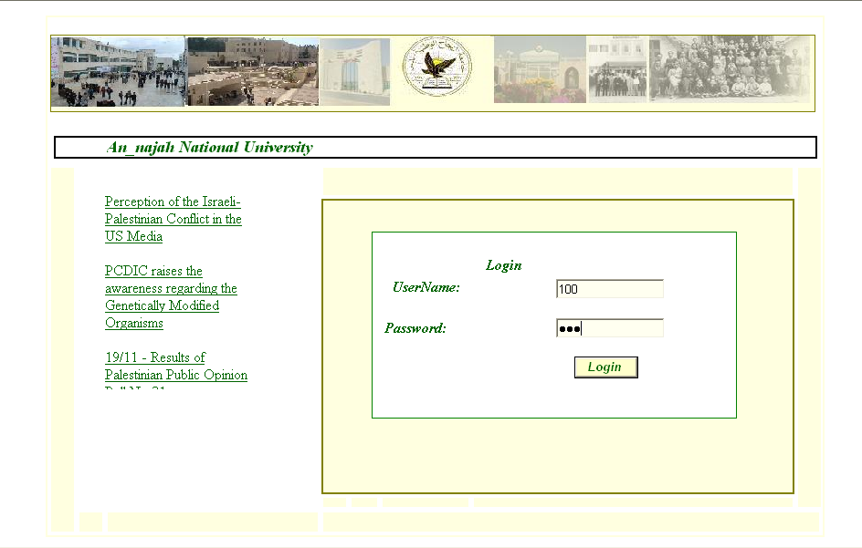

First Page is Log In page user enter his/her name and password to enter to his/her own web pages

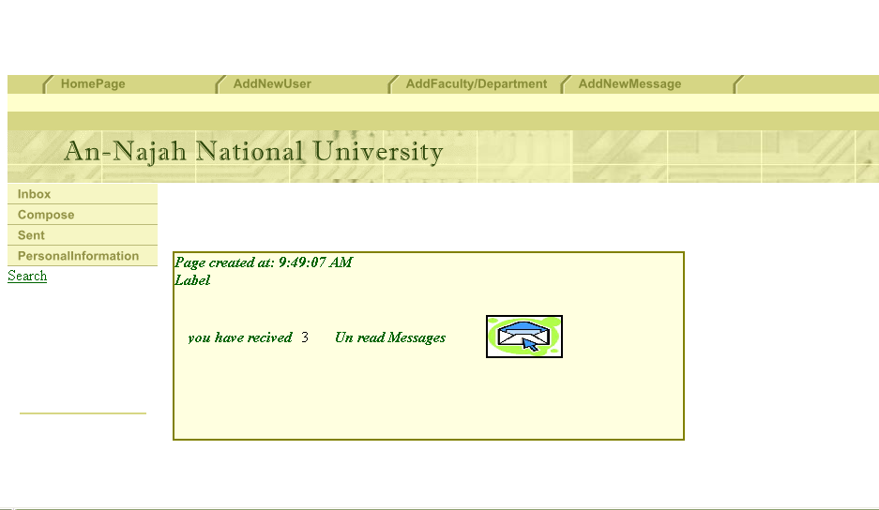

After login user see Inbox page which show No of unread messages and lead to received messages

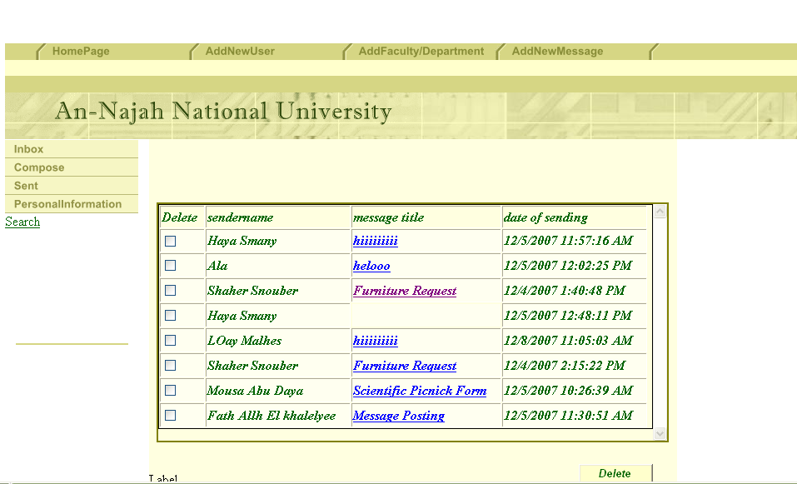

Received Messages page show messages received by user ,user can delete or open any message

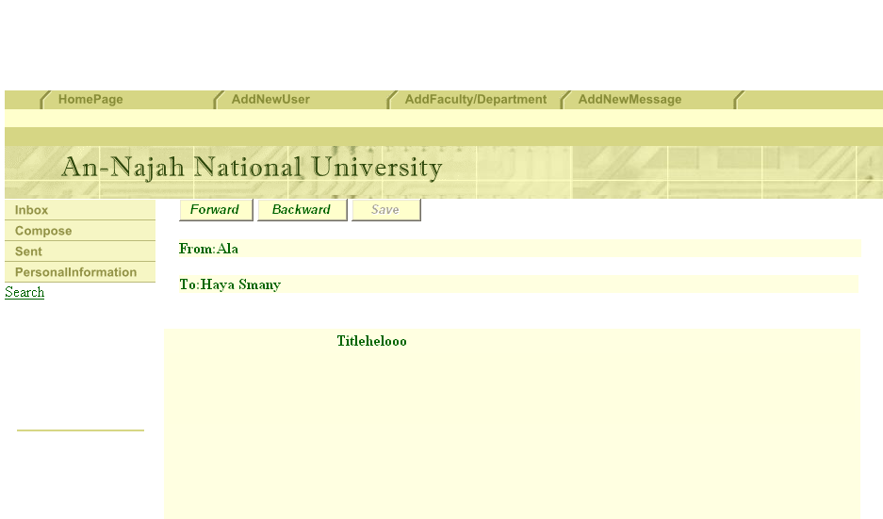

Message Content page here any message user can forward it to any other employee in Najah National Univercity or backward it(return /replay) to the sender

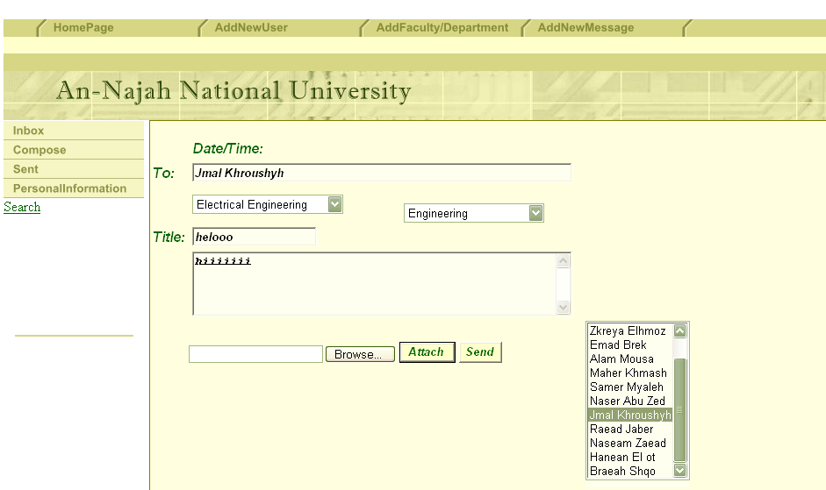

To forward message determine faculty name and department name from drop list thin list of employee names with these faculty and department will appear to user, choose receiver name from list (click on name) then To: box will be
filled with receiver name Type your title name and message content , you can attach files with message and send

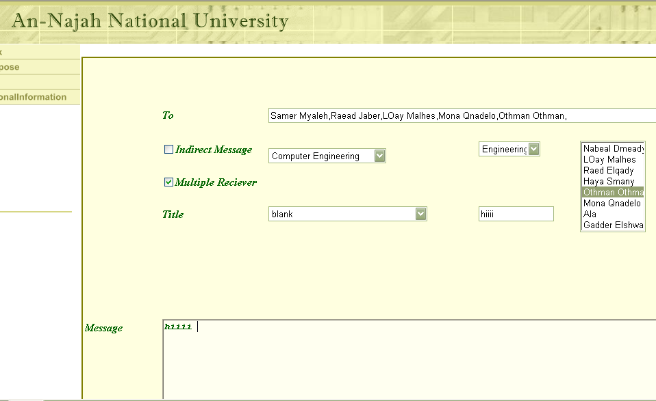

Compose page: here user has many options to send any message to multiple receivers, or send indirect message .

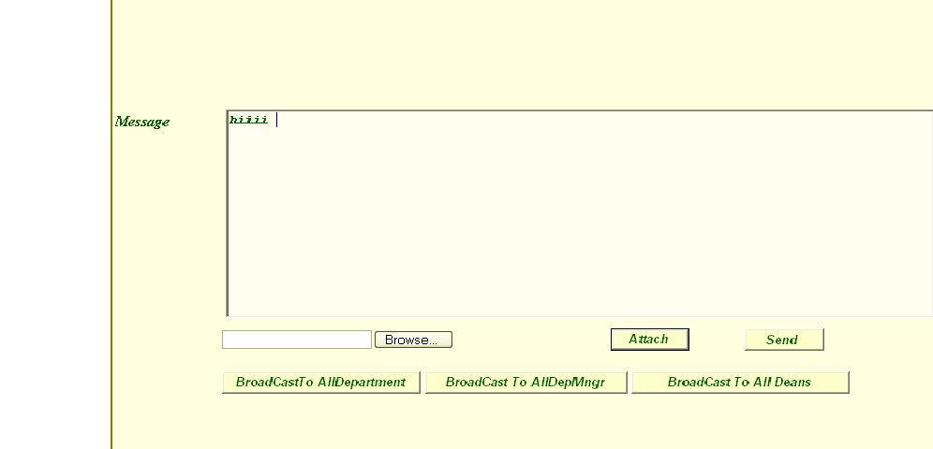

Also user can send to multiple users directly by button press (broad cast to all department :this button send user message to all employee within the same department ) and button broad cast to all department manager within the same faculty and button to broad cast to all Deans in the University

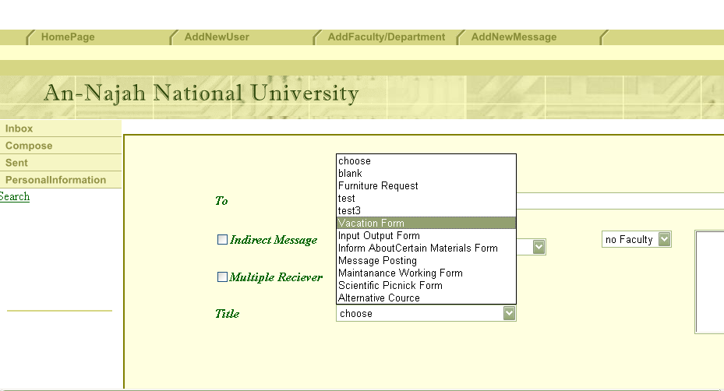

Also user can select forms or subjects to send

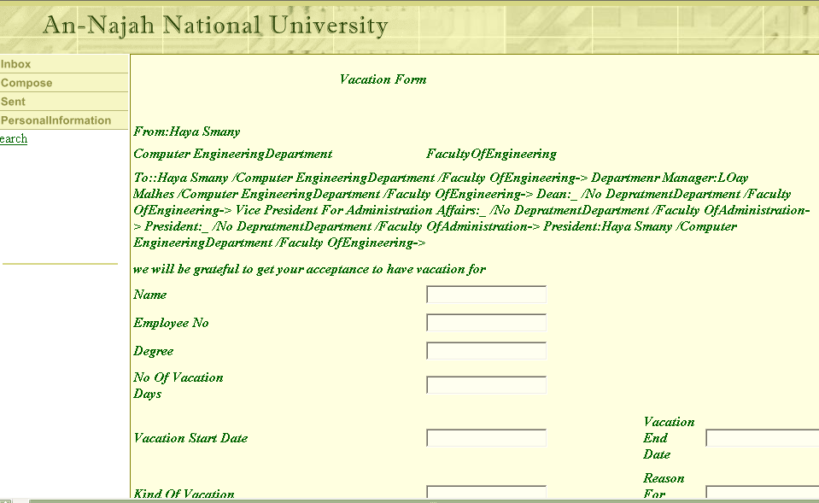

For example Vacation form is one of subject that can user select to send , here user fill all needed information and send message , in these form messages move from employee to another directly (follow path determined to each form as needed)

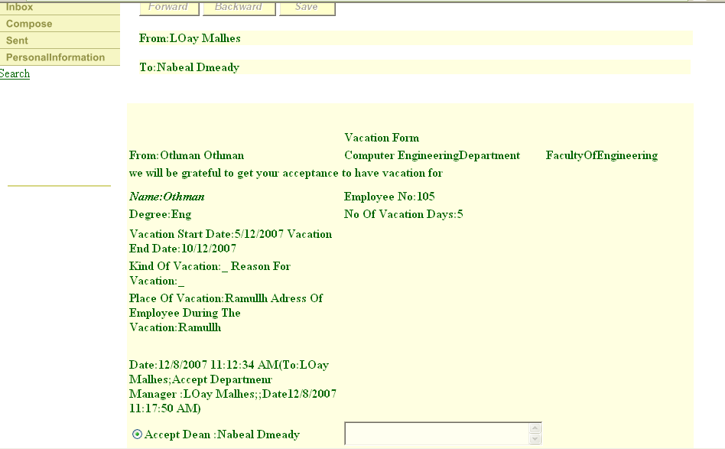

When form reach to suitable employee , user accept this message or reject , so user can either forward it to next receiver or backward it to first sender and this done directly. As seen below

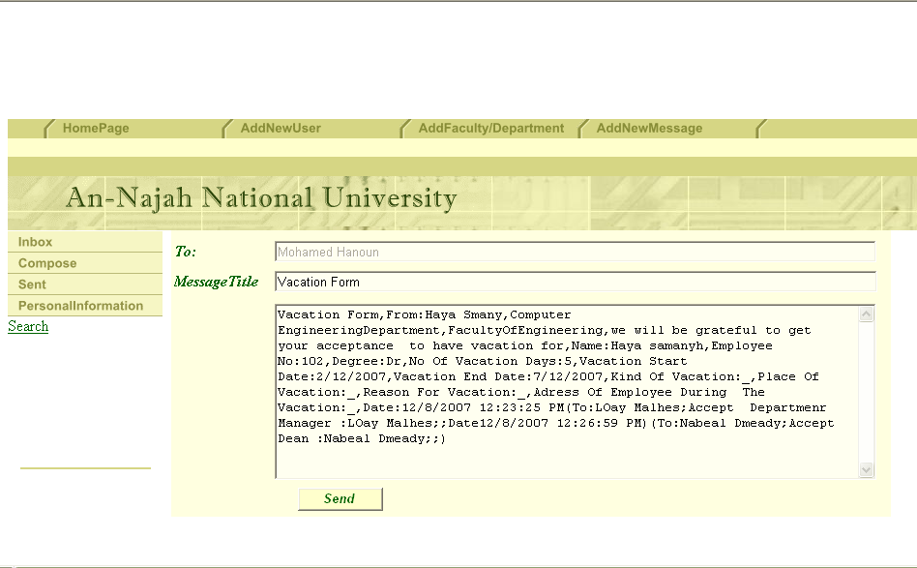

Her user accept, forward and send, or reject , backward and send then the message move by itself to suitable receiver.

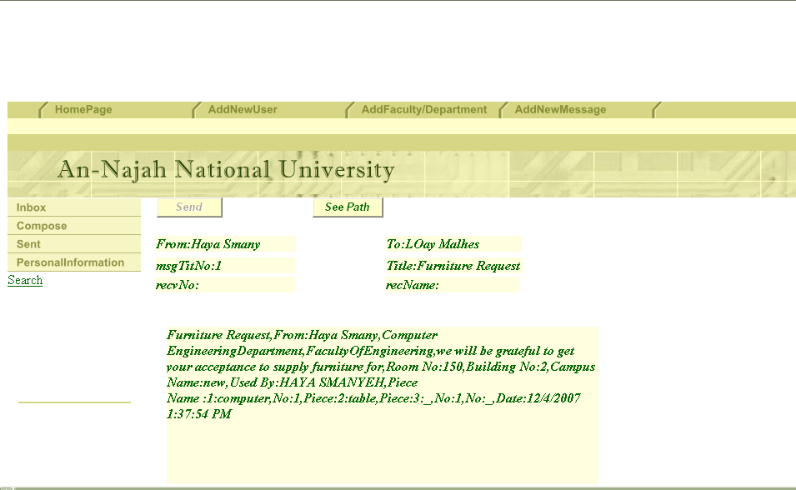

Any user receive this message and send it can follow the path of the message with all details as seen

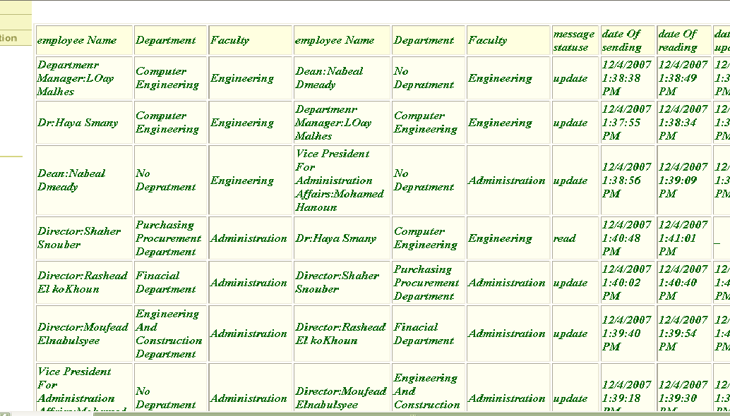

The administrator has more option to do in this web as adding new messages(forms) to be used by user

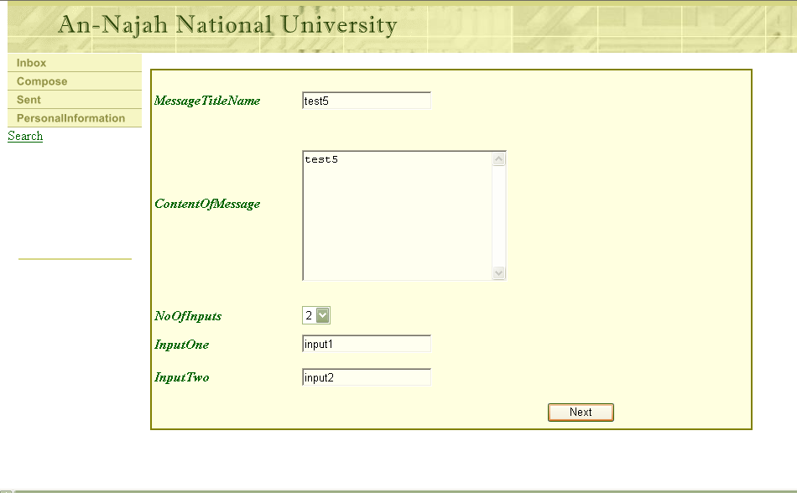

In the first page administrator write message title(subject name)
And content of message , also determine the inputs user has to fill ,then press next button to go to the next page.

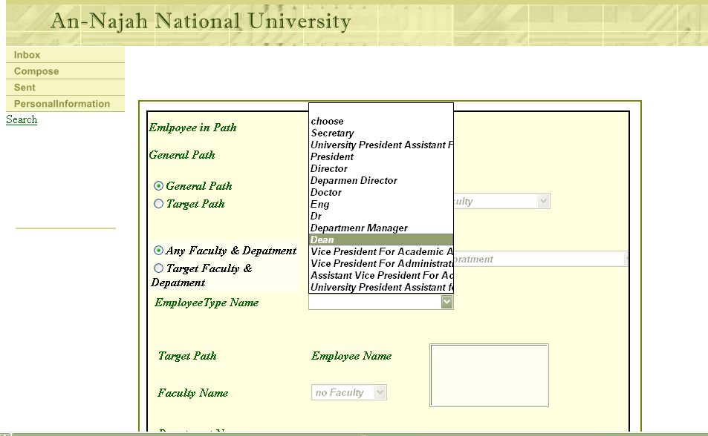

In this page administrator determine the path of Message(form), here admin has two options to select specified employee by his/her name or some level(degree/job)
By selecting general path or target path.
If you select general path:
- determine if this form for specific faculty and department or general for any faculty
By selecting any faculty & department or target faculty and department .
- then select type of employee (job)
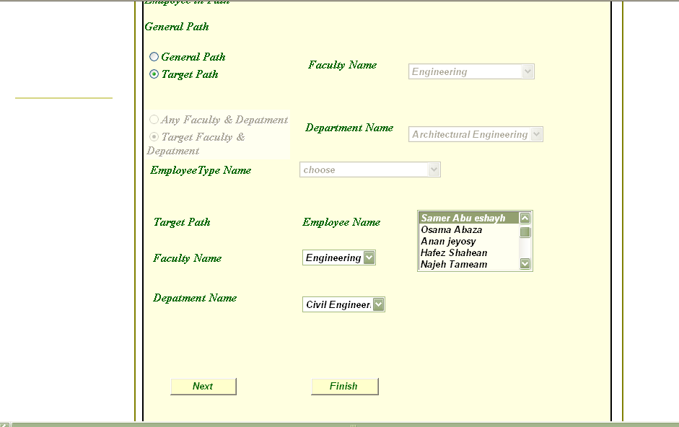
If you select target path you should determine employee name, first select faculty name and department name thin list of all employee names within this department would be seen by you , so select the wounded employee name .
Press next to choose next employee and repeat all of above until you finish your path , so click finish , which moves you to page as below.
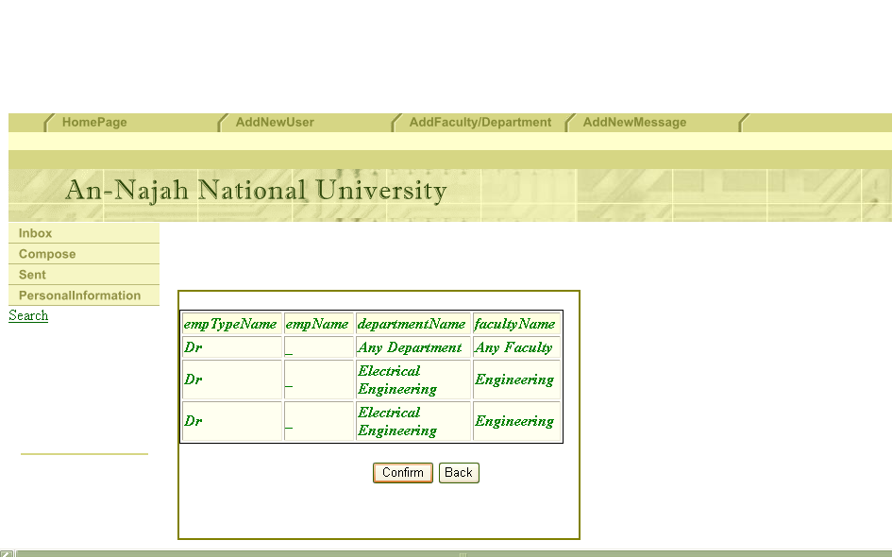

This page show you the path of your form(message ) with all details, you confirm to save this message or back to add another employee to the path .

Finally:

This project give each department the good hirecla of their document that they are need it and explain the circular of these message and determine the path of these message .

