بسم الله الرحمن الرحيم

Documentation For

School System
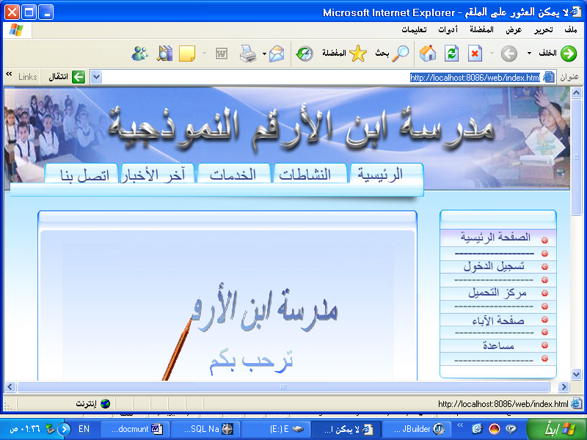
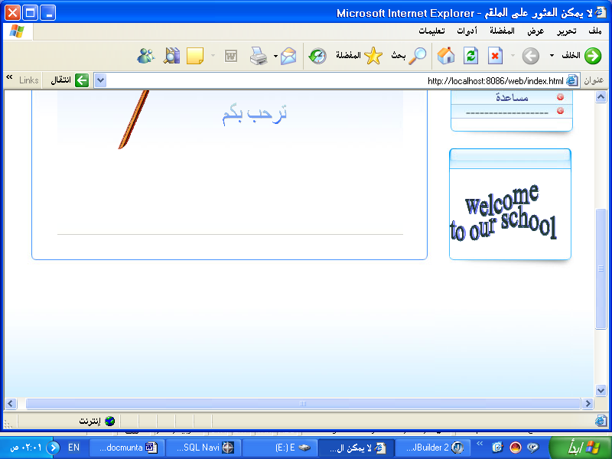

Prepared By

Asma Al-Saqa

Shereen Yaseen

Why School System ?

As we know the Education process is the most important process in our society ,and with the years tasks the school staff does increase so here the idea started !

We aimed to do a system that helps school staff (manager and teachers ) to do their work easily with saving time and effort ,
Also we aimed to get rid of the hundreds of papers stored in each school ,and we did not forget the communication between the school and its students .

So What Does Our Project Do?

helps the manager managing the school system by inserting information easily in the system .

helps the secretary to do his work in presence and absence ,registering new student and teachers ,updating their information ,recording the annual bills collected from students ,recording the fines on students and so on...

Helps the teacher in inserting marks for each class for each exam and update these marks .

Helps fathers to know all information they need about their children in the school.

helps the Students to know their marks throw internet.

helps the store owner to do his work easily and fast .

Platform Of Our project:

JSP (java server page)

JSP Overview:

The Advantages of JSP
JSP has a number of advantages over many of its alternatives. Here are a few of them.
Versus Active Server Pages (ASP)
ASP is a competing technology from Microsoft. The advantages of JSP are twofold. First, the dynamic part is written in Java, not VBScript or another ASP-specific language, so it is more powerful and better suited to complex applications that require reusable components. Second, JSP is portable to other operating systems and Web servers; you aren’t locked into Windows NT/2000 and ITS. You could make the same argument when comparing JSP to Cold Fusion; with JSP you can use Java and are not tied to a particular server product.

Versus PHP
PHP is a free, open-source HTML-embedded scripting language that is some what similar to both ASP and JSP. The advantage of JSP is that the dynamic part is written in Java, which you probably already know, which already has an extensive API for networking, database access, distributed objects, and the like, whereas PHP requires learning an entirely new language.

Versus Pure Servlets
JSP doesn’t provide any capabilities that couldn’t in principle be accomplished with a servlet. In fact, JSP documents are automatically translated into servlets behind the scenes. But it is more convenient to write (and to modify!) regular HTML than to have a zillion print in statements that generate the HTML. Plus, by separating the presentation from the content, you can put different people on different tasks: your Web page design experts can build the HTML using familiar tools and leave places for your servlet pro-grammars to insert the dynamic content.

Apache Tomcat

Tomcat is the official reference implementation of the JSP specifications. It can be used as a small stand-alone server for testing JSP pages, or can be integrated into the Apache Web server. However, many other servers have announced upcoming support. Tomcat, like Apache itself. Is free, However, also like Apache (which is very fast, highly reliable, but a bit hard to configure and install), Tomcat requires significantly more effort to set up than do the commercial servlet engines. For details, see http://jakarta.apache.org. Configure the Server

oracle 9i( to store database for our project)

The program that uses in my projects:

JBuilder 2005 :
JBuilder is the most comprehensive, award winning visual development environment for creating platform-independent business applications, applets, servlets, and JavaBeans for the Java platform.
System Requirements
Microsoft® Windows® XP, 2000 (SP4), or NT 4.0 (SP6a)
Intel® Pentium® III 500 MHz or compatible
512 MB RAM (recommended minimum)
768 MB RAM (recommended)
560-760 MB hard disk space minimum (depending on features installed) ]

Dreamweaver:
Macromedia® Dreamweaver® MX 2004 is the professional choice for building web sites and applications. It provides a powerful combination of visual layout tools, application development features, and code editing support, enabling developers and designers at every skill level to create visually appealing, standards-based sites and applications quickly. From leading support for CSS-based design to hand-coding features, Dreamweaver provides the tools professionals need in an integrated, streamlined environment. Developers can use Dreamweaver with the server technology of their choice to build powerful Internet applications that connect users to databases, web services, and legacy systems.

Oracle 9i:
An Oracle database is a collection of data that is treated as a unit. The purpose of a database is to store and retrieve related information. The database has logical structures and physical structures. Because the physical and logical structures are separate, the physical storage of data can be managed without affecting the access to logical storage structures.

The Oracle server provides: large databases and space management, many concurrent database users high transaction processing performance high availability , connectibility
Manageable security , distributed systems

The SQL Navigator:
The SQL Navigator family of products is a complete development environment for Oracle server-side development and management.
It has been conceived, designed and developed by Oracle developers

Data Base Tables for the system

First we started to construct the database of our project determining the main attributes in it and the relations between them as shown below .
To draw these relations we used the (Visio2003) program

Use Cases of our Project:

Any one who want to use the system must have user id and password, according the user id the system will recognize the type of user which may be one of the following :

Secretary :
who can do the following :
recording presence and absence of the school for teachers and students.
collect the annual bills from students and record them .
register a new student.
updating student's information.
recording student's fines.
register a new teacher.
updating teacher's information.
recording teacher's fines.

Manager :
inserting and updating clasess and sections of classes:
inserting instruction notes for teacher:
detrminig the classes found in the school:
determining the lessons that each class study:
deteming the classes each teacher teach :
determine the responsibilities in the school:

Teacher :
inserting marks of each student for each subject he studies :

Fathers page:
fathers can log in school with ther own password and log in id to see all information they nedd about thie children .

Student page:
where they can see their marks for each exam and other information as last news holidyes and other things .

