CURRICULUM VITAE | 2015

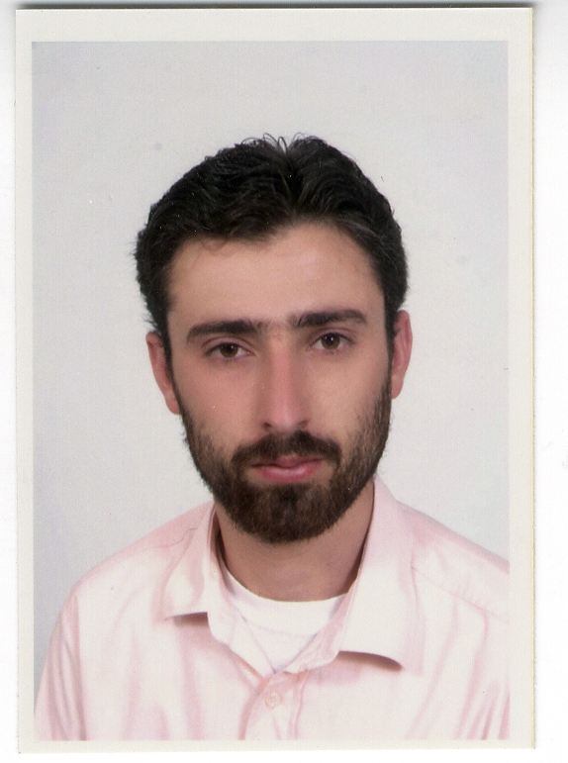

Curriculum Vitae
PERSONAL INFORMATION

Ahmad M. A. Saleh.
Nationality: Palestinian.
Marital Status: Married.
Place of Birth: Tubas, Palestine.
Date of Birth: 6/4/1978.
Sex: Male.
Work: Assistant Professor, An Najah National University.
Address: Palestine, Nablus, Rafedia. Abo So'od Building, 7.
Mobile: 007 0597600453
Email: a.saleh@najah.edu

EDUCATION

- PhD, (11/2008-12/2013) Architectural Design and Creative Multimedia, Multimedia University, Cyberjaya, Malaysia.
Thesis title: Computer Visualization For Improving User Participation In The Early Stage Of Architectural Design Process.
Supervisors: Prof Ahmad Rafi, Prof Peter Woods.

- M.Sc. (09/2002-12/2005) in Architectural Engineering / Community Participation in Architectural Design, An-Najah National University Nablus, Palestine. Rate: excellent (93.2%),the Pest students among all the postgraduate students in the university.
Thesis title: Community Participation in Architectural Design (Evaluation of Al-Maageen Housing in Nablus).
Supervisors: Dr. Ziad Senan, Dr. Khairi Marei..
- B.Arch. (09/1994-05/1999) Architectural Engineering, An-Najah University (Palestine).
Thesis title: A 'comprehensive' designing for a university.
Supervisor: Dr. Ziyad Sinan.

- General Examination Board, (1995-1996) Tubas Secondary School, West Bank, Rate 89.9%, the Pest students among the school.

LANGUAGES

Arabic native language: (Excellent in read, write and conversation).
English: (Very good in reading, writing and speaking).
WORK EXPERIENCE

- Assistant Professor, Building Engineering Department, An Najah National University, August 2015 until present
- Part time Lecturer, Faculty of Architecture & Environmental Design, International Islamic University Malaysia, Kuala Lumpur, Malaysia, 2008,2009.
- Lecturer, Faculty of Engineering/ Building Engineering Department, An- Najah National University (1/9/2006- 1/7/2008), Palestine.
- Teaching assistant, faculty of Engineering, An- Najah National University (1/9/2001- 1/9/2006), Palestine.
- Architect Engineering, Municipality of Aqqaba, 2001 in Palestine.
- Training at engineering supervision (Tbaleh office) in Nablus, Palestine.
- Graduated project was designing a university building and it had gotten the highest mark among all the students.
- Designer, 2001 until present; this includes design and/or supervision the construction of several projects, some of them are:
  - Aqqapa Primary School.
  - Aqqapa roads.
  - Separates house design.
  - Villa design.

COURSES TAUGHT:

- Graduation Project II
- Graduation Project
- Principals of Architectural Design
- Descriptive Geometry
- Engineering drawing
- Introduction to Building Engineering
- Integration of Building Systems
- Architectural Design 7

COMPUTER SKILLS

Very good knowledge Computers software, very good on 2D and 3D AUTOCAD, and good on 3DMAX, SketchUp drawings, Photoshop.

TRAINING & PROFESSIONAL DEVELOPMENT

Certificates and research training:
- Teaching and learning I; Centre for Academic Advancement, National University of Malaysia, Malaysia, 2013.
- Teaching and learning II; Centre for Academic Advancement, National University of Malaysia, Malaysia, 2013.
- International Conference And Workshop On Leadership Management; Pertubuhan Ikram Malaysia, Malaysia, 2013.
- New Media Fundamental; Turjuman Media Consultancy, Malaysia, 2011.
- Planing and Managing Public Relations and Media campaigns; Turjuman Media Consultancy, Malaysia, 2011.
- NVIVO Workshop; school of Accounting & Corporate Reporting And Governance Research, National University of Malaysia, Malaysia, 2010.
- Negotiation & Influencing Skill; Sunway International Business and Management, Malaysia, 2010.

LIST OF PUBLICATIONS

- Published
[1] Daraghma, A., Rafi, A., & Woods, P. (2011). Evaluating the Use of 3D Computer Visualization to Support User’s Participation in Architectural Design Process, 3rd Proceeding International Conference on Applied & Creative Arts: Beyond Boundaries (ICACA), Faculty of Applied and Creative Arts, UNIMAS, Malaysia.

[2] Saleh, A., Rafi, A., & Woods, P. (2011). An Investigation of User Participation in the Architectural Design Process -Evaluation of Housing Process, 2011 IEEE Student Conference on Research and Development (SCORED), Malaysia.

- Submitted
[3] Saleh, A., Rafi, A., & Woods, P. (XXX). A qualitative Quasi-experimental Evaluation of Using 3D Computer Visualization to Support User participation in Architectural Design Process. Journal of Mixed Methods Research

- In process
[4] Saleh, A., Rafi, A., & Woods, P. (XXX). Evaluating the Level of User Participation at the Early Stage of Architectural Design using Three-dimensional Computer Visual Materials

MEMBERSHIPS

2001-Till present: General member at Engineering Association-Jerusalem, Reg. No. 122/L.

2014-present: Jordanian Association of Engineers (Jerusalem Branch), 1999-present.

August 2000: Course in medical first aid, Palestinian Red Crest Society.

AWARDS

Full PhD scholarship award at Multimedia University, Malaysia, 2008.

Honorable Mention in Architectural Competition for the Design of Public Spaces and Urban Facilities in the Old City of Nablus, UNESCO Office Ramallah 2005.

Pest students among all the postgraduate students in An- Najah National University 2005.

Pest graduation project among all Architectural Department projects, An- Najah National University 2001.

REFERENCES

Available upon request

