

An- najah national university

Computer engineering department

Cnc-documntaion

Prepared by:
Rania hasan
Enas hamadneh

Supervisor : dr.ala masri

TABLE OF CONTENTS

cahpter 1--introduction 3
1.1 introduction 4
1.2 over view 4
1.2.1 what is cnc 4
1.2.2 g code 5
1.2.3 motors 5
chapter 2 body design 6
2.1 wood 7
2.1.1wooden layout 7
2.1.2 linear slide bearings 8
2.2 cnc z axis 9
2.2.1 z axis lead screw 9
2.2.2 z axis motor mount 11
2.3 cnc y axis 12
2.3.1 y axis bearnigs and rail support 12
2.3.2 Y-axis assembled 12
2.3.3 Gantry Y-Axis Rail Support 13
2.3.4 Y-Axis Rails and Transmission Nut 13
2.3.5 Y-Axis Lead Screw 13
2.3.6 Y-Axis Motor Mount 14
2.4 X-Axis 15
2.4.1 X-Axis Front and Back 15
2.4.2 Gantry Sides 17
2.4.3 X-Axis Lead Screw 17
2.4.4 X-Axis Motor Mount 17
2.5 safety 17
2.5.1 What we used to make it safety 17
2.5.2 Safety Rules & Safety Functions 18
chapter 3 motor driver 19
chapter 4 programming 22
conclusion 23

Chapter 1
Introduction

1.1 Introduction:
Today, computer numerical control (CNC) machines are found almost everywhere, from small job shops in rural communities to Fortune 500 companies in large urban areas. Truly, there is hardly a facet of manufacturing that is not in some way touched by what these innovative machine tools can do.
While the specific intention and application for CNC machines vary from one machine type to another, all forms of CNC have common benefits. Though the thrust of this presentation is to teach you CNC usage, it helps to understand why these sophisticated machines have become so popular. Here are but a few of the more important benefits offered by CNC equipment.
The first benefit offered by all forms of CNC machine tools is improved automation. The operator intervention related to producing workpieces can be reduced or eliminated. Many CNC machines can run unattended during their entire machining cycle, freeing the operator to do other tasks. This gives the CNC user several side benefits including reduced operator fatigue, fewer mistakes caused by human error, and consistent and predictable machining time for each work piece. Since the machine will be running under program control, the skill level required of the CNC operator (related to basic machining practice) is also reduced as compared to a machinist producing workpieces with conventional machine tools.
The second major benefit of CNC technology is consistent and accurate work pieces. Today's CNC machines boast almost unbelievable accuracy and repeatability specifications. This means that once a program is verified, two, ten, or one thousand identical workpieces can be easily produced with precision and consistency.
A third benefit offered by most forms of CNC machine tools is flexibility. Since these machines are run from programs, running a different work piece is almost as easy as loading a different program. Once a program has been verified and executed for one production run, it can be easily recalled the next time the work piece is to be run. This leads to yet another benefit, fast change-overs. Since these machines are very easy to setup and run, and since programs can be easily loaded, they allow very short setup time. This is imperative with today's Just-In-Time product requirements.
So you are able to draw a paint on your computer it will be digged on your wood piece using a special programme determine the pixel axes and a pic circuit control the motion of three motors each move in the three dimension x,y,z to place the head on the correct place to draw the pixel.

1.2 over view:

1.2.1-What is CNC?

CNC stands for Computer Numeric Control. Basically, CNC is where a computer based machine takes a series of instructions and converts these into motion. A CNC machine can have 1 to several axis, but most have three, X Y and Z. A tool ( cutting tip, router, plasma cutter, laser cutter ) is attached to the machine, and throught the computer controlled movement of this tool, the work piece is machined until the final shape is produced.

CNC has been with us for decades, starting an just NC back in the 1940's. Early NC used hard wired controllers to control the machine motion, so any change in the program meant a re-wire of the controller. Later punch cards were used. As computers got cheaper and easier to use, hand coded G-Code was used to drive the controllers. Then tape, floppy drives and serial connections were used to transfer the G-Code files ( also called NC files ) from the CAD/CAM computer to the CNC controller. These days most CNC controllers use top end OS's like Windows 2000 or Linux, and are connected into the workshop network.

1.2.2-G Code

The "instructions" read by CNC machines are usually a human readable format
called G-Code. The machine is set up with a base unit, like Inch or mm, and a command of G01 X500 Y200 on a metric mm setup tells the machine it needs to move
500 units on the X axis and 200 units on the Y axis. If I wanted to make a 20mm by 30mm square, 3mm deep, I would use

N004 G0 Z5
N005 G01 X0 Y0
N006 G01 Z-3
N007 G01 X0 Y30
N008 G01 X20 Y30
N009 G01 X20 Y0
N010 G01 X0 Y0
N011 G00 Z5

The N004 to N011 are line numbers, these are not ormally needed by the CNC machine. Not shown, but usualy included, is the header and footer informations. These are a few commands to do things like turn on/off the router and coolant, set laser configuration, etc.

1.2.3 Stepper Motors
The motors are the heart of any CNC machine. The size and type of motor can define a CNC routers precision, speed, and accuracy. There are two primary classes of motors used on CNC machines, stepper motors and servo motors. Within these two classes there are several types.
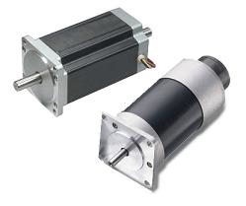
Stepper motors and servo motors both have their advantages and disadvantages which will be discussed in greater detail in later sections. The following sections will attempt to cover all aspects of the types of motors associated with CNC routers and other types of CNC machines.

Chapter 2
Body design
2.1 wood

2.1.1 wooden layout

We cut wood into the pieces shown in the figure 2.1 above using wood CNC I will briefly describe where we will use each
Wood pieces :
Piece number 1: it’s the base piece where we will put the wood piece we will use it to draw on it.
Pieces number2 : it’s the leg that will hold the machine.
Pieces number3 :these pieces we will put them at the front and bottom of the base one will hold the motor the other will hold the bearings that hold the x-axis.
Pieces number4 :these pieces will hold the x-axis.
Pieces number5: use to join pieces number 4 from up and down.
Pieces number6,7,8,9:is connected together to form a box that hold the drill that we will use it to draw.

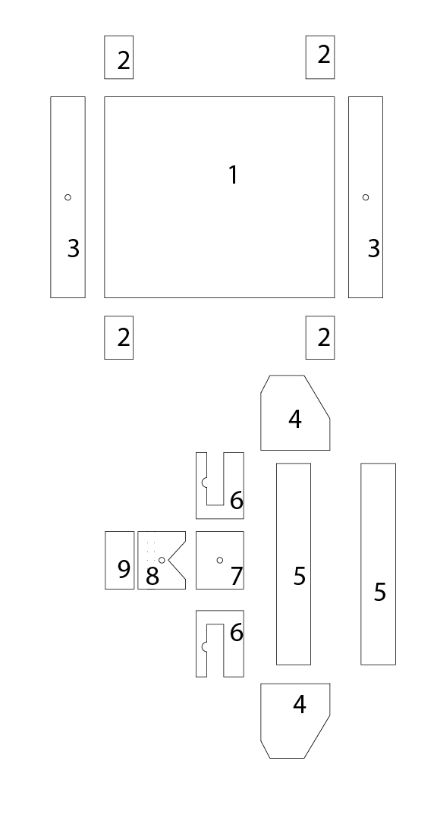
figure 2.1

joining pieces is one of the advanced tricks of the trade for furniture and cabinet builders. Joining medium-density fiberboard, or MDF, requires a little more reinforcement than plywood and hardwoods due to the additional weight and brittle nature of the material. While nails or screws can be used to join corners, joining panels end to end requires the use of plywood supports and mechanically machined joints for specialized fasteners such as pocket screws.. The idea is very simple: with two large holes to receive nuts, and two transversal holes to receive screws (long enough to reach the nuts), a tight and strong connection can be achieved. Not only is this connection strong, it also helps to create the tension desired to tighten an axis assembly around the rods/angles for snug no-play sliding.

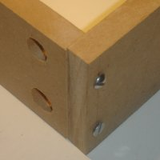

2.1.2 Linear Slide Bearings

A linear-motion bearing or linear slide is a bearing designed to provide free motion in one dimension. There are many different types of linear motion bearings.


Motorized linear slides such as machine slides, XY tables, roller tables and some dovetail slides are bearings moved by drive mechanisms. Not all linear slides are motorized, and non-motorized dovetail slides, ball bearing slides and roller slides provide low-friction linear movement for equipment powered by inertia or by hand. All linear slides provide linear motion based on bearings, whether they are ball bearings, dovetail bearings, linear roller bearings, magnetic or fluid bearings. XY Tables, linear stages, machine slides and other advanced slides use linear motion bearings to provide movement along both X and Y multiple axis.

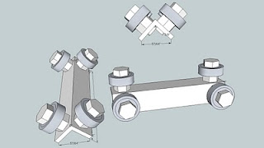

The bearing will slide on an aluminum or steel angle keeping the bearing in place. First, you will need an angle, easily acquired at your local hardware store. I use an aluminum angle for the ease of drilling and tapping.
These bearings walk on aluminum corners.

2.2 - CNC Z-Axis :

This is the first part of the CNC router z-axis build. The z-axis is one of three axes for the CNC (x, y, and z). The z-axis allows the router to move in the up and down direction.
When it comes to CNC machining, things can become a little bit confusing. Most CNC machines operate on 3 axes and those are referred to as X, Y, and Z. Some of the CNC machines implement a 5-axis form of movement where there are 2 more axes that are used. Each axis represents a different motion that can be done. For example: side-to-side motion, up-and-down motion, etc. This is why CNC machines are capable of performing almost any type of motion because of the combination of the axes that are used.
The CNC Z axis is very important to the CNC machines. Without this axis, depth cannot be created. Many projects, from woodworking to auto part making, require the use of the Z axis. If you have any questions about the CNC Z axis or would like to learn more, contact any machinist or your local CNC machine dealer. They will be able to help you learn the importance of the Z axis

The z-axis slide bearings on each side will fit into grooves. This is to insure that they are perfectly perpendicular to the side pieces so that the two slide bearings are parallel and there will not be any rocking. It's also possible to make the holes for all of the so there is some flexibility in the machine.

The overall idea is that this assembly of the z-axis will use tension and compression to stay tight to the rail for smooth flawless operation. To elaborate, the two slide rails will be under pressure from the back of this assembly. The back will be under tension, where the rails and the rail support will be under compression. This will keep the rail nice, aligned and tight. My first machine uses the same concept, but I used round bars instead.

2.2.1 Z-Axis Lead Screw
Now let's talk about the type of screw. The types are categorized as: mechanical type, major diameter, thread pitch and material. The mechanical types are typically common screw threads (second image), acme (first image), and ball screw. In this video, I'm using the common screw thread which are cheap and mechanically abismal. It works fine for me, however. Later I will get into video tutorials regarding the other two types. To briefly describe the other two, the ACME screw is a screw, usually oil dipped steel, with higher precision but still exhibits backlash. The ballscrew is the most precise of them all since all of the threads glide on little metal balls within the nut allow no play, that spins with little effort or friction. Sorry... I didn't explain backlash. Backlash is the brief absence of linear movement when the motor starts turning the reverse direction. This happens because there is a bit of space between the thread of the lead screw, and the inner thread of the nut. To understand what the heck I'm talking about, take a screw and screw a nut onto it. Wiggle it a little bit and you will notice some play. Software can sometimes compensate for this, but it's better to have no play in the mechanism. Unfortunately, the higher the precision, the higher the price. Determine your application and design appropriately. I would use ballscrews for very high precise fabrication. Later, after this video series, I am going to attempt a homemade balls crew using skate bearings. Now you’re thinking'... this guy is off his rocker! We'll see.

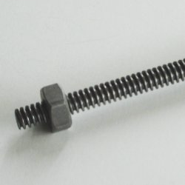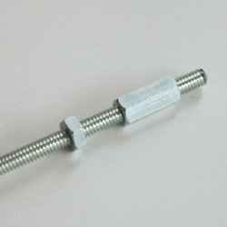

Back to the other specifications: The major diameter is measured to the outside of the thread. I am using 1/4". The pitch is the measurement from the center of one thread to the center of the next thread. In addition, pitch is also stated as pitch count which is the number of threads that fit between one inch. The pitch is the most important when it comes to the speed and resolution of the CNC. Speed is an important factor which will be explained later in much more detail. Specifically, the pitch is one of the characteristics that affect the feed rate (velocity) at which the router will travel along an axis. Too slow and you can melt materials and gum-up the bit, too fast and you will put too much strain on the bit yeilding a failure (yes, I know, there are other factors such as the router motor and router speed). If the pitch is too high, then resolution will be reduced. Resolution may be important to the application of the CNC, whether you will be using it for PCB routing, or cutting larger components. Other components, which will be discussed later regarding controllers, motors and software will also have an impact on the speed, not to mention the router specifications. Yeah, and you though building a CNC was a piece of cake. It is.. he he. but it dies have a bit of a learning curve.

In the video I'm taking my cheapo 1/4" threaded rod, bought from the local hardware store, and inserting it through the holes that I made during the z-axis transmission nut process. First, I send the rod through the top hole and add a few components, a bearing and two nuts to secure the screw assembly in place. Actually, I ended up doing it differently as shown in the image, but there are a thousand ways to skin a cat. I finally chose to only secure it at the top, since gravity is on my side and I had very little friction with the poor workmanship of the z-axis. Additionally, I fastened a nut on both sides of the bearing to secure the screw in place held by the free spinning bearing. In the image, you will note the complete and utter diregard to quality workmanship, but I garuantee it will work like a charm. I don't even have an asthetic shoice on the choice of hardware, screws and bolts used interchangeably. Where you see a bit of screw sticking out, a coupler will be placed to couple the motor to the screw assembly. The bearing is sticking out of the wood very uncomfortably. I may at a later date drill a 7/8" hole partly through the wood so the bearing can be countersunk a little. This also help with the mounting of the motor later. Admitidly, the 1/4" threaded rod had some play within the inside diameter of the bearing, which is about 5/16". A spacer can be used to compensate, or just take some thin pipe thread tape and wind it around the rod until the bearing fits tightly onto it. Check out the fibers of MDF on the bearing (yes, that is what you are breathing).

The video also gets into the cutting of the x-axis aluminum angles, I call em' rails sometimes. It is a very straightforward process. Just measure the board length, in my case I'm using a 24" x 48" board so I cut the angles as a little less than 48" (about 47 7/8"). If it is cut longer, the two stands will get in the way. Oh, by the way, I'm cutting two angles at this lengh, one for each side, if you didn't already know.

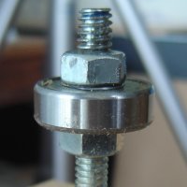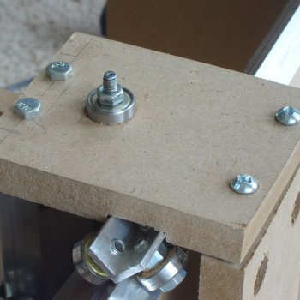

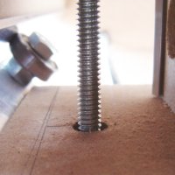

2.2.2 Z-Axis Motor Mount
The y-axis top bearing get's used like a cheapLike I said before, almost every piece of the CNC machine has two functions. In the case of the y-axis top bearing support, it has three functions,to hold the bearing for the y-axis, to help support the z-axis rail and finally to mount the z-axis motor. It's best to design with efficiency and simplicity in mind, and cut out allof the supurfulous material. Extra material should only be used if the material's propertied are not adequate for the job, then structure is needed to essentially engineer the inadequate material. To elaborate, If I wanted to use 1/2" MDF, I would probably have to build a frame for each axis to reduce the tendency to sag or bend.
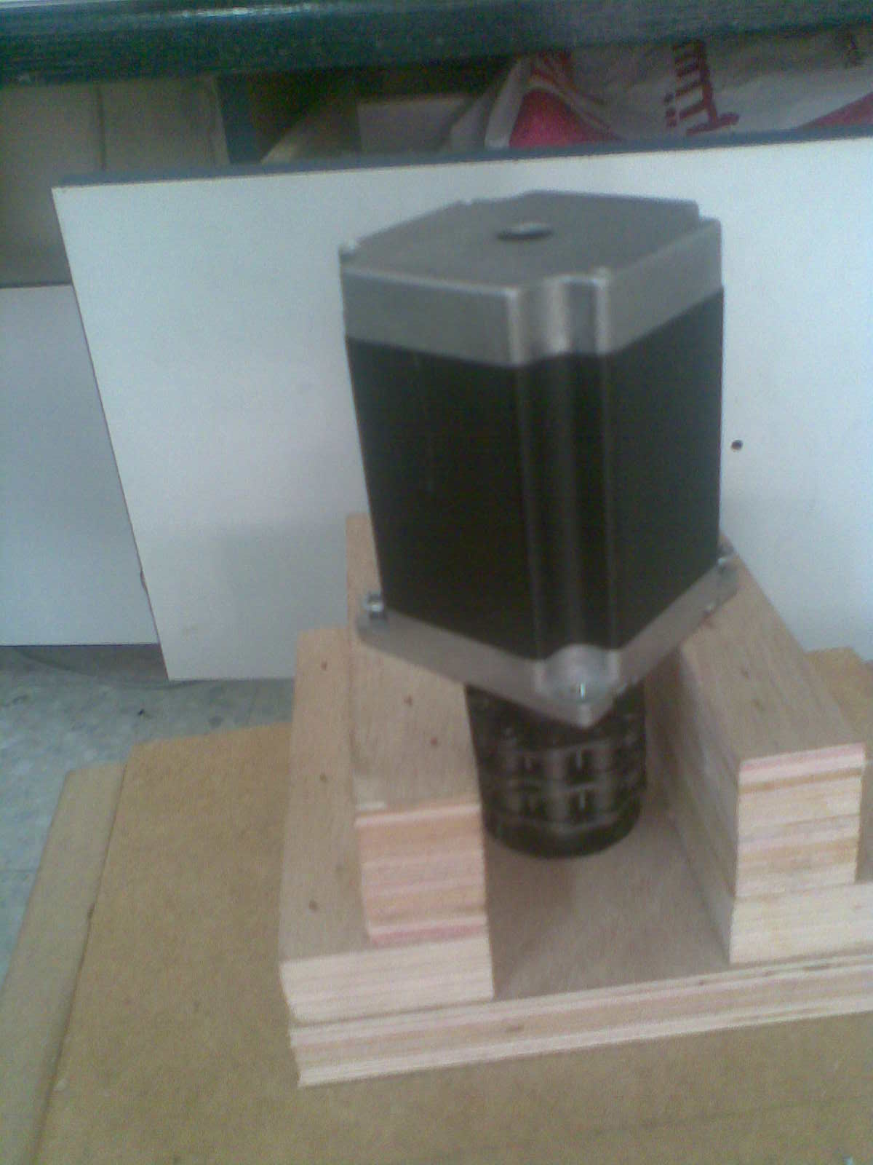

2.3 y-axis
2.3.1 y-axis bearing and rail support
The linear bearing supports are very similar to the z-axis linear bearing supports. The main difference is that the function of the z-axis supports also provide for the router carriage/holder. The function of the y-axis serves as a motor mount to move the z-axis in addition to the slide mechanism.

The measurements for the linear bearing are the same for the z-axis, y-axis as well as the x-axis. All of these axes ride along a similar stock of MDF which is chamfered and contain an aluminum angle. The only thin to keep in mind is: position the linear bearing grooves so that the bearings and the bolt heads have sufficient clearance from the back supports for each axis, but keep them as close as possible. This will minimize the amount of MDF used, and will translate to more travel in the x-axis. That is to say, the mechanism that contains the z and y axes will parametrically relate to the length of the x-axis linear slide bearing to compensate for the center of balance and overall torque imposed by these two axes. In fact, if you think about it, the entire CNC router structure is parametric in nature. One change in measurement in the z-axis will affect all measurements through to the x-axis.

This will be explained again later to reinforce this idea. Other aspect of this video to understand is the motor mount. We do not address it in this video; however, you will undoubtedly wonder where that element will be affixed to these supports. The only critical mechanism that will relate to the motor is the screw. We will be using a 1/4" standard screw at 20 threads per inch. If you wish to use an acme screw, I will address that after the build. This build is about being frugal, and my experience with a standard screw is pretty positive. I could not determine if there was backlash in the pieces that I fabricated. Other than the screw, two 1/4" fastening screws will be used to adhere the motor mount piece to the support piece. The motor mount piece will contain four holes for the NEMA 23 motor, and two 1/4" holes to mount the motor to the support. A motor mount will be needed to extend the position of the motor in relation to the lead screw to make room for the coupler and a little bit of lead screw.
2.3.2 Y-axis assembled

Similar to the z-axis wrapped around the vertical rail, the y-axis hugs the rail of the gantry that rides above the cutting surface. First, the length for the back support and the z-axis rail support needs to be determined. This can be achieved by assembling the two linear bearings, with the bearing supports around the y-axis rail support. Clamp these down and measure. Make sure that the two bearing supports are as parallel as possible to get the most accurate measurement. Take that measurement and subtract about 1/32" to provide for tightening. Cut the back support and z-axis rail support to the lengths determined and then assemble with the step learned previously

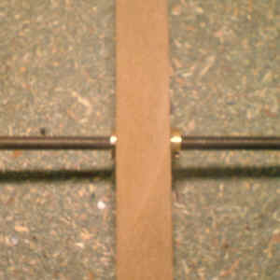

Nuts adjusting:

The two nuts must be fully screwed inside the MDF. Introduce the screw in the first insert, continue turning the screw until it is stopped, and unscrew gently the second insert until the screw accepts to turn almost freely. Ordinary threaded rods are not perfectly accurate so it's important to check this adjustment over the entire length of the screw. It must not exist any hard point, if so, screw/unscrew the second insert to readjust free rotation and re-check again. Remember: lower backlash is a compromise between hindered and free rotation of the screw on its entire length.

2.3.3 Gantry Y-Axis Rail Support

That's how the y-axis will connect to the gantry. One point of importance, the connection should be tight at the y-axis rail support at the gantry, but the bottom gantry support (those two boards side by side) can be a little loose as long as there is sufficient support on the x-rails. That's the place you will torque and tighten the assembly.

2.3.4 Y-Axis Rails and Transmission Nut

The process is pretty straight forward. Draw a line where the y-axis lower support meets the gantry sides. Measure up the thickness of the board (3/8"). Find a spot that will not interfere with the z-axis lead screw or the bearings. You will be screwing all the way through the lower y-axis bearing support. Once that is done, drill a slightly smaller hole than the diameter of the nut, this is of course with the understanding that the nut is much smaller than the thickness of the wood. If it isn't and your way mechanically superior to what I'm demonstrating (anti-backlash nut, balls crew nut, etc.), then you will have to use the y-axis lower support as a place to mount the other type of nut. It's not difficult, but measurements will have to relocate the holes inthe gantry to compensate for this.

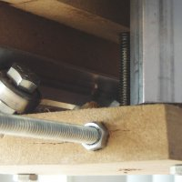

2.3.5 Y-Axis Lead Screw

With that said, I'm going to show you how to secure both ends... anyway. The key is to drill the proper size holes in the sides of the gantry. The skate bearing that I use to secure the lateral position of the screw (I mean to say, to keep the screw from moving in and out), I first drill a hole that has the same outside diameter as the bearing only half way through the wood. I use a 7/8" hole drilling bit. This makes a nice seat for the bearing. A nut is secured on each side of the bearing, so I drill a 3/4" hold the rest of the way through the gantry side. The same is done on the other gantry side. Oh, by the way, the 7/8" hole is on the outside side of the gantry. This way, the secured bearing and the screw can be tensioned a little, but it's not necessary. The screw is actually stabilized by the way I mount the motor, because the motor is pressed against the inside rubber piece inside the coupler and keeps the screw assembly secure.

If at anytime you don't understand some of the terms I use, please give me an email and press me to further articulate and/or define.
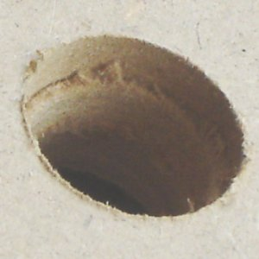

I've already discussed the types of screws so I will not bore you again on that subject. One additional recommendation that I will offer is to lubricate the screw. This is important. I remember with my first machine non lubricated, the sound was horrible and the screw froze. I picked up some synthetic bicycle chain lubricant and from that day on, it was magic! Interesting... skate bearings... bicycle lubricant... hmm. Maybe we should build a carbon fiber CNC with bike chains for motion. Ok, I'm babling, it must be late.

So, now the machine is complete with all axes with linear slide bearings, and two power transmission assemblies, one for the z-axis and one for hte y-axis. What's left? We still have the x nut and lead screw. Then it's off to the motors and motor mounts. I will cover the electronics before I make the router mount, just to keep you guys in suspense.
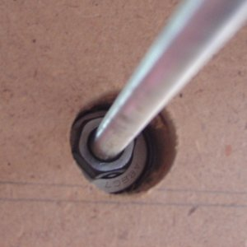

If at anytime you don't understand some of the terms I use, please give me an email and press me to further articulate and/or define.
I've already discussed the types of screw so I will not bore you again on that subject. One additional recommendation that I will offer is to lubricate the screw. This is important. I remember with my first machine none lubricated, the sound was horrible and the screw froze.
So, now the machine is complete with all axes with linear slide bearings, and two power transmission assemblies, one for the z-axis and one for the y-axis. What's left? We still have the x nut and lead screw. Then it's off to the motors and motor mounts.

2.3.6 Y-Axis Motor Mount

Ok, back to the main subject, motor mounts. these mounts are real stupid simple. All we're going to do is take a piece of MDF and put about 7 holes in it, varying sizes of course. Four holes will attach to the motor mounting holes (it's the four holes that kinda stick out on the four corners, that is if you use a NEMA size). Some motors actually don't have mounting provisions. I can't help you there, but if it does, read and watch on. Are you still wondering what NEMA is? Ok, I won't leave you in the dark, it's a size and power specification. The larger the number, the larger the motor, and sometimes higher torque and speed. Some NEMA sizes overlap in power and speed, like a high powered NEMA 23 can match a low power NEMA. Itstands for National Electric Manufacturers Association. Their charge is to make things compatible and provide standards. You can find out more at NEMA.org
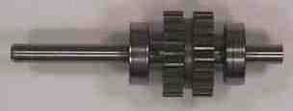
That's not all there is to the power and speed thing. Speed and power are also related to the electronics and software. That's another step but it's worth mentioning here. Before you make your mount, you will obviously need the motor. Select the motor that will be appropriate for your application. I talked a little about screws earlier on, but even the screws relate to speed and power. So, in all, what considerations do you need to ponder: size, power and speed of motor, the electronics and power supply to drive the motor to its fullest safe potential, the software and operating system, and the type of screw.

Ok, the other three holes on the mount will be for the shaft (in the center of the mount), and two holes to mount it to the gantry. For the motor mount holes, I use long #10 screws so the motor can be displaced from the screw assembly giving it room to attach to the coupler.
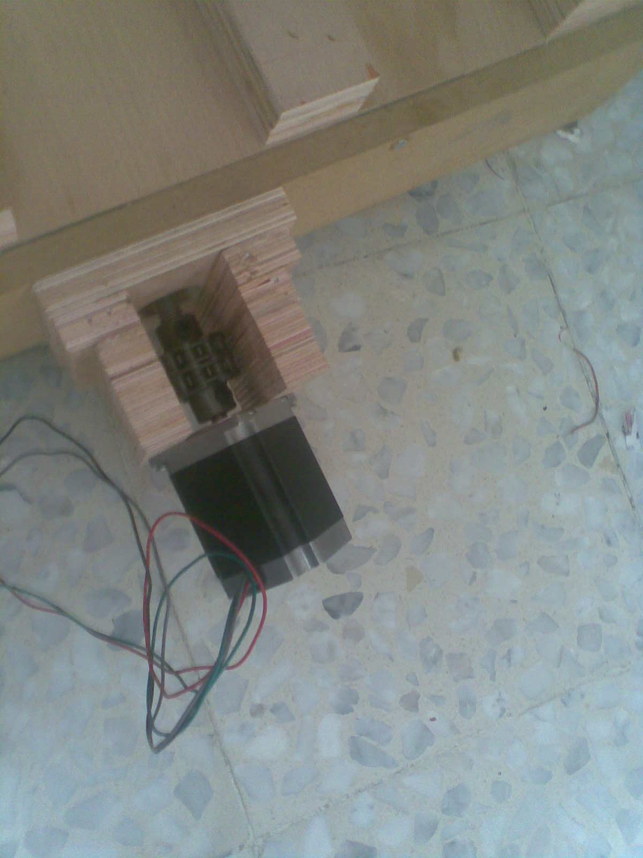

2.4 X-Axis
2.4.1 X-Axis Front and Back

The CNC router has a table, right? The flat piece that you put the stuff on to cut, right? Well, that piece has this thing called the gantry riding over it. How does that gantry move? It needs to hug this surface and requires a piece underneath. In other words, the gantry cannot move unless this surface is lifted above the ground to accommodate the gantry support and the motor underneath.
You will use two 4" x 2' pieces. Nope, we still haven’t gotten to the 4" x 2' 3" pieces yet. One for the front and one for the back. You realld could use pieces wider than 4". In fact, these two pieces could be your standing height stands (if you do, you will have to support them somehow, and maybe I'll get into that later after this series.).
I use three holes and connections on each end. You can put as many connections as you feel, but three should be enough. The x-axis motor will be mounted on one of these ends. In addition, each end of the lead screw will be affixed to these stands.

So... what did I do to reinforce the x-cutting surface? I slapped two 24" x 48" pieces together and chamfered only one side of each piece. The good news: The gantry measurements did not have to change since only 3/8" was added to the top and bottom of the cutting surface. With the measurements I used, there is still enough space for this to occur.

The only major change to the machine is a new size for the aluminum angle at 1-1/4" x 1/8". It's pretty inexpensive. You can see that I also dramatically changed the stands and made the whole unit into a cabinet (with wheels, or casters as they call it at the local hardware store). This thing is so heavy it's even difficult to more with the casters, and I go the pricier ones.

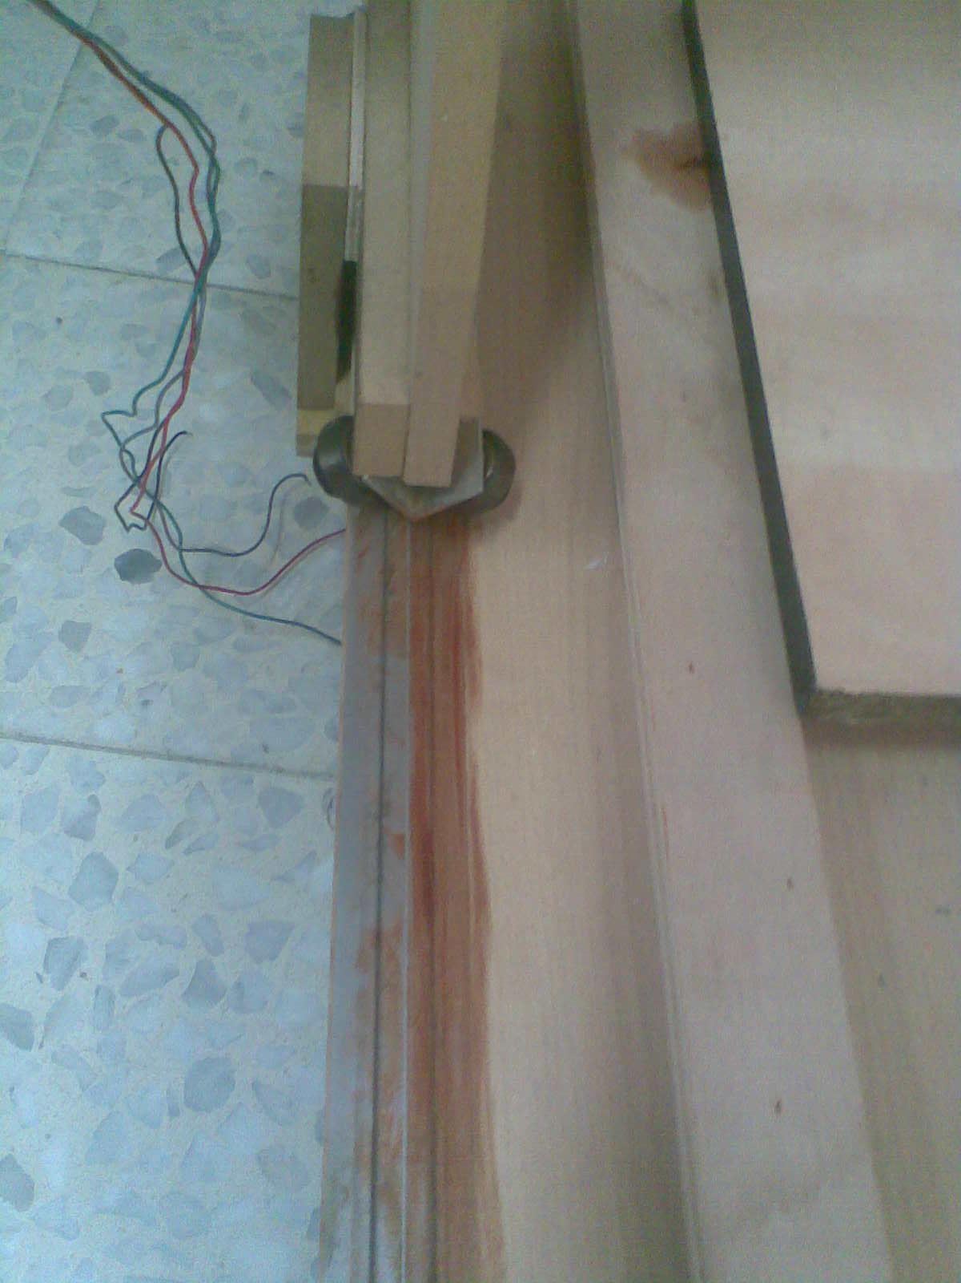

Other changes were to the gantry y-axis rail support, but this machine is so flexible, I just used a few spacers and it's all back to snuff. No play, or flex at all and this puppy is solid! Some detail... notice the double bolts near the motor and the single screw on the cutting surface. The single screw is to hold the two boards together. I also wanted the two board to act against each other so their would be no flex. There are four total on the cutting surface. The double bolts are just the standard connections I always make. This is stronger as well since the board on top is a load acting on the board below, but with the wonderful laws of physics, there is a greet amount of pressure keeping these boards intact.

Can you see a glimpse of some electronic components in the cabinet? I will explain that a bit later after the driver and power supply is complete. My computer is down there. It works for me since I'll be using it in my bathroom, remember? The only negative aspect of this design is that Nicco, my son, climbs into that space and makes me very nervous. The caster contributes in the transfer of a large portion of the loards associated with the computer monitor and other suff, including Nicco.

If you are building a smaller table, you may not need this reinforcement. Optionally, if your x-axis table slides on its own that will be very little load to create any sag, so you will be safe. There are other ways to reinforce without going through this trouble (not much trouble, it took me about 4 hours to complete the cabinet and new motor mounts) such as when pieces to be cut are clamed down, a lot of the deflection will be eliminated, depending on how you clamp the work, that is.

2.4.2 Gantry Sides
The sides of the gantry is pretty simple. All you will need to do is create two grooves on each board to hold the linear slide bearings. The challenge is to make the grooves at a tolerance that doesn't allow play with the linear bearings. There are things we can do to reduce the play if the grooves are too large, like installing screws along the edges of the aluminum angles of the slide bearings to hold its position.
The router is used primarily for this step. The router can route out perfect grooves at about 1/8" in depth. I use a 1/4" spiral upcut bit set to a 1/8" depth. Upcut means the wood chips (wood cloud) is puched upward. The 1/4" size has the ability to make 1" deep cuts. Since we are using 3/4" boards, the 1/4" bit is perfect.

2.4.3 X-Axis Lead Screw

Placement of the nut doesn't have to be set within one of the support pieces (i.e. y-axis nut in the y-axis bearing support). I personally like the simplicity. If the hole is too small, the nut can split or crack the MDF. Alternatively, the y-axis screw can be positioned just above the y-axis lower bearing support. The x-axis can also be positioned just below the bottom gantry support. With the measurements I used, the z-axis is not as flexible; however, if the y-axis bearing supports are a little longer, the z-axis nut can be offset. These alternative locations will enable the positioning of a homemade anti-backlash nut.

2.4.4 X-Axis Motor Mount

Just to leave a little to the imagination, I will explain the torque and leave the rest for later. The torque is the spec of 305 oz-in. that really means ounces (where does the z come from?) per inch. If you know cars then you've heard this convention before (foot-pounds of torque). The more feet-pounds of torque, the more rotational strength given other specific conditions applied to the motor, but let's not go there. The inch - ounce is the same thing as saying: the motor will push 305 ounces one inch away from the shaft of the motor. It's like putting a stick at a right angle to the shaft and applying 305 ounces at that point.

There are many factors that go into the decision for a motor. How much torque is needed? What tool or spindle will used to cut material? What material will be cut most often? What accuracy will I need (related to steps/revolution or resolution as I like to refer to this)? And How much am I willing to spend on the motor and/or electronics to drive the motor? These are the basic factors you will need to determine before purchasing the motors? Ok, so why did I purchase these motors? I liked the price! Ok, ok, the torque is pretty good too, and as far as I know, this is the best resolution you can find. And yes, there are other technologies out there like servos, basic motors with encoders and the like. these will be discussed at a later date.

2.5 safety
2.5.1 What we used to make it safety
We used a limit switches in our body to ensure that the machine will stop directly incase the motor try to rotate a distance more that the length of the axis.
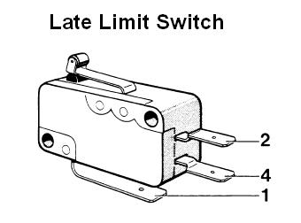

2.5.2 Safety Rules & Safety Functions
Observe these safety rules to prevent injuries and accidents.
a) Place a fence around the machine to remind you and others of dangers
inside the fence. The area enclosed by the fence is referred to as the
hazardous area in this manual.
The worksheet will thrust outward during operation — in the front of the machine during
zero-returning after automatic repositioning or both in the front and the back if the
worksheet is oversized.
We recommend additional installations of optical safety devices — pressure detection mats
and optical sensors. They will stops the machine instantly upon detection of careless entry
in the hazardous area.
b) Have the machine operated by a single, trained person who has read this
manual and acquired a thorough knowledge of the machine and its
operation. If more than one authorized operator must be involved,
coordinate their work to ensure utmost safety.
c) Don't wear loose clothing, a necktie, or a muffler when operating the
machine. They can be extremely dangerous if any part of them is caught in
the machine.
d) Observe the following punching precautions. If you are not sure of whether
or not a particular worksheet can be punched, consult the AMADA engineer.

Chapter 3
Motor Driver

3.1: Stepper Driver
Well... here we are, finally getting started with the electronics portion of the video series. The entire structure of the CNC machine is complete with the exception of the router mount. We will get to that a little later. For now, we will start on the assembly of the HobbyCNC 3 axis chopper unipolar stepper driver. This is a great driver kit and can handle up to 3.0 amps per phase. Another great site for CNC drivers is CNC4PC. They seem to have a great variety. Amps are a measure of the current running through a circuit (not a thing that makes music louder). A phase is actually a single coil within the stepper motor. Most stepper motors have four coils or phases. A coil is just a winding of conductive material to form an electromagnetic phenomenon (a magnet that turns on and off with or without electrical flow). When coils are electrified in a specific combination or sequence, the motor will react in a turning motion (or not, depending on the sequence, or the wiring scheme).

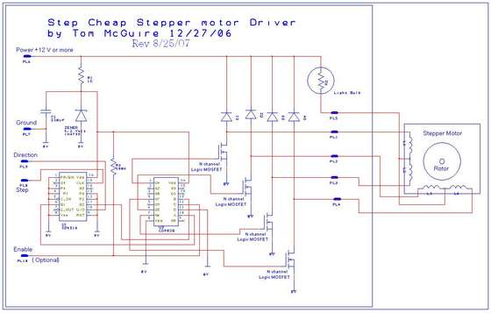

Ok... back to the board. Other features include microstepping (each step can be subdivided by 2, 4, 8 or 16). You probably notice the word chopper and it does not describe the cutting part of the CNC machine, nor will it dice and slice. It essentially chops up the current through the stepper to keep it cool, stable and efficient (well, relatively cool). When we get to the power source for the board and stepper motors, I will explain the electricity and flow in more detail, with formulas (basic electronic stuff that is a definite need to know). Get your calculators ready!

First, take a look at some of the equipment you will need. On the left, you will see what is usually termed as "extra hands." How cute! Although, it does look a little sinister. This was a hard sell with the wife, however, but well worth the investment. Yeah, that's a super worn piece of sponge. The spong is used for cleaning the point of the soldering iron. It usually comes with a magnifying glass, but I removed that since it get in the way most of the time.

The soldering iron that I use is a Weller 40 watt. Ay, geez... a watt is voltage multiplied by amps (power x current). HobbyCNC recommends a lower wattage soldering iron, so if you're not too experienced, use the recommended iron. Let me explain, the iron is used to melt solder. The iron get extremely hot. I've burned myself many times and it doesn't fell good by any means. The recommendation for lower wattage is to reduce the likelyhood of burning components (stressing them beyond their temperature threshold). Follow instructions that are provided with the kit very closely. Oh, and by the way, the instructions are impecable. Read the warning lables on the solder. Moreover, do your soldering in a well ventilated area and keep your kid(s) away from the iron (this includes your pets, cat hair smells horrible when ironed). If touched by one of the kids, they will have a very clear definition of punishment (this would not be good). Read the safety instruction that came with the soldering iron. In addition, get some solder wick (it sucks up solder). For other more in depth tutorial on how to solder, go to sparkfun electronics tutorials page.

Another important item that you will need is a multimeter. They are pretty cheap so there is no reason not to have one. You will receive the benefit of this gadget the first few times you use it. You will need it for this assembly at many stages. Testing components that they function properly prior to soldering them. Testing power, power levels, resistance, currents are all uses of this device. Test everything, you now have the power!

I like to individually package all like components, so when they are called upon, I can find them easily. It's also good to use this method and verify that you have the proper count of each sets of components.

Chapter 4
programming

4.1 pic programming

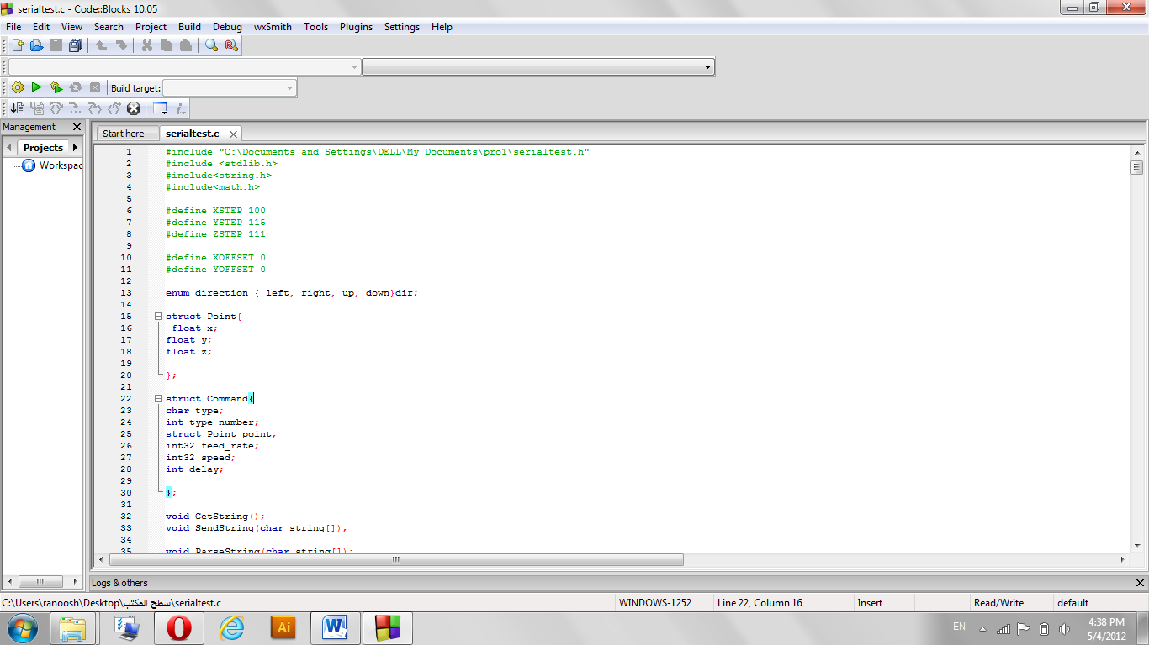
First we programmed a c# code that sends the code serially line by line to the pic then we programmed a pic c parser of the gcode that understand the code and turn the appropriate motors on and off to generate the appropriate drawing on our wood piece.

Step 25 – conclusion
Cnc mean computer numerical control machine its aform of programmable automation drill drawings on wood use gcoding consist of 3 motors and their drivers and pic with its basic circuit and body made of wood hold on motors and drill and the wood we want to draw on it
We tried to make cheap fast safety cnc machine that drill on wood piece according to any drawing we draw to it.

