Appendix

Hardware Schematics:

Amplifier and filter Schematic

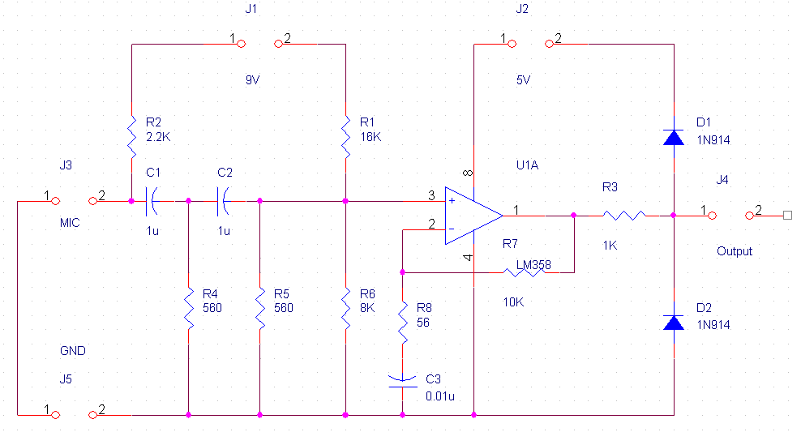

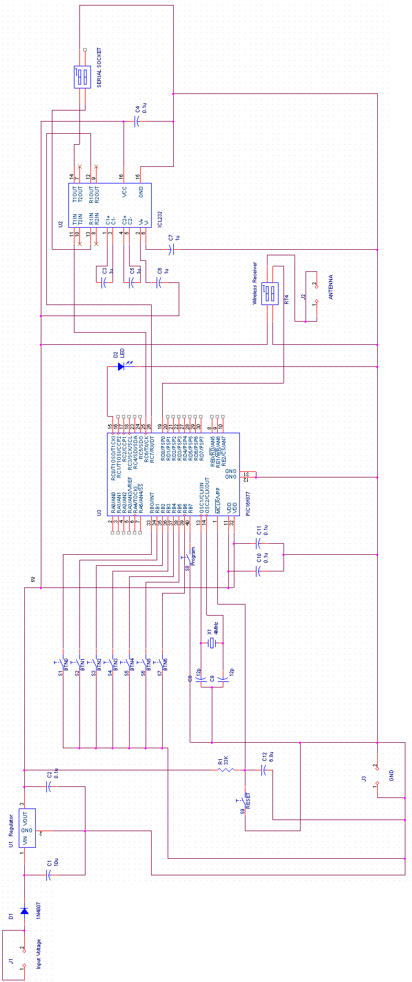
Wireless Transmitter

