Abstract—In this paper we discuss our hardware graduation project which is an Autonomous Parallel Parking Car. It explains the project step by step and the problems we faced.
Auto-Parking (Autonomous Parallel Parking Car)
Abdullah F. Shehadeh, Abd Al-razaq S. Shehadeh

INTRODUCTION
Parallel parking is one of the most complex driving scenarios. AP is system that enables cars to parallel park autonomously.
In this paper we introduce the project steps with explanation to every step, and how we tried to avoid the problems which faced us.
.
To insert images in Word, position the cursor at the insertion point and either use Insert | Picture | From File or copy the image to the Windows clipboard and then Edit | Paste Special | Picture (with “Float over text” unchecked).
IEEE will do the final formatting of your paper. If your paper is intended for a conference, please observe the conference page limits.

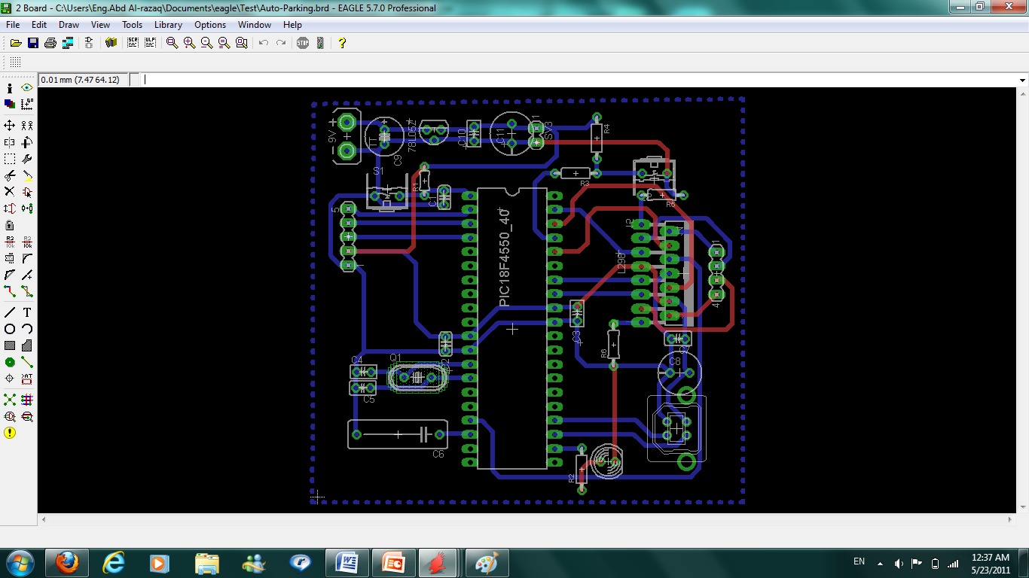
Components and work Procedure

PCB Build Stage
We have been enforced to use a new program which we never used it before it’s the program of building the PCB which is EAGLE Program.
After we finished building the schematic (which is shown in figure 1) we moved on to the board.

Most of the difficulty was in this part in which we arranged the components on the board as it will Appear on the real board and then we routed it ( Figure 2 shows the board).

Components gathering and welding
Since we used eagle then the board will appear of two connecting surfaces they are top and bottom surfaces we faced a problem in welding the top components since it must be welded on both surfaces.
And another problem was in distributing the components on top and bottom which we solved later.
Figure 1
Figure 2

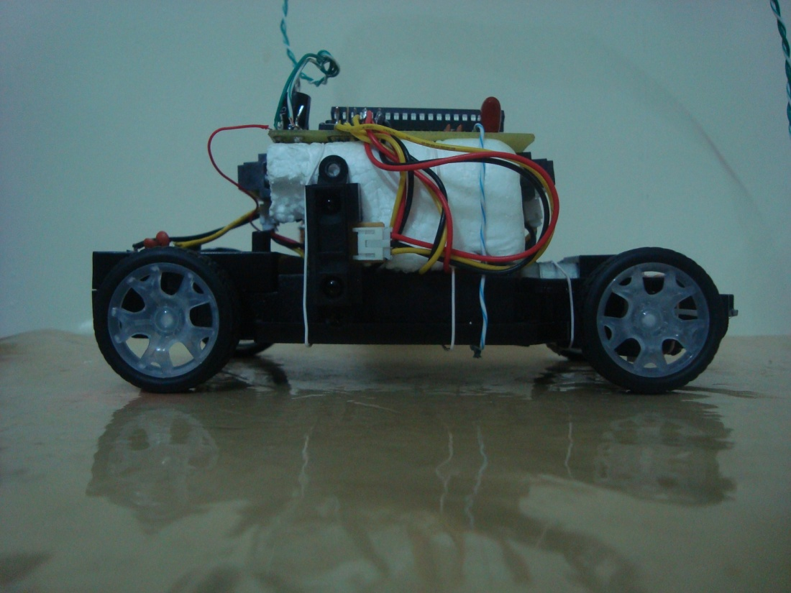
Board Components
The following figure show the board which can be divided into some small parts which is:
Voltage regulation circuit, PIC Basic circuit, USB interface and H-Bridge circuit.
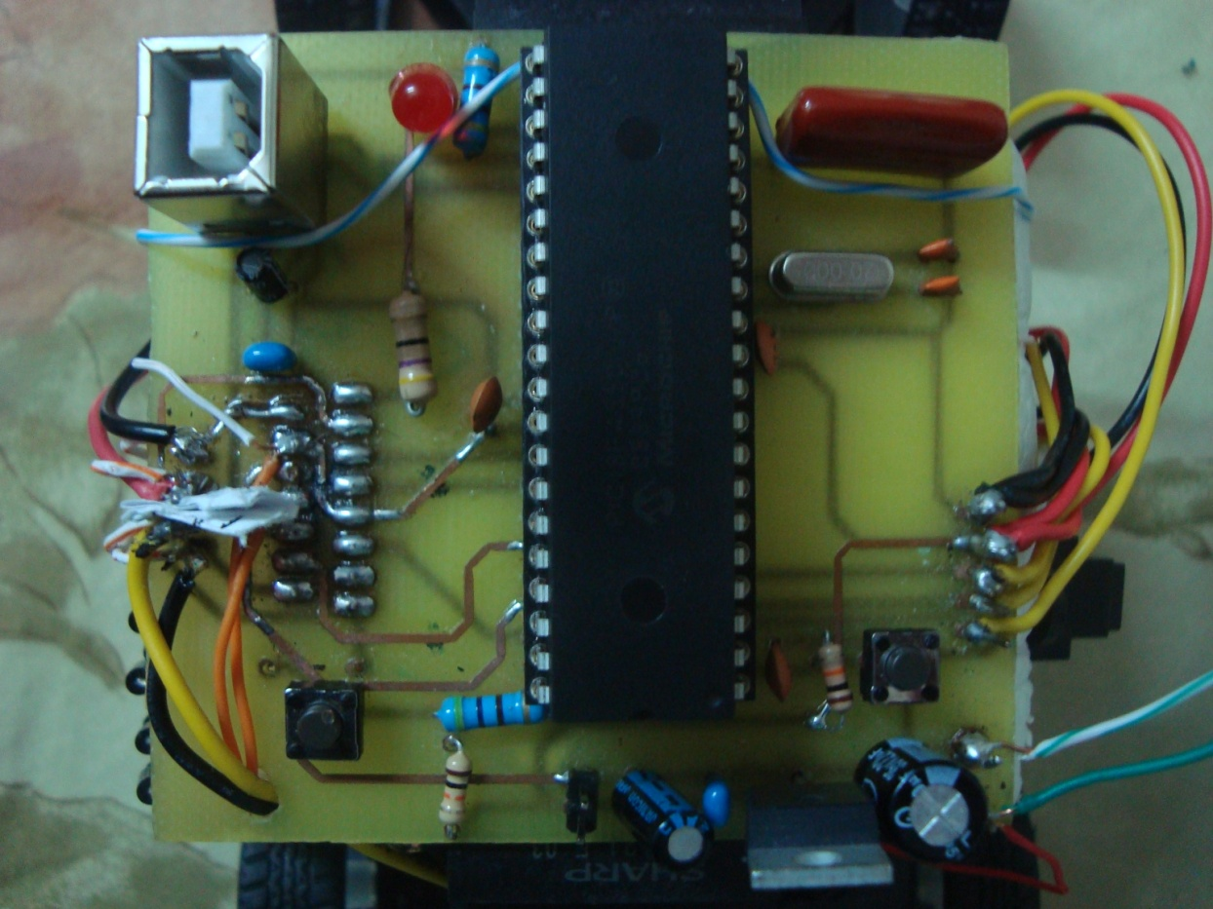

The Car module
We have used a small model in order to reduce the needed power and current to move it since we intended to operate it on rechargeable batteries.
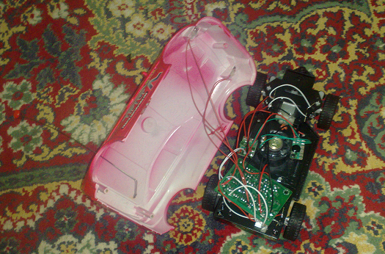
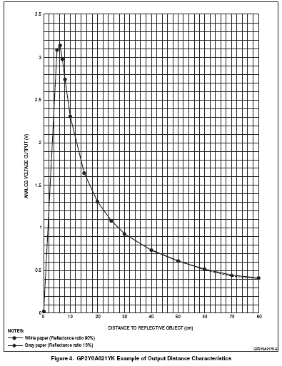
Figure 3 shows the original car and Figure 4 shows the final state of the car.

Figure 3

E. Sensors
The sensors is the most important part in the project, we uses distance sensors, the distance sensors are divided into many types we have been able to choose one of the following sensor types
1- Ultrasonic Sensors: we avoid their usage because of the
Figure 4

nature of ultrasonic waves (not directed) that causes many reflections.
2-IR Sensors: we chose this type because of its simplicity and it covers the ranges we need. We used three (10 – 80 cm) sensors. A longer range exists (up to 1.5 m) can be used when applying the system to real cases.

Figure 5 shows the distance sensor values .
It measures correctly from 10-80 cm while before 10 cm it is not stable so we can’t depend on it to measure that distance.

Figure 5

Sensor Direction
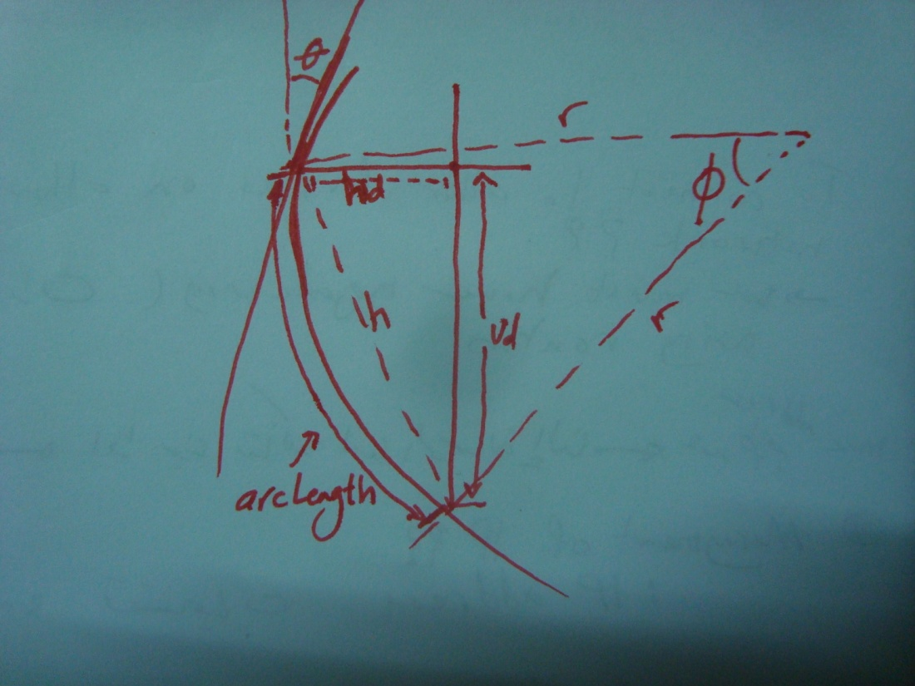
It is preferred to position the sensor such that it is orthogonal with respect to the motion direction.
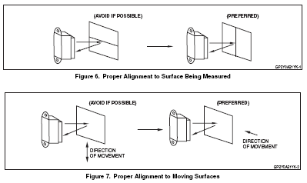

Sensor Noise Elimination
We have used capacitors to organize the signal of the distance sensor .
The following figure shows the noise elimination circuit
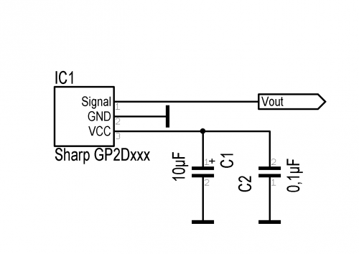

F. USB PIC Modules
Since it’s our first time of dealing with USB PIC we faced many problem the first one was is it PICDEM or HID which differs in its basic circuits and so its bootloaders.

G. Mathematical Module and equations calculation
We have build a mathematical module for the car motion which is shown in Figure 6. And depending on that module and the equation that resulted from it we have calculated the time and the displacement of the car.

Figure 6

The mathematical equations :

$$\begin{aligned}\text{ArcLength}=r∗φ \\ s∗t=r∗φ \\ φ=\frac{s∗t}{r}−−−−−−(1)\end{aligned}$$

According to sine rules:
$$\begin{aligned}\frac{\text{sin}φ}{h}=\frac{\text{sin}(\frac{\text{180}°−φ}{2})}{r} \\ →h=\frac{\text{sin}φ}{\text{sin}(\frac{\text{180}°−φ}{2})}∗r \\ h=\frac{\text{sin}φ}{\text{sin}(\text{90}°−\frac{φ}{2})}∗r \\ h=\frac{\text{sin}φ}{\text{cos}(\frac{φ}{2})}∗r \\ h=\frac{2\text{*sin}(\frac{φ}{2})\text{*cos}(\frac{φ}{2})}{\text{cos}(\frac{φ}{2})}∗r \\ h=2\text{*sin}(\frac{φ}{2})∗r−−−−−−−−(2)\end{aligned}$$

By substituting (1) in (2):

$$\begin{aligned}h=2\text{*sin}(\frac{s∗t}{2∗r})∗r \\ →{\text{vd}}^{2}={\left(2\text{*sin}(\frac{s∗t}{2∗r})∗r\right)}^{2}−{\text{hd}}^{2} \\ \text{vd}=\sqrt{4∗r^{2}{\text{*sin}}^{2}(\frac{s∗t}{2∗r})−{\text{hd}}^{2}}−−−−−−−\end{aligned}$$

The last equation describes the motion of the car.

By substituting the values of r and s:

$${\text{vd}}^{2}=0\text{.}\text{81}{\text{*sin}}^{2}(0\text{.}\text{48}∗t)−{\text{hd}}^{2}$$

Using MS Excel, we have solved this equation for many values:

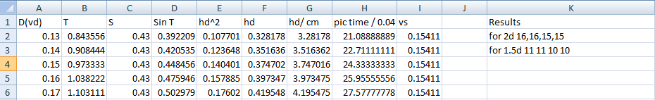

H. Problems we faced

PCB: It is our first project using printed circuits. We have learned how to work on Eagle program and we have faced many problems making the appropriate routing.

PIC 18F4550: It is a USB microcontroller that requires the use of special bootloaders and programs like MPLAB. We faced many problems in defining it on Windows 7.

Mechanical problems: we changed the car model twice, in order to use a small car that can be driven using batteries, but finally we were obliged to use power supply in order to supply the motors with the required current. Another mechanical problem is the rotation angle of the front motor which is much smaller than the real case, what results in the need of doing the parking on many stages.

*Note:
The project source code and videos are attached to this report

 

