An-Najah National University

Faculty of Engineering

Computer Engineering Department

**Smart Market**

AnAs Eid

Isam Sholi

Dr. luai Malhees

Dr. Sufyan Samarh

Submitted in Partial Fulfillment of the requirement for the Degree of B.Sc., Faculty of Engineering, at An-Najah National University, Nablus, Palestine.

**Table of content**

|  |  |  |
| --- | --- | --- |
| Over View | **…………………………………………** | **3** |
| The Problem | **…………………………………………** | **4** |
| Technology | **…………………………………………** | **5** |
| Implementation | **…………………………………………** | **7** |
| Components | **…………………………………………** | **9** |

**Over View**

Our project mainly concentrates on providing some services in the markets and enhances the process of check-out and retrieves the information of the product by replacing the barcode of the product with electronic device fixed with the product and use this device to identify the product and process the product

**The Problem**

The idea of our project came from the awareness of the problems that is presented in the markets specially in the check-out operation and the wasted time on it and there is some sub problems just like providing the information of the products in details and preparing the buying list and have it everywhere . So the motivation to find a solution came and provides us with methods to solve all these problems .

**Technology:**

Our project is based on two main techs:

**1 – RFID**

**2 – Bluetooth**

**RFID:**

**Radio-frequency identification** (**RFID**) is a [technology](http://en.wikipedia.org/wiki/Technology) that uses communication through the use of [radio waves](http://en.wikipedia.org/wiki/Radio_waves) to exchange data between a reader and an electronic tag attached to an object, for the purpose of identification and tracking.

It is possible in the near future, RFID technology will continue to proliferate in our daily lives the way that bar code technology did over the forty years leading up to the turn of the 21st century bringing unobtrusive but remarkable changes when it was new.

RFID makes it possible to give each product in a grocery store its own unique identifying number, to provide assets, people, work in process, medical devices etc. all with individual unique identifiers - like the license plate on a car but for every item in the world. This is a vast improvement over paper and pencil tracking or bar code tracking that has been used since the 1970s. With bar codes, it is only possible to identify the brand and type of package in a grocery store, for instance. Furthermore, passive RFID tags (those without a battery) can be read if passed within close enough proximity to an RFID reader. It is not necessary to "show" the tag to the reader device, as with a bar code. In other words it does not require line of sight to "see" an RFID tag, the tag can be read inside a case, carton, box or other container, and unlike barcodes RFID tags can be read hundreds at a time. Bar codes can only read one at a time.

Some RFID tags can be read from several meters away and beyond the line of sight of the reader. The application of [bulk reading](http://en.wikipedia.org/wiki/Bulk_reading) enables an almost-parallel reading of tags.

Radio-frequency identification involves the hardware known as *interrogators* (also known as *readers*), and *tags* (also known as *labels*), as well as RFID software or RFID middleware.

Most RFID tags contain at least two parts: one is an [integrated circuit](http://en.wikipedia.org/wiki/Integrated_circuit) for storing and processing information, [modulating](http://en.wikipedia.org/wiki/Modulation) and [demodulating](http://en.wikipedia.org/wiki/Demodulation) a [radio-frequency](http://en.wikipedia.org/wiki/Radio-frequency) (RF) signal, and other specialized functions; the other is an [antenna](http://en.wikipedia.org/wiki/Antenna_%28radio%29) for receiving and transmitting the signal.

RFID can be either passive (using no [battery](http://en.wikipedia.org/wiki/Battery_%28electricity%29)), active (with an on-board battery that always broadcasts or beacons its signal) or battery assisted passive (BAP) which has a small battery on board that is activated when in the presence of an RFID reader. Passive tags in 2011 start at $ .05 each and for special tags meant to be mounted on metal, or withstand gamma sterilization go up to $5. Active tags for tracking containers, medical assets, or monitoring environmental conditions in data centers all start at $50 and can go up over $100 each. BAP tags are in the $3–10 range and also have sensor capability like temperature and humidity.

The term RFID refers to the technology. The tags should properly be called "RFID tags" not "RFIDs".

**Fixed RFID and Mobile RFID:** Depending on mobility, RFID readers are classified into two different types: **fixed RFID and** [**mobile RFID**](http://en.wikipedia.org/wiki/Mobile_RFID). If the reader reads tags in a stationary position, it is called fixed RFID. These fixed readers are set up specific interrogation zones and create a "bubble" of RF energy that can be tightly controlled if the physics is well engineered. This allows a very definitive reading area for when tags go in and out of the interrogation zone. On the other hand, if the reader is mobile when the reader reads tags, it is called mobile RFID. Mobile readers include hand helds, carts and vehicle mounted RFID readers from manufacturers such as [Motorola](http://en.wikipedia.org/wiki/Motorola), [Intermec](http://en.wikipedia.org/wiki/Intermec), [Impinj](http://en.wikipedia.org/wiki/Impinj), [Sirit](http://en.wikipedia.org/wiki/Sirit), etc.

There are a variety of groups defining standards and regulating the use of RFID, including the [International Organization for Standardization](http://en.wikipedia.org/wiki/International_Organization_for_Standardization) (ISO), the [International Electrotechnical Commission](http://en.wikipedia.org/wiki/International_Electrotechnical_Commission) (IEC), [ASTM International](http://en.wikipedia.org/wiki/ASTM_International), the [DASH7](http://en.wikipedia.org/wiki/DASH7) Alliance and [EPCglobal](http://en.wikipedia.org/wiki/EPCglobal). (Refer to [Regulation and standardization](http://en.wikipedia.org/wiki/Radio-frequency_identification#Regulation_and_standardization) below.)There are also several specific industries that have set guidelines including the [Financial Services Technology Consortium](http://www.fstc.org) (FSTC) has set a standard for tracking IT Assets with RFID, the Computer Technology Industry Association [CompTIA](http://en.wikipedia.org/wiki/CompTIA) has set a standard for certifying RFID engineers and the International Airlines Transport Association [IATA](http://en.wikipedia.org/wiki/IATA) set tagging guidelines for luggage in airports.

RFID has many applications; for example, it is used in enterprise [supply chain management](http://en.wikipedia.org/wiki/Supply_chain_management) to improve the efficiency of inventory tracking and management. The Healthcare industry has used RFID to create tremendous productivity increases by eliminating "parasitic" roles that don't add value to an organization such as counting, looking for things, or auditing items. Many financial institutions use RFID to track key assets and automate [Sarbanes–Oxley Act](http://en.wikipedia.org/wiki/Sarbanes%E2%80%93Oxley_Act) (SOX) compliance. Also with recent advances in social media RFID is being used to tie the physical world with the virtual world. RFID in Social Media first came to light in 2010 with Facebook's annual conference

**Implementation**:

Our project consists of 3 main parts:

* Mobile phone
* Smart Cart
* The Computer of the point of sale

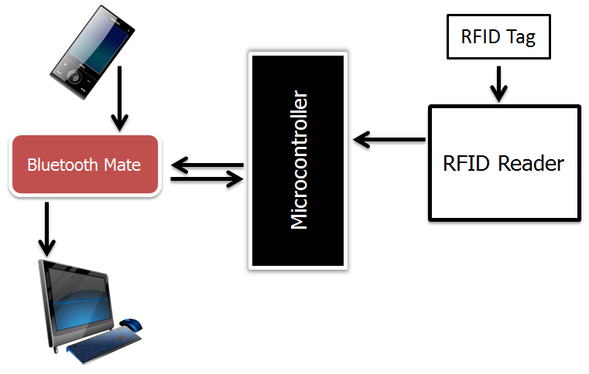

1 – Mobile phone

The mobile phone is provided with a java application that is used to prepare the buying list and take it to the store, at the store the mobile application is used to transfer the buying list to the Cart over the Bluetooth.

2 – Smart Cart

The smart cart has the RFID reader the is used to process the products by reading the tags numbers that is fixed with the products and send the data to the microcontroller which store them in some memory to send them back later.

3 – The Computer of the point of sale

It’s provided with special software and Bluetooth technology. It receives the final list, that been bought, from the cart over Bluetooth and compute the value of the Bill and display it immediately.

**Components**:

In our project we used the following components

1 – Microcontroller (PIC18F4620)

2 – RFID Reader

3 – RFID Tags

4 – Bluetooth mate

5 – GLCD

|  |  |  |
| --- | --- | --- |
| 1 – Microcontroller (PIC18F4620) | | |
| * Operating Voltage Range 2 to 5.5V * Runs up to 20MHz with external crystal * 3,968 Bytes RAM * 1.024 Bytes Data EEPROM |  | |
| 2 – RFID Reader | | |
| * 5V supply * 125kHz read frequency * EM4001 64-bit RFID tag compatible * 9600bps TTL and RS232 output * Magnetic stripe emulation output * Read range of 200mm | C:\Users\OXXY\Desktop\RFID.PNG | |
| 3 – RFID Tags | | |
| * EM4001 ISO based RFID IC * 125kHz Carrier * 2kbps ASK * Manchester encoding * 32-bit unique ID * 64-bit data stream [Header+ID+Data+Parity] | C:\Users\OXXY\Desktop\tag.PNG | |
| 4 – Bluetooth mate | | |
| * Serial communications: 2400-115200bps * Frequency: 2.4~2.524 GHz * Operating Voltage: 3.3V-6V * Encrypted connection * Built-in antenna | C:\Users\OXXY\Desktop\Blutooth.PNG | |
| 5 – GLCD | | |
| * Simple 8-bit parallel interface * Display format   + Columns : 32   + Lines : 8 * Character font   + Horizontal dots : 8   + Vertical dots : 8 * Internal 128 character CG-ROM * Software allocation of Text, Graphic and Character Generator RAM (CG-RAM) | | C:\Users\OXXY\Desktop\pics\Photo0195.jpg |