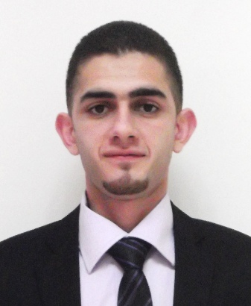

Ahmad M. Al Khader

General Information
- Birth Date: 08/12/1990
- Passport: Palestinian
- Current location: Tulkarm, Palestine.
- E-mail Address: ahmed_khader6@hotmail.com
- Mobile: 00972-598-317726

OBJECTIVE

I am looking for having a positive response to get this opportunity in your company and work together, where I can mobilize my skills in many directions and learn from you what I need for my work life.

EDUCATION
Duration | Institution | Degree | General average
Sep 2008 – June 2013 | An-Najah National University | Bachelor Degree in Mechatronics Engineering | Good 2.96
Sep 2007 - July 2008 | Al Fadliyah Secondary School | General Secondary certificate | Excellent 95 %

GRADUATION PROJECT

2012/2013- "Blind Guidance Tool" Design, and programming a speaker tool which help the blind to walk safely, confidently, and independently by warning him about obstacles that may face, then tell him the available way to walk.

EXPERIENCE
- June 2012 – August 2012
- Trained at North Electricity Distributing Company (NEDCO), Nablus - Palestine
- Trained at Jamil Al Sahori Company for Plastic industries (Samba), Amman - Jordan.
- Trained at Royal Factory, Hebron – Palestine.
- August 2013 to Present
- Work as teaching and research assistant at An-Najah National University.

SKILLS

Personal

Reliable and good team player

Good communicator

Self confidence

Cooperator
- Driving: A valid driving license.

Computer

Have special skills using AutoCAD, Matlab.
- Full command of Microsoft Office Suite.
- Very good Ability to use Programming Languages such as C++, PIC C, Assembly language, Ladder logic.

Languages

Arabic: Mother language.

English:
- Speaking: Good.
- Reading: Excellent.
- Writing: Excellent.

CERTIFICATES
- Completed a 40 hour-training course in “PIC C”, at the Korean Palestinian IT Center.
- Completed a 50 hour-training program in “Control and Security System”, at Hisham Hijjawi College.
- Completed a 12 hour-training course in “Mechanical Desktop Program”.

REFERENCE
- Dr. Bashir Nouri
Assistant Professor, Faculty of Engineering, Department of Mechanical and Mechatronics Engineering, An- Najah National University.
E-mail: Bnouri@najah.edu
Tel: +972599437776
- Dr. Nidal Farahat
Assistant Professor, Faculty of Engineering, Department of Mechanical and Mechatronics Engineering, An- Najah National University.
E-mail: edkadik@hotmail.com

