Abstract
The idea of the project came from the need of sports, entertainment and social interact places which help people to improve their personality and provide them with particular skills.
The design stage extended to architectural, structural, electrical, mechanical & environmental design.

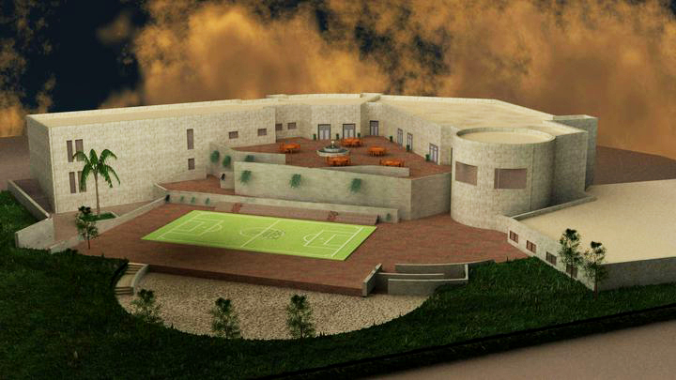

Project Description
- The shape of the building is uniform shape ( V shape) . it consists of 3 parts with 2 expansion joints which is good in seismic design. The first part -which consists of 2 floors- contains gymnastic and multipurpose halls , the second is 3 floors of receptions while the third part has restaurants , sauna and swimming pool collected in 2 floors and basement.

- For the designed part of the building one way Reinforced concrete slabs was used , for the other blocks the construction type was two way concrete slabs.

- The External walls consists of 5 layers ( plaster , blocks , insulation, concrete and stone).

- The total area of building spaces is 5172 m².

- The ratio of the building is about 20% from the site.

Structural Design

The structural design is needed to be performed in any project; no project is being accepted without a true checked structural design.
The structural design includes the static, and the dynamic design which consider the seismic forces that might hit the building any time, that will reduce or prevent the possibility of building collapse due to these forces.
The structure which is subjected to the static loads and the seismic loads is being analyzed using structure analysis program sap2000 then the results will be used to design the structural elements. These elements includes: Beams, Columns and slab system.
Our project is public building in nablus consist of four floors
- The ground floor consists of these units:
Services room (store, mechanical and electrical room, filter room, closed swimming pool)
- The First floor consists of these units:
Sport hall, reception, sauna, open swimming pool and its services.
- The second floor consists of these units:
Multi-purpose room, reception, cafeteria and restaurants
- The third floor consists of these units:
Administration rooms.

Design Data
- Compressive strength of concrete (f’c)=250 kg/cm ²
- Yielding strength of steel (f_{y}) = 4200 kg/cm²
- Unit weights of materials:-
Reinforced concrete = 2500 kg/m³.
Hollow block = 1200 kg/m³.
- Bearing capacity of soil = 3 Kg/cm².
- Reference Code:
ACI-318, 2005 (American Concrete Institute) code .
- Concrete Cover:
Concrete cover for reinforcement shall be:
- (60 mm) for foundation.
- (25mm) for concrete columns and walls
- (30 mm) for concrete beams.

- Loads :
- Dead load = 0.417 ton/m² of 25 cm ribbed slab
- Super imposed dead load= 0.35 ton/m²
- Live load = 0.5 ton/m²

Solar Design

- The aim through passive solar system design is maximinize the gain in winter, and minimize the gain in summer

- The windows designed direction in south direction

- The area of solar windows should be bigger than windows in east and west direction

- The windows should be insulated

- The glasses were designed double glazing

- The shadowing should be found for windows in summer

- All the windows in north direction must be used to lighting and ventilation only

- The surface is perpendicular from the south direction so it gained 1700 BTU/day

- When we used solar window we should used cantiever above

- The advantage of use solar window is:
- Relatively not expensive
- Execution this window is simple
- It is need the accurate contemplation

- The disadvantage of use solar window is:
- The day light is more than intransitive
- It may be change colors of the furniture

- To increase the gain in the day and decrease the loss on the night it should be used:
- Double glass
- Another insulation from this window on the night

Thermal Insulation
Insulation characteristics
- Thermal insulation is material which has properties to prevent the heat transfere from input or output of building it should be stored in place which is dry and covered to prevent water conduct which it

  - There is many kind of thermal insulation such as rock wool insulation,glass wool insulation and others.the selection of insulation does not depend on its thickness but on thermal resistance

    - In this project the rock wall insulation will be used because its thermal coefficient is smaller than other insulation

    - Using rock wall insulation have a lot of advantages such as:
- It fends the building from the humidity
- Durability , prevent the odor ,prevent the corruption
- It is available in markets by many model and volume
- It works out to saving the power
- Produce the air pollution

140 | Density (kg/m³)
0.04 | Thermal conductivity (K) (W/m.Cº)
0.03 | Thickness (x) (m)
0.75 | Transfer coefficient (U) (m².Cº/W)
Thermal characteristics for selected insulation (rock wall)

Water supply
In water supplying for the building we used steel tubes in outside and PVC inside the building, and we have two types of PVC one of it for cold water which bears temperature till 35 Cº and the other one for hot water and bears temperature till 70 Cº. PVC pipes have good advantages such as:
1-control length of pipe as needed
2-flexible pipes
3-easy to change when its destroyed and corrosion
For hot water we used tank less boiler

