An-Najah National University

Faculty of Engineering
Computer Eng. Dep.

Hardware Project Documentation

" Smart Blinds-Guidance Stick "

S.W. Project is designed by :
Mahran I. Quzah & Aghyad M. Saleh
مهران ابراهيم قوزح و أغيد مجدي صالح

Presented to :
Supervisor : Miss Haya Sama'neh
And :
Dr. Lo’ai Malhees
Dr. Ra’ed Al-Qadi
Mr. Sufian Samara

2006/2007
Smart Guidance Stick
Project Documentation

Work Group :
Aghyad M. Saleh & Mahran I. Quzah
أغيد مجدي صالح مهران ابراهيم قوزح
10227417 10126271

Introduction :

Lots of blind people suffer from a problem of inability to walk alone without probability of hitting obstacles on their way. They use a guidance stick in order to discover the proper way to walk through.
One of the problems of this is the inability for stick to detect obstacles without hitting stuff on road.

About the project :

This project creates a new hope for blinds to be able to see their road and walk alone. This is by a smart stick that detect obstacles and sends a beep telling the user to be careful.
Scanning will be done using an ultrasonic transducer of 40KHz.
Scanning range is within the range of 1-1.7 meters.
Transmitting & receiving driver circuits is used to control the operation on the stage of ultrasound.
To detect obstacles, we use the method of delay detection for the received echo. Controlling this is done using a PIC16F877 microcontroller.
The logic we implemented in this project is the ultrasonic method of bats to see in the dark ; ultrasonic echo waves delay time.

IC's and electronic parts used :

In this project we used the following hardware components :
- PIC16F877 microcontroller.
- 2 ultra-sonic microphones transmitter/receiver.
- Op-Amps :
  - LM741 for receiving unit amplification.
  - LM385 for receiving unit comparator.
- NE555 timer, each for transmitter and receiver.
- 4011 NAND IC ; one chip of 4 gates :
  - 3 gates for receiver (used as flip flop).
  - 1 gate for transmitter.
- 4069 Inverter IC ; one chip of 4 gates : all 4 gates for transmitter unit.
- 7805 IC ; 5 volts regulator for the power source of the project.
- 1SS106 Shottky barrier diodes ; 2 diodes for receiver unit to rectify the received signals.
- 2SC1815 transistors ; 2 transistors for transmitting unit.
- ULN2003 driver for output devices.
- Resistors :
  - 10 K ……. ( 10 pieces)
  - 1 M ……. ( 2 pieces)
  - 100 K ……. ( 1 pieces)
  - 47 K ……. (1 pieces)
  - 4.7 K ……. (1 pieces)
  - 5.6 K ……. (3 pieces)
  - 1 K ……. (1 pieces)
  - 40 K ……. (1 pieces)
- Capacitors :
  - 1000pF ……. (4 pieces)
  - 1.2 nF ……. (2 pieces)
  - 1 uF …… (1 piece)
  - 0.1 microF ……. (8 pieces)
  - 10 pF ……. (2 pieces)

Project Hardware Units Explanation :
((1)) Power supply circuit :
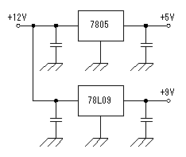
The voltage of +5V and +9V are made with +12V power supply using the 3 terminal regulator.
+9V are used for the transmitter and the receiver. 100-mA type is used because few needed electric currents.
In other circuit, +5V is used. +5V voltage is used for the lighting-up of LEDs, because they are controlled by PIC. The about 10-mA electric current per segment flows through the LED. So, it becomes about 80 mA when all segments(eight) light up.
Because few electric currents of the other IC occur, I think that you can use a 100-mA type, too. We used a 1A type for the safety.

((2)) Receiver circuit :
The receiver circuit is almost same as the "Ultrasonic Range Meter" which is not used PIC.
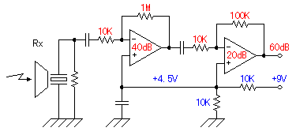
A - Signal amplification circuit
The ultrasonic signal which was received with the reception sensor is amplified by 1000 times(60dB) of voltage with the operational amplifier with two stages. It is 100 times at the first stage (40dB) and 10 times (20dB) at the next stage.
As for the dB (decibel), refer to "Logarithm Table".
Generally, the positive and the negative power supply are used for the operational amplifier. The circuit this time works with the single power supply of +9 V. Therefore, for the positive input of the operational amplifiers, the half of the power supply voltage is appied as the bias voltage. Then the alternating current signal can be amplified on 4.5V central voltage. When using the operational amplifier with the negative feedback, the voltage of the positive input terminal and the voltage of the negative input terminal become equal approximately. This is called virtual grounding. So, by this bias voltage, the side of the positive and the side of the negative of the alternating current signal can be equally amplified. When not using this bias voltage, the distortion causes the alternating current signal. This technique is often used when using the operational amplifier which needs two kinds of powers in the single power.

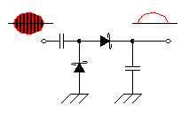
B - Detection circuit
The detection is done to detect the received ultrasonic signal. This is the half-wave rectification circuit with Shottky barrier diodes. The DC voltage according to the level of the detection signal is output to the capacitor behind the diode. The Shottky barrier diodes are used because the high frequency characteristic is good.

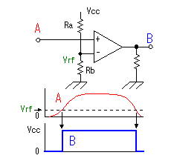
C - Signal detector
This circuit is the circuit which detects the ultrasonic which returned from the measurement object. The output of the detection circuit is detected using the comparator. At the circuit this time, the operational amplifier of the single power supply is used instead of the comparator. The operational amplifier amplifies and outputs the difference between the positive input and the negative input.
In case of the operational amplifier which doesn't have the negative feedback, the output becomes the saturation state by a little input voltage. Generally, the operational amplifier has over 10000 times of mu factors. So, when the positive input becomes higher a little than the negative input, the difference is tens of thousands of times amplified and the output becomes the same as the power supply almost.(It is the saturation state) Oppositely, when the positive input becomes lower a little than the negative input, the difference is tens of thousands of times amplified and the output becomes 0 V almost.(It is in the OFF condition) This operation is the same as the operation of the comparator. However, because the inner circuit of the comparator is different from the operational amplifier, the comparator can not be used as the operational amplifier.
At the circuit this time, the output of the detection circuit is connected with the positive input of the signal detector and the voltage of the negative input is made constant.
Vrf | = ( Rb x Vcc )/( Ra + Rb )
 | = ( 47^{K-ohm} x 9^{V} )/( 1^{M-ohm} + 47^{K-ohm} )
 | = 0.4V

So, when the rectified ultrasonic signal becomes more than 0.4 V, the output of the signal detector becomes the H level (Approximately 9V). This output is lowered with the resistor to make fit with the input of signal holding circuit (TTL:0V to 5V).

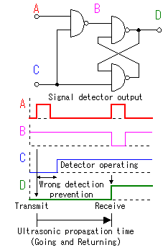
D - Signal holding circuit
This is the holding circuit of detected signal. SR ( Set and Reset ) flip-flop is used.
The detector is made to be not operate in the constant time(About 1.5 milliseconds) after sending out a transmission pulse to prevent from the wrong detection which is due to the influence of the transmission pulse. This operation is controlled with the software of PIC.
When using the capture feature of PIC, this circuit isn't indispensable. Capture operation is done by the change of the capture input in the once. The reason why I am using this circuit is to confirm signal detection operation within the reflected signal detection time(About 65 milliseconds). When sending out next ultrasonic pulse, the output of this circuit is checked. And when the output is L level, an error display is done because the reflected signal could not be detected.
------------------------------------------------------------------------
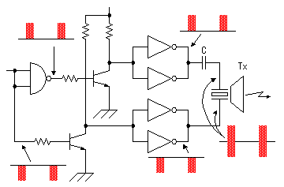
((3)) Transmitter circuit :
The inverter is used for the drive of the ultrasonic sensor. The two inverters are connected in parallel because of the transmission electric power increase.
The phase with the voltage to apply to the positive terminal and the negative terminal of the sensor has been 180 degrees shifted. Because it is cutting the direct current with the capacitor, about twice of voltage of the inverter output are appied to the sensor.
The power supply voltage of this drive circuit is +9V. It is converting voltage with the transistor to make control at the operating voltage of PIC(+5V). Because C-MOS inverters are used, it is possible to do ON/OFF at high speed comparatively.
------------------------------------------------------------------------
((4)) Resonator (4MHz Clock) of the PIC16F877 :
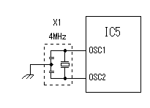
I used 4-MHz resonator.
I used 4 MHz in the relation of the timer in the count time. When using 4-MHz clock, it is 1 microsecond per count for the counter count up time. Timer1 to use for capture is a maximum of 65535 counts(16 bits). So, a maximum of 65.535 milliseconds count is made.
The propagation speed of the sound in air is 343 m/second in case of 20°C. In the time which goes and returns in the 10-m distance, it is 20^{m}/343^{m/sec} = 0.0583 seconds (58.3 milliseconds). As the range meter this time, it is an exactly good value.
------------------------------------------------------------------------
((5)) 555-timer 40KHz transmitter unit (Transmitter Driver) :

General Calculations of the frequency of 555 oscillator :
The oscillation frequency of this oscillator is fixed by the value of capacitor (C) and resistor (Ra) and resistor (Rb).

Roughly oscillation frequency can be calculated by the following formula.
Because there is an error of the part, the oscillation frequency of the actual circuit is sometimes different from the calculated value little.
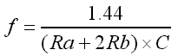
Unit f : Hz / C : Farad / Ra and Rb : ohm
It is possible to calculate by the following formula in the time that the output becomes H level and the time which is made an L level.
The time that the output becomes H level (t_{H})
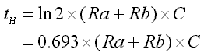
The time that the output becomes L level (t_{L})
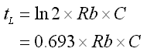
The frequency (f)
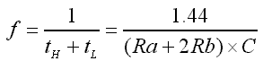

Depending on the previous calculations, it was determined that the transmitter unit must use Ra & Rb each = 10Kohm, and a capacitor of 1.2 nFarads, to give the 40KHz frequency signals.
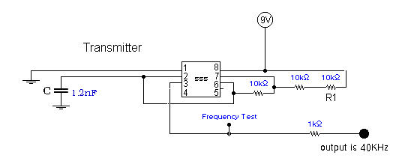
The main purpose of this signal is to generate a stable permanent 40KHz signals to feed the transmitter of the whole project in stable way.
By controlling the values of resistors and capacitors, we can determine the frewuency of the output signal. We made sure that the output frequency is 40KHz because the ultrasonic is driven correctly and ultimately on this frequency to give the widest scanning of unltrasonic waves.

((6)) 555-timer receiver unit (Receiver Driver) :

This unit main purpose is to detect the 40Khz signals reflected from the transmitter and in a mono-stable retriggerable 555 circuit it makes it wide signal to enter the microcontroller in a very relatively low frequency.

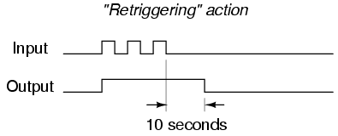

The circuit combination we used for the receiver 555 :

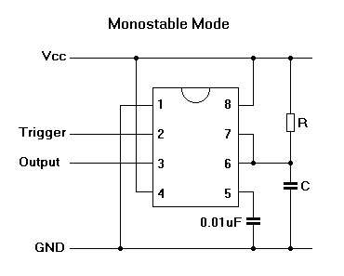

By using the calculation rule of the 555 monostable circuit :
T = 1.1 X R X C (in seconds)
we can determine the resistor value to be 1Kohm and the capacitor to be 1uF, and those values gives us an output of time T = 1mili second approximately.

The full hardware design circuit :

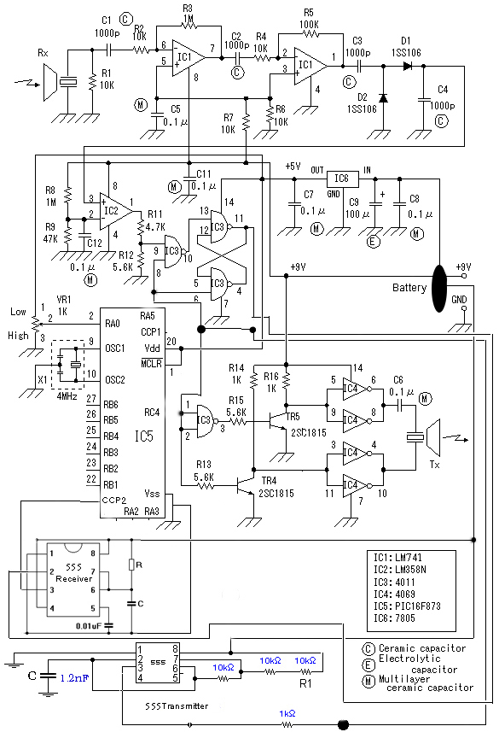
How this project works :

When the circuit is switched on; the power source gives the 9 & 5 volts to all parts of it, the 555 transmitter unit (transmitter driver) starts generating a stable 40Khz signals sent to the NAND gate in the transmitter unit to start generating the 40KHz out of the ultrasonic transducer piece.
Also, this 40Khz generated by the transmitter 555 is sent to the NAND gates of the receiver unit at pins 6 and 8 to trigger them and stimulate the unit to start receiving.

By this the sender and receiver of the circuit are active. The transmitter 555 generates the signals and sends them to the NAND gate of transmitter which uses them on pins 1&2 to switch between the 2 transistors, one at a time, where each transistor at its time gives 9 volts and at the other time gives 0 volts. This happens very fast at 40KHz frequency. After the inverter IC the signal goes out to air as output from the transmitter of frequency 40KHz.

On the other hand, and at the same time, the receiver's NAND gates gets the 555-transmitter's signals and this makes them active to flip the result out of pin 11.
The result at pin 11 is important because it goes to the 555-receiver (receiver driver) which in turn modifies the 40KHz to give a retriggered signal of time 1ms, which goes into the CCP2 of the microcontroller to check it.

When the signals generated ultimately from the transmitter unit reflects back to the receiver unit, it's first filtered, then amplified by passing the series of Op-Amps LM741 which amplifies it more than 1000 times.
The signals then are rectified by using the schottky diodes.
After that, they pass through another Op-Amp connected as a comparator that gives output 0 or 5 volts depending on the input rectified signals.

Output of the comparator is now fully 5 volts or 0 volts and at about 40KHz frequency, so to make use of them we pass them into a flip flop (here is combined of the 4011 IC NAND gates). Remember that the clock of this flip-flop is the 555-transmitter's 40KHz signal.
The output of the flip-flop is then passed to the pin 2 of the 555-receiver (receiver's drive).
At this stage, modifications are accomplished on the 40KHz signals to make it become lower at frequency and time equals about 1ms. This is done to ensure that the microcontroller 16F877 will detect the signals of the receiver unit with no overlapping between them, and thus ensure that the reaction on them is made accurately.

The CCP2 pin of PIC is connected to the output of the 555-receiver to detect the change in signals. The CCP2 always receive at normal case high signal and this pin input becomes up-down-up-down signals which means there's a received signal on the PIC because of some obstacle reflects the ultrasound signals.

Then the PIC reacts as the following :
PIC16F877 sends low signal output on pin D1 which is connected to the ULN2003 which in turn connected to a vibrator, and then switches the vibrator to start vibrating (because ULN2003 is active low). Also PIC gives on pin D2 another low signal to enable a buzzer connected to the ULN2003 also like the vibrator.

(( The common case of the pins D1 & D2 of the PIC is high signal to disable the ULN2003 and then disable buzzer and vibrator from switching on )).

When the input to the PIC is again high, because of no longer reflected on receiver unit, the PIC outs high signals on pins D1 &D2 and no reactions.

Software code of PIC16F877 :

A simple code was used to make the PIC detect the obstacles and make a reaction on.
The software was programmed using PIC C compiler for microcontrollers.

The code is :

- BlindsStick.h file :

#include <16F877.h>
#device adc=8
#use delay(clock=4000000,RESTART_WDT)
#fuses NOWDT,RC, NOPUT, NOPROTECT, BROWNOUT, LVP, NOCPD, NOWRT, NODEBUG
#use rs232(baud=9600,parity=N,xmit=PIN_C6,rcv=PIN_C7,bits=8,restart_wdt)

- BlindsStick.c file :

/////////////////////////////////////////////////////////////////////////////////////////////////////
// Hardware Project : Blinds Stick //
// Programmed and designed by : Aghyad Saleh & Mahran Qozah. //
/////////////////////////////////////////////////////////////////////////////////////////////////////

#include "BlindsStick.h"
#include <stdio.h>
#include <stdlib.h>
#include <float.h>

// PIN D1 is the vibrator.
// PIN D2 is the buzzer.

unsigned long rise,fall;
float ton;

// Capture Mode on CCP2 : ////////////////////////////////////////////

#int_CCP2
CCP2_isr()
{
if(rise==0){
rise=ccp_2;
}
else if(fall==0){
fall=ccp_2;
}
}

//function that catches the rise and fall timings :////////////////////

void Catch_RF()
{
while((rise==0)&&(fall==0))
{
restart_wdt();
if(rise==0) setup_ccp2(CCP_CAPTURE_RE); // catch the value of rise
else if(fall==0) setup_ccp2(CCP_CAPTURE_FE); // catch the value of fall
}
restart_wdt();
ton=fall-rise;
rise =0;
fall=0;
}

// Main Function : ///////////////////////////////////////////////////

void main()
{
setup_adc_ports(NO_ANALOGS);
setup_adc(ADC_OFF);
setup_psp(PSP_DISABLED);
setup_spi(FALSE);
setup_timer_0(RTCC_INTERNAL|RTCC_DIV_1);
setup_timer_1(T1_DISABLED);
setup_timer_2(T2_DIV_BY_1,24,1);
enable_interrupts(INT_CCP2); // CCP2 is in captue mode to catch received signals
enable_interrupts(GLOBAL);

rise = 0;
fall = 0;
ton = 0;

while(1)
{
//do it : switch on the transmitter ... .
delay_ms(1);

Catch_RF(); //check if a signal is received ...

if(ton>0)
{
output_bit(PIN_D1,0); //enable vibrator of the stick.
output_bit(PIN_D2,1); //enable buzzer.
}
else if(ton == 0)
{
output_bit(PIN_D1,1); //disable vibrator of the stick.
output_bit(PIN_D2,0); //disable buzzer.
}

//after that reset every thing to initial state and again from the begining test // the same stuffs... .

delay_ms(1);
rise=0;
fall=0;
ton =0;

}//while(1)
}//main

Finally,

We managed in this project to understand the basic ideas of how to make a PIC see what around it. Other ideas and modifications jumped to head through working on the circuit tens of times so we reached to this final form of it.
This project still have some shortcomings like the ability to make a descending beep, let's say, or a vibration depending on the distance of the obstacle to the stick.
But it in deed was able to apply the idea of making the guidance stick see on behalf of the blinds.

We proudly present this project to all who are not able to see by their eyes how life is so beautiful, but we are sure they still can see the life through their hearts. To all blinds, may ALLAH bless them and us.

One Last Word,

We'd like thank our doctors supervisors in this project who was a good assistants and supporters to us.
Special thanks to our supervisor Haya Sama'aneh & also to Mr. Othman Othman.

The End

