An-Najah National University
Faculty of Engineering
Computer Engineering Department

Graduation Project:

Prepared by:

Youssef Hammoudeh
Deema Sawalha

Supervisor:

Eng. Ashraf Armoush

2004/2005

Replication Environment Manager
Introduction:
The main idea in the project is constructing a banking environment system that uses the replication as method of sharing data between several data-servers.
As the purpose of replication, is to manipulate the data required from a main Master server from other branches as if it is locally administered to decrease the traffic on the connection network to the master site, and to offer a benefit of working in an offline status to the main data source.
Other goals rise with ideas to computerize all the banking system actions and documentations plus providing bank services over a wide area that covers even 10s of countries so the customer can find his proper account on every branch anywhere with all his personal archives and information.
Then, to achieve these goals two main working areas are used to develop the Replication Banking System Environment:
- Oracle Developer 6i: used to develop a Client/Server application that will represent the banking interface between the user and the data. This interface serves some main tasks like management of the bank employees, management of the bank services and actions, management of the bank financial and information settings and monitoring the replication system (errors, conflicts, status…).
- Oracle 9i database: used to set the background platform of the replication with all its sites, jobs, conflicts resolution, groups and object replicas.

We want to improve and make banking system easier to deal with. Since the banking system in these days depends greatly on hard copy documents and archiving, and in case we want to search for some old client in the system we need time in hours in best cases to get this information. It’s much easier to have this information in seconds and without delaying for days an argent request for any data.
Thus, we came up with the idea of client/server application to support banking systems.
The subject of this application is to watch on database replicas to detect any change on the database as mentioned earlier.
Replication Environment Manager (REM) is the name we chose for our application to produce a good and sufficient idea about dealing with modern banking systems and delivering any update on one site to all other sites that contain replicas of the main database.
Replication is the process of copying and maintaining database objects, such as tables, in multiple databases that make up a distributed database system. Changes applied at one site are captured and stored locally before being forwarded and applied at each of the remote locations.
The main objectives for the project are:
- Creating a Client/Server application for Bank System.
- Distributed Bank System using Replication supported by Oracle9i.
We will look more closely on the first objective, the Client/Server Application.

Requirements:
Services managing users of this application are the primary key for success in supporting a Bank System. Services provided by this application are:
- User Management service: this service gives you the ability to add new user, delete users, modify data on some users, and search for specific users of the application based on easy and reliable ways to do all of the above.
- REM Banking System service: this service manages the operations you can perform on customers’ accounts, checks, cash actions, and reports providing information about the customers.
- Banking Settings service: it handles the settings and initiations of the bank and its different branches. This handles the branches of the bank and any operation performed on one of those branches whether changing its address, postal code, money details of buy and sale prices in different predefined currencies.
And we will come to each of these services in more details later in this documentation.

Specifications:
The specifications of the application are those in which we can understand the progress in work in the banking system. The meaning is that when you look on the banking settings you can see the initial data of it and its branches.
Tables, packages, and directories are the important database aspects to best predefine specifications.
Tables on which the project was established are mainly 14 tables and they are:
TNAME TABTYPE CLUSTERID
------------------------------ ------------ ---------------
REM_ACCT TABLE
REM_ACCT_BRCH TABLE
REM-ACCT_CHECK TABLE
REM_ACCT_FLOW TABLE
REM_ALL_FLOW TABLE
REM_BANK TABLE
REM_BANK_RESP TABLE
REM_CHECK_FLOW TABLE
REM_CUST_PROF TABLE
REM_CUST_TABLE TABLE
REM_MONY TABLE
REM_REGN TABLE
REM_TRAN_TABLE TABLE
REM_TRSF_FLOW TABLE
The tables’ attributes are shown respectively to each table in the project.

- REM_ACCT table is the abbreviation of REM accounts table; this table has no primary keys. This table holds the main operations performed on customers’ accounts.
Name Null? Type
--------------------------- --- -------- -------------
RA# NOT NULL NUMBER(9)
RA_TYPE NOT NULL VARCHAR2(20)
RA_DATE_CRT NOT NULL DATE
RA_DATE_MODF NOT NULL DATE
RA_ATM NOT NULL CHAR(1)
RA_CHECK NOT NULL CHAR(1)
RA_BANK_CRT NOT NULL NUMBER(9)
RA_BANK_MOD NOT NULL NUMBER(9)
RA_CITY NOT NULL VARCHAR2(30)
RA_STRT_ADDR VARCHAR2(150)
RA_REGN NOT NULL NUMBER(9)
RA_COMN VARCHAR2(400)
- The REM_ACCT_BRCH table contains type of money and balance in a customer’s account and any date of modification occurs on that account:
Name Null? Type
---------------------------- ----------- ----------------
RAB_ACCT_ID NOT NULL NUMBER(9)
RAB_MONY NOT NULL NUMBER(9)
RAB_BALANCE NOT NULL NUMBER(15,5)
RAB_DATE_CRT NOT NULL DATE
RAB_DATE_MODF NOT NULL DATE
- REM_ACCT_FLOW table describes the flow of money between accounts, with the transaction ID type and amount and the branch in which the operation occurred given the initial and current value after performing a transaction on certain account.
Name Null? Type
------------------------------------ ----------- -------------
RAF# NOT NULL NUMBER(9)
RAF_TRAN_ID NUMBER(9)
RAF_BRCH_ID NUMBER(9)
RAF_PRV_VAL NUMBER(15,5)
RAF_TRAN_VAL NUMBER(15,5)
RAF_NEXT_VAL NUMBER(15,5)
- The REM_ACCT_CHECK handles the check service attributes which you can have a check book or deal with the other operations provided for checks based on this table and others described later.
Name Null? Type
------------------------------ ----------- -------------
RCC# NOT NULL NUMBER(9)
RCC_ACCT_ID NOT NULL NUMBER(9)
RCC_PAGE# NOT NULL NUMBER(3)
RCC_DATE_REQU DATE
RCC_DATE_RECV DATE
RCC_CHECK_STAT CHAR(1)
RCC_BANK_CRT NUMBER(9)
- The REM_ALL_FLOW table takes the IDs of transaction process and of the money’s type, with the previous and transaction and the new values describing all the transactions occurred on the different accounts determining previous and new and the amount of transaction values.
Name Null? Type
-------------------------- -------- ------------
TRAN_ID NUMBER(9)
BRCH_ID NUMBER(9)
PRV_VAL NUMBER(15,5)
TRAN_VAL NUMBER(15,5)
NEXT_VAL NUMBER(15,5)
- The REM_BANK table has the information about the bank itself, including postal code ID, address and the server IP address and name, database link that means the link to which the table is connected to store data in.
Name Null? Type
------------------------------ ---------- -------------
RB# NOT NULL NUMBER(9)
RB_REGN_ID NUMBER(9)
RB_ADDR NOT NULL VARCHAR2(300)
RB_SRVR_IP NOT NULL VARCHAR2(15)
RB_SRVR_NAME NOT NULL VARCHAR2(30)
RB_DB_LINK NOT NULL VARCHAR2(30)
RB_TEL VARCHAR2(20)
RB_FAX VARCHAR2(20)
RB_TYPE NOT NULL VARCHAR2(20)
- REM_BANK_RESP table is the bank responsible table that holds information about the users of the application; as the first, second, and last names, a user name and password. The type of the user indicates the privileges a user have to access the system with all its fields.
Name Null? Type
---------------------------- ------------ -------------
RBR# NOT NULL NUMBER(9)
RBR_FRST_NAME VARCHAR2(25)
RBR_MIDD_NAME VARCHAR2(25)
RBR_LAST_NAME VARCHAR2(25)
RBR_USER_NAME NOT NULL VARCHAR2(25)
RBR_PASS NOT NULL VARCHAR2(25)
RBR_TYPE NOT NULL VARCHAR2(25)
RBR_EMAIL VARCHAR2(60)
RBR_TEL_OFFI VARCHAR2(25)
RBR_TEL_HOME VARCHAR2(25)
RBR_MOBI VARCHAR2(25)
RBR_ADDR VARCHAR2(200)
RBR_RESP_STAT VARCHAR2(10)
RBR_COMN VARCHAR2(400)
- REM_CHECK_FLOW table, this table is the important table on the checks’ processes. It helps creating the check book with the customer ID, number of pages in the book, and the name of the customer with other normal information connected to this topic.
Name Null? Type
------------------------- ----------- ------------
RCF# NOT NULL NUMBER(9)
RCF_TRAN_ID NUMBER(9)
RCF_CHECK_ID NUMBER(12)
RCF_BRCH_ID NUMBER(9)
RCF_DEST_ID VARCHAR2(25)
RCF_DEST_NAME VARCHAR2(120)
RCF_PRV_VAL NUMBER(15,5)
RCF_TRAN_VAL NUMBER(15,5)
RCF_NEXT_VAL NUMBER(15,5)
RCF_CHECK BLOB
- REM_CUST_PROF describes the customers’ profile in the system when adding a new customer to the system, providing full name, address, nationality, and the sign and picture of the customer to guarantee integrity on each customer’s account.
Name Null? Type
---------------------------- ------------ -------------
RCP# NOT NULL NUMBER(9)
RCP_CUST_ID NOT NULL NUMBER(9)
RCP_FRST_NAME NOT NULL VARCHAR2(20)
RCP_MIDD_NAME NOT NULL VARCHAR2(20)
RCP_LAST_NAME NOT NULL VARCHAR2(20)
RCP_TITL NOT NULL VARCHAR2(5)
RCP_TEL_HOME VARCHAR2(30)
RCP_TEL_OFIC VARCHAR2(30)
RCP_EMAIL NOT NULL VARCHAR2(150)
RCP_PASP_ID VARCHAR2(20)
RCP_NATN_ID VARCHAR2(20)
RCP_NATN VARCHAR2(20)
RCP_BRTH_DATE NOT NULL DATE
RCP_PICT BLOB
- The REM_CUST_TABLE gives the priority of the customers in an account of type joint, this means that for multiple clients in the same account with one of them has the highest priority to control that account.
Name Null? Type
----------------------------- ----------- ------------
RCT# NOT NULL NUMBER(9)
RCT_ACCT_ID NOT NULL NUMBER(9)
RCT_CUST_PRI NOT NULL NUMBER(3)
RCT_DATE_CRT NOT NULL DATE
RCT_DATE_MODF NOT NULL DATE
RCT_BANK_CRT NOT NULL NUMBER(9)
RCT_BANK_MODF NOT NULL NUMBER(9)
RCT_SIGN BLOB
- REM_MONY table handles the money information and prices of sale and buy. It also gives the sign of the money, name and the flag of the country using this type of money.
Name Null? Type
------------------------ ---------- ------------
RM# NOT NULL NUMBER(9)
RM_SMBL NOT NULL VARCHAR2(9)
RM_NAME NOT NULL VARCHAR2(30)
RM_BUY NOT NULL NUMBER(15,5)
RM_SALE NOT NULL NUMBER(15,5)
RM_MODF NOT NULL DATE
RM_PICT BLOB
- REM_REGN table gives the postal code and name of the region in which branches of the bank are located, i.e. RR_CODE= 9 for region’s name= Nablus.
Name Null? Type
---------------------- ----------- ------------
RR# NOT NULL NUMBER(9)
RR_CODE NOT NULL NUMBER(4)
RR_NAME NOT NULL VARCHAR2(25)
- REM_TRAN_TABLE includes attributes to describe the transaction type given the customer’s ID and his\her account’s ID, date, and the bank ID in which the transaction occurred.
Name Null? Type
------------------------- ----------- ------------
RTT# NOT NULL NUMBER(9)
RTT_ACCT_ID NUMBER(9)
RTT_CUST_ID NUMBER(9)
RTT_TYPE VARCHAR2(25)
RTT_DATE DATE
RTT_BANK_ID NUMBER(9)
- REM_TRSF_FLOW indicates the source and destination accounts’ IDs, previous and current value after performing the transaction with the given transaction value, and the branch that the operations occurred on.
Name Null? Type
------------------------ ------------ ------------
RTF# NOT NULL NUMBER(9)
RTF_TRAN_ID NUMBER(9)
RTF_SRC_ACCT NUMBER(9)
RTF_SRC_BRCH NUMBER(9)
RTF_PRV_VAL NUMBER(15,5)
RTF_TRAN_VAL NUMBER(15,5)
RTF_NEXT_VAL NUMBER(15,5)
RTF_SCALE NUMBER(15,5)
RTF_DST_ACCT NUMBER(9)
RTF_DST_BRCH NUMBER(9)
RTF_PRV2_VAL NUMBER(15,5)
RTF_TRAN2_VAL NUMBER(15,5)
RTF_NEXT2_VAL NUMBER(15,5)

The directories are specific to describe the path from which we can import the pictures of the customers, their signatures, and the flags for the currencies’ countries. These directories are predefined in the application and can’t import elsewhere from the specified ones.
Packages in the application are divided mainly into categories:
- One for the SQL packages that defines the operations mainly performed on the database and must be executed via the SQL environment.
- The developer’s package that can be executed separately from the SQL and to enable building the forms correctly.

Concepts:
The concepts of this project can be summarized as a first step in the following ideas:
- Buttons that contain special procedures that do the same job as the default buttons on Oracle, but the difference is according to the user’s requirements.
- Using the data block wizards constructed by the Developer. The wizards allow you to quickly and easily create a data block based on a table, or a view, or a set of stored procedures.

Installation:
This application is responsible for handling with a normal bank system via the head office of the bank and its branches over a country.
In order to run this application on the Master server; first we need to install it and to do so we follow these steps:
- Store the folder containing the whole project on the master server.
- Then open an SQL*Plus session to start the application installation
- Start executing the SQL file named INSTALL.SQL

This file includes the following statements to be executed
@c:\REM\SRC\TABLESPACE\REM_TABLESPACE.SQL
@c:\REM\SRC\ROLE\REM_ROLE.SQL
@c:\REM\SRC\USER\REM_USER.SQL
It appends or adds the mentioned SQL files and executes them.
- Next we execute the table file by running the TABLE.BAT twice which automatically build and execute the commands defined in the TABLE.SQL file.

The TABLE.SQL file contains these instructions which append all the tables below to the database, which were described earlier:
@TABLE\REM_REGN.SQL
@TABLE\REM_BANK.SQL
@TABLE\REM_BANK_RESP.SQL
@TABLE\REM_ACCT.SQL
@TABLE\REM_MONY
@TABLE\REM_ACCT_BRCH.SQL
@TABLE\REM_CUST_TABLE.SQL
@TABLE\REM_CUST_PROF.SQL
@TABLE\REM_TRAN_TABLE.SQL
@TABLE\REM_TRSF_FLOW.SQL
@TABLE\REM_ACCT_FLOW.SQL
@TABLE\REM_ACCT_CHECK.SQL
@TABLE\REM_CHECK_FLOW.SQL
@TABLE\REM_ALL_FLOW.SQL
- Then execute in the same manner the DIRECTORIES.BAT twice to run its attached SQL file that is the DIRECTORIES.SQL. This is also applied on the replicas and executed with the directories file.

And the DIRECTORIES.SQL file contains
@DIRECTORIES\IMAGE_DIR.SQL
@DIRECTORIES\SIGN_DIR.SQL
@DIRECTORIES\FLAG_DIR.SQL
@DIRECTORIES\CHECK_DIR.SQL
- And finally execute the PACKAGE.BAT in the same way.

@PACKAGE\SQL_PACKAGE\IMMEDIATE_EXEC.SQL
@PACKAGE\SQL_PACKAGE\IMMEDIATE_EXEC_BODY.SQL
@PACKAGE\SQL_PACKAGE\PICTURES.SQL
@PACKAGE\SQL_PACKAGE\PICTURES_BODY.SQL
They add some procedures to the database enabling the user of the database to access it correctly.
This allows you to access images preinstalled in the specific paths above and not from else where.
Now the application is ready to be used by end-users, we can see the specified icon available to start running the REM.
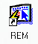
Each of the files above is responsible for the access of the tables on which the project stands.

Naming methodology:
Naming tables and attributes took an easy and simple method. We took the first letters or more, of the words, and came up with the abbreviations seen and mentioned in the project. For example, REM_ACCT_BRCH stands for REM Account Branch, and RAB_ACCT_ID stands for Rem_Acct_Brch Account ID. So tables included the name of the project REM followed by description for the field that used the table. And for the attributes inside tables; we took the first letter of each word in a table name and after it description for the use of that attribute, i.e. RBR# came from REM_BANK_RESP, that is the name of the table containing this key, and so on.

Problems:
While the progress operation on the project, we faced several problems that caused some latency in the plan we drew for our progress. From these problems we mention the following:
- The LOB problem. This is a datatype which defines images(BLOBs), characters(CLOBs), and binary files(BFILEs). We used the BLOBs in our project to define images used in it. There was no problem when using the Long Raw datatype to define the pictures inside the database, but the problem arose when updating images on replicas on different sites; Long Raw isn’t a replication supported.
Here a comparison between the two datatypes:
LOBs LONGs
Up to 4 gigabytes Up to 2 gigabytes
Multiple LOB columns allowed in a single table Only one LONG column allowed per table
Replication supported No replication
Random data access supported Only sequential access supported
Better table space management (only LOB locator is stored) Less efficient (data is stored directly in
table)
Allowed in user-defined object types Not allowed
Easily passed to procedures and external calls Not easily passed
In the comparison above it’s mentioned that multiple LOB columns allowed in a single table, but in our project we placed each BLOB column in a separate table with no extra cost because we have already defined each BLOB attribute for a different use in separate tables, one for the customers picture, second for his/her signature, and third for the flag indicating the money’s type, and each of these attributes are stored in different table.

Tabling:
Tables of the project are introduced by the figure below indicating the relations between them and specifying each one’s attributes and keys.
You can start watching this image from the REM_ACCT_RESP table which stands for the abbreviation REM ACCounT RESPonsible. This table conations the information about the employees in the bank who can access and use the system, data such as first, middle, and last names for each employee, a user name to access the database with a password, user type if he/she is a manager or an administrator or an end-user, and other official and private information seen in the table below.
You can follow the relations between the tables in the project and observing the primary, foreign and remaining attributes (keys).
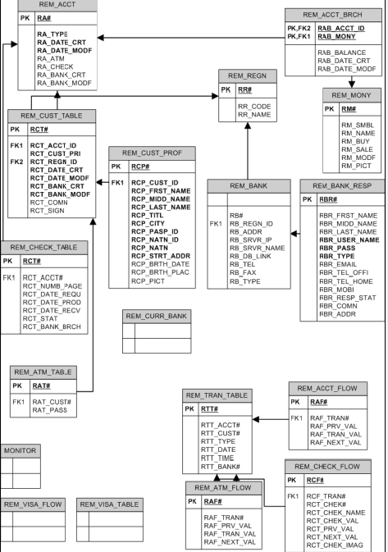
A relation leading to REM_BANK table from the starting one we said above. This table specifies the branches of the bank, including its number and region ID, address, server IP address and name, database link and type. The number of branch indicates how the head office of the bank can define each branch regardless its name.
REM_REGN stands for REM region of the branches taking its code and name as attributes.
As you can see in the image, our system is divided mainly into what we can say about three groups. The first group describes the system itself and its employees, while the second focuses on the customers and their accounts and the operations they perform, and the third group is about money and its values in many currencies.
So the first group is mentioned above, and now we will describe the second one.
REM_ACCT table stands for the accounts of the customers in the bank. It contains information about money’s value of sale and buy prices, ATM services, checks and any type of modification on these attributes is saved in the database as we will see later while describing the forms of the project.
The related table to REM_ACCT is the REM_ACCT_BRCH table. It includes information about the different branches of the bank with two primary keys for this table; the RAB_ACCT_ID and RAB_MONY, standing for the ID of the user and the value of money does his account has($,JD,NIS,…etc), dates of creation of the account and any access or modification to it.
REM_CUST_TABLE is the table containing information about the customers who are partners in the same account (joint account). The main point in this table is it provides the priority of the customers in that account.
REM_CUST_PROF is the abbreviation for customers’ profiles and the information about them.

The Interface:
The forms of the project are the faces which will the users work with and handle. We tried to make it as much easy and familiar as possible in order to guarantee the end-user’s comfort and satisfaction.
The first window to show up after running the program is the LOGIN window. It’s the key to deal and use this application. Only users with predefined accounts can enter to the next window from here.
For ease of use and explaining the aim of the project we have created a default user ANA and a password ANA to enter and use this application. The type of this user is defined as administrator ( this means user has the maximum privileges allowed in the application).
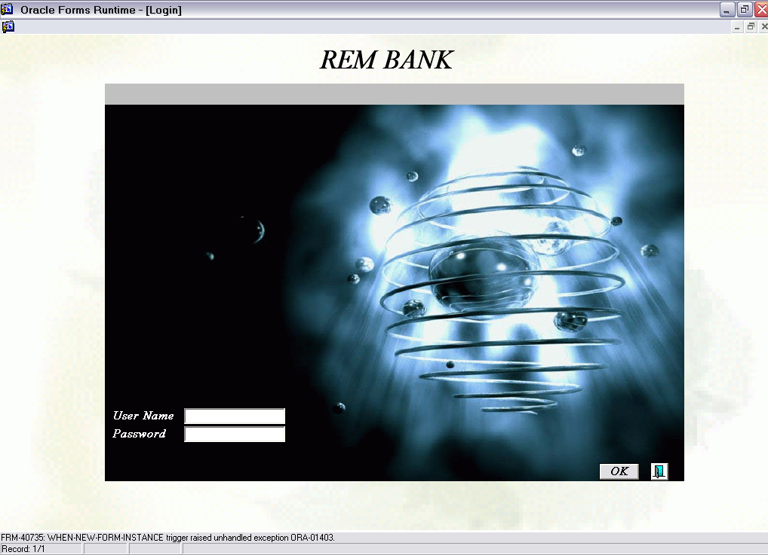
This window after registration will lead to the main window providing the services offered in the project. Each of which will lead to another new window providing more detailed services about the category field you first chose from the main services mentioned.
The services provided are the USER MANAGEMENT, REM BANKING SYSTEM, BANK SETTINGS, and REM MONITOR. An exit button is provided () in case a user decided to leave the application in this early step. Notice also that in the forms to follow there is a back button () that enables you to go back to the previous window. The services window is the last you can get back to; meaning you can’t go back from this window to the LOGIN window without exiting first and rerunning the application again!
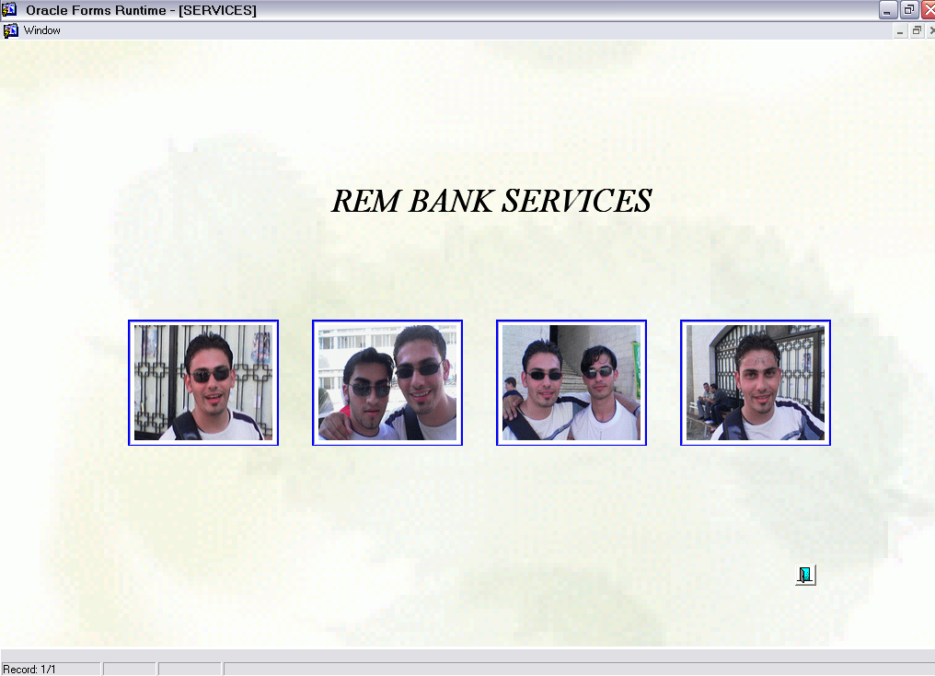
Each service and respectively is described with all the functions it is responsible for.
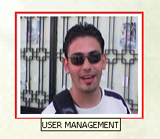
The USER MANAGEMENT service provides multiple operations that can be performed on users such as creation, modification, deletion, and search on the employees’ side.
These operations are accessed by the users of three levels defined in REM, the administrator who is able to create and modify any field within the application, the manager who is able to perform the same operations but only on users of the same priority as his or less, but not on administrator’s data, and finally the end-user type with the least level of priority to access those files.
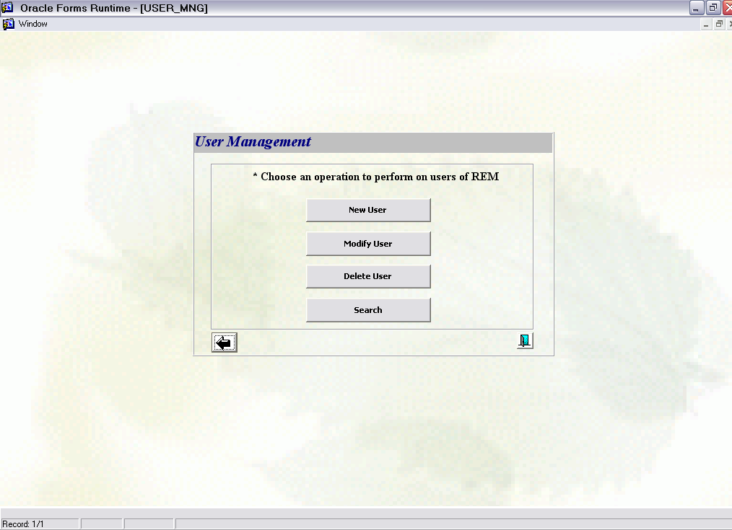
The NEW USER operation allows you to add new user to the database so this user will be able to access the database and uses efficiently this application. Information required is almost well known to everyone and some fields of the form are more important thus they were marked with a ‘*’, as shown in the form here:
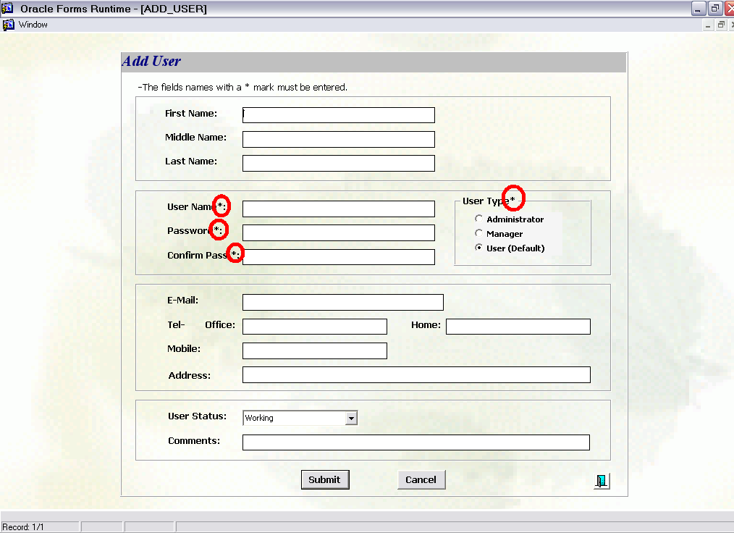
In the User Type option; if you didn’t choose a type of your registration then by default it will be considered as end-user type. The User Status means if this user is already working or taking a vacation. The Submit button will store the new data in a record saved by the database and the Cancel button will take you back to the previous window (that is, the Services form) without saving anything.
Note: you can’t create a new user with a privilege type higher than the current user of the application.
The Modify User operation enables you to edit and change information entered earlier to a user’s record. This form will view all the users registered and stored in the database’s file and the main information about them; the full name and the user name. Beside each user there is a modify button, by clicking on it you will be moved to the original modify window, that is similar to New User window but preserving the information about that user, and hence editing any field there.
Any modification here is not allowed on administrator type user only if the user was an administrator in the first place, and managers or end-users are allowed only to perform changes on users of their types only, since users of higher priority are invisible to less priority users.
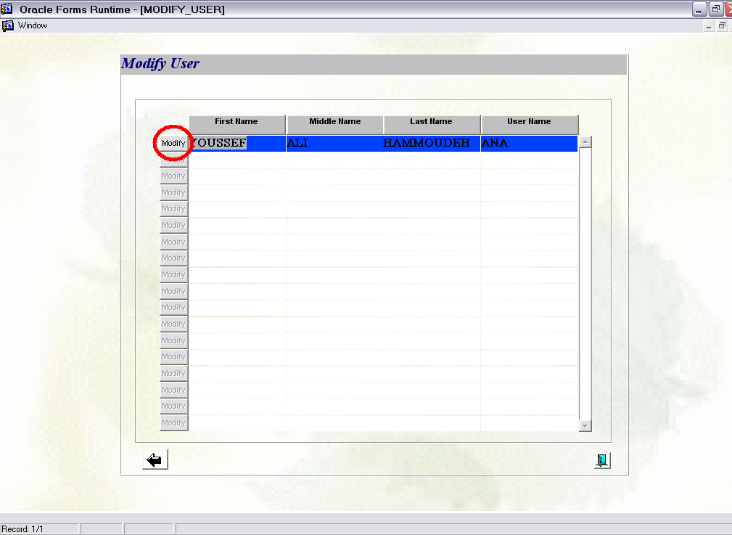
The Delete User service can be accessed only by an administrator. This service enables you to delete and remove a user from your employees’ tables and all the related fields associated with this user.
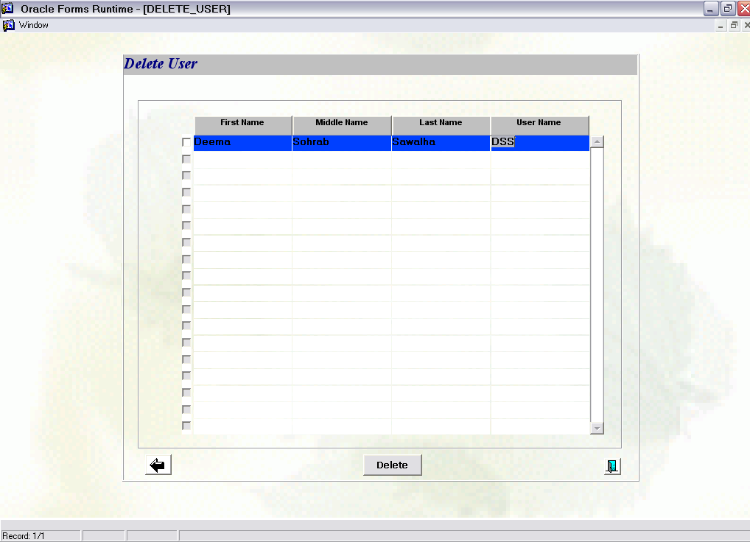
The last service we provide is the Search service. This enables us to find some user and the related information about that user, by specifying a field to search on.
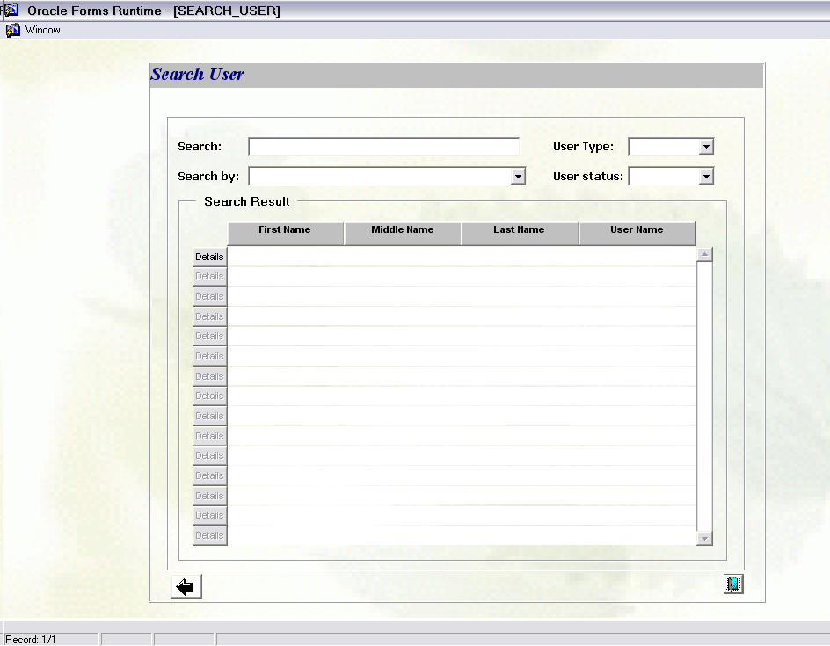

Now we will look at the second main service in the system; REM BANKING SYSTEM.
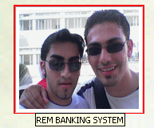
This service handles the customers’ aspects and fields, including the addition, modification, deletion, and operations performed on accounts for the customers. This service can be accessed by any level of users in the bank system whether administrator or end-user. The first window to show up in this service is an empty window with a menu bar at the top of it enabling us to choose which operation to perform in this area.
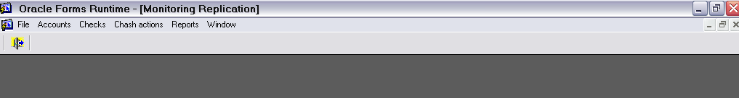
Accounts are to perform operations on customers like new account, delete account, modify, search, and also it handles the addition of new types of money in some account.
Account submenu:
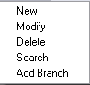
New customer frame has the normal requirement to create a new account like the full name, address, number of partners in the same account, and a picture and signature for the customer.
The first option is to determine the account type whether it is individual or joint, by multiple partners (max of three in this form). In case of joint, each partner has separate fields to fill and signs and pictures to load.
Double click on the place of the image and a new window appears to enable you to pick the appropriate picture from a specified path given the correct name for that image. A default image will be chose if you didn’t fill one, and nothing will show if canceling the work on this window.
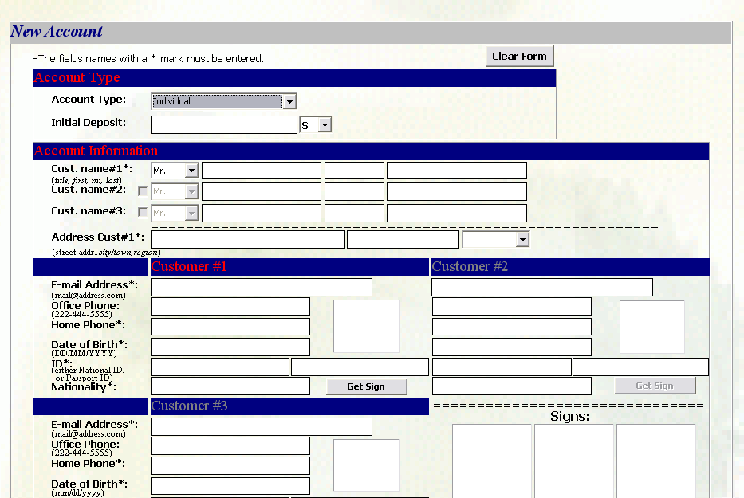
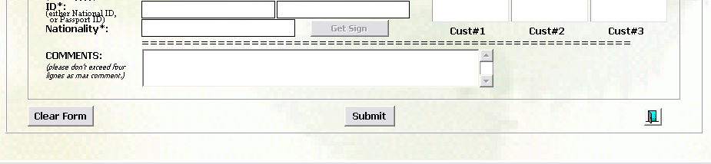
Any modification on the form can be done on the modify window which by choosing a client to modify its data will take you to a window same as that for New User.
This is done on the Modify Account window.
In the same way we performed the modification, we can perform the deletion operation. We just determine the account we want to delete and be default all the related information to that account are deleted as well.
The search option will lead to a frame that includes the customer’s accounts and its type. On the right side of the table, there is a button named “Details” from which you can go to a new window including the information about that account.
The window, as you can see, is divided into four parts. The 4th part “Account Customer” contains the customers that own the account, either individual or joint. By clicking on the details button next to this table, you can see more detailed information about this customer.
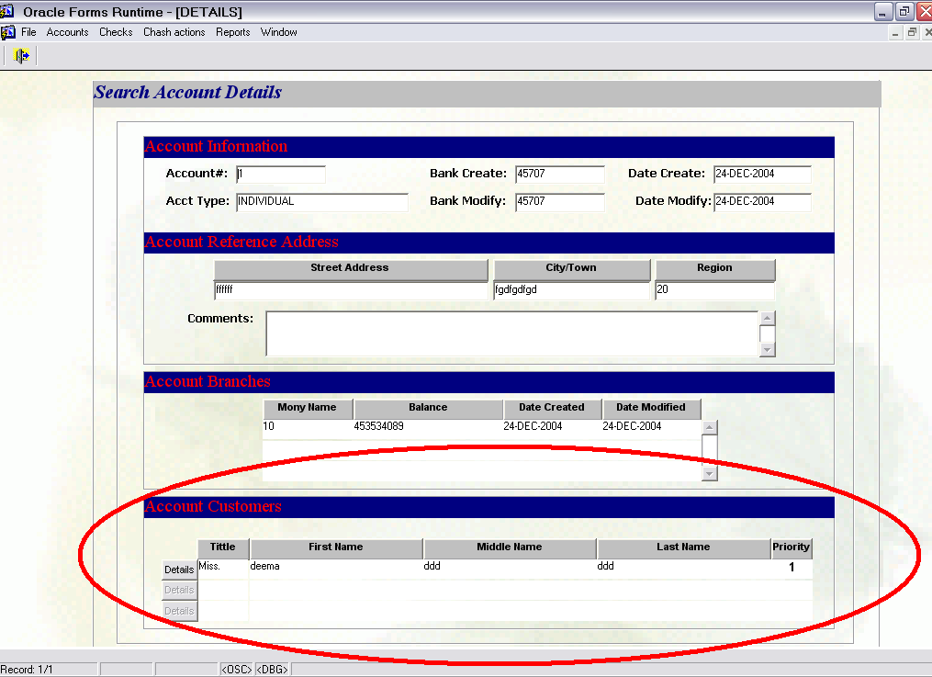

The last choice in this submenu, is the add branch.
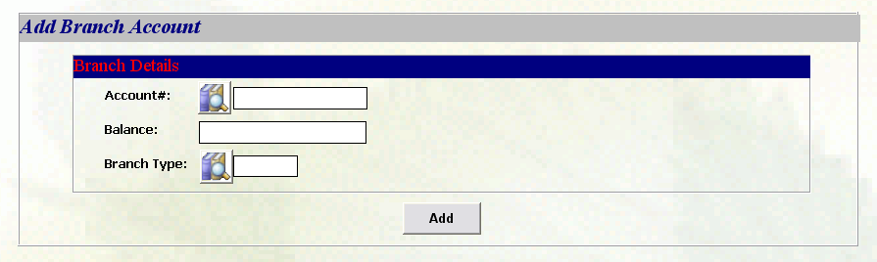
Choosing the account# from a list defined and the balance and type of money you want to add to the account. This enables the customer to have more than one type of money in the same account, i.e. account of type $, and another type of Canadian Dollar …etc.
Another service provided by the bank for the customers is the cash operations that one can perform on his/her account.
Cash Actions submenu:
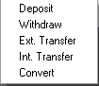
Deposit operation enables you to increase your balance in the type of money you specified. The same thing can be said about the Withdraw.
The application support the money transfer between two different accounts belonging to the same bank branch or to different branches, they are called Internal Transfer and External Transfer, respectively. The Internal transfer enables the transaction from some account to your own account with the benefit that different types of money can be solved.
The External transfer between different accounts indicating both IDs for the customers is provided by system.
The last operation can be performed on the accounts is the Convert. By this operation you can convert any amount of money from type to another with implicit equations for the different types.
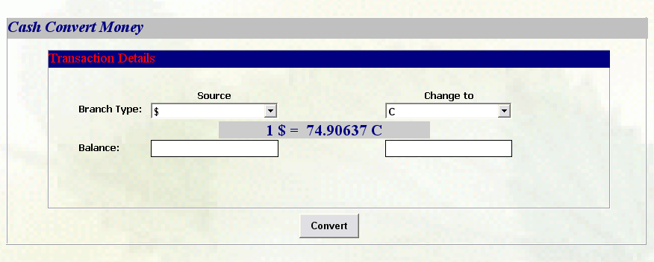
Checks service concerns the ability to give the customers a check book with specified number of checks inside.
The Checks submenu:
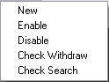
The New operation creates a check book for a customer needing his ID and number of pages he would like to have within that book.
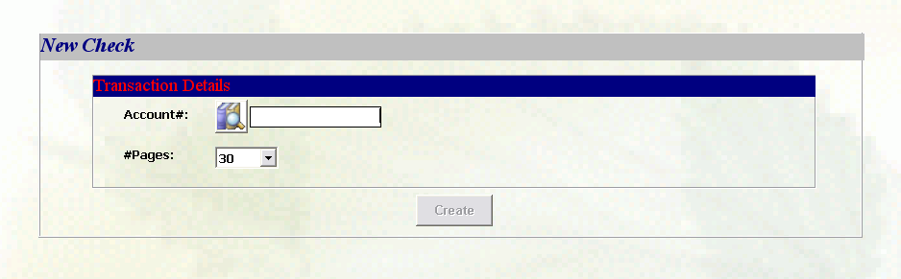
The Enable allows a customer to start using check book providing the account ID and the number of check book, and no operations can be done on checks without first enabling this service.
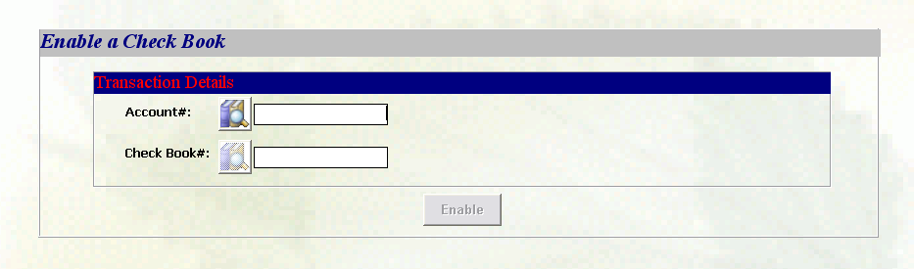
The Disable operation does the opposite of the Enable. It disables the use of check book and no operations allowed after this involving check services.
Now Check Withdraw controls the transaction on accounts using the checks; provided the balance, the source and destination names of the clients, and when specifying the source’s name, his sign will appear in the right bottom box. And a picture of the check must be inserted before the operation can complete.
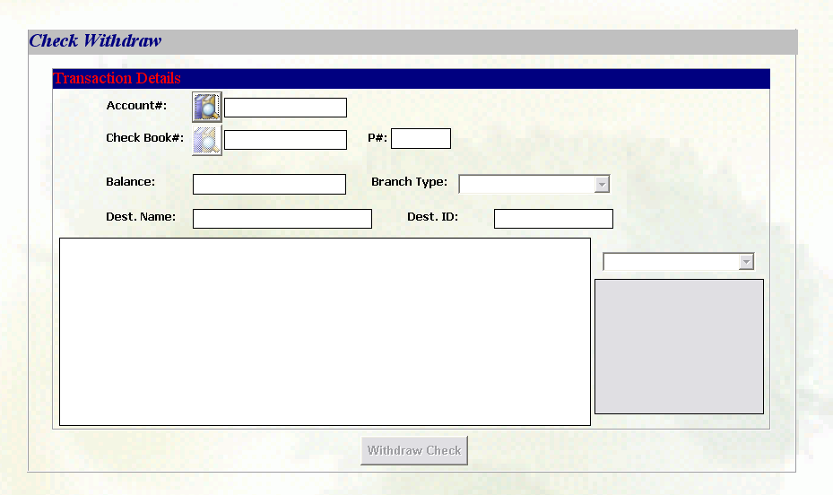
The last operation is Check Search. It helps the end-user to search for information on operations done by checks giving the account#, money ID defined by the application, and there is a button in front of each row named Details which opens a new window with more detailed information about the check we are concerned with.
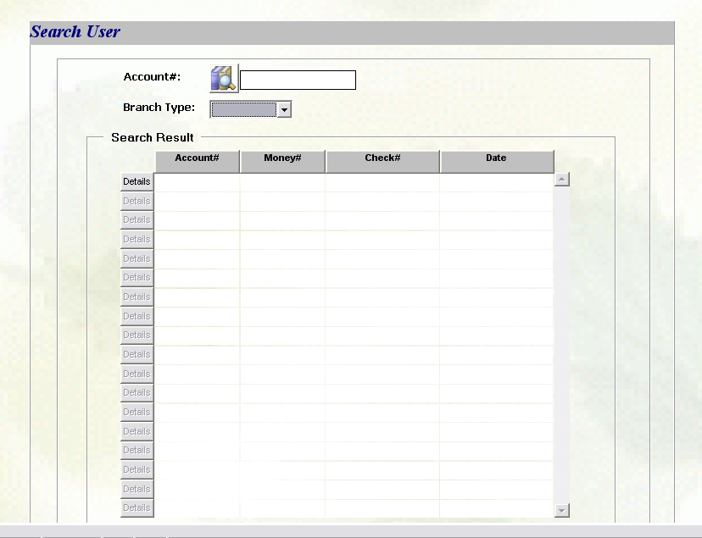

Reports enable you to see the main transactions performed on the accounts found in the system. The operations provided by this service are viewing the transactions made on an account and all the transactions done on it, under the name Account Full Flow. Other specified actions can be viewed by other types of reports.
The reports submenu is:
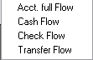
The Account Full Flow report gives the whole transactions done on some account in some specified period determined by the end-user of the application.
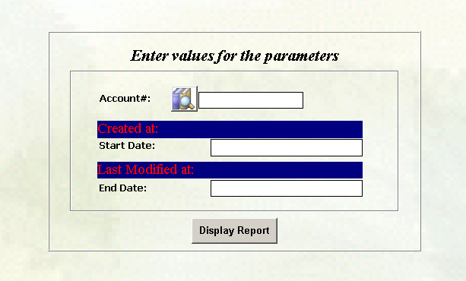
The second report you can see, is the Cash Flow specialized for the cash actions and the transactions done on an account within a given period of time and an additional requirement is needed to determine the type of money the transactions were done by.
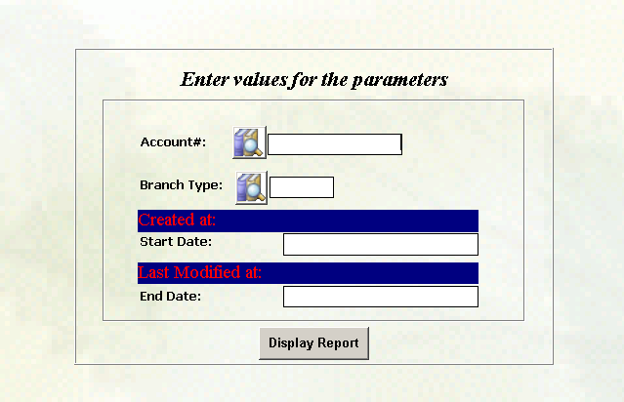
The Check Flow reports are concerned with the operations performed by the checks service. The same form as for the Cash Flow, but the result shows the transactions for the checks whether they were transfer, withdrawal, or else.
The Transfer Flow report shows the transactions that are to transfer money from a specified account to others, given the amount transferred, the branch from which the transaction occurred, it also specified whether the transfer was external or internal, the type of money and an equivalent value if the other customers don't have the same type in their accounts, date of transfer and the current value in both accounts.

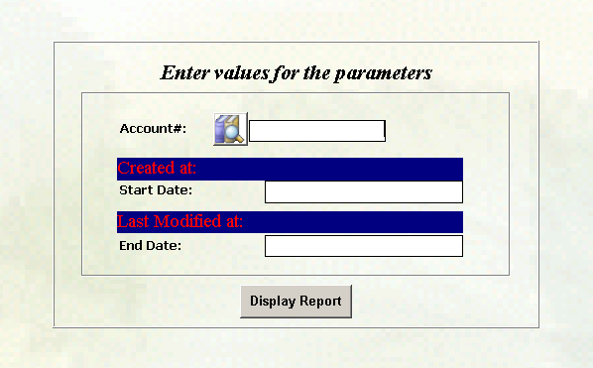

The third main service in the REM application is the BANK SETTINGS.
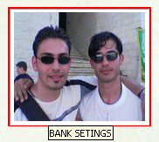
This service is concerned in the settings and the initiation of the bank and its branches. In this service we can define the different branches and adding or modifying on some previous branches in the system. Also by this service, we can add the different currencies which we can create accounts based on them.
Each operation in the menu has two main operations to be performed on them, one is the Inquiry which is for read-only purposes, and the other is the Modify which is for modification any field within the form.
The first page that will come up is an empty window with the menu bars only, leaving the option for the user to decide which service to perform. The first menu contains the services provided by the system to set specific fields. The second bar contains the operations you can perform inside any service chosen to set.
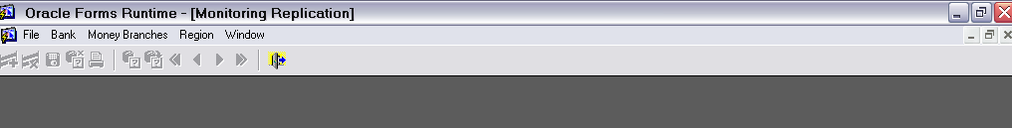
The next menu bar becomes active in the both options inside any of the services to be set- except the Bank Inquiry option, and on first enter to this form; the Save operation button only will be active- and inside the other forms, the menu will be active.
The Exit button will close the opened window and takes you back to the last window that was accessed. The other buttons are enabled after saving the modification made on the fields in a form.
Add and delete buttons are to add or delete new branches, money types, and regions. The Arrows are to travel inside the form’s fields. You can cancel the last operation you did before saving the changes by clicking the cancel button. A print button enables the user to print this form directly. There is also a search and execute buttons are used for searching for some attribute, when clicking the search button the form opened will be clear. You indicate the field you want to search by and then click the execute button to view all the other fields’ values if the search succeeded and if not then no fields will be filled with any data.
The first choice is the Bank Specification service. This service gives you the details about the center bank branch and its region area, indicating the Server name and IP address. For modification on these fields or the other fields provided in the form. Any change in the data won’t appear to the user until he/she exits the form on which the change occurred.
The Money Branches service enables the user to add new types of currencies to this table, determining its symbol, buy and sale prices and the last date on which a modification occurred with the flag of the country supporting the currency specified. The flag parameter is imported from predetermined path containing specific flags.
The Region service gives the ability to see the region’s name and postal code for each city in which a bank branch exists.
All the services mentioned above are the ones that achieved the first objective from this application, USER MANAGEMENT, REM BANKING SYSTEM, and BANK SETTINGS.

The last service provided by the REM Banking System is the REM MONITOR, and this service involves the second objective in the application.
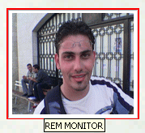
This service is upgradeable and not built in our current application. It is supposed to watch on the transactions and operations performed on different account on different branches at the same time approximately. It monitors any conflict between replicas and tells the main server to handle this conflict and resolve it.

Increasingly, companies are turning to Oracle replication to provide the high availability, scalability, and improved performance required by their applications.
Replication principles:
Replication is the process of copying and maintaining database objects, such as tables, in multiple databases that make up a distributed database system. Changes applied at one site are captured and stored locally before being forwarded and applied at each of the remote locations.
Reasons for Replication:
- Availability – it provides application with alternative data access options. If one site becomes unavailable, users can continue to query or even update the remaining locations.
- Performance – users can access data from the replication site that has the lowest access cost.
- Disconnected Computing – snapshots enable users to work on a subset of a database while disconnected from the central database server.
- Network Load Reduction – applications can access various regional servers instead of accessing one central server.
- Mass Deployment – deployment templates enable you to create multiple snapshot environments quickly.
We defined the application on the central server in order to control and mange the branches that contain copies of the database. This option provides the ability to declare some fields of the database directly from the server, such as the Tables, and others locally on each client, such as the Packages and the Directories.
The replication is performed and built via the Enterprise Manager Console. We define mainly:
- One Master Site inside the Master Groups.
- As many as we want materialized view sites.
- And for each predefined snapshot, we define a Refresh group.

Materialized View Replication allows complete or partial replicas of tables on the source database (called the Master Site) to be created on one or more destination databases (called Materialized View Sites).
Materialized view replication can be accomplished in different ways.
- Use Deployment Templates to efficiently deploy and administer a widely distributed materialized view environment. Deployment Templates enable you to define a collection of materialized view definitions at a master site and use parameters in the definitions so that the materialized views can be customized for individual users.
- Use Materialized Views to deploy and administer a read-only materialized view environment. A materialized view contains a complete or partial replica of a target master table from a single point in time.
- Use Materialized View Groups to deploy and administer an updatable materialized view environment. A materialized view group contains all or some of the objects in a corresponding master group. Materialized views in a materialized view group can be updatable or read-only.
- Use Refresh Groups to refresh multiple materialized views in one step. A Refresh Group organizes materialized views together so that they can be refreshed in one step.
Any update on the data on any site will be sent to all the others after a predefined period of time whether the data was defined as synchronous or asynchronous. This step is important on the transactions preformed on the customers’ accounts.
The tables that are synchronized are the REM_ACCT and the REM_ACCT_BRCH tables mentioned earlier.
The tables defined asynchronous are the remaining tables except the REM_BANK and the REM_BANK_RESP tables which are downloaded on the master site and any modification on these both tables is done on it only.
The master site only receives data and updates done on the client sites. The client sites are able to send and receive data from each other as well send to the master site.

Upgrades:
Some fields can be inserted for future upgrades on the project such as The REM Monitor Service which is meant to watch on and handle the conflicts on multiple sites at the same time.

