AN_NAJAH NATIONAL UNIVERSITY


FACILITY OF ENGINEERING

ELECTRICAL ENGINEERING DEPARTEMENT

Graduation project:
Home monitoring

Students: Mais Jamous
Hadeel Dwikat
Amani taqateq.

Supervised by: Dr. Alam musa.

Table of contents:

Chapter one: Abstract and introduction.

Chapter two: Project features and applications.

Chapter three: Block diagram

Chapter four: pictures of the project applications

Chapter five: Software

Chapter six: Hardware

Chapter seven: Appendix.

Chapter one:
Abstract and introduction

Abstract:
The idea of "home monitoring" project, is a system makes you ablt to observe any place you want without the need of internet connection or wires.
This project deals with a PC to do the monitoring through a camera. The camera is controlled by an application written in C# by the Visual studio 2005.NET and the Matlab,a keypad is connected to the system as a switch for the transmission.
The software in our projects has two aims. One to control the camera in taking photos or videos and track people. The second part aims together with XBee module (wireless module) to transmit and do the monitoring from a specific distance. XBee module consists of two transceivers. one connected to the first computer serially and the other connected to another computer for who wants to monitor.
The keypad code works as switch with code, so whenever you insert the right code you can stop or start the transmission through cutting the power from the wireless module other wise nothing happens.

Introduction
This project aims to monitor a specific area using a camera connected to a personal computer. The camera is controlled to take videos through software written in C# by the Visual studio 2005.NET and the Matlab. Also this software is used to control the transmission of the data (live video) from inside a GUI.
We have another software which do the tracking for anyone in the site of the camera, by creating a box around the moving person and follow him as he moves.
The keypad purpose is to switch the system on or off through acode,and If intrusion happened an SMS is send to the owner or who ever concerned.
Serial data communications is one of the most important parts of this project the data (live video) must be transmitted from the local computer through its serial ports serially to the wireless module connected to the computer which transmits it wireless to another wireless module, and again it's connected serially to the other computer, their a software previews the live video which was transmitted.
The software written for this project is advanced, it includes searching for install serial port on the computer and opening the selected one with control for its properties, life and real time video display TCP connection between the modules, many other features will be discussed later.

Chapter two:
Project features and
applications

Project features
- PC based control
- Serial data communication using RS-232 protocol
- GUI and software written in C# by the Visual studio 2005.NET
- TCP connection between the wireless modules
- XBee wireless module to connect the computer with the other one
- Camera used for taking videos and displaying them on the applications.
- The video signal is transmitted from the local computer to the other computer through network data stream with minimum acceptable delay.
- Microcontroller (16f877a) to connect the keypad to it.
- A keypad.

Project applications:

1. Houses and residential
2. Companies and governmental buildings.
3. Labs and scientific work places
4. Shops and out doors
5. Hospitals
6. Children watching
7. Security

Chapter three
Block diagrams

Block diagram

The block diagram for the project is as follows.
As pictures:
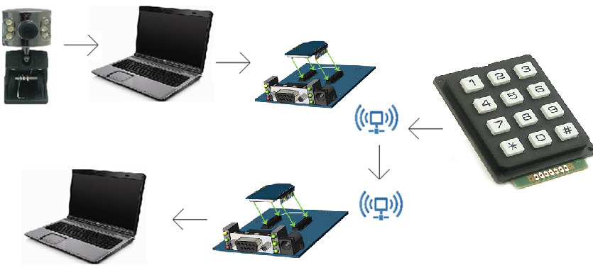
As blocks:

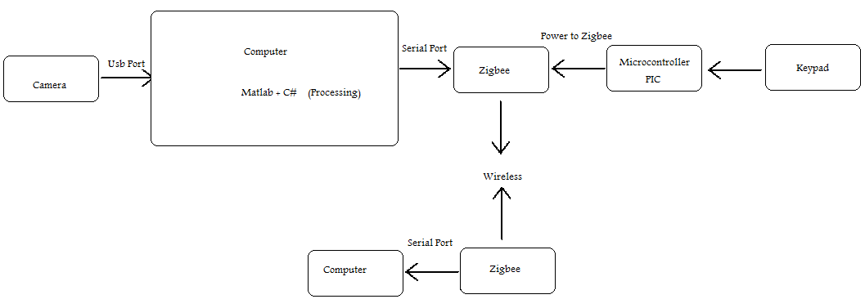

Chapter four:
Pictures of the project

The C# program.

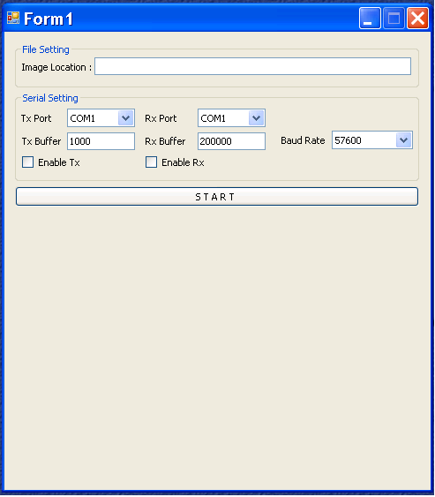

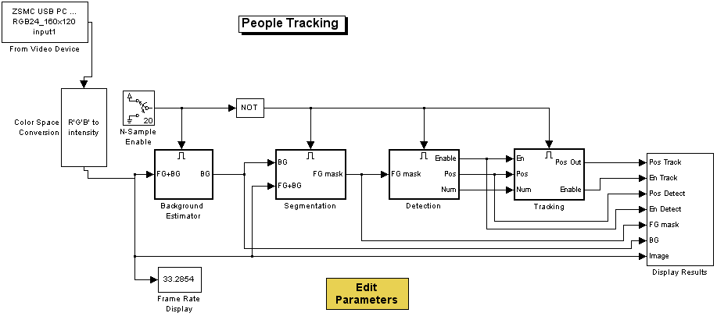

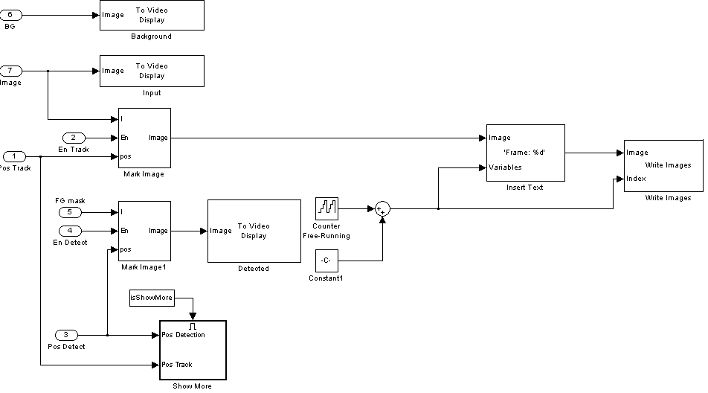

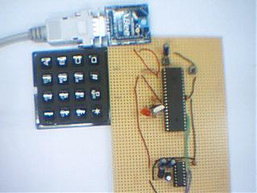

Chapter five:
Software

Software.

The software section includes:
- Server on local computer
- Client on another local computer

  - Server software on local computer.
This software is designed to be installed on the local computer which is connected to the hardware part, this program deals with:
- Serial port and serial data transmission.
- Camera video display and tracking.
- Networking.
- keypad controlling,

Serial port:
The program uses the serial port to send the video to the wireless module, the serial port control software includes:
- Search for the installed serial ports on the computer when the user clicks on the "Get Ports" button.
- The names of the serial ports found are displayed on the combo box
- The user should select the port he wants by clicking on it to be opened.
- The camera signal should be displayed on the same application which we select the port at.

The default vales of the serial port settings are:
Baud rate: 57600 bit/sec
Data Bits: 8 bits
Stop Bits: 1 bit
Parity Bits: none

How do the C# application works?

After choosing whether the application works as transmitter or receiver, the sender opens the image from the file we selected with the video pictures in, release it.

This let the matlab to replace the resources (photo) with the next one immediately.

The first frame is converted to array of bites.

It should be mentioned that the pics taken is already compressed (about 24 kb).

The array of bites has a header (4 bytes size) including information about the size of the picture.

And then this array is send to the module through serial connection then wireless to the other module.

The 4 bytes information allows the receiver to know when the stream of bits concerning the one frame ends to create it again into a picture,
Send the file.

If any error occurs it can be handled through dropping this image as another one will be received shortly.

It must be known that it's not a week point for the project, on contrary it's a strength point, because if the program had to recover or ask the sender to send the same frame again, this will decrease the efficiency of viewing the live video.

The buffer,
we can notice that the buffer of the transmitter is much less than the sender,this is due to the fact that the xbee module buffer is relatively small(1000), so loading it with larger amount of data will cause problems,
But the receiver buffer as it is the computers, it can take a huge value(200000), so the Xbee buffer should be out of bytes(all sent) to take new ones.

Handshaking
Another strength point that both modules talks to each other,
I.e. confirmation happens when a full frame is reached to the receiver part.

We used invoke and delegates methods to solve the threads conflict problem.

Camera video display and tracking:

Part of the project aims to detect any motion happens in the sight of the camera eye, creates a box around it and walk with it where ever it moves, whether it was day or night.

This was done through matlab simulink, in which detects tracks and views the motion happening in the place.

The software is capable to detect up to 4 people moving at the same time.
We have chosen to transmit the part of the simulink which detects the motion as the other parts may not be useful to the person who wants to do the monitoring.

So the simulink will prepare a folder on the computer (matlab directory) with the frames it takes refreshing them 5 times per second with the same name, as the c# application needs to take a specific name frame.
The frames is written in JPEG format and compressed.
Networking:
The networking in this project can be as small as LAN or smaller, and can be as large as WAN..

- Peer-to-Peer is what we are using,

This is because the wireless module is designed to be able to talk to more than one other module.

Only by selecting the right baud rate and channel.

there is 7 channels in which you can select, this provides a, efficiency to the system, as if more than one signal in the air from same modules (same freq) it will not interfere with each other.

The module depends on the WIFI system in it's connection,

Keypad controlling:

the keypad is 4X4 used to decide whether we want to start transmission or not,through a code installed in the program.
we depended on the fact that the microchip (16f877a) can give up to 5 volts, which is the perfect voltage for the module.
5.2 Client Software:
The client can be computer with the XBee module and the right configurations, and the application for receiving the data (live video).
This increases the security of the system that only the computer that has the software can connect to the server.

Chapter six:
hardware

6.1 Wireless module:
The wireless module I used is XBee this module is highly reliable and many extended applications can be done using it the most attractive feature it contains is the high serial bit rate it can support which is up to 115.2Kbps. It can also work in networks (pear to pear or point to multipoint) for extended ranges.

The main features of XBee:
1.long range data integrity.
- Indoor/Urban : up to 100 (30m)
- Outdoor line-of –sight: up to 300 (100m)
- Transmit power: 1mW (0 db)
- Receiver Sensitivity:-92 dbm XBee
2.Low power
- TX current:45 mA (at 3.3v)
- RX current:50mA (at 3.3v)
- Power-down Current:<10µA

- Advanced and Networking

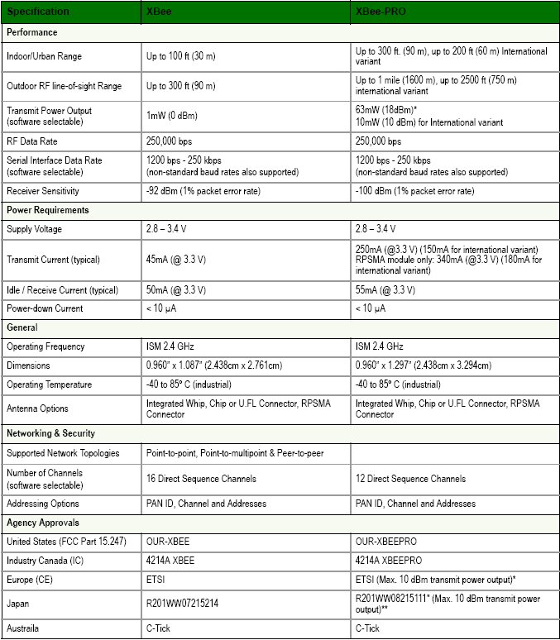

Xbee in serial communication:
The XBee®/XBee-PRO OEM RF Modules interface to a host device through a logic-level asynchro-nous serial port. Through its serial port, the module can communicate with any logic and voltage compatible UART; or through a level translator to any serial device (For example: Through a Digi proprietary RS-232 or USB interface board).

Serial Data
Data enters the module UART through the DI pin (pin 3) as an asynchronous serial signal. The sig-nal should idle high when no data is being transmitted. Each data byte consists of a start bit (low), 8 data bits (least significant bit first) and a stop bit (high).

FLOW CONTROL:
The serial board

Xbee operation mode:
XBee®/XBee-PRO RF Modules operate in five modes.
When not receiving or transmitting data, the RF module is in Idle Mode. The module shifts into the other modes of operation under the following conditions: • Transmit Mode (Serial data is received in the DI Buffer) • Receive Mode (Valid RF data is received through the antenna) • Sleep Mode (Sleep Mode condition is met) • Command Mode (Command Mode Sequence is issued)

Xbee software X-CTU:
This software enables for range test of the Xbee modules and can be used to program the module chip.
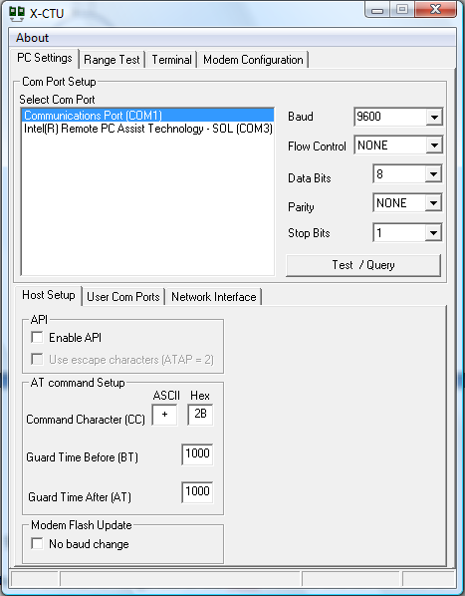

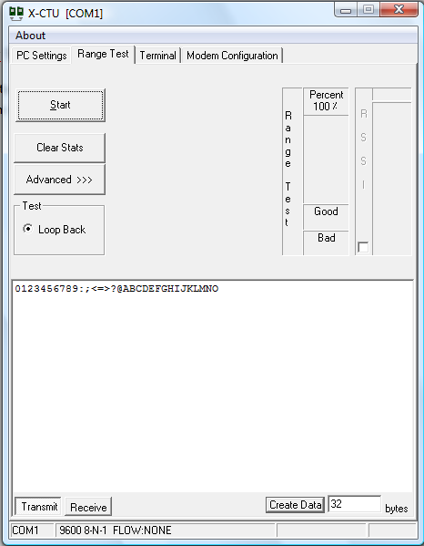

6.2: micro controller:
in our project we used 16f877a microcontroller from micro chip..
4 MHz operating speed (50 ns instruction cycle).

we used it for 2 purposes:
- to connect the keypad and it's connected through port B
- to provide the wireless module wit h needed voltage and current according to the code installed on it.

6.3: The camera.
the camera in our project can be wither be connected as usb device or we can use the cameras built in on the laptops , all it's purpose is to take video which is taken by matlab to be processed.

Chapter seven
Appendixes

Appendix 1
using System;
using System.Collections.Generic;
using System.ComponentModel;
using System.Data;
using System.Drawing;
using System.Text;
using System.Windows.Forms;
using System.IO.Ports;
using System.Threading;
using System.IO;

namespace Video_Serial
{
public partial class Form1 : Form
{
bool newImage = true;
Bitmap Image;
byte[] data;
int Index;
Thread SThread;
delegate void chng_pic(Bitmap image);
int len;
public Form1()
{
InitializeComponent();
comboBox3.SelectedIndex = 3;
comboBox1.Items.AddRange(SerialPort.GetPortNames());
comboBox1.SelectedIndex = 0;
comboBox2.Items.AddRange(SerialPort.GetPortNames());
comboBox2.SelectedIndex = 0;
SThread = new Thread(new ThreadStart(this.SendingVideo));
}

private void comboBox2_SelectedIndexChanged(object sender, EventArgs e)
{
}
private void textBox1_MouseDoubleClick(object sender, MouseEventArgs e)
{
OpenFileDialog dlg = new OpenFileDialog();
dlg.Filter = "JPEG Files|*.jpg" +
"|Enhanced Windows MetaFile|*.emf" +
"|Exchangeable Image File|*.exif" +
"|Gif Files|*.gif|Icons|*.ico|Bitmap Files|*.bmp" +
"|PNG Files|*.png|TIFF Files|*.tif|Windows MetaFile|*.wmf";
if (dlg.ShowDialog() == DialogResult.OK)
{
//FileInfo f = new FileInfo(dlg.FileName);
textBox1.Text = dlg.FileName;
}
}
private void button1_Click(object sender, EventArgs e)
{
if (comboBox2.SelectedItem == comboBox1.SelectedItem && checkBox1.Checked == true && checkBox2.Checked == true)
MessageBox.Show("Please choose another port for reciever");
else if (textBox1.Text == "" && checkBox1.Checked == true)
MessageBox.Show("Please browse for a file");
else
{
if (checkBox1.Checked == true)
{
TSerial.BaudRate = int.Parse(comboBox3.SelectedItem.ToString());
TSerial.WriteBufferSize = int.Parse(textBox2.Text);
TSerial.PortName = comboBox1.SelectedItem.ToString();
button1.Enabled = false;
SThread.Start();
}
if (checkBox2.Checked == true){
RSerial.BaudRate = int.Parse(comboBox3.SelectedItem.ToString());
RSerial.ReadBufferSize = int.Parse(textBox3.Text);
RSerial.PortName = comboBox2.SelectedItem.ToString();
RSerial.Open();
button1.Enabled = false;
}
}
}

public static byte[] ImageToByte(Image img)
{
ImageConverter converter = new ImageConverter();
return (byte[])converter.ConvertTo(img, typeof(byte[]));
}

public void SendingVideo ()
{
int length;
byte[] size = new byte[4];
while (true)
{
FileStream image_file = new FileStream(textBox1.Text, FileMode.Open, FileAccess.Read, FileShare.ReadWrite);
Image = new Bitmap(image_file);
data = ImageToByte(Image);
Image.Dispose();

length = data.Length;
//MessageBox.Show(length.ToString());
for (int i = 0; i < 4; i++)
{
size[i] = (byte)(length % 255);
length = length / 255;
//MessageBox.Show(size[i].ToString());

}
if (!TSerial.IsOpen) TSerial.Open();
TSerial.Write(size, 0, 4);

TSerial.Write(data, 0, data.Length);
Thread.Sleep(1000);

}

}
private void timer1_Tick(object sender, EventArgs e)
{

}

private void update_pic(Bitmap image)
{
pictureBox1.Image = image;
}

private void RSerial_DataReceived(object sender, SerialDataReceivedEventArgs e)
{
try
{
try
{
try
{
while (RSerial.BytesToRead > 0)
{
byte[] RecData;
len = 0;
for (int i = 0; i < 4; i++)
{
len += RSerial.ReadByte() * (int)Math.Pow(255.0, i);
}
//MessageBox.Show(len.ToString());
RecData = new byte[len];
int j = 0;
while (j < len)
{
//Thread.Sleep(1);
//MessageBox.Show(serialPort1.BytesToRead.ToString());
RecData[j++] = (byte)RSerial.ReadByte();
}
//MessageBox.Show(RecData[RecData.Length - 1].ToString());
ImageConverter ic = new ImageConverter();

Image img = (Image)ic.ConvertFrom(RecData);

Bitmap bitmap1 = new Bitmap(img);
//pictureBox1.Image = bitmap1;
Invoke(new chng_pic(update_pic), bitmap1);

}
}
catch (OverflowException es)
{
}
}
catch (OutOfMemoryException esx)
{
MessageBox.Show(esx.Message);
}
}
catch (ObjectDisposedException esxz)
{
}
}

private void Form1_FormClosing(object sender, FormClosingEventArgs e)
{
SThread.Abort();
}
}
}

Appendix 2:Keypad code
#use fast_io(b)
#use rs232(baud=9600, xmit=PIN_c6,rcv=PIN_c7)
// b4 <---- 1 2 3 a
// b5 <---- 4 5 6 b
// b6 <---- 7 8 9 c
// b7 <---- * 0 # d
// | | | |
// b0 b1 b2 b3

char t='p',t1,t2,t3;
int x;
char key(){
output_b(0xf7);
x=input_b();
x=x&0xf0;
if(x!=0xf0){
if (x==0xe0){
return '1';
}
else if (x==0xd0){
return '4';
}
else if (x==0xb0){
return '7';
}
else if (x==0x70){
return '*';
}
}
output_b(0xfb);
x=input_b();
x=x&0xf0;
if(x!=0xf0){
if (x==0xe0){
return '2';
}
else if (x==0xd0){
return '5';
}
else if (x==0xb0){
return '8';
}
else if (x==0x70){
return '0';
}
}
output_b(0xfd);
x=input_b();
x=x&0xf0;
if(x!=0xf0){
if (x==0xe0){
return '3';
}
else if (x==0xd0){
return '6';
}
else if (x==0xb0){
return '9';
}
else if (x==0x70){
return '#';
}
}

output_b(0xfe);
x=input_b();
x=x&0xf0;
if(x!=0xf0){
if (x==0xe0){
return 'a';
}
else if (x==0xd0){
return 'b';
}
else if (x==0xb0){
return 'c';
}
else if (x==0x70){
return 'd';
}
}
return 'p';
}

void main()
{

setup_adc_ports(NO_ANALOGS);
setup_adc(ADC_OFF);
setup_psp(PSP_DISABLED);
setup_spi(FALSE);
setup_timer_0(RTCC_INTERNAL);
setup_wdt(WDT_2304MS);
setup_timer_1(T1_DISABLED);
setup_timer_2(T2_DISABLED,0,1);
port_b_pullups(false);
//set_tris_b(0x1f);
set_tris_d (0xf0);

t='p';
while(1){

while(t=='p')
{
t=key();
restart_wdt();
}
t1=t;
restart_wdt();
printf(" the key == %c ",t);
delay_ms(100);
restart_wdt();
restart_wdt();
t='p';
while(t=='p')
{
t=key();
restart_wdt();
}
t2=t;
restart_wdt();
delay_ms(100);
printf(" %c",t);
delay_ms(100);
restart_wdt();
restart_wdt();
t='p';
while(t=='p')
{
t=key();
restart_wdt();
}
t3=t;

restart_wdt();
restart_wdt();
if(t1=='4' && t2=='5' && t3=='8')
{
printf("password is correct");
output_low(pin_c0);
delay_ms(100);
restart_wdt();
}
if(t1=='8' && t2=='5' && t3=='4')
{
printf("password2 is correct");
output_high(pin_c0);
delay_ms(100);
restart_wdt();
}
}
}

Chapter Eight
Conclusion

1. We were able to build an entire system as hard ware and software.
2. We were able to understand that the wireless is the most important thing in the communication; most of the applications is done through it.
3. We were able to be introduced to new programming techniques.
4. Dealing with microchips and microprocessors are getting easier.
5. We built a monitoring system with various important uses.
6. Of course, we are looking forward to improving this system for example, to be used in larger distances, or to send the video through internet, and maybe sending the voice as well.

We will not forget all people who shared with us this experience, as they had an effective roll.

