

Al-Najah National University
Faculty of Engineering
Computer Department

Best Program Documentation

Presented to:
Dr. Loui Malhis.

Presented from:
Mahmoud Sleman.
Tawfiq Humidi

2005

Descriptions:
In our graduation project we try to solve school timetable problem by building software called it Best Solution program that overcome school timetable problem. The main idea is to build algorithm for scheduling in optimal way. School timetable is one of scheduling problems which is the most complicated problem.

Introduction:
At the start of new school semester, school needs to manage all issues that made it run in perfect way; the school management faces problems in solving the most important issue which is the creation of new school time table.
Building new school time table is difficult, complicated and consuming much time to do, and if it is done by human. It needs skillful one to build it, farther more if any manipulating is needed to done it means as rebuilding the table from scratch.

Sometimes the new built timetable may found opposition. This will case problem. To get ride of this problem you must try to achieve teacher timetable wishes.
The needs to software to solve this problem was appeared, building this software save time and get ride of this problem.

Best Solution program is software that builds new school time table in addition to give the best one (optimal). By Best Solution program any school headmaster can build his own school time table in simple way. Additional two solutions are provided too. The school headmaster can choose one of the three solutions to his school which achieve his school requirement.

The program offer the ability to achieve each teacher needs. Teacher gives the headmaster his own prefer time table and the headmaster try by the program to achieve his requirement.

The aim of the project:
The project goal is to give the best school time table that achieves the school requirement in addition to:
- Satisfy all pedagogical requirements for teaching individual subjects;
- Eliminate non-effective activities and the human factor when creating timetables in the school environment;
- Satisfy the needs and possibilities of the pedagogical team;
- Give blatancy and justly to the program.
- Satisfy the ability to achieve teachers need.
- Flexibility and the ability to achieve the requirement of the school.
- The ability to make print and save for timetables txt file.
- Easily to make changes.
- Easily to add new teacher, course or class.

Building of the program:
- the steps of building the program:
  - Building the database of the school, showing the relationship between tables.
  - Building the algorithm for scheduling.
  - Building the interface and other peripherals need to make input output easier.

1. Building database required for the program:
We built ERM model then we built tables and Views. We used SqlServer2000 in building the data base required.

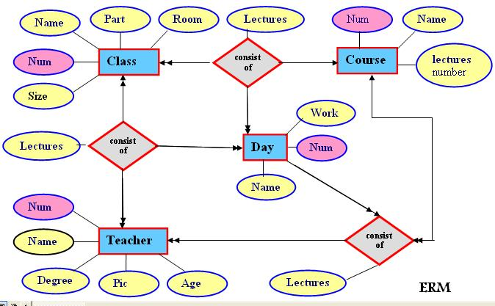

We used SqlServer2000 in building the data base required. We changed the ERM model to tables. The following tables must create:
Tables:
- teacher table:
The table contains teacher number which is primary key, teacher name, age, degree, teacher picture.

Number | Name | Age | Degree | Picture

- class table:
The table contains class number as primary key, class name, class size, class part, room number.

Number | Name | Part | Room number | Size

- course table:
The table contains course number as primary key, course name, number of lectures, class number.

Number | Name | Number of lectures | Class number

- day table
The table contains day number, day name, work (working day or holiday).

Number | Name | Work

Relationship tables

- teacher courses table:
The table shows the relation between teacher and course, the relation is many to many. The table contains teacher number , course number, day number, in addition to lecture 1 to 6.

Teacher ID | Course ID | Day ID | Lectue1 | Lecture 2 | Lecture 3 | Lecture 4 | Lecture 5 | Lecture 6

- teacher class table:
The table shows the relation between teacher and class, the relation is many to many. The table contains teacher number , class number, day number,in addition to lecture 1 to 6.

Teacher ID | Class ID | Day ID | Lectue1 | Lecture 2 | Lecture 3 | Lecture 4 | Lecture 5 | Lecture 6

- class course table:
The table shows the relation between course and class, the relation is many to many. The table contains course number, class number, day number, in addition to lecture 1 to 6.

Course ID | Class ID | Day ID | Lectue1 | Lecture 2 | Lecture 3 | Lecture 4 | Lecture 5 | Lecture 6

Additional tables:
- teacher lesson table:
The table contains teacher lesson.

Teacher ID | Day ID | Lectue1 | Lecture 2 | Lecture 3 | Lecture 4 | Lecture 5 | Lecture 6

- Class lesson table:
The table contains teacher lesson

Class ID | Day ID | Lectue1 | Lecture 2 | Lecture 3 | Lecture 4 | Lecture 5 | Lecture 6

Views:

- teacher-course-class view:
This view contains course ID, course name, class ID, class name, class part, teacher ID, teacher name, teacher picture, teacher degree.
Course ID | Course Name | Class ID | Class name | Teacher  Number | Teacher  Name | Class  Part | Teacher  Degree | Picture  File

- class-course view:
This view contains course ID, course name, class ID, class name, class part, lesson number.
Course ID | Course  Name | Class ID | Class Name | Class  Part | Lesson  Number

- class-teacher view:
This view contains class ID, class name, class part, room number, class size, teacher number, name and picture.

Class  ID | Class  Name | Class  Part | Room  Number | Class  Size | Teacher  Number | Teacher  Name | Teacher  picture

- Class lectures view:
This view contains the timetable for class.

Class  ID | Class  Name | Class  Part | Day  Number | Day  Name | L1 | L2 | L3 | L4 | L5 | L6

- teacher-course
This view contains teacher ID, teacher name, class ID, class name, class part, course ID, course name, picture file, max lesson, lesson number.

Teacher  Number | Teacher  Name | Course  Number | Course  Name | Class  Number | Class  Name | Class  Part | Lesson  Sum | Picture  File | Max  Hour

2. Building the algorithm for the scheduling:
Our project interest in building algorithm to schedule school timetable related to the preferable teacher table, to start schedule will the algorithm you need to get all information (teacher, class and teacher constraint information) and put them in structures.

Algorithm:
Before you start you should knew the following idiom:
- Pcourse means check if more than on lesson for the same course was scheduled in the same day.
- Constraint means the teacher do not want to take this lesson, and the program must achieve this demand.

The main step of the algorithm:
Step 0:
- Starting from the first class and walk to end.
- for each class Ci under schedule get the Ci course with the highest lesson number
- check if there is conflict with other courses by :
  - Check if there is constraint found in the preferable teacher timetable. If yes, try to take another max Ci course.
  - Check if there is lesson conflict that is to say if the teacher of this course has another lesson in the same time; try to take another max course
  - Check if the same course was appended to same class day, and this course was the last course scheduled to this class Ci then make all pcourse to true and reschedule the course again. Else take another max course.
- The algorithm will enter the next step when class number equals the number of classes. The figure 1, show the flow chart of the algorithm.

Step 1: after step zero finished, algorithm enter next step which has the following procedure:
- The algorithm checks if each class courses had finished their lesson number, if yes algorithm would enter next schedule step.
- If not add each class courses which they were not scheduled sequentially even there is conflict. And register them in error course structure.
- Try to exchange error lectures with any true lecture in the same class until find true place.
- Check if there are still error courses that have no true places. If yes show message that the program can’t scheduling this table.
- If not go to the scheduling step. Figure 2, show flow chart step1.

After finishing this step the program will be ready to start the next step.
The program may stop and show error message that scheduling can’t complete because the algorithm fail to do scheduling all course for the next step and that means courses in this situation can’t scheduled. The headmaster may need to remove some teacher constraint or reduce teacher requirement.

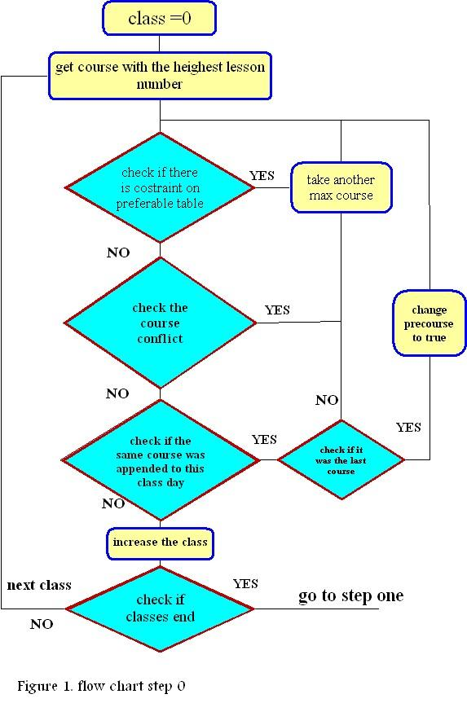

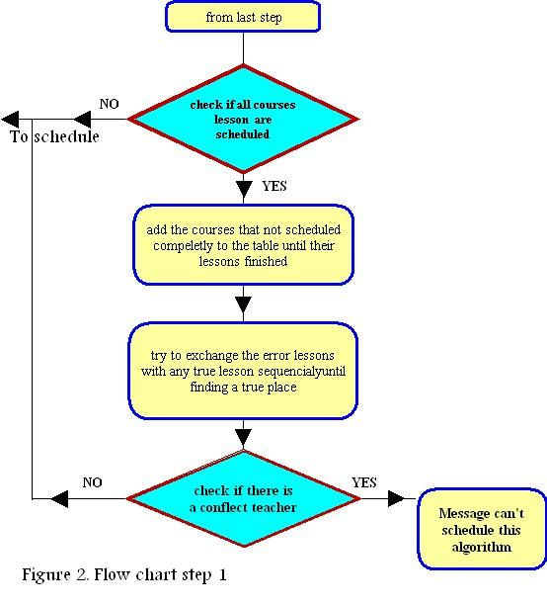

step2: after the program finished step 1, we have school timetable with no conflict, do not have any preferable lesson treated. This step tries to solve the preferable lesson.

This step has the following procedure:
- Start from the first class Ck and walk to end.
- For each day Di where I from 0 to 6, take Lecture Lj where j from 1to 6.
- Change lecture Lj with each lecture in the class and each time calculate the priority.
- Check if the new priority if higher from the old one. if new priority>old one save change and increment the lecture by one. Else rollback; return Li to it last location and increase lecture by one.
- If Lj> last lecture in Di change the day.
- After last class finished the algorithm will finished. Figure 2, show flow chart step 2.

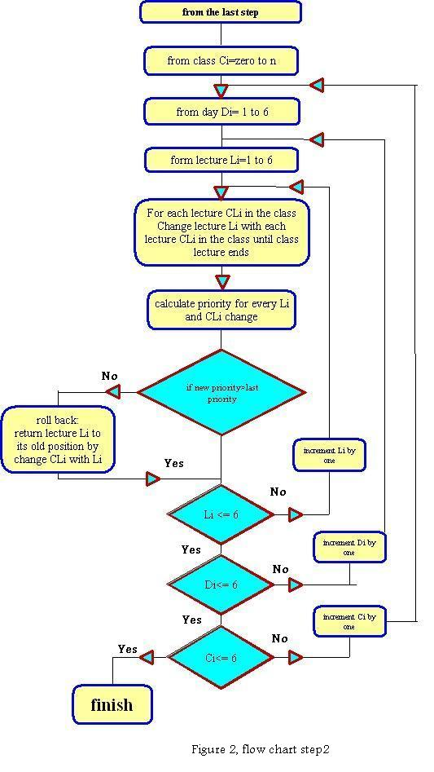
3. Building user interface:
The interface is built using C sharp. The interface for the program is easy to deal with. The enter face consist of forms to insert the information about the teacher, class and courses. Form to show information about them. Form for deletion and form for preferable teacher table in addition to the main form of the program.

Summary:
This project solve school timetable problem. The project contains database to store all information about the school. We used Microsoft SqlServer2000 in building database. We built a schedule algorithm to solve the problem. We used Microsoft C sharp dot net in building the algorithm and also for the interface.
The program gives teachers permissions to put there timetables, and the algorithm try to achieve them.

The algorithm concerns about scheduling timetable achieve teacher demand by looking at the preferable timetable for each teacher.

