AN-Najah National University
Faculty Of Engineering
Computer Engineering Department

Documentation Of Graduation Project

Project Topic:
Database System for An-Najah University

Supervised By:

Ashraf Armoush

Students:

Banan Al-Wadi
Khalid Al-Sayyed

First Semester
2004
Project topic:
Our project is a software system for An-Najah University with several capabilities the main one is the student’s courses registration.

Parts Of Our Project:
Our project consists of two paerts, one of which is operated over the university Intranet
and is programmed using visual basic, and the other is operated on the Internet and is programmed using ASP.

Why two parts?
Our project has two parts the part which is programmed using visual basic
Is operated on the university intranet, this part is basically operated by the administrators and has larger and more specific facilities than the internet part

This part concerns with managing head administrative jobs like managing current semester courses , managing university courses, managing the university courses, managing the university faculties and departments, managing rooms lectures,
Managing the students accounts, managing the various faculties studying plans.

So briefly we can say that all the internal job of the university which need not to be done through the internet is done on this internal software system as it is more secure and only specific users can manage this part.

Also all the facilities which are available on our internet part are also available on the intranet part like courses registration and other features mentioned later.

The second part of our project which is programmed using ASP and operated on the
Internet concerns with the students and gives some facilities to the head administrators.
This part gives the student the ability to register the courses, also to see their
departments plans which illustrates the finished courses with their marks and the
remaining courses with their prerequisites, also this part give the students the ability to see if they have any borrowed books from the university library,also there are other facilities illustrated later.
So having the desktop part we can get the advantage of having less network traffic
and more security, and having the internet part enables tele registration process .

So briefly the internet part is made to make the registration process easier for the students in the first degree and for the university in the second degree.

And by this way the load is distributed over the internet and the university intranet
of course with unified database.

The Problems which we faced during constructing our project:
Actually there was no real problems but the main difficulty was the huge work in
our project because our project consists of two parts with two different languages
so it seemed that we have two projects instead of one project with two languages
which we didn’t program with before this time, so during constructing our project
we had to study these two languages and to program our project with it in the
same time.

Basic Tools:
In our project we used the following main tools:
*Microsoft visual basic 6.0
*ASP(Active Server Pages)
*Oracl Database

Why Oracle Database?
Oracle Database is built on high performance, realibility, consistency, and very high security that provides powerful and comprehensive data management platform.

Why ASP?
After a researching and reading to look for the appropriate application we found that ASP is the one of the flexible languages that meets our needs in this web page and this is a brief definition of ASP.
Besides this language is with high security as its server side script so the script stays away of the users reach.

What is ASP?
- ASP stands for Active Server Pages
- ASP is a program that runs inside IIS
- IIS stands for Internet Information Services

ASP Compatibility
- ASP is a Microsoft Technology
- To run IIS you must have Windows NT 4.0 or later
- Chili ASP is a technology that runs ASP without Windows OS
- Instant ASP is another technology that runs ASP without Windows

What is an ASP File?
- An ASP file is just the same as an HTML file
- An ASP file can contain text, HTML, XML, and scripts
- Scripts in an ASP file are executed on the server
- An ASP file has the file extension ".asp"

How Does ASP Differ from HTML?
- When a browser requests an HTML file, the server returns the file
- When a browser requests an ASP file, IIS passes the request to the ASP engine. The ASP engine reads the ASP file, line by line, and executes the scripts in the file. Finally, the ASP file is returned to the browser as plain HTML

What can ASP do for you?
- Dynamically edit, change or add any content of a Web page
- Respond to user queries or data submitted from HTML forms
- Access any data or databases and return the results to a browser
- Customize a Web page to make it more useful for individual users
- The advantages of using ASP instead of CGI and Perl, are those of simplicity and speed
- Provides security since your ASP code can not be viewed from the browser
- Since ASP files are returned as plain HTML, they can be viewed in any browser
- Clever ASP programming can minimize the network traffic
Helping Tools:
In building our project we used the following helping tools:
*Dream weaver 3
*Microsoft FrontPages 2003
*Flash MX

Building the database:
Our first steps in our project were studying and analyzing the existing system used in the university and analyzing the advantages and disadvantages of it.
In building and designing the database and creating the relations between the tables we tried to take in consideration the advantages of the existing system and avoid its disadvantages.
In our project we build the following basic tables:
*Students table
*Teachers table
*The university courses table
*The current semester courses table
*The transaction table
*The Active semester settings table
*The marks table
*The finance table
And other lookups tables.

The students table: It contains the followingfields: studentID, StudentName,
StudentGender, StudentNationality, StudentBirthplace,
StudentBranch (School Branch i.e scientific, literature...etc)
StudentAverage (School marks average), StudentTotalAvrg (University marks average), Student Religion, Serial Number,
Students Instructor, Plan number, and password.

The teachers table: It contains the following fields:
Teacher ID, Teacher Name, Teacher Certification, SerialNumber, and password.

The university Courses table:
This table contains the following fields:
CourseID, CourseName, CourseHourscount, CoursrType, and SerialNumber.

The Current Semester Courses Table:
This table contains the following fields:
Course ID, Course Section, Teacher ID, Section Begin Time, Section End Time, Course Day, Course Capacity, Children (number of recorded students), Active (the current semester), Room ID.

The Transaction Table:
In this table we store all the transactions the student does which concerns with the courses registration transactions. So it contains all the courses which the student registered from his first semester in the university tells he graduates, and after the student graduates the records of this table are stored in a log file for recovery.
This table contains the following fields:
Student ID ,Course ID ,Course Class, Active(in which semester he registered that course),User name(which user recorded this course)
And Operation Date (the date in which the course was registered).

The Active Semester Setting Table:
This table contains the setting of the current semester, and it contains the following fields:
Active (in which semester we are?),Date Begin Record(sets the starting date of courses registration),Date End Record(sets the last date for courses registration ) ,Date Begin Mark(sets the starting date for entering the mark to the system) ,Date End Mark(sets the last date for entering the marks into the system) .

The marks Table:
This table contains all the student marks for all the finished courses. It contains the following fields:
StudentID, CourseID, Active (the semester in which the course was taken), and the mark.

The finance table:
This table contains information about the number of paid hours with the amount of paid money for all the students in all the semesters, and this table contains the following fields:
Student Id, active semester, paid money, and paid hours count.

Data Flow Diagram:

Search
Insert
Update
Delete
Storage
Storage
Storage

DataBase
Website
Storage
Storage
Storage
Delete
Update
Insert
Search
Intranet program Forms

Our Project main Features and Facilities:
* The facility of recording student's courses at each semester.

* The facility of recording students marks in all courses.

The facility of adding new colleges and departments for the university. *

The facility of recording all the university courses. *

The facility of adding all the teaching plans for all university faculties.*

The facility of recording all the teaching rooms and their information. *

A financial system for students accounting.*

A user guide or Help to be as support system for beginner users.*

Recovery system incase of system failure through the log files.*

General Web Site Structure:

Home Page
About University
LogIn
SemesterCourses
News&Advert.
Site Map
Admin. Login
Students Login
Departments
Delete
Update
Add
Faculties
Check user
InValid
Valid
Contact Us
Check user
InValid
Valid
Library
StProgram
Plans
Marks

Registartion
Delete Courses

Update Courses
Add courses

AS seen from the previous diagram the home page of our site contains the following
main Features:
*Semester courses
*About the university
*log in
*University news and advertisements
*Site map
*Contact us

And here is a picture for the home page of our site:

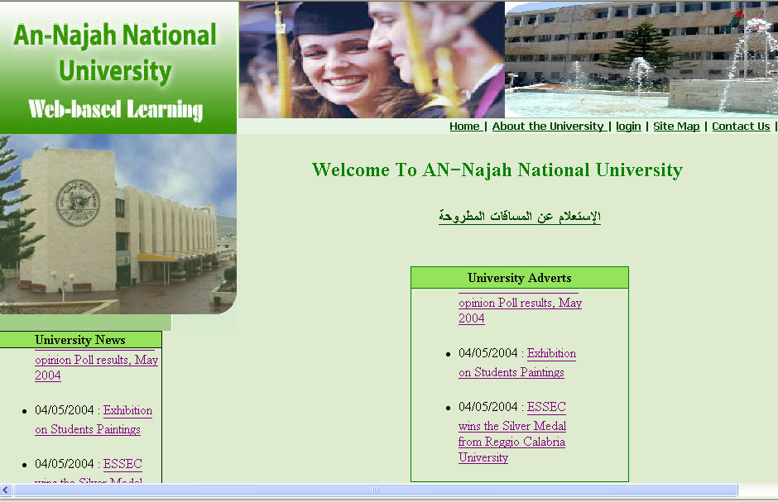

The semester courses screen:
The semester courses is a form which gives any visitors of the university
Site the facility to search in the semester courses, the search is either search
By Course ID, Course Name, Course Instructor, Course Teacher ID, Course
Room or the user can see all that semester courses by choosing display
Every thing.

In this screen we tried to make it easy for the user if he wants to search
About any course in that semester by programming the facility of
Searching about any thing just by typing the first character of that thing

For example if the user don’t know the full name of the course instructor he
Can just type the first few characters of the instructor name and the search result
Gives him all the courses who teaches them any instructor whose name starts
With these characters.

Also if the user want to search about any course and he don’t know the
Exact or full name of that course he can just type the first characters
Of that course and the search result gives him all courses start with
The typed characters.

The result of the search is this page gives the user all the information about the searched course and these information are:
*A sign to indicate if the section of the searched course is closed or open
I.e. if the registered students in this section are greater or less than its capacity.
*The course ID
*Course Name
*Course Prerequisites IDs.
*Course Hours Count.
*Course Room.
*Course day and time.
*Number of registered students in that course.
*Course Capacity
*Course Faculty and Department
*Course Instructor

The following page displays a picture for this form.

A picture of the semester courses form:

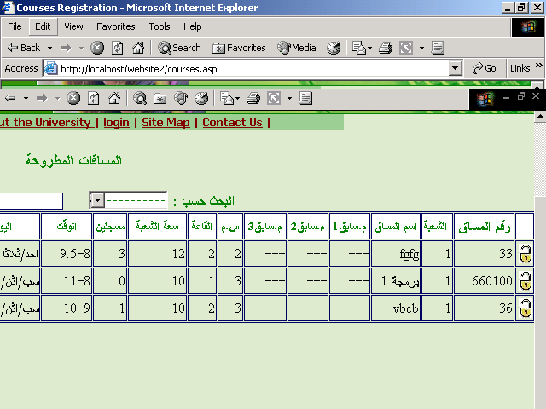

About the university:
This is a screen which gives the user an article about
AN-Najah university, this article gives the visitor of the site general
Idea about the university and its faculties and departments.

And here is a picture for this article:



And from this screen the user can go to any screen in the site.

The Site map : this is a screen which gives the user general view about the site and its contents and how can he go between screen and gives him general idea about the facility of each screen .
And here is a picture for this screen:

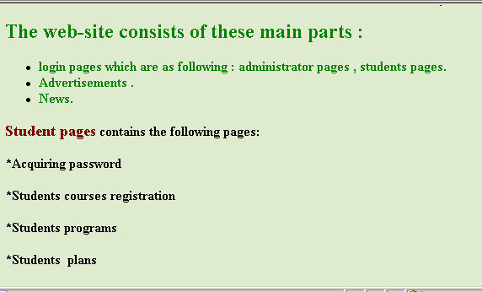

Contact us: this is a screen which gives the visitor the facility to e-mail the university, but in this screen we put our e-mails.

Log in:
This screen consists of two parts the Student Login and the administrator login.
The administrator login:
The administrator log in is a screen which has two features:
If the administrator already have password he can log in directly just by typing
His ID and password.
If the administrators don’t have a password he can get one by choosing get a password.
If the administrator chooses get a password a new screen appears to him which asks
him to enter his id, serial number, a password, and confirm password; if all the
registered information are correct the administrator is given a password and
a message appears to him to indicate that anew password is added.
Here is a picture for the main administrator log in page and a picture for the screen of getting an administrator password.

The main administrator log in page:

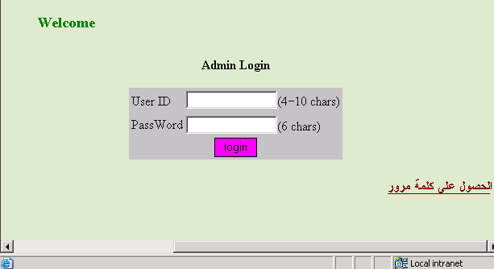

The getting a password screen:

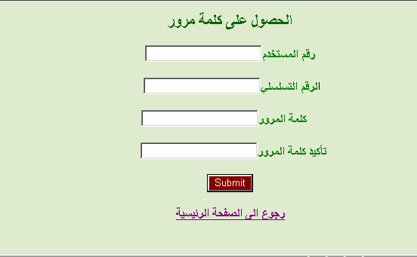

After the administrator login he has two facilities:
The facility to manage the university faculties and departments
And by the word manage I mean Adding new faculties, updating
Existing faculties and deleting existing faculties.

The Student log in:
The student log in is a screen which has two features:
If the student is already having a password he can log in directly just by typing
His ID and password.

If the student doesn’t have a password he can get one by choosing get a password.
If the the student chooses get a password a new screen appears to him which asks him to enter his id, university average ,school average, a password, and confirm password ; if all the submitted information are correct the student is given a password and a message appears to him to indicate that anew password is added.

But if any registered information is incorrect a warning message appears to him to indicate that in valid information was submitted and ask the student to try again.

The main Students log in page:
This us a screen which appears to the student after he registers his ID and password
This screen displays the Student ID, Student name, Student Faculty, Student Department
And the Student Instructor.

This screen has the following features:
*Student Course Registration.
*Student Courses programs
*Student marks
*Student studying plan.

The following page displays the picture of the main student log in page and illustrate the main features of it:

The picture of the main students log in page:

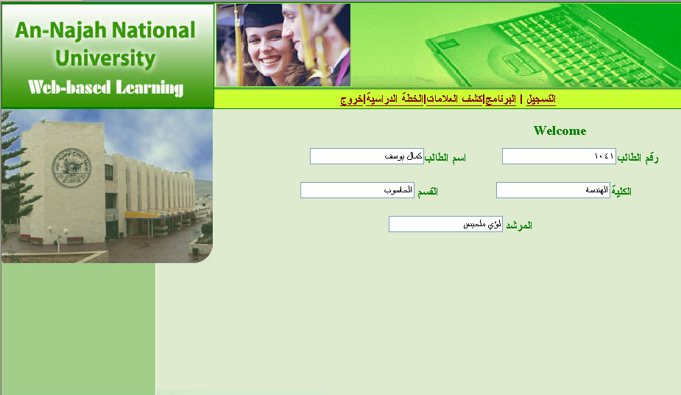

The registration:
The registration page displays the registered courses for the student and gives the
Student the ability to delete the registered courses and if there are no registered
Courses it indicates to him by a message appears on the screen that there
Are no registered courses for this semester.

Also this page displays to the student the number of registered hours and the
number of paid hours.

The following page displays a picture for the main registration page.

Picture for the main registration page:
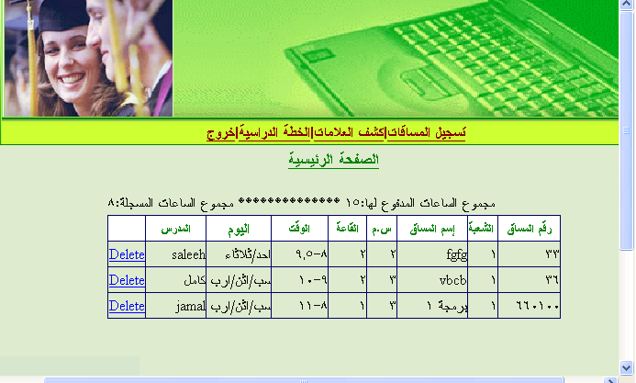
The course registration page:
The student in this page searches for the courses he wants to register
“The search is done either on course id ,on course name,
On instructor name, on instructor id, or he can choose show every thing”

The student can register only the courses included in his plan, so the search result
Gives us only the courses included in the student plan.
Note: it is easy to change this feature and let the student register any course
Not included in his plan” this is done only by removing single constrain
In the SQL statement” but we decided to give the student the facility to register
Only the courses included in his plan, and the student instructor can register any
Other courses not included in the plan.

When the student registers any course the registered course is displayed for the student in another screen with full information about this course.

Before registering any course to the student several validations are taken in our
Consideration, of which the followings are:
*Checking if the student had paid money

*Checking if the student tries to register hours more than the paid hours.

*Checking if the student tries to register a course without registering the course
prerequisite in a previous semester.

*Checking if the student tries to register a taken course and allowing him to register
this course if his mark in this taken course is less than 70 and preventing him from
registering If his mark is greater than 60.

*Checking if the student tries to register more than 18 hours and allowing him if
his average greater than 80 or if he is a graduate student and preventing him from
registering more than 18 hours else where .

*Checking if the student tries to register in a closed section by checking if the number of registered students is equal or greater than its capacity and preventing the user from registering if the section is closed.

The student studying plan Form:
This form display for the student his plan and indicates for him for each course
in his plan The course id,the type of this course, and indicates for the student
if this course is taken or not using special signs and if the course has been taken
it displays the mark of this course .
The following page displays a picture for this form.
The student studying plans form:

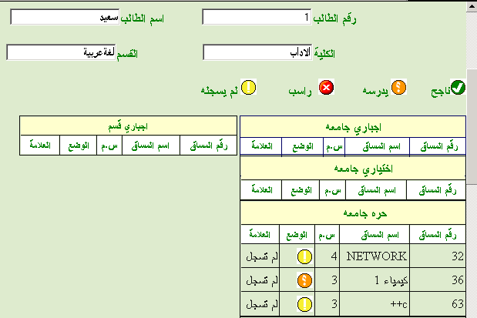

AS I mentioned before, the displayed information is taken from a trial database
And the real database is constructed later.

The other features of the student page are the student program displayed for two
Semesters.

Also there is the library feature which indicates to the student if he has
Any borrowed book from the university library and displays the name of this
Book for him.

The last feature available for the student on the web site is the mark statement
which contains a list of all the taken courses with their mark and each semester
average and the general marks average.

The Intranet(visual basic) program

Our intranet program is designed in a way which facilitate the work on the end user
So the end user don’t have to enter many confusing information and in most cases he only chooses from several choices, and the names of the attributes are clear and not misleading and it is easy on the end user to move between the screen, and in some cases we designed bottoms inside the forms to move between the forms instead of closing that form and opening the needed form
For example in the registration form we added a bottom to open the form of searching in the semester courses so the semester courses information can appear in the same time with the registration form.

So the ultimate goal in our design and programming was to construct reliable and well structured and designed software which cares about the end user comfort.

The intranet program has the following main forms:

University courses form:

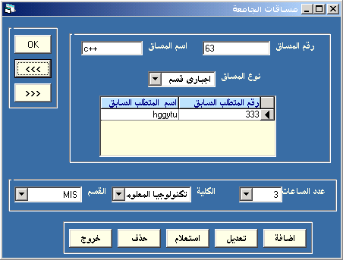

This form is used to manage the university courses, and by the word manage I mean on of the
Four operations add, update, search and or delete.

If the user chooses the operation add he has to enter the course id, course name and he has to
Add the course prerequisites if exist and also he has to choose the number of hours, and the faculty And the department of this course.

After filling the previously mentioned information the user clicks OK to commit the insertion.
Before inserting any new course into the database the following validation are taken in our
Consideration:

*Checking if the user has the privilege to add a new course into the university courses and If he Doesn’t have this privilege an error message appears to the user to indicate that he doesn’t have this Privilege and the course is not added to the database.

*Checking if all required information are filled, and if not an error message appears to the user to Indicate that he has to fill all the required information and the missing information field becomes Red.
*If all required information is filled, we check if all information is of correct data type,
And if not an error message appears to the user.

If the user chooses to update or delete any course, he should first choose the update or delete then he enters any information in any field and clicks OK then we make a quick search for the entered information and we display all the information about that course, then the user update any information of that course and he chooses OK.

This way of dealing with update and delete facilitate on the user very much for example if the user wants to delete all the courses of a certain faculty he chooses delete the he chooses the faculty ,Then he chooses OK and by the << and the >> bottoms he moves between the chosen faculties and delete all its courses.

This way of dealing with these four operations “Add,update,delete,or search”
Is used in all the program forms.

In this case (Update or delete) the following validations are taken in our account:
*Checking if the user has the privilege to update or delete, and if he doesn’t an error message appears to him.
*Checking if the user has made any change in course information in case of update and if he didn’t a message appear to him to indicate that no change in the entered information, and we don’t update the database.
.* After the user chooses OK a message appears to him to confirm the chosen operation and if he chooses “yes” we update the database.
If the user chooses search
The Semester courses form:
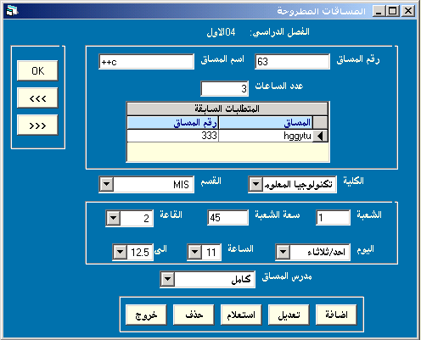
This form is used to add courses in the current semester, the course which we add here should be one of the university courses which we added using the form we described before this form so the user just enters the course id here and the course information like its name and hours count is displayed automatically. Also the section is filled automatically by 1 if the course is added for the first time in this course and if it is added before this time the section as incremented automatically.

The user has to enter only the course capacity, room, teacher, time and day.
The following validations are taken in our account before adding any course to the database:

*Checking if the instructor has another course in the same entered time and if he has a message is generated to indicate that the instructor teaches another course in the selected time
*Checking if there is another course in the chosen room in the same chosen time and if there is a message appears to the user indicating that the room is busy in the selected tome.
*Checking if the course capacity is greater than the selected room capacity and if it is a message appears to the user indicating that the course capacity is greater than the selected room capacity.
Registration form:
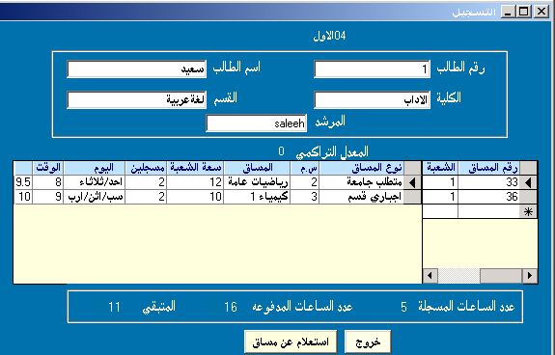

This form is used to register the student courses.

And the validations done in the registration form of the internet are also taken in our account
here in this form.

Also from this form we can choose the search bottom to search about any course in the current semester.

Searching for university courses form:

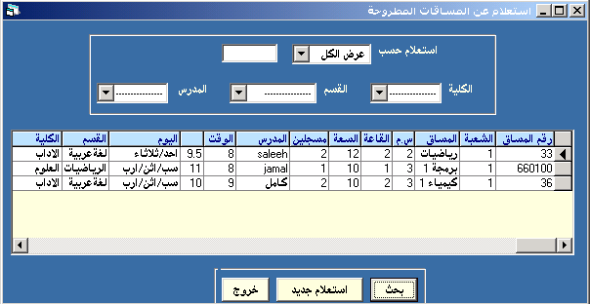

The user in this form can choose the search to be done based on the following choices which appears for the user in the compo box:
*Search by course id
*Search by course name
*Search by instructor name “the user chooses the instructor name or write a part of it”
*Search by instructor id
*Search by the course faculty and department “the user chooses the faculty and department”
*Search by the course room
*Search by the course time
*Display all courses

The students form:
This form is used to enter information about the newly registered students in the
university, also it is used to update or delete or search about the current student in the university.

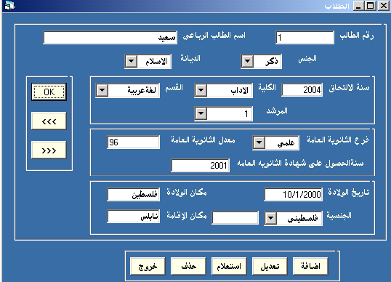

Teachers form:

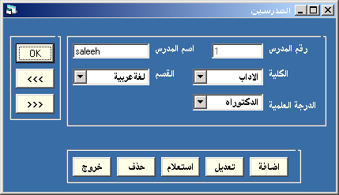

Faculties and departments forms:
This form is used to add, update, delete or search for the university faculties
and before allowing the user to perform any of these operation we check his privileges and prevent him if he doesn’t have the required privilege to perform the determined operation
We also have similar form for the university departments.

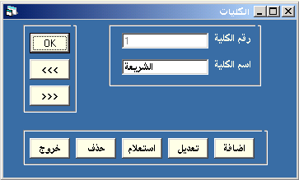

The marks form:
This form is used to enter the marks to the system

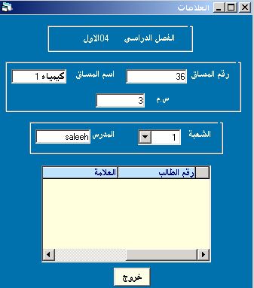

The finance form:

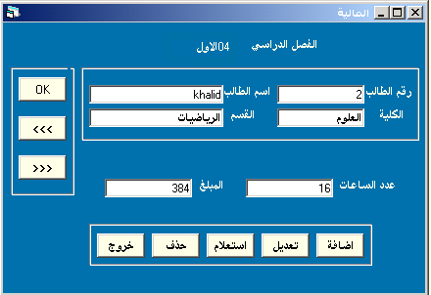

This form is used by the financial department to insert the number of paid hours
and in this form we calculate the money needed for the entered number of hours
which is different depending on the student faculty.

Rooms form:
This form is used to record all the university teaching rooms.

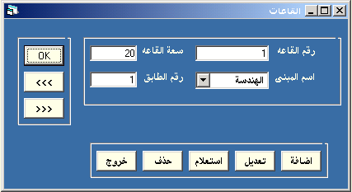

The registered students form:
This form is used to display information about registered students in
a certain course
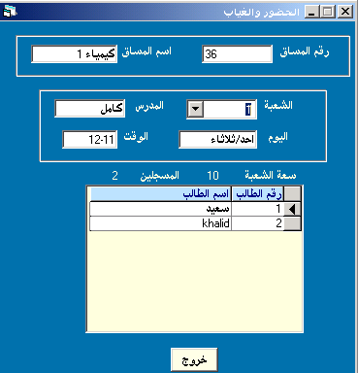
The settings Form:
This form is managed by the head administrator user with the highest privilege .
This form is used to:
*Determine the active semester
*Determine the starting and ending date of the registration process
*Determine the starting end ending date of adding and deleting student courses
*Determine the starting and ending date of entering the students marks

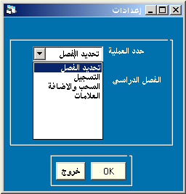
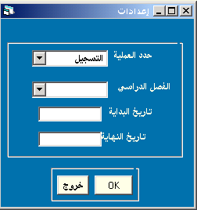

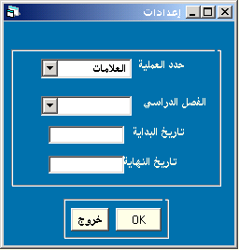

The reports:
Our system produces several reports, some of them are produced based on the entered information, and others are produced based on previously determined information
For example we generate reports to display information about the semester courses,
reports to display information about the courses teached in a certain room ,reports to
display information about university teachers, also the student marks and programs are displayed using reports, and other types of reports are produced.

Future expansion of our project:
As a future expansion of our project we may include mark system on the
internet Part so the teachers can enter the first ,second and final exams marks directly through the internet.

