Magetice card reader

**The aim** of our is to exploit the magnetic cards and related technology in order to realize students attendance monitoring system

**The idea** of the project is to help the teachers at An- Najah University to get the attendance record for their students , in an easy and efficient way , thus we designed and built a simple unit , which enable each student to insert his card and get logged in , by means of saving the related data in the unit associated memory .

**The advantages of the project**

1- Low cost to implement .

2- Exploits the cards which are already distributed to an Najah university students

**Brief background of technologies which may be used to monitor attendance**

**Barcode**

the data is encoded based on the width and spacing of dark line.

The use of bar codes is limited, They are cheap but there is virtually no security and the bar. code stripe can be easily damaged

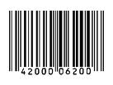

A **smart card**( **chip card**, or [**integrated circuit**](http://en.wikipedia.org/wiki/Integrated_circuit) **card** (**ICC**))

is any pocket-sized card with embedded integrated circuits. There are two broad categories of ICCs. [Memory cards](http://en.wikipedia.org/wiki/Memory_card) contain only non-volatile memory storage components, and perhaps dedicated security logic. [Microprocessor](http://en.wikipedia.org/wiki/Microprocessor) cards contain volatile memory and microprocessor components. The card is made of plastic, generally [polyvinyl chloride](http://en.wikipedia.org/wiki/Polyvinyl_chloride), but sometimes [acrylonitrile butadiene styrene](http://en.wikipedia.org/wiki/Acrylonitrile_butadiene_styrene) or [polycarbonate](http://en.wikipedia.org/wiki/Polycarbonate). The card may embed a [hologram](http://en.wikipedia.org/wiki/Holography) to prevent [counterfeiting](http://en.wikipedia.org/wiki/Counterfeit). Smart cards may also provide strong security [authentication](http://en.wikipedia.org/wiki/Authentication) for [single sign-on](http://en.wikipedia.org/wiki/Single_sign-on) within large organizations.

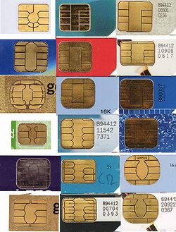

**magnetic stripe card**

**In general what is a magnetic stripe card?**

**magnetic stripe card** is a type of card capable of storing [data](http://en.wikipedia.org/wiki/Data) by modifying the [magnetism](http://en.wikipedia.org/wiki/Magnetism) of tiny iron based magnetic particles on a band of magnetic material on the card. The magnetic stripe, sometimes called a **magstripe**, is read by physical contact and swiping past a reading head.

A number of [International Organization for Standardization](http://en.wikipedia.org/wiki/International_Organization_for_Standardization) standards, [ISO/IEC 7810](http://en.wikipedia.org/wiki/ISO/IEC_7810), [ISO/IEC 7811](http://en.wikipedia.org/wiki/ISO/IEC_7811), [ISO/IEC 7812](http://en.wikipedia.org/wiki/ISO/IEC_7812), [ISO/IEC 7813](http://en.wikipedia.org/wiki/ISO/IEC_7813), [ISO 8583](http://en.wikipedia.org/wiki/ISO_8583), and [ISO/IEC 4909](http://en.wikipedia.org/w/index.php?title=ISO/IEC_4909&action=edit&redlink=1), define the physical properties of the card, including size, flexibility, location of the magstripe, magnetic characteristics, and data formats. They also provide the standards for financial cards, including the allocation of card number ranges to different card issuing institutions.

**History of magnetic stripe card:**

The process of attaching a magnetic stripe to a plastic card was invented by [IBM](http://en.wikipedia.org/wiki/IBM) under a contract with the US government for a security system. [Forrest Parry](http://en.wikipedia.org/wiki/Forrest_Parry), an IBM Engineer, had the idea of securing a piece of magnetic tape, the predominant storage medium at the time, to a plastic card base. He became frustrated because every adhesive he tried produced unacceptable results. The tape strip either warped or its characteristics were affected by the adhesive, rendering the tape strip unusable. After a frustrating day in the laboratory, trying to get the right adhesive, he came home with several pieces of magnetic tape and several plastic cards. As he walked in the door at home, his wife was ironing and watching TV. She immediately saw the frustration on his face and asked what was wrong. He explained the source of his frustration: inability to get the tape to "stick" to the plastic in a way that would work. She said, "Here, let me try the iron."

She did and the problem was solved. The heat of the iron was just high enough to bond the tape to the card.

There were a number of steps required to convert the magnetic striped media into an industry acceptable device. These steps included: 1) Creating the international standards for stripe record content, including which information, in what format, and using which defining codes. 2) Field testing the proposed device and standards for market acceptance. 3) Developing the manufacturing steps needed to mass produce the large number of cards required. 4) Adding stripe issue and acceptance capabilities to available equipment. These steps were initially managed by Jerome Svigals of the Advanced Systems Division of IBM, Los Gatos, California from 1966 to 1975.

**Why we have chosen magnetic card?**

**- Cheap**

**- Widely spread**

**- The An-najah university students already**

**use it**

**- Easy to encode**

**-Consists of coercive materials with low reluctance**

**More about magnetic stripe cards,**

In most magnetic stripe cards, the magnetic stripe is contained in a plastic-like film. The magnetic stripe is located 0.223 inches (5.56 mm) from the edge of the card, and is 0.375 inches (9.52 mm) wide.

There are up to three tracks on magnetic cards used for financial transactions, known as tracks 1, 2, and 3. Track 3 is virtually unused by the major worldwide networks such as [VISA](http://en.wikipedia.org/wiki/VISA), and often isn't even physically present on the card by virtue of a narrower magnetic stripe. Point-of-sale card readers almost always read track 1, or track 2, and sometimes both, in case one track is unreadable. The minimum cardholder account information needed to complete a transaction is present on both tracks. Track 1 has a higher bit density (210 bits per inch vs. 75), is the only track that may contain alphabetic text, and hence is the only track that contains the cardholder's name.

Each tracks 0.110 inches (2.79 mm) wide. Tracks one and three are typically recorded at 210 bits per inch (8.27 bits per mm), while track two typically has a recording density of 75 bits per inch (2.95 bits per mm). Each track can either contain 7-bit alphanumeric characters, or 5-bit numeric characters. Track 1 standards were created by the [airlines industry (IATA)](http://en.wikipedia.org/wiki/International_Air_Transport_Association). Track 2 standards were created by the [banking industry (ABA)](http://en.wikipedia.org/wiki/American_Bankers_Association). Track 3 standards were created by the Thrift-Savings industry

**Track 2**

**Track 1**

**Track 3**

**0.223”**

**0.353”**

**0.493”**

Magnetic Stripe

**Magetice stripes examples**

[ATM cards](http://en.wikipedia.org/wiki/ATM_card)

[bank cards](http://en.wikipedia.org/wiki/Bank_card)

[VISA](http://en.wikipedia.org/wiki/VISA)

[MasterCard](http://en.wikipedia.org/wiki/MasterCard)

[gift cards](http://en.wikipedia.org/wiki/Gift_card)

loyalty cards

driver's licenses

telephone calling cards

membership cards

electronic benefit transfer cards (e.g. [food stamps](http://en.wikipedia.org/wiki/Supplemental_Nutrition_Assistance_Program)).

**Magnetic stripe coercivity**

Magstripes come in two main varieties: high-[coercivity](http://en.wikipedia.org/wiki/Coercivity" \o "Coercivity) (HiCo) at 4000 [Oe](http://en.wikipedia.org/wiki/Oersted) and low-coercivity (LoCo) at 300 [Oe](http://en.wikipedia.org/wiki/Oersted)

High-coercivity magstripes are harder to erase, and therefore are appropriate for cards that are frequently used or that need to have a long life. Low-coercivity magstripes require a lower amount of magnetic energy to record, and hence the card writers are much cheaper than machines which are capable of recording high-coercivity magstripes. A card reader can read either type of magstripe, and a high-coercivity card writer may write both high and low-coercivity cards (most have two settings, but writing a LoCo card in HiCo may sometimes work), while a low-coercivity card writer may write only low-coercivity cards.

In practical terms, usually low coercivity magnetic stripes are a light brown color, and high coercivity stripes are nearly black.High coercivity stripes are resistant to damage from most magnets likely to be owned by consumers. Low coercivity stripes are easily damaged by even a brief contact with a magnetic purse strap or fastener. Because of this, virtually all bank cards today are encoded on high coercivity stripes despite a slightly higher per-unit cost.

Magnetic stripe cards are used in very high volumes in the mass transit sector, replacing paper based tickets with either a directly applied magnetic [slurry](http://en.wikipedia.org/wiki/Slurry) or hot foil stripe. Slurry applied stripes are generally less expensive to produce and are less resilient but are suitable for cards meant to be disposed after a few uses

**Magnetic stripe card ecoding**

FERROMAGNETIC materials are substances that retain magnetism after an external magnetizing field is removed. This principle is the basis of ALL magnetic recording and playback. Magnetic POLES always occur in pairs within magnetized material, and MAGNETIC FLUX lines emerge from the NORTH pole and terminate at the SOUTH. The elemental parts of MAGSTRIPES are ferromagnetic particles about 20 millionths of an inch long, each of which acts like a tiny bar magnet. These particles are rigidly held together by a resin binder. The magnetic particles are made by companies which make colorin pigments for the paint industry, and are usually called pigments. When making the magstripe media, the elemental magnetic particles are aligned with their North-South axes parallel to the magnetic stripe by means of an external magnetic fields while the binder hardens.

These particles are actually permanent bar magnets with TWO STABLE POLARITIES. If a magnetic particle is placed in a strong external magnetic field of the opposite polarity, it will FLIP its own polarity (North becomes South, South becomes North). The external magnetic field strength required to produce this flip is called the COERCIVE FORCE, or COERCIVITY of the particle.

Magnetic

An unencoded magstripe is actually a series of North-South magnetic domains(see Figure 1). The adjacent N-S fluxes merge, and the entire stripe acts as a single bar magnet with North and South poles at its ends.

**Figure 1:**

**N-S.N-S.N-S.N-S.N-S.N-S.N-S.N-S <-particles in stripe represented as->**

**N-----------------------------S**

However, if a S-S interface is created somewhere on the stripe, the fluxes will REPEL, and we get a concentration of flux lines around the S-S interface (same with N-N interface). ENCODING consists of creating S-S and N-N interfaces, and READING consists of detecting 'em. The S-S and N-N interfaces

are called FLUX REVERSALS.

||| ||| <-flux lines

Figure 2:

N----------N-N-S-S------------S

flux lines ->

The external magnetic field used to flip the polarities is produced by a SOLENOID, which can REVERSE its polarity by reversing the direction of CURRENT. An ENCODING head solenoid looks like a bar magnet bent into the shape of a ring so that the North/South poles are very close and face each other across a tiny gap. The field of the solenoid is concentrated across this gap, and when elemental magnetic particles of the magstripe are exposed to this field, they polarize to the OPPOSITE .Movement of the stripe past the solenoid gap during which the polarity of the solenoid is REVERSED will produce a SINGLE flux reversal (see Figure 3). To erase a magstripe, the encoding head is held at a CONSTANT polarity and the ENTIRE stripe is movedpast it. No flux reversals, no data.

**| | <----wires leading to solenoid**

**| | (wrapped around ring)**

**/-|-|-\**

**/ \**

**Figure 3: | | <----solenoid (has JUST changed polarity)**

**--------- \ /**

**\ N S / <---gap in ring.. NS polarity across gap**

**N----------------------SS-N-------------------------S**

**^^**

**<<<<<-direction of stripe movement**

S-S flux reversal created at trailing edge of solenoid!So, we now know that flux reversals are only created the INSTANT the solenoid CHANGES its POLARITY. If the solenoid in Figure 3 were to remain at its current polarity, no further flux reversals would be created as the magstripe moves from right to left. But, if we were to change the solenoid gap polarity >from NS to *SN*, then a *N-N* flux reversal would instantly be created. Just remember, for each and every reversal in solenoid polarity, a single flux reversal is created .An encoded magstripe is therefore just a series offlux reversals (NN followed by SS followed by NN)

See Figure 4.

magstripe--->

-------NN--------SS--------NN---------SS------

Figure 4: voltage-----> .....+.......-......+........-

---------- -------------

peak readout--> | | | |

--------| |----------| |----

Now, metho of encode data?

The most common technique used is known as Aiken Biphase, or "two-frequency coherent-phase encoding"

First, digest the diagrams in Figure 5.

**Figure 5: ---------- ---------- ----------**

**--------- | | | | | | <- peak**

**a) | |--------| |--------| | readouts**

**\* 0 * 0 * 0 * 0 * 0 \***

**----- ----- ----- ----- ----- -**

**| | | | | | | | | | |**

**b) | |----| |----| |----| |----| |----|**

**\* 1 * 1 * 1 * 1 * 1 \***

**----- ---------- ----- ----- -**

**| | | | | | | | |**

**c) | |----| |--------| |----| |----|**

* 1 * 0 * 0 * 1 * 1 *

There you have it. Data is encoded in "bit cells," the frequency of which is the frequency of '0' signals. '1' signals are exactly TWICE the frequency of '0' signals. Therefore, while the actual frequency of the data passing the read head will vary due to swipe speed, data density, etc, the '1' frequency will ALWAYS be TWICE the '0' frequency. Figure 5C shows exactly how '1' and'0' data exists side by side.

**to read DATA!**

American National Standards Institute (ANSI) and the International Standards Organization (ISO) have chosen 2 standards. The first is

**ANSI/ISO BCD Data format **

This is a 5-bit Binary Coded Decimal format. It uses a 16-character set, which uses 4 of the 5 available bits. The 5th bit is an ODD parity bit, which means there must be an odd number of 1's in the 5-bit character..the parity bit will "force" the total to be odd. Also, the Least Significant Bits are read FIRST

on the strip.

The sum of the 1's in each case is odd, thanks to the parity bit. If the read system adds up the 5 bits and gets an EVEN number, it flags the read as ERROR, and you got to scan the card again

ANSI/ISO BCD Data Format

---------

* Remember that b1 (bit #1) is the LSB (least significant bit)!

* The LSB is read FIRST!

* Hexadecimal conversions of the Data Bits are given in parenthesis (xH).

**--Data Bits-- Parity**

**b1 b2 b3 b4 b5 Character Function**

**0 0 0 0 1 0 (0H) Data**

**1 0 0 0 0 1 (1H) "**

**0 1 0 0 0 2 (2H) "**

**1 1 0 0 1 3 (3H) "**

**0 0 1 0 0 4 (4H) "**

**1 0 1 0 1 5 (5H) "**

**0 1 1 0 1 6 (6H) "**

**1 1 1 0 0 7 (7H) "**

**0 0 0 1 0 8 (8H) "**

**1 0 0 1 1 9 (9H) "**

**0 1 0 1 1 : (AH) Control**

**1 1 0 1 0 ; (BH) Start Sentinel**

**0 0 1 1 1 < (CH) Control**

**1 0 1 1 0 = (DH) Field Separator**

**0 1 1 1 0 > (EH) Control**

**1 1 1 1 1 ? (FH) End Sentinel**

**\*\*\*\*\* 16 Character 5-bit Set \*\*\*\*\***

**10 Numeric Data Characters**

**3 Framing/Field Characters**

**3 Control Characters**

The magstripe begins with a string of Zero bit-cells to permit the self- clocking feature of biphase to "sync" and begin decoding. A "Start Sentinel" character then tells the reformatting process where to start grouping the decoded bit stream into groups of 5 bits each. At the end of the data, an "End Sentinel" is encountered, which is followed by an "Longitudinal Redundancy

Check (LRC) character. The LRC is a parity check for the sums of all b1, b2, b3, and b4 data bits of all preceding characters. The LRC character will catch

the remote error that could occur if an individual character had two

compensating errors in its bit pattern (which would fool the 5th-bit parity check).

The START SENTINEL, END SENTINEL, and LRC are collectively called "Framing

Characters", and are discarded at the end of the reformatting process.

** ANSI/ISO ALPHA Data Format **

Alphanumeric data can also be encoded on magstripes. The second ANSI/ISO data format is ALPHA (alphanumeric) and involves a 7-bit character set with 64 characters. As before, an odd parity bit is added to the required 6 data bits for each of the 64 characters.

--------- ANSI/ISO ALPHA Data Format

* Remember that b1 (bit #1) is the LSB (least significant bit)!

* The LSB is read FIRST!

* Hexadecimal conversions of the Data Bits are given in parenthesis (xH).

**------Data Bits------- Parity**

**b1 b2 b3 b4 b5 b6 b7 Character Function**

**0 0 0 0 0 0 1 space (0H) Special**

**1 0 0 0 0 0 0 ! (1H) "**

**0 1 0 0 0 0 0 " (2H) "**

**1 1 0 0 0 0 1 # (3H) "**

**0 0 1 0 0 0 0 $ (4H) "**

**1 0 1 0 0 0 1 % (5H) Start Sentinel**

**0 1 1 0 0 0 1 & (6H) Special**

**1 1 1 0 0 0 0 ' (7H) "**

**0 0 0 1 0 0 0 ( (8H) "**

**1 0 0 1 0 0 1 ) (9H) "**

**0 1 0 1 0 0 1 * (AH) "**

**1 1 0 1 0 0 0 + (BH) "**

**0 0 1 1 0 0 1 , (CH) "**

**1 0 1 1 0 0 0 - (DH) "**

**0 1 1 1 0 0 0 . (EH) "**

**1 1 1 1 0 0 1 / (FH) "**

**0 0 0 0 1 0 0 0 (10H) Data (numeric)**

**1 0 0 0 1 0 1 1 (11H) "**

**0 1 0 0 1 0 1 2 (12H) "**

**1 1 0 0 1 0 0 3 (13H) "**

**0 0 1 0 1 0 1 4 (14H) "**

**1 0 1 0 1 0 0 5 (15H) "**

**0 1 1 0 1 0 0 6 (16H) "**

**1 1 1 0 1 0 1 7 (17H) "**

**0 0 0 1 1 0 1 8 (18H) "**

**1 0 0 1 1 0 0 9 (19H) "**

**0 1 0 1 1 0 0 : (1AH) Special**

**1 1 0 1 1 0 1 ; (1BH) "**

**0 0 1 1 1 0 0 < (1CH) "**

**1 0 1 1 1 0 1 = (1DH) "**

**0 1 1 1 1 0 1 > (1EH) "**

**1 1 1 1 1 0 0 ? (1FH) End Sentinel**

**0 0 0 0 0 1 0 @ (20H) Special**

**1 0 0 0 0 1 1 A (21H) Data (alpha)**

**0 1 0 0 0 1 1 B (22H) "**

**1 1 0 0 0 1 0 C (23H) "**

**0 0 1 0 0 1 1 D (24H) "**

**1 0 1 0 0 1 0 E (25H) "**

**0 1 1 0 0 1 0 F (26H) "**

**1 1 1 0 0 1 1 G (27H) "**

**0 0 0 1 0 1 1 H (28H) "**

**1 0 0 1 0 1 0 I (29H) "**

**0 1 0 1 0 1 0 J (2AH) "**

**1 1 0 1 0 1 1 K (2BH) "**

**0 0 1 1 0 1 0 L (2CH) "**

**1 0 1 1 0 1 1 M (2DH) "**

**0 1 1 1 0 1 1 N (2EH) "**

**1 1 1 1 0 1 0 O (2FH) "**

**0 0 0 0 1 1 1 P (30H) "**

**1 0 0 0 1 1 0 Q (31H) "**

**0 1 0 0 1 1 0 R (32H) "**

**1 1 0 0 1 1 1 S (33H) "**

**0 0 1 0 1 1 0 T (34H) "**

**1 0 1 0 1 1 1 U (35H) "**

**0 1 1 0 1 1 1 V (36H) "**

**1 1 1 0 1 1 0 W (37H) "**

**0 0 0 1 1 1 0 X (38H) "**

**1 0 0 1 1 1 1 Y (39H) "**

**0 1 0 1 1 1 1 Z (3AH) "**

**1 1 0 1 1 1 0 [ (3BH) Special**

**0 0 1 1 1 1 1 \ (3DH) Special**

**1 0 1 1 1 1 0 ] (3EH) Special**

**0 1 1 1 1 1 0 ^ (3FH) Field Separator**

**1 1 1 1 1 1 1 _ (40H) Special**

**\*\*\*\*\* 64 Character 7-bit Set \*\*\*\*\***

**\* 43 Alphanumeric Data Characters**

**\* 3 Framing/Field Characters**

**\* 18 Control/Special Characters**

**OUR PROJECT**

* **The Hardware part**





Magnetic stripe reader circuit

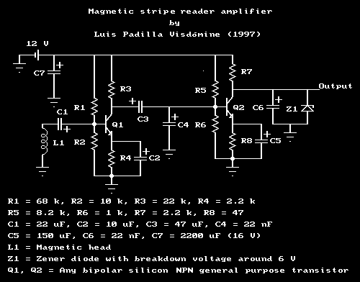



**Requirements**

To read magnetic stripes with this design you will need a magnetic head, two transistors, a few resistors and capacitors, a 12 Volts DC power supply, a computer to decode the data and some soldering skills. A voltmeter and an oscilloscope are highly advisable while adjusting and testing the circuit.

The magnetic head has to be chosen such that the size of the track matches that of the magnetic stripe...

**Circuit description**

The weak signal from the magnetic head has to be amplified in order to drive an input port of the computer. For that reason you will need a circuit like the one in the figure (or a similar one) which is basically an amplifier. The transistor Q1 acts like a preamplifier, raising the weak head signal, under 1 mV, to the level of tenths of volts. As a preamplifier, it has a low noise factor; this is achieved through operating the transistor at low current (under 1 mA) and low voltage (under 2 V).

The transistor Q2 acts like an amplifier and a driver for the input port of the computer. For that reason its output is connected directly, without any capacitor, to the input port of the computer. Therefore the DC voltage level of the transistor has to be adjusted to match the specifications of the port you are using. Both transistors, Q1 and Q2, have to be normal silicon bipolar general purpose NPN transistors. The value of the electronic components is not critical, specially for capacitors. You can choose from what you already have, those which are closer to the ones in the drawing.

This circuit is designed to work with a 12 V DC power supply. You can use another one, but then you will have to change the value of the resistors to keep the working point of the transistors in the same place. You can obtain +12 V DC from the power supply of your PC, which also have +5 V DC. The power consumption of this circuit should be around 60 mW. If your power supply is stabilized (that is the case of the power supply of the computer) then you may remove the capacitor C7, otherwise you should use a value as big as possible. Pay attention on the voltage the capacitor is rated, it should be **no less** than 16 V. You should also pay attention on the polarity of this and the other capacitors. The terminal rated "-" **must** be connected to **ground** or closer to ground than the other terminal

**Microprocessor circuit**



**The PIC18F4620**

- Cheap

- Can be programmed in Najah

- Has suitable memory

-Available

**The flow charts**

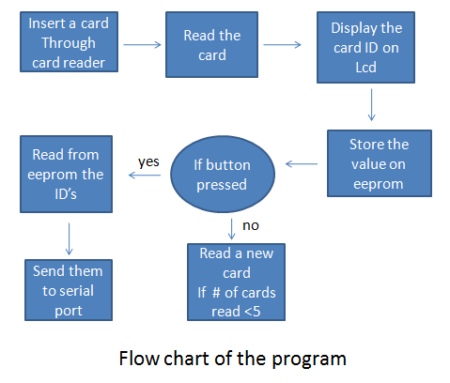

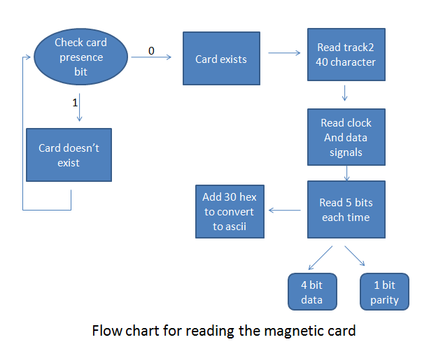

**Conclusion**

The code check if the card is exist or not

when you insert the card, the code start reading process where the data that exist on card contains series of zero indicats that the info will pass know and when the “;” is pass that means start reading& take each four bits together and store it in EPROM, where “?”sign show the end of data

store & on LCD then the result appear

in EPROM ,then the serial is connected between PC and our system and the data can transmit from EPROM to Pc by pressing on the button… and the data will be deleted from EPROM