بسم الله الرحمن الرحيم""

AN-NAJAH NATIONAL UNIVIRSITY
FUCLTY OF ENGINEERING
COMPUTER ENGINEERING DEPARTMENT


Proposal About HOME AUTOMATION BY DTMF
Prepared by:
ARIJ ABUOBAID.
NAHREEN AMEEN.

Supervisor:
ENG. HAYA SAMA' NEH

Introduction
Our project is very important for these days because of many works in our life.
You can control your room from any where especially that the telephone now is discrete every place and every where,
So you can go any where you want and don’t worry about your home.

User manual
Before you using it you should configure it to using locally or from telephone by putting the key to keypad or telephone and switch another key to speaker or telephone.
After that open the project , if you chose locally you can use it from keypad and enter the desired command, firstly you should enter the correct password which has defult value 1234567890and end mark# the enter the command at form#number#, to exit
Enter #3#,
If you chose the telephone, , firstly you should enter the correct password which has defult value 1234567890and end mark# the enter the command at form*number*, to exit
Enter *3*.
Interest and try,

DTMF protocol

History
Prior to DTMF, phone systems used a system known as pulse (Dial Pulse or DP in the USA) or loop disconnect (LD) signaling to dial numbers, which works by rapidly disconnecting and connecting the calling party's phone line, like flicking a light switch on and off. The repeated connection and disconnection, as the dial spins, sounds like a series of clicks. The exchange equipment counts those clicks or dial pulses to determine the called number. LD range was restricted by telegraphic distortion and other technical problems, and placing calls over longer distances required either operator assistance (operators used an earlier kind of multi-frequency dial) or the provision of subscriber trunk dialing equipment.
DTMF was developed at Bell Labs in order to allow dialing signals to dial long-distance numbers, potentially over nonwire links such as microwave radio relay links or satellites. For a few non crossbar offices, encoder/decoders were added that would convert the older pulse signals into DTMF tones and play them down the line to the remote end office. At the remote site another encoder/decoder could decode the tones and perform pulse dialing, for example for Stronger switches. It was as if you were connected directly to that end office, yet the signaling would work over any sort of link. This idea of using the existing network for signaling as well as the message is known as in-band signaling.
It was clear even in the late 1950s when DTMF was being developed that the future of switching lay in electronic switches, as opposed to the electromechanical crossbar systems then in use. Either switching system could use either dial system, but DTMF promised shorter holding times, which was more important in the larger and more complex registers used in crossbar systems. In this case pulse dialing made no sense at any point in the circuit, and plans were made to roll DTMF out to end users as soon as possible. Tests of the system occurred in the early 1960s, where DTMF became known as Touch Tone. Though Touch Tone phones were already in use in a few places, they were vigorously promoted at the 1964 New York World's Fair.
The Touch Tone system also introduced a standardized keypad layout. After testing 18 different layouts, they eventually chose the one familiar to us today, with 1 in the upper-left and 0 at the bottom. The adding-machine layout, with 1 in the lower-left was also tried, but at that time few people used adding machines, and having the 1 at the "start" (in European language reading order) led to fewer typing errors. In retrospect, many people consider that this was a mistake. With the widespread introduction of computers and bank machines, the phone keyboard has become "oddball", causing mistakes.
The engineers had also envisioned phones being used to access computers, and surveyed a number of companies to see what they would need for this role. This led to the addition of the number sign (#) and star (*) keys, as well as a group of keys for menu selection, A, B, C and D. In the end the lettered keys were dropped from most phones, and it was many years before the # and * keys became widely used, such as for vertical service codes such as *67 in the United States and Canada to suppress caller ID.
Public payphones that accept credit cards use these additional codes to send the information from the magnetic strip.
Present-day uses of the A, B, C and D keys on telephone networks are few, and exclusive to network control. For example, the A key is used on some networks to cycle through different carriers at will (thereby listening in on calls). Their use is probably prohibited by most carriers. The A, B, C and D tones are used in amateur radio phone patch and repeater operations to allow, among other uses, control of the repeater while connected to an active phone line. Every modern handheld radio can generate these tones.
DTMF tones were also used by some cable television networks to signal the local cable company to insert a local advertisement. These tones were often heard during a station ID preceding a local ad insert. Terrestrial television stations also used DTMF tones to shut off and turn on remote transmitters.
DTMF tones are also sometimes used in caller ID systems to transfer the caller ID information, however in the USA only Bell 202 modulated FSK signaling is used to transfer the data.

Keypad
The DTMF keypad is laid out in a 4×4 matrix, with each row representing a low frequency, and each column representing a high frequency. Pressing a single key such as '1' will send a sinusoidal tone of the two frequencies 697 and 1209 (Hz). The original keypads had levers inside, so each button activated two contacts. The multiple tones are the reason for calling the system multi frequency. These tones are then decoded by the switching center to determine which key was pressed.
DTMF keypad frequencies (with sound clips)
 | 1209 Hz | 1336 Hz | 1477 Hz | 1633 Hz
697 Hz | 1 | 2 | 3 | A
770 Hz | 4 | 5 | 6 | B
852 Hz | 7 | 8 | 9 | C
941 Hz | * | 0 | # | D

DTMF event frequencies
Event | Low frequency | High frequency
Busy signal | 480 Hz | 620 Hz
Dial tone | 350 Hz | 440 Hz
Ring back tone (US) | 440 Hz | 480 Hz
The tone frequencies, as defined by the Precise Tone Plan, are selected such that harmonics and inter modulation products will not cause an unreliable signal. No frequency is a multiple of another, the difference between any two frequencies does not equal any of the frequencies, and the sum of any two frequencies does not equal any of the frequencies. The frequencies were initially designed with a ratio of 21/19, which is slightly less than a whole tone. The frequencies may not vary more than ±1.5% from their nominal frequency, or the switching center will ignore the signal. The high frequencies may be the same volume or louder as the low frequencies when sent across the line. The loudness difference between the high and low frequencies can be as large as 3 decibels (dB) and is referred to as "twist".

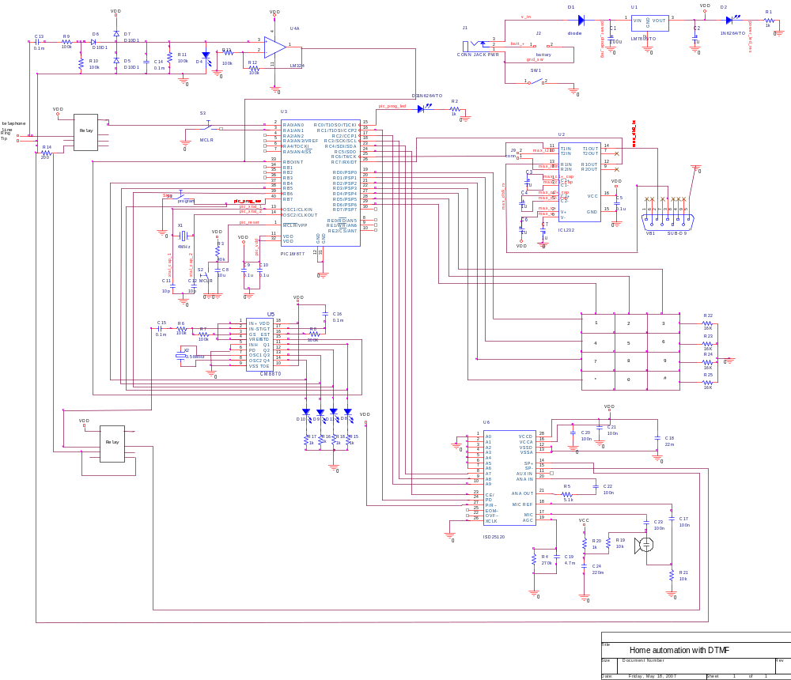

Hardware
- Ring detection circuit.

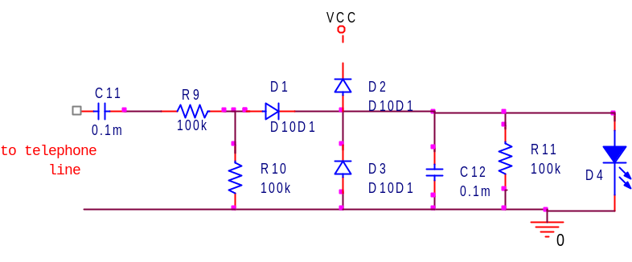
This circuit used to detect the ring of the telephone and this circuit give deferent voltage according to the telephone line connection :
- External telephone exchange (مقسم هاتف خارجي) Normally there is only the 48V DC voltage from central office battery in the line, and when phone ring there is 70-130V AC voltage in the line. That's what in the line in normal operation.in this case the figure (1) only used to detect the ring the circuit give voltage from (0-3.5V) which can used as external interrupt to PIC16F877 but the problem appear when we used the project in internal telephone exchange in which the telephone line on ring give 50V AC only.
- Internal telephone exchange (مقسم هاتف داخلي)the range is between (0-1.5 )V and this voltage is not Appropriate to use as external interrupt to PIC16F877 so that we use amplifier circuit that double the voltage in range of (0-5)V and in this case we avoid the voltage to become higher than 5V if we used this circuit in external telephone exchange.

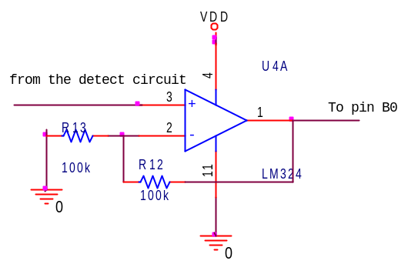

- The tone decoding circuit.

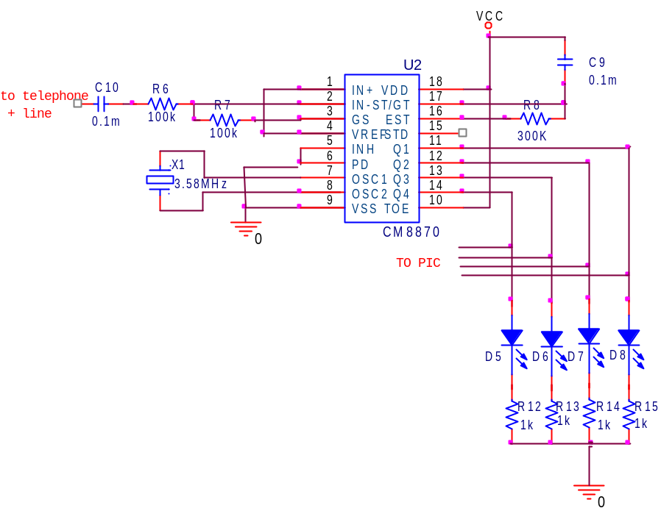
in this circuit we detect the number which pressed in the remote place using the DTMF protocol as describe in the DTMF protocol in this circuit the main component is Cm8870 (CMOS Integrated DTMF Receiver).

Description of CM8870:
The CAMD CM8870/70C provides full DTMF receiver capability by integrating both the band split filter and digital decoder functions into a single 18-pin DIP, SOIC, or 20-pin PLCC package. The CM8870/70C is manufactured using state-of-the-art CMOS process technology for low power consumption (35mW, max.) and precise data handling. The filter section uses a switched capacitor technique for both high and low group filters and dial tone rejection. The CM8870/70C decoder uses digital counting techniques for the detection and decoding of all 16 DTMF tone pairs into a 4-bit code. This DTMF receiver minimizes external component count by providing an on-chip differential input amplifier, clock generator, and a latched three-state interface bus. The on-chip clock generator requires only a low cost TV crystal or ceramic resonator as an external component.
And the block diagrams in the figure bellow.
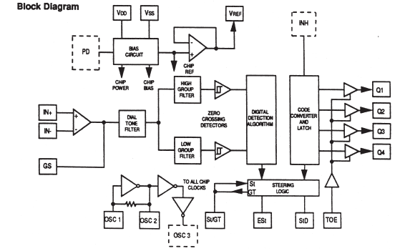

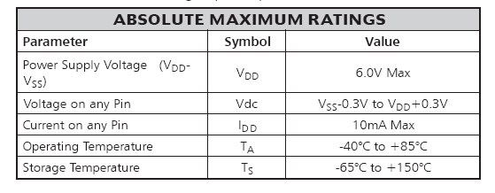
Decoder Section
The CM8870/70C decoder uses a digital counting technique to determine the frequencies of the limited tones and to verify that these tones correspond to standard DTMF frequencies. A complex averaging algorithm is used to protect against tone simulation by extraneous signals (such as voice) while
Providing tolerance to small frequency variations. The averaging algorithm has been developed to ensure an optimum combination of immunity to “talk-off” and tolerance to the presence of interfering signals (third tones) and noise. When the detector recognizes the simultaneous presence of two valid tones (known as “signal condition”), it raises the “Early Steering” flag (ESt). Any subsequent loss of signal condition will cause ESt to fall.

Steering Circuit
Before the registration of a decoded tone pair, the receiver checks for a valid signal duration (referred to as “characterrecognition-condition”). This check is performed by an external RC time constant driven by ESt. A logic high on ESt causes VC to rise as the capacitor discharges.
Providing signal condition is maintained (ESt remains high) for the validation period (tGTP), VC reaches the threshold (VTSt) of the steering logic to register the tone pair, thus latching its corresponding 4-bit code as I table bellow into the output latch.
At this point, the GT output is activated and drives VC to VDD. GT continues to drive high as long as ESt remains high, signaling that a received tone pair has been registered. The contents of the output latch are made available on the 4-bit output bus by raising the three-state control input (TOE) to a logic high. The steering circuit works in reverse to validate the
Inter digit pause between signals. Thus, as well as rejecting signals too short to be considered valid, the receiver will tolerate signal interruptions (drop outs) too short to be considered a valid pause. This capability together with the capability of selecting the steering time constants externally, allows the designer to tailor performance to meet a wide variety of system requirements.
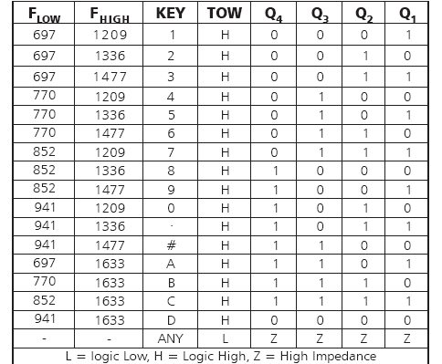

the basic circuit for CM8870 as bellow
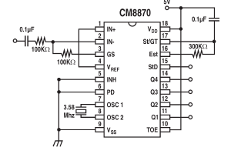
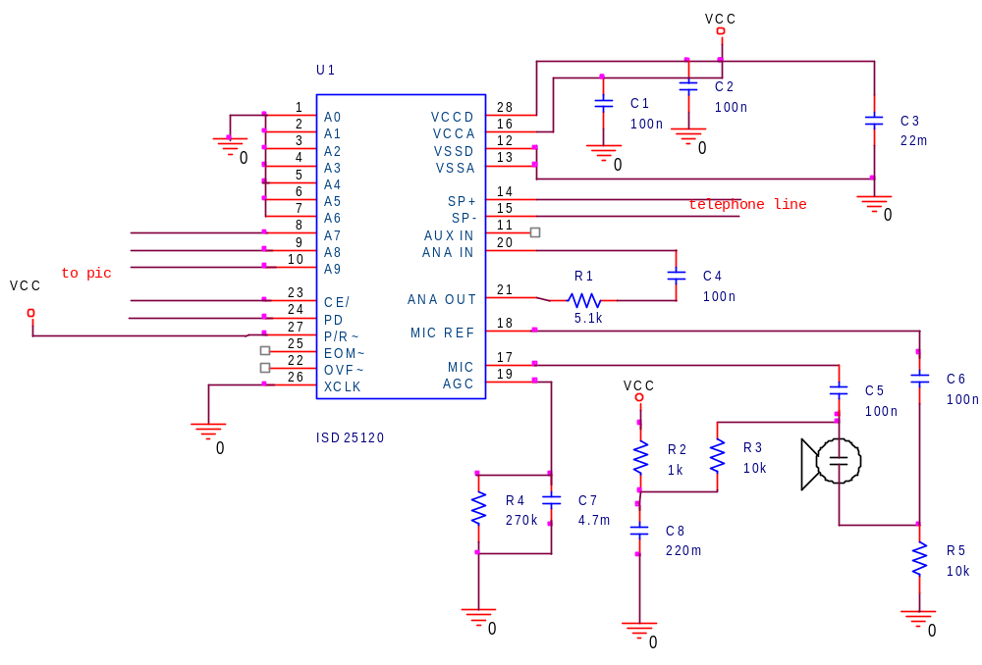
- the circuit for voice playback:

We use in circuit ISD25120 IC which used to record and playback voice the block diagram as bellow:
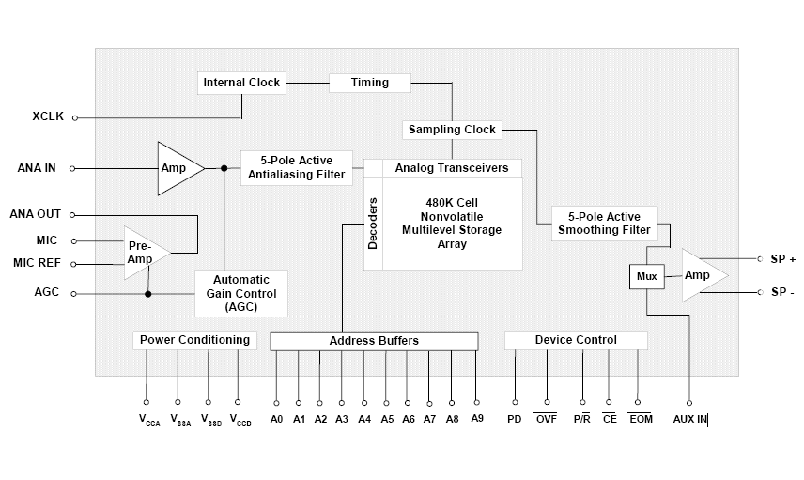

The Figures below are intended to assist the user of ISD products in better understanding the flexibility and limitations of these record and playback devices. They have been compiled based on questions asked by ISD customers. These charts will continue to be expanded as more questions are asked.
ISD Chip CORDER devices are now built in numerous sizes and memory aspect ratios.
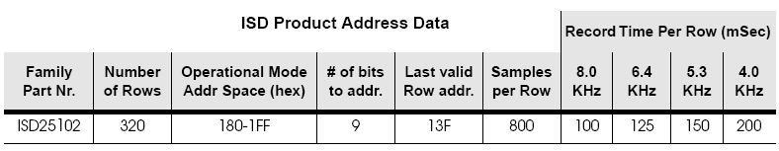
EOM Placement Information: All addressable ISD products have multiple End Of Message locations (EOMs) available on each row. This allows the record process to end as close as possible to the end of the event being recording. In each case, the first possible EOM in a row will occur at the indicated time after the beginning of the row. Each subsequent EOM location will be a multiple of that time period after the beginning of the row. The final EOM of the row will occur at the end of the row. Note that there can only be one possible EOM used in any single row. It is possible for every row to have an EOM (that would be a lot of very short messages!).
The ISD25120 work in different modes as in the table below.
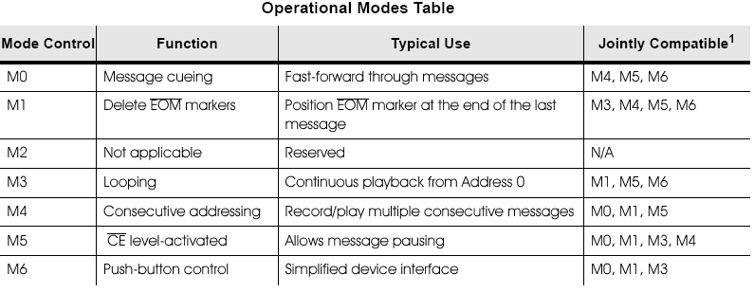
We use the mode M4 and there is some important pins we used to record and playback voice as the table below:
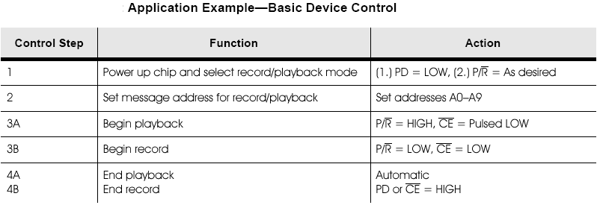
and the timing diagram for ISD25120 as below 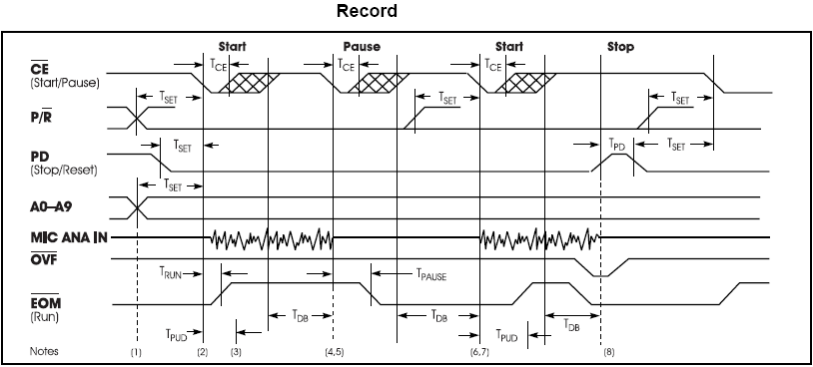

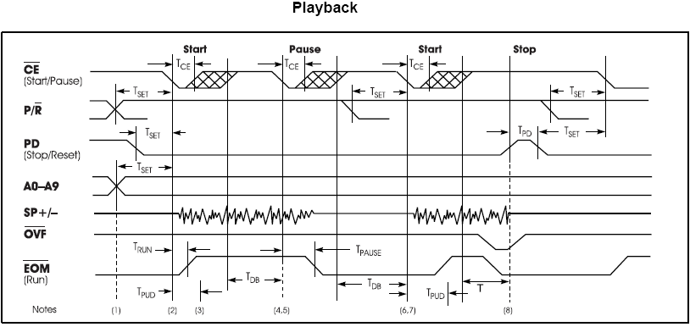

Components:-
PIC 16F877 | 1
ISD25120 | 1
CM8870 | 1
MIC | 1
Speaker 16 Ω | 1
LM324 | 1
Relay | 3
X1 (3.58MHz) | 1
X2 (4 MHz) | 1
300 KΩ | 1
100 k | 4
0.1μf | 8
10μf | 2
5.1 kΩ | 1
470 kΩ | 1
4.7 kΩ | 1
10 kΩ | 5
1 kΩ | 5
22μf | 1
40kΩ | 1
1μf | 6

