Table of Contents...........................................................................................................1
إهداء.................................................................................................................................3
Abstract..........................................................................................................................4
Introduction...................................................................................................................5
CH.1 Wireless Communication....................................................................................6
1.1XBee.............................................................................................................6
1.2General Specifications................................................................................7
1.3Programming the XBee module..................................................................7
1.4Testing..........................................................................................................8
CH.2 Remote Unit.......................................................................................................10
Part One: Sensors............................................................................................10
2.1.1 Temperature Sensor...................................................................10
2.1.1.1 Features and Advantages............................................10
2.1.1.2 How we calibrate it? ...................................................11
2.1.2 Pulse Oximeter Sensor...............................................................11
2.1.2.1 What is the Pulse Oximeter? ......................................11
2.1.2.2 Principles of Pulse Oximetry......................................12
2.1.2.3 Pulse Oximeter Circuit................................................12
2.1.2.4 Block diagram of Pulse Oximeter Circuit..................13
2.1.2.5 Theoretical Calibration Curve....................................14
2.1.3 ECG Sensor................................................................................15
2.1.3.1 ECG Signal..................................................................15
2.1.3.2 How this Produced......................................................15
2.1.3.3 Normal Parameters.....................................................16
2.1.3.4 Electrical Diagram......................................................17
2.1.3.5 Electrodes.....................................................................18
2.1.3.6 Instrumentation Amplifier..........................................19
2.1.3.6.1 1st Stage of Instrumentation Amplifier........20
2.1.3.6.2 2nd Stage of Instrumentation Amplifier.......21
2.1.3.7 Filters...........................................................................22
2.1.3.7.1 BPF...............................................................22
2.1.3.7.2 LPF...............................................................23
2.1.3.7.3 Driven-right-leg Circuit...............................25
Part Two: Programming the PIC...................................................................28
2.2 PIC Microcontroller......................................................................28
2.2.1 General Characteristics..................................................28
2.2.2 Patient Alert System.......................................................29
CH.3 Base Station (BC)..............................................................................................32
3.1 Graphical User Interface..........................................................................32
3.1.1 Main Panel.................................................................................33
3.1.2 Display Panel..............................................................................33
3.1.3 Communication Setting Panel...................................................34
3.1.4 Alarm Setting Panel...................................................................35
CH.4 Data Processing.................................................................................................38
4.1 Data Processing.........................................................................................38
4.2 ECG Processing.........................................................................................38
4.2.1 Heart Rate...................................................................................38
4.2.2 QRS Complex Width..................................................................40
4.3 Body Temperature Processing..................................................................43
4.4 Pulse Oximeter Processing.......................................................................44

إهداء
إلى حكمتي .....وعلمي
إلى أدبي ........وحلمي
إلى طريقي .... المستقيم
إلى طريق........ الهداية
إلى ينبوع الصبر والتفاؤل والأمل
إلى كل من في الوجود بعد الله ورسوله ... أبي الغالي و أمي الغالية

إلى سندي وقوتي وملاذي بعد الله
إلى من آثروني على أنفسهم
إلى من علموني علم الحياة
إلى من أظهروا لي ما هو أجمل من الحياة ... إخوتي وأخواتي

إلى من كانوا ملاذي وملجئي
إلى من تذوقت معهم أجمل اللحظات
إلى من سأفتقدهم ...... وأتمنى أني يفتقدوني
إلى من جعلهم الله أخوتي وأخواتي بالله .....ومن أحببتهم بالله ... طلاب وطالبات قسم الهندسة الكهربائية

إلى من يجمع بين سعادتي وحزني
إلى من لم أعرفهم .... ولن يعرفوني
إلى من أتمنى أن أذكرهم .... إذا ذكروني
إلى من أتمنى أن تبقى صورهم ............في عيوني

Abstract

The wireless patient monitoring system was designed to monitor a patient while offering the convenience of being at home and carrying on with one’s day-to-day activities. It acquires, transmits, processes, and displays three physiological signals, using wireless modules to communicate from a remote unit to its base station. The remote unit carried by the patient incorporates sensors to obtain the electrocardiogram, the body temperature, and the blood oxygen saturation concentration and to coordinate their transmission to the base station. The system is intended to be home-based, using a personal computer to run Matlab-based software for data collection and processing. An integrated patient alert feature alerts the patient if one of the measured physiological parameters is outside of the range set by his or her doctor. The software also has the capability to email the collected data to doctors, allowing greater flexibility and convenience for off-site continuous monitoring.

Introduction

The Wireless patient monitoring system is designed for continuous monitoring of patients in a home setting which makes it distinct from the current products available commercially. Since some cardiac conditions are activity-induced, continuous monitoring of patients provides critical information that cannot necessarily be obtained while a patient is in a medical facility. In addition, the use of wireless technology provides more freedom and a more comfortable, normal lifestyle while being monitored.
Currently, there are wireless monitors that allow more freedom for a patient both within and outside of a medical environment. Ambulatory electrocardiographs can be taken home and can monitor the ECG of the patient in a few different ways.
Continuous monitors are set up in the doctor’s office by a professional and then worn by the patient for 24-72 hours. The recorder accumulates all of the data until the patient returns to the office and the recording tape is read by a computer.
Intermittent recorders require more patient participation as they do not monitor the full ECG at all times. Patients must be aware of their bodies and begin recording data when they detect symptoms of their condition. Loop recorders have electrodes that are always attached to the patient and constantly record heartbeats, but the rhythm of the heart is only recorded when the patient initiates the recorder. Event recorders are not attached to the patient, but must be applied to the chest and initiated to start recording. Event recorders are only used when symptoms of the problem occur.
More recently, hospitals are beginning to implement telemetry systems that wirelessly connect patient monitors to nurse stations, and at times, to the attending doctor themselves. These systems provide more freedom for the patients, relieving the bother of multiple wires tying them to a bed, as well as improving treatment by allowing doctors to be directly contacted in the event of emergencies.

Chapter one
Wireless communication

This project revolves around the use of a wireless protocol to allow the patient to move freely within the home while still having important vital signs monitored. To accomplish this task, the IEEE 802.15.4 Zigbee protocol was used. Within the Zigbee protocol, MaxStream produces the XBee module: a single self-contained, programmable wireless transmission module. Two of these are used, one incorporated into the remote unit and one connected to the base station PC, to create the wireless link necessary to allow the freedom of movement desired.
1.1 XBee:
XBee is RF modules are embedded solutions providing wireless end-point connectivity to devices. These modules use the zigbee networking protocol called IEEE 802.15.4 for fast point-to-multipoint or peer-to-peer networking. They are designed for high-throughput applications requiring low latency and predictable communication timing.
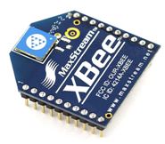
Compared to other wireless technologies such as Bluetooth, Zigbee offers a cost-effective and a low power consumption wireless technology with low data transmission rate. However, patient monitoring does not require high speed data transmission and therefore, its low cost and low power consumption makes Zigbee ideal for use in wireless patient monitoring devices.

1.2 General specifications
To limit power consumption and weight of the remote unit, a low-voltage system was desired. The XBee module can be powered between 2.8-3.4 V and draws a typical current of 45 mA when transmitting and 50 mA when receiving data. It is specified to transmit data up to 100 ft. (30 m) indoors and up to 300 ft. (100 m) outdoors. For the purpose of this project, this is an adequate range capability, though MaxStream also produces the XBee Pro module, which would seamlessly replace the XBee module and increase the indoor range up to 300 ft. However, this will increase the power consumption and therefore reduces the battery life.
The serial data baud rate of the module ranges between 1200-115200 bps. The largest concern in choosing the baud rate is ensuring that all ECG data points, which comprises of the majority of the data, can be transmitted. The sampling rate for the ECG waveform used for the project is 620 Hz. Since an 8 bit analogue to digital converter (ADC) was used, each second of data was represented by approximately 5000 bits. By setting the baud rate to 9600 bps, successful transmission of ECG data was accomplished.

1.3 Programming the XBee module:
We can program the XBee module in two ways and both are efficient, by using hyper terminal of the pc, or by using the XCTU software (as shown in the figure below).
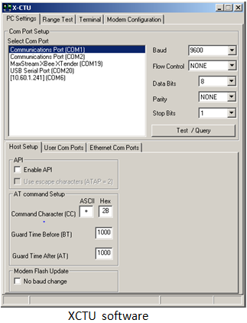

The same instructions are used in both ways; here are some examples about the instructions used in programming XBee:

1.4 Testing:
Preliminary testing of the modules was conducted using the XBee development boards and HyperTerminal to establish simple two-way communication between two PCs. The next step involved using a PIC microcontroller to transmit to a PC via the XBee modules. Finally, the destination addressing was tested in the presence of other modules and it was confirmed that data was sent solely to the desired destination.
The figure below shows the configuration of the two XBee modules to communicate between them.
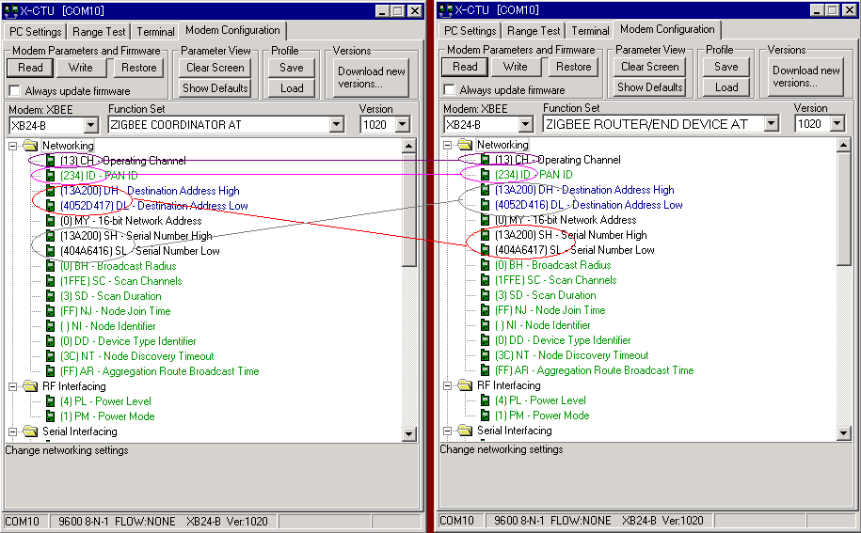

Chapter Two
Remote Unit
The remote unit is a compact portable module that integrates multiple physiological sensors such as electrocardiogram electrodes, a body temperature sensor and a pulse oximeter.

Part One: Sensors.
2.1.1 Temperature sensor
The temperature sensor used in the project for measuring body temperature is “LM35DZ”
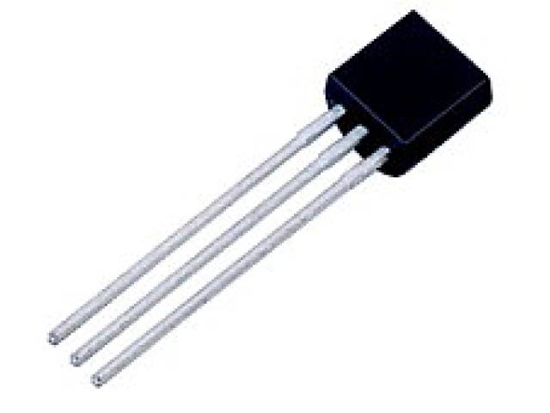
The LM35 series are precision integrated-circuit temperature sensors, whose output voltage is linearly proportional to the Celsius (Centigrade) temperature. The LM35 thus has an advantage over linear temperature sensors calibrated in ° Kelvin, as the user is not required to subtract a large constant voltage from its output to obtain convenient Centigrade scaling. The LM35 does not require any external calibration or trimming to provide typical accuracies of ±¼°C at room temperature and ±¾°C over a full -55 to +150°C temperature range. Low cost is assured by trimming and calibration at the wafer level. The LM35's low output impedance, linear output, and precise inherent calibration make interfacing to readout or control circuitry especially easy. It can be used with single power supplies, or with plus and minus supplies.

2.1.1.1 Features and advantages:
• | Calibrated directly in ° Celsius (Centigrade).
• | It has an output voltage that is proportional to the Celsius temperature.
• | Linear + 10.0 mV/°C scale factor.
• | 0.5°C accuracy guaranteeable (at +25°C).
• | Rated for full -55° to +150°C range.
• | Suitable for remote applications.
• | Low cost due to wafer-level trimming.
• | Operates from 4 to 30 volts.
• | The output voltage is converted to temperature by a simple conversion factor.
• | Less than 60 µA current drain.
• | Low self-heating, 0.08°C in still air.
• | Nonlinearity only ±¼°C typical.
• | Low impedance output, 0.1 Ohm for 1 mA load.
• | You can measure temperature more accurately than a using a thermistor.

2.1.1.2 How we calibrate it???
We read a value from the L35DZ but this value was not accurate 100%, then we have a thermometer and we read the accurate value by using it, then we calculate the factor between the accurate and the non accurate value, and by using PIC micro controller we multiply this factor by the output value from the temperature sensor.

2.1.2 Pulse Oximeter Sensor (P.O)
Before start talking about P.O here are some definitions:
Diastole- relaxation of heart muscles
Reduced hemoglobin (Hb) - hemoglobin unbound to oxygen molecule. Oxygenated hemoglobin (Hb02) - hemoglobin with a bound oxygen molecule.
Sp02- pulse oximeter measurement Sa02- arterial blood's actual oxygen
Systole- contraction of heart muscles.
2.1.2.1 What is the pulse oximeter?
A pulse oximeter is a medical device that indirectly measures the oxygen saturation of a patient's blood (as opposed to measuring oxygen saturation directly through a blood sample), or to monitor the oxygen level of a patient's blood.
2.1.2.2 Principles of pulse oximetry:
A pulse oximeter sensor shines light of two different frequencies through a capillary bed such as the finger and the ear lobe. The two frequencies of light, red (660 nm) and infra red (940 nm) are chosen so that there is a large difference in the absorption of these lights by oxygenated and reduced hemoglobin. The opaqueness of the Hb and HbO₂ for a light of certain frequency is called its extinction coefficient. The extinction coefficient of Hb and HbO₂ for various frequencies is shown in the figure below.
As seen from the figure, while the extinction coefficient of HbO₂ is higher than that of Hb at infrared frequency (940 nm), the reverse is true at 660 nm. This implies that if SaO₂ increases, the absorption of infrared light will increase while the absorption of the red light will decrease.
The light transmitted through the tissue bed is absorbed by tissues and bones along with components of the blood. Therefore, it is necessary to distinguish between the tissue/ bone absorption and absorption by hemoglobin. The pulse oximeter takes advantage of the pulsatile nature of the arterial blood for this purpose. The absorption of light by hemoglobin increases during systole and decreasing during diastole. The total absorption of light comprises of a DC component caused by tissues, bones and non-pulsating arterial blood and an AC component due to the changes in the arterial size during systole and diastole.

2.1.2.3 Pulse oximeter circuit
Oximax pulse oximeter sensors from Nellcor are designed to be used with pulse oximetry monitors. Since no datasheets or technical information was available about the sensors, one of the sensors was taken apart and its components were tested and their operation analyzed. The sensor consisted of two LEDs, red and infrared, a photodiode and copper shielding with small slits for the photodiode. The copper shielding is placed in order to reduce error due to electromagnetic interference.
The two LEDs are arranged in parallel to each other in opposite orientations such that only one LED turns one at a time. When light from the LED falls on the photodiode, it allows current to pass through it depending on the intensity of the light. This was verified using a resistor in series with the photodiode which resulted in a voltage drop across the resistor when the LED was turned on.
The pulse oximeter sensor was equipped with a RS-232 male port to make it compatible with commercial pulse oximeter monitors. The connections of each of the pins of the port are shown in Table1.
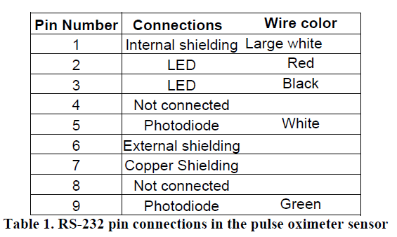

2.1.2.4 Block diagram of pulse oximeter circuit
In a pulse oximeter sensor, the timing of the two LEDs, red and infrared, is controlled such that only one of the two LEDs is on at a time. This control was acquired using a microcontroller which was programmed such that LEDs switched about 200 times per second. The output of the photodiode due to the incident light from the LEDs was then processed using analog circuitry shown in Figure below.

2.1.2.5 Theoretical calibration curve
In order to account for different emission intensity of red and infrared LEDs, the measured light intensities have to be normalized. This normalization is done by dividing the transmitted intensities with the by the peak transmitted values of each wavelength. The ratio ‘R’ is then calculated as follows
R= ln (IL,R/ IH,R) / ln (IL,IR/ IH,IR)
Where IL,R = normalized least transmitted red light
IH,R = normalized maximum transmitted red light
IL,R = normalized least transmitted infrared light
IH,R = normalized maximum transmitted infrared light

The functional oxygen saturation can be calculated from the ratio R using the following equation:
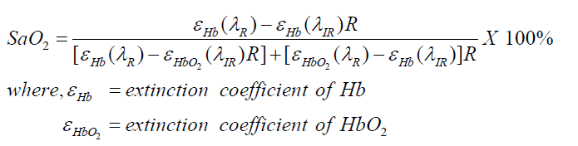

Other references say to calculate oxygen saturation from the formula shown below: 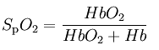
2.1.3 ECG Sensor
The electrocardiograph is an instrument used to produce a graphic representation of the electrical activity of the heart, the electrocardiogram (ECG or EKG), as measured by body-surface electrodes. It is an invaluable tool in the diagnosis of cardiovascular diseases, the monitoring of patients while under anesthesia, and occasionally used for the diagnosis of non-cardiac diseases.
The activity of the heart can be approximately modeled by an electric dipole, also called the cardiac vector. The magnitude and orientation of the dipole characterize the current state of the heart along the cardiac cycle. To measure these qualities, lead vectors are defined such that, when electrodes are placed along two different vectors that lie in the same plane as the cardiac vector, it can be fully defined

2.1.3.1 ECG signal
The electrocardiogram is typically composed of three separate components:
[1] P wave
[2] QRS complex
[3] T wave
2.1.3.2 How this produced:

A single heart beat begins when an electrical signal from the S-A node in the atria propagates throughout both atria. This signal depolarizes the atria, therefore causing them to contract and force blood into the ventricles. On the ECG, this is seen as the P wave. The ventricles follow the same fashion when an electrical signal from the A-V node depolarizes both ventricles, causing them to contract. This electrical activity is displayed in the ECG as the QRS complex. Finally, the ventricles return to their previous state and prepare for the next contraction, resulting in the depolarization wave, the T wave. Depending on which lead is being examined, the clarity and magnitude of the individual waves varies.

2.1.3.3 Normal parameters
*Heart Rate: 50 - 100 beat / min
*P-wave: 0.08 – 0.12 sec
* QRS complex: 0.06 – 0.08 sec

Any values out of these standard values cause diseases, For example:
Normal sinus rhythm for leads I, II, and III. Note that the peak-peak distance is approximately 3 divisions (0.20 seconds per division).

Tachycardia. Note that the peak-peak distance is approximately 2 divisions (0.20 seconds per division)
Bradycardia. Note that the peak-peak distance is approximately 7 divisions (0.20 seconds per division)

2.1.3.4 Electrical Diagram

* Single-supply op-amps and virtual ground

This circuit used in order to display the oscillating AC signal correctly, because the signal may oscillate from positive to negative.

In this circuit we use TLV2774 op-amps as
• Single-supply
• Rail-to-rail output
• Low supply current of 1mA

The op-amp is configured as a voltage follower with resistors R8 and R9 serving as a voltage divider to divide VDD in half.
The capacitor is a bypass capacitor that serves to reduce the effect of non-uniform current draw on the op-amp by the rest of the circuit

2.1.3.5 Electrodes

To acquire the ECG, 3M soft cloth Red Dot electrodes are used. These are body-surface electrodes that use an Ag/AgCl interface to transmit the biopotential signal. The metal does not directly contact the skin, but a solid-state electrolytic gel is used to ensure good electrical contact without the mess of a more liquid-based gel. The backing is a breathable, stretchable cloth for patient comfort and to maintain good contact when the patient moves.

2.1.3.6 Instrumentation amplifier
To characterize lead I, the potential difference across the chest must be measured. To this end, an instrumentation amplifier was employed. At the front end of the amplifier, a passive AC-coupling circuit is the first step to cutting out any DC offset potential that may be present in the patient’s body or at the electrode-skin interface. To avoid drawing too much current and distorting the signal, an instrumentation amplifier uses a voltage-follower-with-gain op-amp at each input, thereby ideally drawing zero current from the patient’s body.
The passive AC-coupling circuit was implemented as suggested by Spinelli, etc. al to maintain a high common mode rejection ratio for the instrumentation amplifier while consuming no additional power
To reduce the amount of gain that must be obtained from the difference amplifier stage of the instrumentation amplifier, the first stage amplifies the difference signal before passing it to the second stage. The common-mode is passed through the first stage, but not amplified. The gain varies according to the 100 kΩ digital potentiometer placed between the positive terminals of the two op-amps. A digital potentiometer functions as a variable resistor whose value can be set by a microcontroller. The gain for the first stage is found to be,

With the resistor values in this configuration, the first stage ideally can have a gain of 10 to ∞.
2.1.3.6.1 First stage of instrumentation amplifier

The second stage of the instrumentation amplifier further amplifies the signal and rejects the common-mode of the signal. This stage is composed of a single difference op-amp. The gain that can be obtained from this stage can be calculated, Combined with the gain from the first stage, the entire system has a gain from 51.1 to, again ideally, ∞. The ECG signal ranges from 0 to around 1 mV in amplitude. Therefore, to amplify the signal to a usable range of 0 to around 2 V, a gain of approximately 2000 is necessary. Thus, the circuit was designed so that the potentiometer’s value can increase or decrease so that the circuit can adapt to signals with amplitudes either greater or less than the average.
2.1.3.6.2 Second stage of instrumentation amplifier

The Common-Mode Rejection Ratio (CMRR) has been calculated to be 62.9 dB

2.1.3.7 Filters:

The difference signal obtained from the instrumentation amplifier still contains a large amount of noise.

2.1.3.7.1 BPF
The ECG contains frequencies ranging from about 0.05 Hz to 1 kHz, but an electrocardiograph with a frequency response of 0.05 to 150 Hz can produce a well-defined ECG.
We use the cut-off frequencies, ω_{L} and ω_{H,} are 0.048 Hz and 159.2 Hz respectively
Bode plot for the band-pass filter.

2.1.3.7.2 LPF
The band-pass filter still permitted an unacceptable amount of high-frequency noise to distort the signal. Although the band-pass filter had a cut-off at 159.2 Hz, high-frequency noise was not being attenuated sufficiently.
By putting previous values we obtain:
Bode plot for the 2nd order low-pass
2.1.3.7.3 Driven-right-leg circuit:
This circuit functions as a negative feedback loop to reduce the transmission and amplification of the common-mode portion of the signal.

All the operations in the remote unit such as data sampling and communicating with the integrated wireless module are controlled by a microcontroller.
Part Two
Programming the PIC

2.2 PIC MICROCONROLLER

2.2.1 GENERAL CHARACTERISTICS:

The basic requirement for microcontroller to be incorporated in the remote unite are listed below. To meet these requirements the PIC16LF877A was chosen.

- LOW OPERATING VOLTAGE _the max operating voltage of the xbee module is 3.4V. This makes it imperative for the microcontroller to operate with a source less that 3.4 V. The PIC16LF877A has a wide operating voltage range from 2.0 V to 5.5V. This feature makes it compatible with a low voltage source.

- 8-BIT ANALOG TO DIGITAL CONVERTER_ the analog to digital converter in the PIC16LF877A can be set to either an 8 bit or a 10 bit ADC.

- 3-ADC channels_ for continuous monitoring of temperature, ECG and blood oxygen saturation, the microcontroller has to be equipped with at least three ADC channels. The PIC16LF877A has 8 ADC channels.

- Universal Synchronous Asynchronous Receiver (USART) _This feature is required to send the sampled data to the XBee module serially for wireless transmission to the base unit.

- TIMERS_ the PIC16LF877A provide 3 timers.

The PIC microcontroller is programmed to control the physiological data collection and the patient alarm system. All of these operations require controlled timing which was achieved by the use of timers. The following flow chart show the process which done by using pic.

READ ADC CHANELS
Ready to transmit?
Write data to USART
NO

YES

Flowchart demonstrating how pic controls the overall process.

2.2.2 Patient alert system:
This feature is incorporated in the patient monitoring system design to alert the patient if any of the physiological parameters that are being monitored are out of normal range. The alarm informs the patient to either contact the doctor or restrain activity that might have induced cardiac activity which poses a danger to the patient.
The alarm settings are based on the threshold values that are set by a doctor using the graphical user interface. When the physiological parameters are beyond the threshold, the interface communicates with the remote unit wirelessly to initiate a buzzer.
The PIC microcontroller in the remote unit controls the patient alarm system. When an alert notice is received from the base unit, the microcontroller turns on the buzzer. The buzzer-snooze pushbutton available to the user allows the patient to turn off the buzzer once he or she is informed of the situation. However, after 30 seconds of “snooze” time, if the monitored parameter is still beyond the specified threshold, the alarm is re-initiated. The flowchart summarizes how the alarm system works.

Flowchart describing the patient alert system.

The circuit set up for the alarm system is shown in Figure:

The circuit set up for the alert system with the buzzer-snooze pushbutton.

Chapter Three
Base Station (PC)

The base station of the monitoring system includes a wireless-module connected to a computer that receives data from the remote unit and a MATLAB-based graphical user interface (GUI) that processes and displays the physiological data.

In the base station unit we receive data from the remote unit by using XBee module, we connect the XBee module to DTE board (as shown in the figure below) , and the DTE board connected to the PC by using serial connection, and the data is shown to the screen of the computer on the GUI made by matlab.
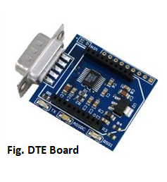

3.1 Graphic User Interface (GUI)

We want to use Matlab program to display our results. This is as a result of the MATLAB programming environment is flexible and there are many ways to achieve the same functionality, especially in GUI programs.

The GUI is divided into three main categories.
1. Main panel.
2. Display panel.
3. Communication Settings panel.
4. Alarm Settings panel.

3.1.1 Main panel
This panel contains the name of the main topics of panels as display panel, communication Settings panel, and alarm Settings panel.

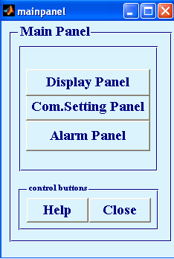

3.1.2 Display panel
All the physiological parameters recorded from the sensors are displayed in this panel. These include the body temperature, the heart rate, the width of the QRS complex, of the ECG wave of the patient, and the percentage of the oxygen saturation of the blood.

Also the panel consists of a panel for ECG wave display. The ECG waveform display is almost real time as it is updated every five seconds, while the values of heart rate, widths of QRS of the ECG, and the percentage of the oxygen saturation of the blood are updated every twenty five seconds.

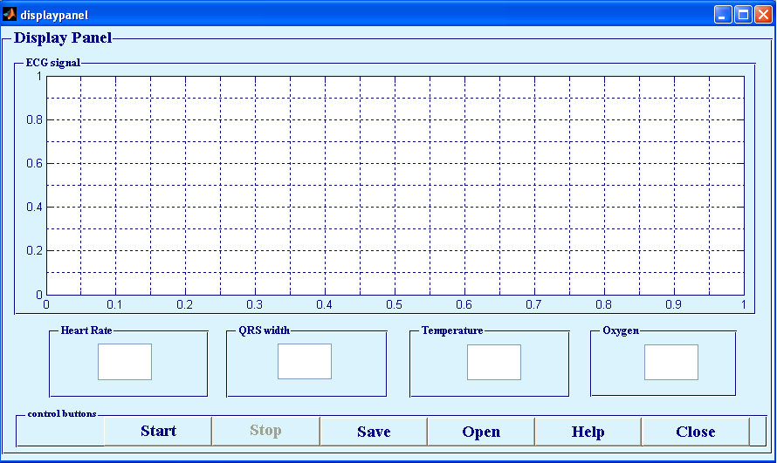

3.1.3 Communication Settings panel
This panel contains all the fields necessary for communication with the XBee module and for sending the patient data to the doctor. The server settings and email addresses required to send the collected physiological data are also specified in this panel. Under the email settings, the user needs to enter a password for the sender’s email address. To ensure security, the password field is masked with asterisks. Finally, the panel also offers an “auto-email send” feature, which automatically sends the patient data by email upon end of data collection.
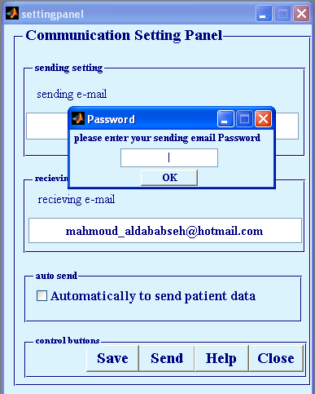

3.1.4 Alarm Settings panel
This panel is constructed to determine the thresholds of all of the physiological parameters as the body temperature, the heart rate, the width of the QRS complex, and the percentage of the oxygen saturation of the blood .
This panel is specified only for the doctor who monitors the state of patient.

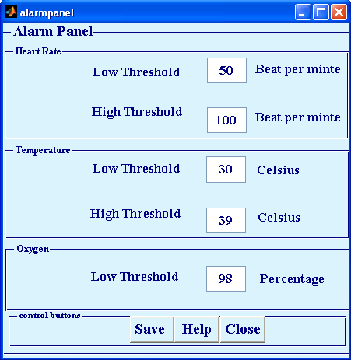
This panel is specified only for the doctor who monitors the state of patient.

All panels contains Help panel which can identify the function of each button in the panel.

Below figure is an example of help panel of alarm setting panel.
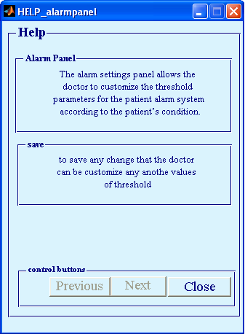

Chapter Four
Signal Processing
4.1 Data processing:
The stream of data received by the XBee module connected to the base station contains the ECG, the temperature data, and the pulse oximeter data. The interface collects 3000 data points, approximately 5 seconds of data, each time it reads the serial port buffer. The parsing algorithm used on these 3000 data points is based on controlled amplification of the ECG signal by the digital potentiometer and the event flag used for the temperature data in the PIC microcontroller. The digital potentiometer in the ECG processing circuit ensures that the gain of the ECG is such that analog-to-digital converter (ADC) value is always less than 255. Therefore, if an array of 3000 data points contains a ‘255’, the event flag, the algorithm recognizes the value that immediately follows the flag as temperature data , and ‘254’, flag of pulse oximeter data .

4.2 ECG processing:
4.2.1 Heart rate
To calculate the heart rate, the R wave was used to identify a single heart beat. The QRS complex peaks just once per heart beat and so it can be used to calculate the time between heart beats. Two characteristics of the R wave were used to identify it: a voltage threshold and the slope of the surrounding points.

Since the ECG was being processed with a circuit with adaptive gain, the peaks of the QRS complex are always within the same range. Thus, a voltage threshold can be used to search for the exact R peak. Figure below demonstrates this first filtering step. Any points along the ECG waveform that are not above the voltage threshold are not considered as possible R peaks.

Figure. Voltage threshold filtering for R peak identification

The next step in finding the R peaks is to examine each point that is above the threshold and calculate the slope of the best line fit of the four points before and after the point being considered. This is done with MATLAB’s polyfit command. The slope of the fit is then compared to two thresholds that were determined from examples of ECG data. The point that represents the R peak must have a “before” fit with a positive slope between 1 and 8 and an “after” fit with a negative slope between -1 and -8. The array index of the R
Peak is then saved for later reference. To ensure that only one point per heart beat is specified, once a point is designated as the R peak, the code will ignore the next 1/10 of a second of data. Figure below outlines the entire R peak search process.

Figure 40. R peak search flow chart.

4.2.2 QRS complex width

To calculate the QRS complex width, the Q and S points must be known. As can be seen in Figure, these points lie on either side of the R peak and are junctions at which the slope of the ECG waveform sharply changes, with respect to the R peak, from negative to positive. To reduce the effect of noise, the entire ECG data set is passed through a digital median filter with a window of 5 points. This process eliminates outliers that may disrupt the search for the Q and S points. It could not be performed earlier because the very nature of R peaks is exactly what the filter eliminates.
Once the R peaks have been identified, each complex is searched to find the Q and S points. A technique similar to that used to find the R peaks is employed for each. Starting from the R peak, each point of the complex on either side of the peak is examined and the slope of the best line fit of the four points on the side opposite of the R peak is calculated. If the slope reaches a certain threshold, determined from examples of ECG data, that sample is designated the Q or S point, depending on which side of the complex is being processed. For the Q point, the best line fit slope must be less than 1; for the S point, it must be greater than -0.5
To improve the search speed, a modification was attempted that used previous Q and S point locations to approximate the search start location for the next Q and S point locations. This modification averaged the R-Q and R-S distances of the previous data set and divided that distance in half. Thus, the search would start at the approximate midpoint of each slope of the QRS complex instead of at the R peak. However, after comparing processing time both with and without the modification, it was found that this addition did not show any speed improvement. Instead it seemed that variation in the processing usage of the PC had more of an effect. Therefore, to maintain as simple of a code as possible, the modification was not included and the Q and S search always start at the R peak.
This algorithm required extensive testing and revision. Since values for the threshold slopes were based on empirical data, they had to constantly be tested and modified. Also, the algorithm evolved greatly to accommodate all foreseen situations. Due to the fact that four data samples are used with the polyfit command, certain restrictions must be considered. For the Q point search, the first four samples before the R peak are ignored. In the S point search, the last four samples of the data set are ignored. This situation is acceptable unless the QRS begins (Q point) or ends (S point) within those eight ignored samples. These cases are treated just as if the points were truncated, as explained next.
For a given set of data, it is possible that the ECG was captured such that either the Q or S point of a given QRS complex was truncated, depending on the timing of the data set collection. In these cases, the Q and S points are set as the first or last data samples of the data set. Although this results in a shorter QRS complex width, the effects of this inaccurate measurement are mitigated by the averaging of several QRS calculations. This compromise is necessary as the first iteration of the algorithm would often freeze in the attempt to find a Q or S point that did not exist in the given data set. The final resulting algorithm and its implementation is shown in Figures 41 and 42 respectively.
Using the array indices of the Q and S points and the known sampling rate of the data, the time that passes between the two can be calculated. The average over approximately 25 seconds is then displayed in the GUI.

Figure 41. Q and S point search flow chart

Figure 42. Example Q point search.

4.3 Body temperature processing:

From datasheet of LM35DZ we see that
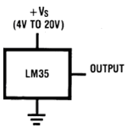

V OUT =+1,500 mV at +150°C
= +250 mV at +25°C
= −550 mV at −55°C

We use 8 bit ADC ➔ 0-255
If Vref = 5v
So, accuracy = ( Vmax-Vmin )/ (2^n - 1 )
Where: Vmax= Vref =5v
Vmin = 0
n= number of bits=8bit

➔ Accuracy=0.02v

if result of ADC is X
then the value of voltage = 0.02 * X
with +0.250 V at +25°C

then TEMP BODY = 0.02*X*25/0.25 = 2X

4.4 Pulse Oximeter processing:

As seen in body temperature body 8 bit ADC gives accuracy 0.02v

From formula
SPO2=H2b/( H2B+Hb )

Where: H2b = output voltage of ADC multiply by accuracy
Hb = 0.5v as suggestion

