CHAPTER ONE

INTRODUCTION

This chapter is devoted to make a review for the site and the project. Also, at the end of this chapter, The scope of this project is stated precisely.

  - THE SITE

Tulkarm city lies in the north side of the west bank in Palestine, Tulkarm city has an area of 13790.351 donum, and about 36000 person living in it. The famous streets in Tulkarm are: Nablus st. , Al- nozha st. , shweka st. , bareese st. , yafa st. and the hospital st.
Tulkarm city has a good whether specially in winter it is almost worm, Tulkarm has so many schools, commercial building and mosques. Tulkarm has two types of soil: clay and limestone.Our project lies on a basin number 8199, parcel number 111 and has an area of 400 (m^2).
The site is located at the center of Tulkarm city. It has a beautiful site due to the wide road in front of the project is, This road is long and full with green trees.
The site is boarded from the north by the governmental hospital, in the south side by small normal building used for offices and commercial purposes, in the east side boarded by AL-Adawiya school and in the west side Dea’bas mole and AL-Salam T.V. center.
This site is very important because it lies in the center of the city, it is very close to the largest hospital in the city, the road is almost the largest one in Tulkarm and the commercial movement is very active there.
In general the site takes the following considerations:
- Simplicity to reach from the major street.
- Available of the puplic services such as electricity, water and sewer networks.

  - THE PROJECT

The project consists of the construction that is a six story building with a plan construction area (320 m^2).The site is located to south of Tulkarm governmental hospital. by a 12 m street from the west and a playing ground from the east.
No high voltage, electrical or telephone poles, sewer or water pipes were observed within the depth of the drilled boreholes.The formation within the depths of the drilled boreholes consists mostly of formation of marlstone covered by a layer of silty clay deposits.No groundwater and no cavities.
The project divided to six stories, the first two floors used to storage the electric, mechanical equipments and the archive.
The remaining floors contain offices and multi – purpose halls.
Clear from the general location of the project that the building is located on the street and this much easier for citizens who visit the mall, but for the offices is characterized the relationship of rooms to each other as easily and smoothly, thereby the independence of the rooms from each other and non-overlapping events, which take into account the nature of Human Movement and its needs, connecting rooms on the same floor corridors, linking the various floors of drawers mobile working to provide vertical movement between the different decks and facilitate access to different levels.

  - The scope

- Evaluation of the foundations.
- Selection of the proper foundations of the project.
- Design of foundations:
- Isolated.
- Shear wall.
- Retaining wall.

CHAPTER TWO

Background

We will talk in this chapter about problem we may find in the field when perform the work, Bearing capacity, Field testing, Laboratory testing, And types of foundation.

  - THE PROBLEM WE MAY FIND IN THE FIELD

Possible that there is a difference between the original design of the foundations of the project and the design applied to reality and because of differences in soil quality or durability and other variables that govern us in the design.
For example, in the halls of Ihsan Samara and Al Asma’e school was the original design isolated footing On the basis that the bearing capacity in the soil of Tulkarem ranged between (2.5-3) kg/cm^2 but in the fact the applied design is mat foundation because red clay to great depth and low value of bearing capacity.
In halls of Rasem kmal the original design is piles which is diameter equal 80cm knowing the school ground located next to the valley therefore its red clay but when we start the excavation work and taking samples of soil for testing shows that Qall assumed>Qall real and friction factor=1 then we redesign the foundation on the basis of piles But the depth and diameter greater than the initial design.
Finally, The project to establish the unity of public health in the city was the initial design mat foundation because the soil was weak there, after drilling showed that the soil of existing soil and there is no poplar (rock) only in a few areas to great depths Thus the design applied in reality isolated footing with Qall=1.5 kg/cm^2 after drilling to the depth 2m, Pour a layer of rubble and concrete (40 cm) instead of pouring hygiene (10 cm) of the work of the bottom layer of constituent rules .
One building has been constructed at the same time which is the sports hall.
The soil in our project is silt clay-marlstone and no ground water and no cavities there, but the soil in sports hall is Coastal clay soil and there is a groundwater soil is very weak, and get there a permanent decline in soil.
There are three-storey building mobile access, is currently under the ground floor and ground floor and first floor, The Sports Hall is the settlement of ground floor only, but high and there are ramps and trusses.
There is a single gateway for building mobile and is situated opposite the main street in front of the building is the western facade, but it facing the sports hall is also one which is in the eastern facade.
The importance of building mobile accommodated technological needs of the people and facilitate people communicate in different age groups, the gymnasium, they take into account the needs of youth sports, recreational and work to raise the level of youth sports.
This site is one of the most important sites in Tulkarem, located almost in the center of the country, which makes it easier for people to access and benefit from its services, while is the gym closed near the building of cultural club in the north in the area of urbanization, the future of the town and close to the Magistrate's Court and the Directorate of Education and Higher Education, which This will make the site more important in the near future.
In our project used isolated footing or continuous footing with tie beams, but in closed sports hall must use pile foundation because the soil is very weak.

  - BEARING CAPACITY ANALYSIS

Because of that the Terzaghi’s equations are just for continuous ,square and circular foundations .And they do not take into account the shearing resistance of the failure surface in soil above the bottom of the foundation .Also the load may be inclined on the foundation .Meyerhof (1963) suggested the following form for the bearing capacity equation:
qu = c’NcFcsFcdFci + qNqFqsFqdFqi + ½ γBNγFγsFγdFγi
where:
c’ = cohesion
q = effective stress at the level of the bottom of the foundation
γ = unit weight of the soil
B = width of the foundation
Fcs,Fqs,Fγs = shape factors
Fcd,Fqd,Fγd = depth factors
Fci,Fqi,Fγi = load inclination factors
Nc,Nq,Nγ = bearing capacity factors

2.3 TERZAGHI’S BEARING CAPACITY

The ultimate load which a foundation can support may be calculated using bearing Capacity theory. For preliminary design, presumed bearing values can be used to indicate the pressures which would normally result in an adequate factor of safety. Alternatively, there is a range of empirical methods based on in situ test results.
Terzaghi was the first to present the comprehensive theory for the evaluation of the ultimate bearing capacity of shallow foundations .He suggested that the shallow foundation is the that foundation of depth Df less than or equal to its width.
Also terzaghi suggested that for continuous or strip foundations that its width to length ratio approaches zero ,the failure surface in the soil at the ultimate load will be like the shown in figure 1 .The effect of the soil above the foundation bottom may be replaced by equivalent surcharge .
The ultimate bearing capacity (qf) is the value of bearing stress which causes a sudden catastrophic settlement of the foundation (due to shear failure).
The allowable bearing capacity (qa) is the maximum bearing stress that can be applied to the foundation such that it is safe against instability due to shear failure and the maximum tolerable settlement is not exceeded. The allowable bearing capacity is normally calculated from the ultimate bearing capacity using a factor of safety (Fs).

The zone of failure under the foundation separates into three parts:
1) The triangular zone DEF immediately under the foundation
2) The radial shear zone CDE and EFG
3) Rankine triangular passive zones BCD and FGH
From the equilibrium analysis, Terzaghi expressed the ultimate bearing capacity as the following:
qu = c’Nc + qNq + ½ (γ BNγ) ( for continuous foundation )
where:
Nc, Nq and N γ, which are related to the angle of friction (Φ´).
c = apparent cohesion intercept
qo = γ D (i.e. density x depth)
D = founding depth
B = breadth of foundation
γ = unit weight of the soil removed.
qu = 1.3c’ Nc + qNq + 0.4 γ BNγ ( square foundation)
and
qu = 1.3c’ Nc + qNq + 0.3 γ BN γ (circular foundation)

2.4 MODIFICATION OF BEARING CAPACITY EQUATIONS FOR WATER TABLE

The previous equations are applied for foundations that are well above the water table.
So if the water table is closer to foundations, some modifications on the bearing capacity equations should be applied.
Case 1: if the water table is above the bottom of the foundation (0 < D1 < Df)
The factor q in the bearing capacity equations takes the form
q = effective surcharge = D1 γ + D2 (γ sat - γ w )
Where:
γ sat = saturated unit weight of soil
γ w = unit weight of water
Also the value of γ is the last term of the equations has to be replaced by
γ’ = γ sat - γ w
Case 2: for the water table under the bottom of the foundation by a distance d less than the foundation width B ( 0 < d < B )
q = γ Df
In this case, the last factor of the equation γ should replaced by the factor
γ f = γ’ + d/B (γ γ’ )
These modifications are based on that there is no seepage force on the soil.

Case 3 : When the water table is located so that the depth of the water table is more than or equal of the width of the foundation ( d > B ) ,the water will have no effect on the ultimate bearing capacity.

2.5 FIELD EXPLORATION AND TESTING

1) Drilling
The site investigation program proposed by HCL and agreed upon with the client included the exploration of site subsurface condition at the construction area through the drilling of three boreholes :two to a depth of 8 .0 m each and one borehole to a depth of 12.0 m below the existing ground level on the date of exploration.
Drilling has been carried out utilizing a truck-mounted drilling rig (mobile Drill B-31) with the possibility of continuous sampling at different depths and at each litho logical change of the strata.
2) Sampling
Due to the nature of the encountered marlstone, mostly within the whole depth of drilling, it was difficult to obtain undisturbed samples, As a practically acceptable solution, disturbed samples suitable for identification and index property testing purposes were sampled at various depths. Samples required for strength tests were remolded in laboratory conditions.
Representative samples were placed in sealed plastic bags and transported to the laboratory for future testing.

2.6 LABORATORY TESTING

Representative soil and rock samples were collected from the drilled boreholes, tightly sealed and transported to HCLs Laboratories in Nablus.
1) Natural moisture contents were determined in accordance with ASTM D-2216.
2) Grain size distribution (sieve analysis) in accordance with ASTM D-422.
The obtained cuttings were washed on sieve No.200.
3) Atterberg limits (Liquid and Plastic) in accordance with ASTM D-4318.
Liquid and plastic limit tests were conducted on the power of the obtained samples and the plasticity index (PI) was determined.
4) Direct shear test (on remolded samples from the cuttings of the soft marlstone) in accordance with ASTM D-3080, where three identical specimens were sheared under three vertical load conditions and the maximum shear stress in each case was measured. The strength parameters, namely cohesion (c) and angle of friction (φ) were determined from the maximum shear-vs-normal stress plot.

2.7 TYPES OF FOUNDATIONS

1. Shallow Foundation:
Shallow foundations are those founded near to the finished ground surface; generally where the foundation depth (Df) is less than the width of the footing and less than 3m. These are not strict rules, but merely guidelines: basically, if surface loading or other surface conditions will affect the bearing capacity of a foundation it is 'shallow'.
a. Isolated Foundations (Pad Foundations):
Isolated foundations are used to support an individual point load such as that due to a structural column. They may be circular, square or rectangular. They usually consist of a block or slab of uniform thickness, but they may be stepped or hunched if they are required to spread the load from a heavy column. isolated foundations are usually shallow, but deep isolated foundations can also be used.

b. Strip Foundations
1. Typical use
Strip foundation normally provide for loads bearing walls, and for rows of column which are space so close that pad foundation would nearly touch each other.

2. Advantages & Disadvantage
It is more economic to excavate and concrete the strip foundation that to work in a large number of individual pits. In fact, it is often thought to be more economical to provide a strip foundation whenever the distance between the adjacent square pads is less than the dimension of the pads, and for ease in construction closed spaced pad foundation can be formed by inserting vertical joints in a continuous strip of concrete. This foundation won't apply for low bearing capacity soil. The working procedure is too much such as diging, framing and other is the weakness.

3. Typical parameter
The width depends on the hardness of soil and the load on it. The minimum strip width is 450mm. It’s enough for two stories building on the normal standard soil. The minimum dept is 150mm.

4. Narrow strip or Deep strip footing
This type of foundation is used for normal soil and normal loads which just need 0.9m depth, cheep in cost construction.
The essential feature of the narrow strip foundation is that the trench is too narrow to be dug by labors working in trench. It depends for its success in the ability of a mechanical excavator, such as a light tractor-mounted back-actor with a narrow bucket to dig the trench, which must be self-support until it can be backfill with concrete.
It can’t be economical be use in very soft clays or water bearing sand which support by close timbering.

5. Wide strip footing
These type of foundations are necessary where the bearing capacity is low enough to necessitate where the bearing capacity of the soil is low enough to necessitate a strip so wide that transverse bending occur in the projecting portion of the foundation beam and reinforcement is required to prevent cracking. Fr heavy loads on it, the wickedness is shear force under the concrete footing should overcome by steel bar.

6. Stepped foundation
It need no necessary be at the same level through the building. The step should be lap for a distance at least equal to the thickness of the foundation or twice the height of the step whichever is the greater. The step should not greater height than the thickness foundation unless special precaution is taken.

7. Reinforced concrete strip foundation
They are likely to show an advantage in cost over un reinforced concrete where weak soil and un reinforced loading and heavy wall loading require a width strip at a comparative shallow depth. Reinforced in longitudinal bars is also desirable in strip foundation on highly variable soils when the foundation is enabling to bridge over local weak or hard spot in the soil at foundation level or when there is no change in loading. The main reinforcement takes the frames of bars at his bottom of the slab. The slabs also design to withstand shear and stress.
Bending moment,
Mb = ( qn x b2 )/2 kNm per m length of wall
Shear stress,
S = ( qn x b’ )/d N/mm2

c. Combined Foundations
A combined footing is usually used to support two columns of unequal loads. In such a case, the resultant of the applied loads would not coincide with the centroid of the footing, and the consequent the soil pressure would not be uniform.
Another case where a combined footing is an efficient foundation solution is when there are two interior columns which are so close to each other that the two isolated footings stress zones in the soil areas would overlap.
The area of the combined footing may be proportioned for a uniform settlement by making its centroid coincide with the resultant of the column loads supported by the footing.

There are many instances when the load to be carried by a column and the soil bearing capacity are such that the standard spread footing design will require an extension of the column foundation beyond the property line. In such a case, two or more columns can be supported on a single rectangular foundation. If the net allowable soil pressure is known, the size of the foundation B x L can be determined.
The use of combined footings helps spread out the loads out to the adjacent footings in order to minimize stresses in the footings and reduce the differential settlement between them.
A third case of a useful application of a combined footing is if one (or several) columns are placed right at the property line. The footings for those columns can not be centered around the columns. The consequent eccentric load would generate a large moment in the footing. By tying the exterior footing to an interior footing through a continuous footing, the moment can be substantially reduced, and a more efficient design is attained.
A combined footing will deform as shown in the fig (2.1) . The eccentric loading condition upon the left end, due to the restrictions of a property line, will generate tensile stresses on the top of the footing. These stresses mean that a combined footing will require flexural reinforcement both at the top and the bottom of the footing.

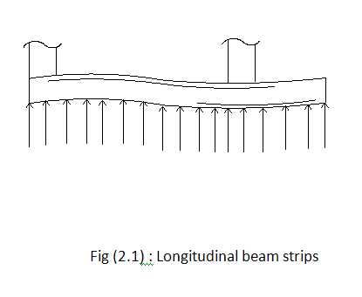
1. Rectangular Combined Footings:
This type of foundation shown in the fig (2):

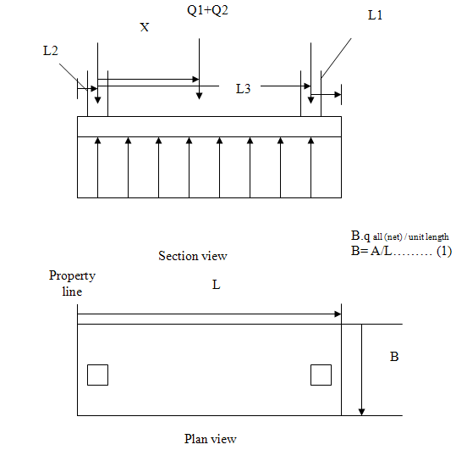
Fig (2.2) : section view and plan view for the rectangular combined footing.

The size of the rectangular footing that will generate a uniform pressure on the soil can be found through the following procedure:

Step #1. The required design area A of a footing can be found from,
A = Q1+Q2 /q all (net) …………………………………… (2)
Where Q1, Q2 are the loads in columns #1 and #2, and q all (net) is the net allowable soil bearing capacity.

Step #2. Determine the location of the resultant of the column loads.
X = (Q2L3)/ (Q1+Q2)…………………………………….(3)

Step #3. For a uniform distribution of soil pressure under the footing, the resultant of the column loads should pass through the centroid of the foundation. Thus,
L = 2(L2 + x) …..…………………………………….. (4)
Where L = length of the foundation

Step #4. Once the length L is determined from above, the value of L1 can be obtained from,
L1 = L – L2 – L3 ………………………………………. (5)
The magnitude of L2 will be known and depends on the location of the property line.
2. Trapezoidal Combined Footing
This type of combined footing, shown in Figure 3, is sometimes used as an isolated spread foundation for a column that is required to carry a large load in a tight space. The size of the trapezoidal footing that will generate a uniform pressure on the soil can be found through the following procedure:
Step #1. If the net allowable soil pressure is known, determine the area of the footing,
A = Q1+Q2 /q all (net)
From Figure 2, A = [ ( B1 + B2 ) / 2 ] L……………..... (6)

Step #2. Determine the location of the resultant for the column loads,
X= (Q2L3)/ (Q1+Q2
From the properties of a trapezoid,
X+L = ( (B1+2B2) / (B1+B2) ) L/3…………………….(7)
With known values of A, L, x, and L2, solve equations (6) and (7) to obtain B1 and B2. Note that for a trapezoid (L/3) < (x+ L2) < (L/2).

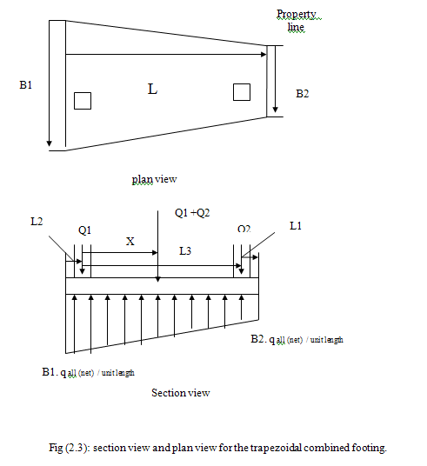

3. Cantilever or Strap Footings
A strap footing is used to connect an eccentrically loaded column footing to an interior column.
The strap is used to transmit the moment caused from an eccentricity to the interior column footing so that a uniform soil pressure is generated beneath both footings.

The strap footing may be used instead of a rectangular or trapezoidal combined footing if the distance between columns is large and / or the allowable soil pressure is relatively large so that the additional footing area is not needed. The strap footing shown in fig 2.4

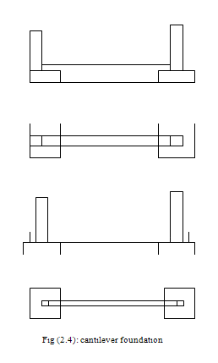

d. Mat Foundation
Mat foundations are chosen in lieu of a spread footing when:
- The spread footings cover over 50% of the building's ground area.
- The building requires several basement levels below the water table.
There are pockets of very weak soils which need to use a "compensated foundation” in order to reduce the net load upon the soil.

When using mats with different building sizes, check for compatibility of their deformations. A solution may be to use mats of different thickness, and a system of joints between buildings to minimize differential settlement. However, most mats built today use a constant thickness in order to minimize labor costs. Mats are complex structures, and require controlled steel, attempt large single pours, handle complex joints, etc.) Mats are rarely used for buildings lower than 7 stories, since they are typically expensive as a deep foundation.

The mat foundation, which is sometimes referred to as a raft foundation, is a combined footing that may cover the entire area under area a structure supporting several columns and walls.mat foundation are sometimes preferred for soils that have low load – bearing capacities , but have to support high columns or wall loads.

Mats are typically used for buildings eight stories or higher, and when the bearings capacities of the soil are $q_{all}$qall < 3 ksf. In loose sands, where is $q_{all}$qall approximately 1.5 ksf, a mat may fail from either general rupture or from excessively large settlements.
Under some condition, spread footing would have to cover more than half the building area, and mat foundation might be more economical. Several types of mat foundation are used currently. Some of the common ones are shown schematically in figure (2.5) and include the following:
Flat plate (figure 2.5a).The mat is of uniform thickness.
Flat plate (figure 2.5b). Thickened under columns
Beams and slab (figure2.5 c).The beams run both ways, and the columns are located at the intersection of the beam.
Flat plats with pedestals (figure 2.5d)
Slab with basement walls as a part of the mat (figure 2.5c).The walls act as stiffeners for the mat.
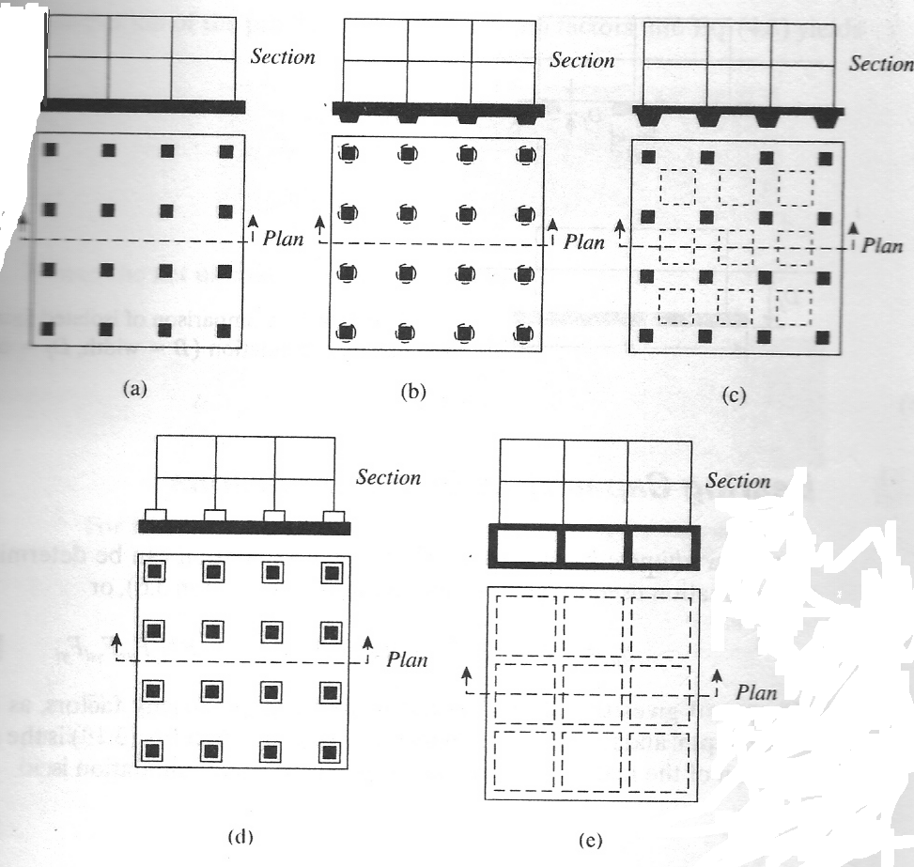
Figure 2.5: Common type of mat foundation.

Mats may be supported by piles, which help reduce the settlement of the structure built over highly compressible soil. Where the water table is high. Mats are often placed over piles to control buoyancy .figure 2.6 shown the difference between the depth $D_{f}$Df and the width B of the isolated foundation and mat foundation.
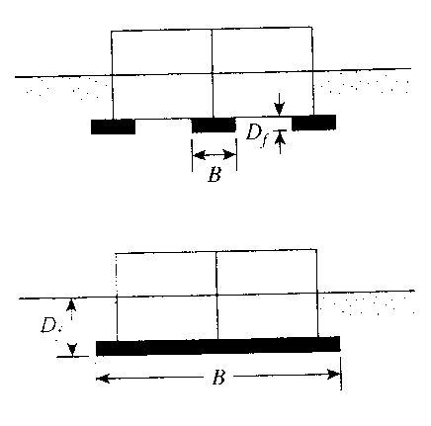

Figure2.6: Comparison of isolated foundation and mat foundation (B= width, $D_{f}$Df depth).
2. Deep Foundations
Deep foundations are those founding too deeply below the finished ground surface for their base bearing capacity to be affected by surface conditions , this is usually at depths >3 m below finished ground level. They include piles, piers and caissons or compensated foundations using deep basements and also deep pad or strip foundations. Deep foundations can be used to transfer the loading to deeper, more competent strata at depth if unsuitable soils are present near the surface.
Piles are relatively long, slender members that transmit foundation loads through soil strata of low bearing capacity to deeper soil or rock strata having a high bearing capacity. They are used when for economic, constructional or soil condition considerations it is desirable to transmit loads to strata beyond the practical reach of shallow foundations. In addition to supporting structures, piles are also used to anchor structures against uplift forces and to assist structures in resisting lateral and overturning forces.
Piers are foundations for carrying a heavy structural load which is constructed insitu in a deep excavation.
Caissons are a form of deep foundation which are constructed above ground level, then sunk to the required level by excavating or dredging material from within the caisson.
Compensated foundations are deep foundations in which the relief of stress due to excavation is approximately balanced by the applied stress due to the foundation. The net stress applied is therefore very small. A compensated foundation normally comprises a deep basement.

a. Types of pile
- End bearing piles
- Friction piles
- Settlement reducing piles
- Tension piles
- Laterally loaded piles
- Piles in fill
Piles are often used because adequate bearing capacity can not be found at shallow enough depths to support the structural loads. It is important to understand that piles get support from both end bearing and skin friction. The proportion of carrying capacity generated by either end bearing or skin friction depends on the soil conditions. Piles can be used to support various different types of structural loads.
*End bearing piles
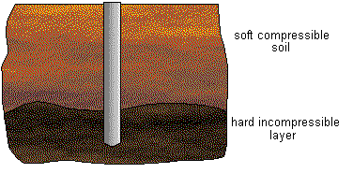
End bearing piles are those which terminate in hard, relatively impenetrable material such as rock or very dense sand and gravel. They derive most of their carrying capacity from the resistance of the stratum at the toe of the pile.
*Friction piles
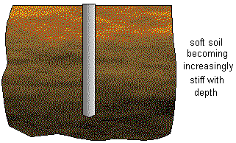
Friction piles obtain a greater part of their carrying capacity by skin friction or adhesion. This tends to occur when piles do not reach an impenetrable stratum but are driven for some distance into a penetrable soil. Their carrying capacity is derived partly from end bearing and partly from skin friction between the embedded surface of the soil and the surrounding soil.
*Settlement reducing piles
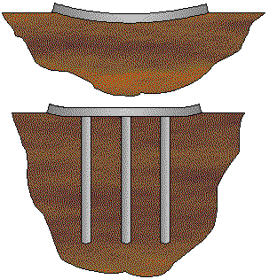
Settlement reducing piles are usually incorporated beneath the central part of a raft foundation in order to reduce differential settlement to an acceptable level. Such piles act to reinforce the soil beneath the raft and help to prevent dishing of the raft in the centre.
*Tension piles
Structures such as tall chimneys, transmission towers and jetties can be subject to large overturning moments and so piles are often used to resist the resulting uplift forces at the foundations. In such cases the resulting forces are transmitted to the soil along the embedded length of the pile. The resisting force can be increased in the case of bored piles by under-reaming. In the design of tension piles the effect of radial contraction of the pile must be taken into account as this can cause about a 10% - 20% reduction in shaft resistance.
*Laterally loaded piles
Almost all piled foundations are subjected to at least some degree of horizontal loading. The magnitude of the loads in relation to the applied vertical axial loading will generally be small and no additional design calculations will normally be necessary. However, in the case of wharves and jetties carrying the impact forces of berthing ships, piled foundations to bridge piers, trestles to overhead cranes, tall chimneys and retaining walls, the horizontal component is relatively large and may prove critical in design. Traditionally piles have been installed at an angle to the vertical in such cases, providing sufficient horizontal resistance by virtue of the component of axial capacity of the pile which acts horizontally. However the capacity of a vertical pile to resist loads applied normally to the axis, although significantly smaller than the axial capacity of that pile, may be sufficient to avoid the need for such 'raking' or 'battered' piles which are more expensive to install. When designing piles to take lateral forces it is therefore important to take this into account.

*Piles in fill
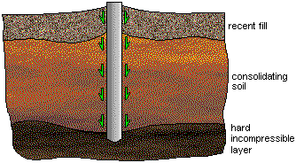
Piles that pass through layers of moderately- to poorly-compacted fill will be affected by negative skin friction, which produces a downward drag along the pile shaft and therefore an additional load on the pile. This occurs as the fill consolidates under its own weight.

b. Pile groups
Piles are more usually installed in groups, rather than as single piles. A pile group must be considered as a composite block of piles and soil, and not a multiple set of single piles. The capacity of each pile may be affected by the driving of subsequent piles in close proximity. Compaction of the soil between adjacent piles is likely to lead to higher contact stresses and thus higher shaft capacities for those piles. The ultimate capacity of a pile group is not always dependent on the individual capacity of each pile. When analyzing the capacity of a pile group 3 modes of failure must be considered.
· Single pile failure
· Failure of rows of piles
· Block failure
The methods of insertion, ground conditions, the geometry of the pile group and how the group is capped all effect how any pile group will behave. If the group should fail as a block, full shaft friction will only be mobilized around the perimeter of the block and so any increase in shaft capacity of individual piles is irrelevant. The area of the whole base of the block must be used in calculating the end bearing capacity and not just the base areas of the individual piles in the group. Such block failure is likely to occur if piles are closely spaced or if a ground-contacting pile cap is used.
Failure of rows of piles is likely to occur where pile spacing in one direction is much greater than in the perpendicular direction.

CHAPTER THRER

CALCULATIONS

3.1 Load distribution on columns

Service Load

Load (ton) | Column #
49.14 | 1 , 2
96.6 | 16 , 15
47.46 | 17 , 18
98.28 | 3 , 4 , 5
193.2 | 12 , 13 , 14
94.92 | 19 , 20 , 21
97.67 | 6
192 | 11
94.33 | 22
126.6 | 7
211.3 | 10
86 | 23
68.5 | 8
116.52 | 9
67.63 | 24

Footing areas :

Area of footing (Af) = service load(Pa) / qall
qall= 2.5kg/cm²
e.g :
Af = (49.14*1000) / 2.5
= 19656 cm^2 = 1.9656 m²
use a square footing 2*2
Footing dimensions  (m) | Af (m^2) | Column #
2*2 | 1.9656 | 1 , 2
2*2 | 3.8640 | 16 , 15
2*2 | 1.8984 | 17 , 18
2*2 | 3.9312 | 3 , 4 , 5
3*3 | 7.7280 | 12 , 13 , 14
2*2 | 3.7968 | 19 , 20 , 21
2*2 | 3.9068 | 6
3*3 | 7.68 | 11
2*2 | 3.7732 | 22
2.5*2.5 | 5.0640 | 7
3*3 | 8.4520 | 10
2*2 | 3.44 | 23
2*2 | 2.74 | 8
2.5*2.5 | 4.6608 | 9
2*2 | 2.7052 | 24

3.2 Footings Design

Group A (2*2) Columns # 1, 2, 17, 18
Use H = 0.35 m ………. d = 0.28 m
Check wide beam shear
Vc = 0.75*0.53* √fc* bw *d
= 0.75*0.53√300(10)(1)(0.28)
= 19.27 ton

qu = Pu / Af
= 66 / 4 = 12.5 ton/m²

Vn req = qu*L1 / 0.75
= 12.5*(0.6 – 0.28) / 0.75
= 7 ton

φVc ≥ Vn req ……… OK

Check for punching shear
Pup = Pu – qu(b+d)(h+d)
= 66 – 12.5(.8+.28)(.3+.28)
= 58.17ton

Ao = ((b+d)*2 +(h+d)*2))*d
= ((0.8+0.28)*2+(.3+.28)*2)*0.28
= 0.93

фVcp = ф *1.06√fc * Ao*10
= 0.75*1.06√300 *0.93*10
= 128.06 ton
фVcp ≥ Pup ………………….OK

Design for flexure
Mu = qu*L^2 /2
= 12.5*0.6^2 / 2
= 2.25 ton.m

ρ = 0.85fc/fy (1 - √1 – (2.61*10^5 * Mu / bd^2 *fc))
= 0.85*300/4200 (1 -√1 – (2.61*10^5 * 2.25 / 100*28^2 *300))
= 0.001

As = ρbd
= 0.001*100*28
= 2.8 cm^2/m

As min=0.0033*100*28
=9.24cm^2\m
Use 6φ14 (As = 9.24cm^2\m)

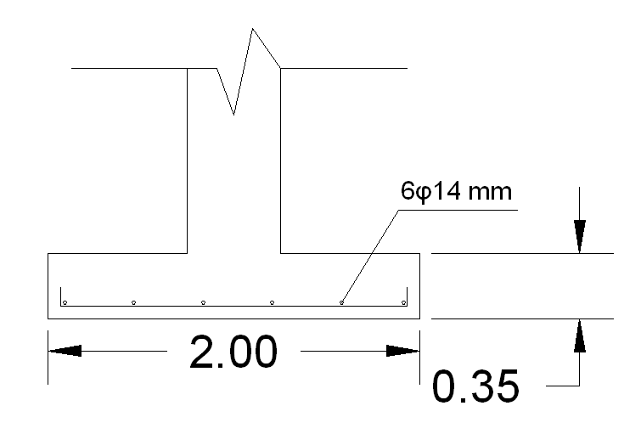

shrinkage steel = 0.0018 *bh
= 0.0018*100*35
= 6.3 cm^2/m
Use 6φ12 (As = 6.78cm^2\m)

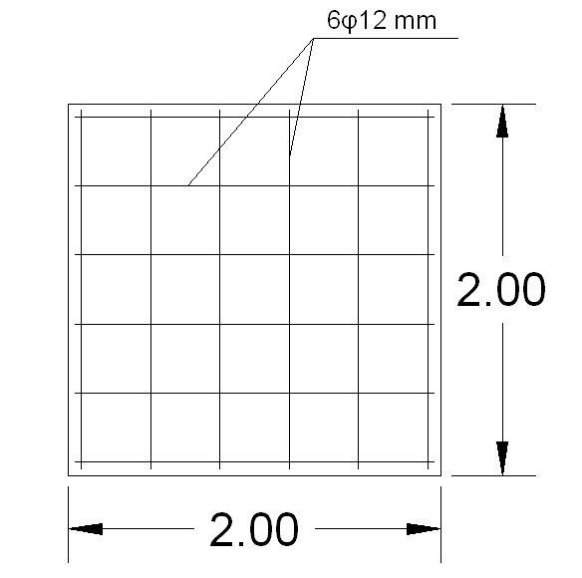

Group B (2*2) Columns # 3,4,5,6,15,16
Use H = 0.35 m ………. d = 0.28 m
Check wide beam shear
φVc = 0.75*0.53* √fc* bw *d
= 0.75*0.53√300(10)(1)(0.28)
= 19.28 ton
qu = Pu / Af.
= 132 / 4 = 33 ton/m^2

Vn req = qu*L1 / 0.75
= 33*(0.6 – 0.28) / 0.75
= 14.08 ton
φVc ≥ Vn req ……… OK

Check for punching shear
Pup = Pu – qu(b+d)(h+d)
= 132 – 33(.8+.28)(.3+.28)
= 111.33 ton

Ao = ((b+d)*2+(h+d)*2) *d
= ((0.8+0.28)*2+(.3+.28)*2)*0.28
= 0.93

фVcp = ф *1.06√fc * Ao*10
= 0.75*1.06√300 *0.93*10
= 128.06 ton
фVcp ≥ Pup ………………….OK
Design for flexure
Mu = qu*L^2 /2
= 33*0.6^2 / 2
= 5.94 ton.m

ρ = 0.85fc/fy (1 - √1 – (2.61*10^5 * Mu / bd^2 *fc))
= 0.85*300/4200 (1 -√1 – (2.61*10^5 *5.94 / 100*28^2 *300))
= 0.002

As = ρbd
= 0.002*100*28
= 5.69 cm^2/m

As min= 0.0033*100*28
=9.24cm^2\m
Use 6φ14 (As = 9.24cm^2\m)
Shrinkage steel = 0.0018 *bh
= 0.0018*100*35
= 6.3 cm^2/m

Use 6φ12 (As = 6.78cm²\m)

Group C (2*2) Columns # 19,20,21,22
Use H = 0.35 m ………. d = 0.28 m

Check wide beam shear
φVc = 0.53* √fc* bw *d
=.75* 0.53√300(10)(1)(0.28)
= 19.28 ton

qu = Pu / Af
= 127.46 / 4 = 31.865 ton/m^2

Vn req = qu*L1 / 0.75
= 31.865*(0.6 – 0.28) / 0.75
= 13.6 ton

φVc ≥ Vn req ……… OK

Check for punching shear

Pup = Pu – qu(b+d)(h+d)
= 127.46 – 31.6(.8+.28)(.3+.28)
= 107.7ton

Ao = ((b+d)*2+(h+d)*2) *d
= ((0.8+0.28)*2+(.3+.28)*2)*0.28
= 0.93 m^2

фVcp = ф *1.06√fc * Ao*10
= 0.75*1.06√300 *0.93*10
= 128.06 ton
фVcp ≥ Pup ………………….OK

Design for flexure
Mu = qu*L^2 /2
= 31.865*0.6^2 / 2
= 5.74 ton.m

ρ = 0.85fc/fy (1 - √1 – (2.61*10^5 * Mu / bd^2 *fc))
= 0.85*300/4200 (1 -√1 – (2.61*10^5 * 5.74 / 100*28^2 *300))
= 0.002

As = ρbd
= 0.002*100*28
= 5.6 cm^2/m

As min= 0.0033*100*28
=9.24cm^2\m

Use 6φ14 (As = 9.24cm²\m)
Shrinkage steel = 0.0018 *bh
= 0.0018*100*35
= 6.3 cm^2/m
Use 6φ12 (As = 6.78 cm^2\m)

Group D (2*2) Column # 23
Use H = 0.35 m ………. d = 0.28 m
Check wide beam shear
φVc = 0.53* √fc* bw *d
= 0.75*0.53√300(10)(1)(0.28)
= 19.28 ton

qu = Pu / Af
= 115.5 / 4 = 28.875 ton/m^2

Vn req = qu*L1 / 0.75
= 28.875*(0.6 – 0.28) / 0.75
= 12.32 ton

φVc ≥ Vn req ……… OK

Check for punching shear
Pup = Pu – qu(b+d)(h+d)
= 115.5 – 28.875(.8+.28)(.3+.28)
= 97.4 ton

Ao = ((b+d)*2+(h+d)*2)) *d
= ((0.8+0.28)*2+(.3+.28)*2)*.28
= 0.93 m^2

фVcp = ф *1.06√fc * Ao*10
= 0.75*1.06√300 *0.93*10
= 128.06 ton
фVcp ≥ Pup ………………….OK

Design for flexure
Mu = qu*L^2 /2
= 28.875*0.6^2 / 2
= 5.2 ton.m

ρ = 0.85fc/fy (1 - √1 – (2.61*10^5 * Mu / bd^2 *fc))
= 0.85*300/4200 (1 -√1 – (2.61*10^5 * 5.2/ 100*28^2 *300))
= 0.002

As = ρbd
= 0.002*100*28
= 5.6 cm^2/m

As min= 0.0033*100*28
=9.24cm^2\m

Use 6φ14 (As = 9.24cm^2\m)

Shrinkage steel = 0.0018 *bh
= 0.0018*100*35
= 6.3 cm^2/m

Use 6φ12 (As = 6.78 cm^2\m)

Group I (2.5*2.5) Column # 7

Use H = 0.40 m ………. d = 0.33 m

Check wide beam shear
φVc = 0.75*0.53* √fc* bw *d
=.75* 0.53√300(10)(1)(0.33)
= 22.72 ton

qu = Pu / Af
= 169.87 /6.25 = 27.18 ton/m²
Vn req = qu*L1 / 0.75
= 27.18*(0.85 – 0.33) / 0.75
= 18.84 ton
φVc ≥ Vn req ……… OK

Check for punching shear
Pup = Pu – qu(b+d)(h+d)
= 169.87 – 27.18(.8+.33)(.3+.33)
=150.52 ton

Ao = ((b+d)*2+(h+d)*2) *d
= ((0.8+0.33)*2+(.3+.33)*2)*0.33
= 1.16 m^2

фVcp = ф *1.06√fc * Ao*10
= 0.75*1.06√300 *1.16*10
= 159.93 ton
фVcp ≥ Pup ………………….OK

Design for flexure
Mu = qu*L² /2
= 27.179*0.85² / 2
= 9.82 ton.m

ρ = 0.85fc/fy (1 - √1 – (2.61*10^5 * Mu / bd^2 *fc))
= 0.85*300/4200 (1 -√1 – (2.61*10^5 * 9.82 / 100*33^2 *300))
= 0.0024

As = ρbd
= 0.0024*100*33
= 7.92 cm²/m

As min= 0.0033*100*33
=10.89cm^2\m

Use 8φ14 (As = 12.32cm^2\m)
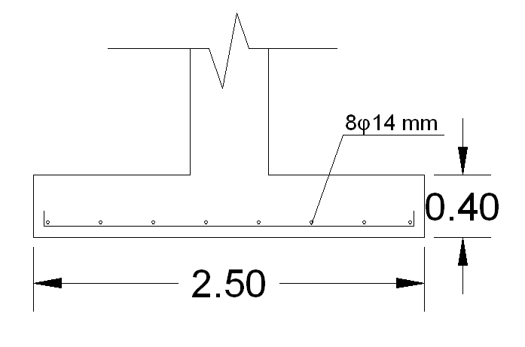

Shrinkage steel = 0.0018 *bh
= 0.0018*100*40
= 7.2 cm^2/m

Use 7φ12 (As = 7.91 cm²\m)
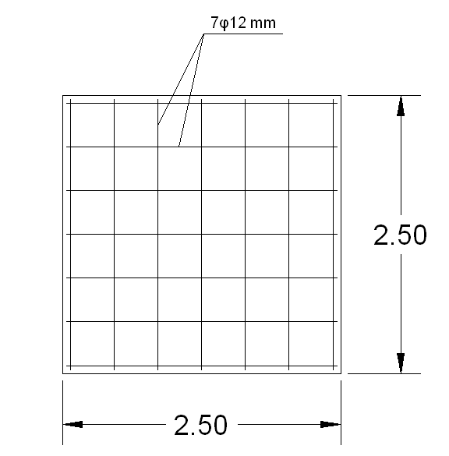

Group F (3*3) columns # 11, 12, 13
Use H = 0.55 m ………. d = 0.48 m
Check wide beam shear
φVc =0.75* 0.53* √fc* bw *d
= 0.75*0.53√300(10)(1)(0.48)
= 33.05 ton

qu = Pu / Af
= 259.4 / 9 = 28.82 ton/m^2

Vn req = qu*L1 / 0.75
= 28.82*(1.225 – 0.48) / 0.75
= 28.63 ton

Vc ≥ Vn req ……… OK

Check for punching shear
Pup = Pu – qu(b+d)(h+d)
= 259.4 – 28.82(.55+.48)(0.55+.48)
= 228.8 ton

Ao = (b+d)*4 *d
= (0.55+0.48)*4*0.48
= 1.98 m^2

фVcp = ф *1.06√fc * Ao*10
= 0.75*1.06√300 *1.98*10
=272.3 ton
фVcp ≥ Pup ………………….OK

Design for flexure
Mu = qu*L^2 /2
= 28.82*1.225^2 / 2
= 21.62 ton.m

ρ = 0.85fc/fy (1 - √1 – (2.61*10^5 * Mu / bd^2 *fc))
= 0.85*300/4200 (1 -√1 – (2.61*10^5 * 21.62 / 100*48^2 *300))
= 0.0025
As = ρbd
= 0.0025*100*48
= 12.15 cm^2/m

As min= 0.0033*100*48
=15.84cm^2\m

Use 11φ14 (As = 16.94cm^2\m)
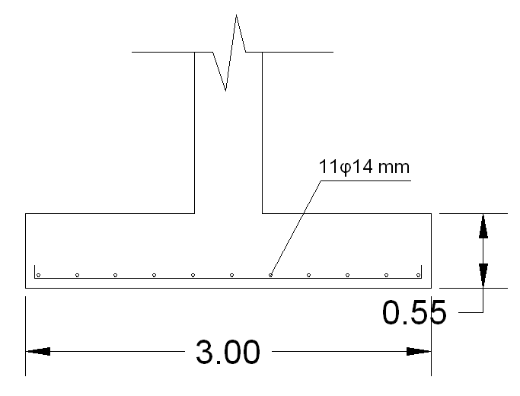
Shrinkage steel = 0.0018 *bh
= 0.0018*100*55
= 9.9 cm^2/m
Use 9φ12 (As = 10.17 cm^2\m)
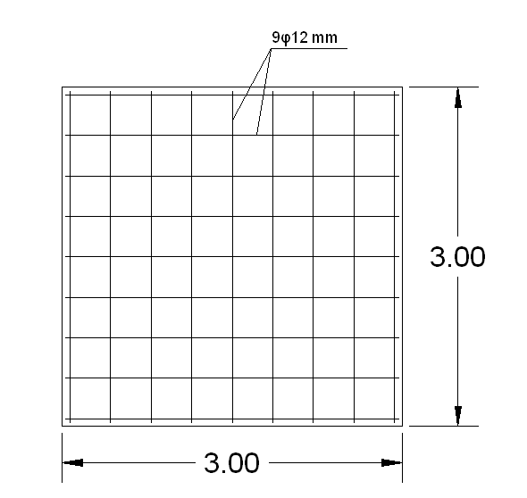
Group G (3*3) column # 10
Use H = 0.55 m ………. d = 0.48 m
Check wide beam shear
φ Vc = 0.53* √fc* bw *d
=0.75* 0.53√300(10)(1)(0.48)
= 33.05 ton

qu = Pu / Af
= 283.7 / 9 = 31.52 ton/m^2

Vn req = qu*L1 / 0.75
= 31.52*(1.225 – 0.48) / 0.75
= 31.31 ton

Vc ≥ Vn req ……… OK φ

Check for punching shear

Pup = Pu – qu(b+d)(h+d)
= 283.7 – 31.52(.55+.48)(0.55+.48)
= 250.26 ton

Ao = (b+d)*4 *d
= (0.55+0.48)*4*0.48
= 1.98 m^2
фVcp = ф *1.06√fc * Ao*10
= 0.75*1.06√300 *1.98*10
= 272.3 ton
фVcp ≥ Pup ………………….OK

Design for flexure
Mu = qu*L^2 /2
= 31.52*1.225^2 / 2
= 23.65 ton.m

ρ = 0.85fc/fy (1 - √1 – (2.61*10^5 * Mu / bd^2 *fc))
= 0.85*300/4200 (1 -√1 – (2.61*10^5 * 23.65 / 100*48^2 *300))
= 0.0028

As = ρbd
= 0.0028*100*48
= 13.32 cm^2/m
As min= 0.0033*100*48
= 15.84

Use 11φ14 (As = 16.94cm^2\m)
Shrinkage steel = 0.0018 *bh
= 0.0018*100*55
= 9.9 cm^2/m
Use 9φ12 (As = 10.17 cm^2\m)
3.3 Ultimate load

Load (ton) | Column #
66 | 1 , 2
132 | 3
132 | 4
132 | 5
131 | 6
169.87 | 7
129.7 | 15, 16
259.4 | 14
259.4 | 13
259.4 | 12
257.75 | 11
283.7 | 10
63.7 | 17, 18
127.46 | 19
127.46 | 20
127.46 | 21
126.67 | 22
115.5 | 23
92 | 8
156 | 9
64.5 | 24

Ultimate load groups:
Load (ton) | Column # | Group
66 | 2,1 /17,18 / 24 | A
132 | 3,4,5,6 / 15,16 | B
127.46 | 19,20,21 / 22 | C
115.5 | 23 | D
92 | 8 | E
259.4 | 14,13,12 / 11 | F
283.7 | 10 | G
156 | 9 | H
169.87 | 7 | I

3.4 Shear Wall
Groups E (column #8) , H (column # 9) , column # 24

The maximum service load is on column # 9
B = service load (max.) / qall soil
= 116.52 / 25
= 4.7 m

qu = Pu / B
= 156 / 4.7 = 33.2 ton

Vu = qu * L
= 33.2 (2.2 - d)

фVc = 0.75 * 0.53√300 *10 * 1 * d

Vu = фVc
33.2 (2.2 - d) = 0.75 * 0.53√300 *10 * 1 * d
d = 0.716 m

try h = 0.8 m ………….. d = 0.73 m

Mu = qu * L^2 /2
L = (4.7 - .3)/2
= 2.2 m
So Mu = 33.2 * 2.2^2 /2
= 80.34 ton.m

ρ = 0.85fc/fy (1 - √1 – (2.61*10^5 * Mu / bd^2 *fc))
= 0.85*300/4200 (1 -√1 – (2.61*10^5 * 80.34 / 100*73^2 *300))
= 0.004

As = ρbd
= 0.004 *100 *73
= 30.09 cm^2 /m

As min. = 0.0018 *100 *80
= 14.4

Use 10φ20 (As = 31.4cm^2\m)

3.5 Retaining Wall
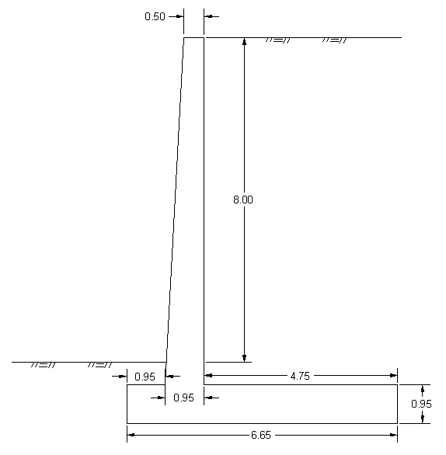

H= H1 + H2
= 1.5 + 8 = 9.5 m
B = 6.65 , x = 0.95
Check Overturning
q = γhKa ,
Ka = (1-sinф) / (1+sinф) = 0.455
q = 17*9.5*.455
= 73.482 KN/m
Pp = 0.5*73.482*9.5
= 349.04 KN
Mo = P (H/3) = 1105.3 KN.m

Weight = area * unit weight
Table (1)
weight (KN/m) | Area (m^2) | sec. #
102.6 | 4.275 | 1
46.176 | 1.924 | 2
151.68 | 6.32 | 3
690.412 | 40.612 | 4

Mr = Σ(weight * Moment arm)
Table (2)
moment (KN.m) | moment arm
169.29 | 1.65
57.72 | 1.25
504.34 | 3.325
2951.51 | 4.275
Σ = 3682.86

F.s. = Mr / Mo
= 3682.86 / 1105.3
= 3.33 > 2 …………………….. OK

Check sliding
P sliding = 349.04 KN

P against sliding = Σw*f + 0.5*γs*h^2 *Kp,
Kp = tan^2 (45 + ф/2)
= 2.198
Pagainst sliding = (990.87*.5) + (0.5*17*0.95^2 *2.198)
= 512.3 KN

F.s. = Pagainst sliding / Psliding
= 512.3 / 349.04
= 1.5 …………………….OK

Check bearing capacity
e = B/2 – (Mr - Mo) / P,
P = Σw = 990.87 KN , Mr = 3682.86 KN.m , Mo = 1105.3 KN.m , B = 6.65 m
e = 0.724 m

M = P*e
= 990.87 * 0.724
= 717.1 KN.m

q toe,heal = P/B (1 ± 6e / B) = 990.87/6.65 (1 ± (6*0.724)/6.65)
= 246.295 KN/m^2 , 51.71 KN/m^2

qu = 250 KN/m^2

F.s. = 250 / 246.295
= 1.015 >1 ………………..OK

Design of the wall
q = γhKa
= 17*8.55*.455
= 66.134 KN/m

P = 0.5 * q * 8.55
= 282.724 KN

M = P(H/3)
= 282.724 (8.55/3)
= 805.76 KN.m

Mu = 1.6*M
=1289.22 KN.m

Vu = 1.6*P
= 452.36 KN

Check shear
фVc = 0.75*0.53* √fc* bw *d
= .75*.53 * √300 *100*1*0.78
= 537.02 KN > Vu …………………OK
ρ = 0.85fc/fy (1 - √1 – (1.62*10^5 * Mu / bd^2 *fc))

= 0.85*300/4200 (1 -√1 – (1.62*10^5 * 128.92 / 100*78^2 *300))
= 0.00588

ρmin. = 14 / fy
= 14 / 4200
= 0.0033

As = ρbd
= 0.00588* 100* 78
= 45.864 cm^2
Use 9ф26 ……………As = 47.79 cm^2

Vertical bars at the other side (shrinkage)

As = 0.0018* 100* 85
= 15.3 cm^2 …………………use 8ф16

Horizontal bars
As = 0.0025* 100* 85
= 21.25 cm^2 ……………………..use 11ф16
Design of the heal

V = (1.2* 0.95* 4.75* 24 + 1.2* 690.412) – (1.2* 0.5* (51.71 + 190.7)* 4.75)
= 267.59 KN

фvc = 0.75 * 0.53 √300 * 1* 100* 0.78
= 537.02 KN > Vu …………………..OK

Mu = (1.2* 0.95* 24 + 1.2* 17* 8.55) *(4.75^2 /2) –{ (1.6* 51.71*(4.75^2 /2)*1.6) + 0.5* 4.75* 138.99* (4.75/3)*1.6 }
= 506.7 KN.m

ρ = 0.85fc/fy (1 - √1 – (1.62*10^5 * Mu / bd^2 *fc))
= 0.00175 < ρmin. = 0.0033

As = ρbd
= 0.0033* 100* 88.
= 29.04 cm^2
Use 10ф20 …………………..As = 31.4cm^2

Asmin. = 0.0018* 100* 95
= 17.1 cm^2 < 29.04
Design of toe

Vu = (1.2* 0.95* 0.95* 24 + 1.2* 9.02) – (1.2* 0.5* (218.5 + 246.295)* 0.95)
= -228.106

фvc > Vu……………………….OK

Mu = { (1.2*0.95*0.95*24*0.95^2 /2) + (1.2*9.02*0.95/2) – (1.2*(0.95^2 /2) *218.5) – (1.2*.5*.95*27.79*.316) }

= 105.84 ton.m

ρ = 0.000362 < ρmin

As = ρbd
= 0.0018 * 100*88
= 15.84 cm^2

Use 6ф20 = 18.84 cm^2

3.6 Conclusion

. The name of our project is jawwal building.
. The building contains six floors, Tow of them under the ground.
. Our project lies on a basin number 8199, parcel number 111 and has an area of 400 (m^2).
. The project lies in Tulkarem city.
. The project consists of the construction that is a six story building with a plan construction area (320 m^2).
. Allawable bearing capacity in our soil is equal 2.5 kg\cm^2.
.We calculate the load in the column, then the Footing in our project is isolated.
. We design in our project shear wall.
. We design in our project retaining wall.
. Concrete crushing strength is equal 300 kg\cm^2.
. Reinforcement steel yield stress is equal 4200 kg\cm^2.
. Dead load is equal 0.9 t\m^2.
. Live load is equal 0.5 t\m^2.

CHAPTER FOUR

References

DAS. B.M. PRINCIPLES OF FOUNDATION ENGINEERING . SIX EDITION
TENG. W.C. FOUNDATION DESIGN
CODRTO, D.P , FOUNDATION DESIGN AND PRACTICES
HIJAWI CONSTRUCTION LABS
TULKARM MINACIPALITY

CHAPTER FIVE
Appendix

