Embedded remote monitoring
web server

introduced by
Abdullah Yahya Yassen
Abdullah Yahya Jabr

Supervisor :
Eng : Haya Sama3neh
Dr.Raed alqadi
Dr. luai malhees
Eng :sufian samara

There are many applications that work on remote monitoring but the problem with it is the distance of the monitor or how its hard to get live information about the monitored thing and the way of giving it commands to do .

There are many projects that worked on remote monitoring and also many protocols written for that like SNMP but lets see ;each of these projects need many resource to work e.g. the machine has to have the SNMP client on it so that SNMP can control it . and if we use a computer with SNMP protocol or enter net connection and that computer is used for monitor or control a machine or any thing else then the computer is a big resource .

So that we thought in building a hardware so simple put efficient and also can work on Ether net and that required a lot of work and search.

The Project:

We decides to make a embedded web server that will monitor and save power consumption of 3 rooms and save and shows the status of each room like the temperature of the each one, and to light the room when there is a course given inside it and the status of the rooms will be stored in an html pages in side the hardware and of course any one that have permeations to see the status of the rooms he can easily open its URL and see or configure the status of the rooms and when it should be on or off and for that the hardware will take the time and date from the computer that is connected to the hardware and opening the html pages.

Project Resources :

As we say that the project will work on the ether net so it have to understand the TCP/IP stack and to function what needed from its protocols .

For that there exists a powerful controller called the RTL8029AS put the problem with this controller is its pins due to it’s a mount surface so that will be hard to deal with it also the TCP/IP stack will be installed in side it already .

Other controller is the ENC28J60 this controller under stand the physical and Mac layers and then the controller puts the frames ready on the transmit buffer to be sent to the hardware that understand the rest of the TCP/IP stack ; and this hardware has to have a good memory space to handle the TCP?IP codes and also to work efficiently with the stack and for that we choosed the PIC18f4620 .

The hardware that is used in the project:
RJ45: all of us know it .its an ether net jack and it need to be interfaced with a small circuit that handle the deferential modulation of the ether net transmitting ,for that we used a ready RJ45 module that has a build in differentiation handler circuit ,this RJ45 is called bel 0810-1xx1-03 that also has two leds both can be use to show the status of the network .

ENC28J60 : Ether net controller that gets the frames from the Ether net and send it via an SPI interface to the responsible hardware this controller can be programmed via a SPI interface by giving it the MAC and IP addresses . this controller needs an 25 MHz crystal to operate and it gives an connection of 10 Mbps connection .but there is a problem with the ENC that is the working voltage it works on 3.3V so its outputs have to be shefted to be 0 or 1 for that we use the 74LC125 try stat buffer to make shifting for the outputs to be exactly 5 volts also to cobble the serial eeprom from the ENC so the ENC can send data and the SEEPROM will ever harm the output and also the ENC cant affect the SEEPROM ,why? This will be shown later.

PIC18F4620 : powerful controller with (code memory) 64k Flash, 4k ram ,1k eeprom at 5 volts power supply these capabilities serve the ability of processing the TCP/IP stack and also it has 5 I/O ports 12bit adc with 7 chanels we used that controller with a 10Mhz crystal and the clock circuit in side the PIC can multiply the input frequency by 4 if we enable the PLL so at a crystal of 10MHz the PIC will work at 40MHz as an internally working frequency .

DS1302: serial real time clock that we used to get the time for the project,
This IC works on 32768 Hz with two power supplies one is the usual one the other on is used as an temporary source when the first supplier is disconnected this IC store the date as a BCD data inside it so when writing or reading to/from it we have to convert the data from BCD to know how to dealwith it.
.
PIC16F877 : now if we will read the RTC and the adc’s and serve the TCP/IP this will produce some error due to the delay that may be produced for that we used the PIC16 just to read the RTC then send its value back to PIC18f so that will reduce the amount of time .

25c256: serial EEPOM that work on a very high speed at 10MHz SPI interface ,this IC is used as an external storage to store the web pages in it and the SPI can serve the requests of the PIC so fast, so the delay is minimized when the pages requested from the client side .

Serial interface : simple RS232 protocol between the pic and the computer for down loading the code and other things for testing purposes like printing out a value of some input arguments came from the ether net and so on.

Project building:

Hardware Side:

The first thing we had done is building the basic circuit of the PIC and the ENC and we face a big trouble that was ; finding the ferried bead that is to be connected between the VDD (3.3 v) and the TD-CT, we couldn’t buy it due to it does not exist in the market for that we searched on some NEC’s until we found one ,that is similar to what we need and it worked and the function of that ferried beat is to reduce the noise .

Next building the basic circuit and the serial interface with the computer we started to add the project components the first thing is the 25C256 serial EEPROM that is connected at the same SPI interface that exists between the ENC and the PIC18F4620 ,and the PIC controller can select one of the ENC or the SEEPROM by enabling it via its chip select ,and the try state buffer 74lc125 prevent the output of any IC to short circuit the other IC .
Then we build the sensors circuit that is simply to connect a temperature sensor like LM335 as the figure shows :

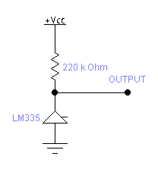
Where the resistance value depend on our calculations .next that we take the output as an input to an op_amp then to one of the PIC18f4620 analog channels . an other circuit we need to build is the circuit of the lights and the fans, this circuit is simply an fan or light connected with a relay as an analog controller the input of the relay is 5 volts that is digital ,the control of the relay is taken from a powerful Darlington transistor (ULN2003) that’s input is taken from the PIC18F4620 . the Darlington is an CMOS transistor so there is no input current that can be mentioned so we connect the same ULN2003 input with an LED .

Now we finished the Hardware side let us begin with the Software:

Software Side:

As we said our project is an embedded web server that’s mean we are working on the application layer so there should exist an TCP/IP stack so that our application lays at the top of it ,for that we used Microchip TCP/IP Ver 3.75 and we changed some parts of it that will go with our project .

we will divide this part so that it will be as :pages design , C code writing

C code writing:

At first we will talk about the temperature sensors ,these sensors will be taken on channel 0 and 1 and in the code we change the channel so we read one channel next an other ,as we know that the floating point operations takes a lot of clock cycles and that of course a bad thing to so we do it by this way :

ws=*((WORD*)(&ADRESL));// take the data from the ADC
tempreture=(ws -552);
tempreture*=.35525;// equations the only float operations used
x1=(int)( tempreture*100);
x2=x1%100;
x1=x1/100;
itoa(x1,s1);
itoa(x2,s2);
strcpy(AN0String,s1);
strcat(AN0String,xa);//the “.”
strcat(AN0String,s2);

this code will take the float value the multiply it by 100 that will shift it to the left by two digits then we divide it into two parts before the dot and after it the concatenate the three strings to gather and store them into a variable that can be sent when requested .

now we will discus how the hardware deals with the software ,there is a simple parser for parsing the URL of the requested page or for the requested command this parser return the arguments one by one then the pic can see the argument and do the command associated with argument taken this is simple description about what happens .

we added some code to the project so that it work also as a client for time ,this is by opening a TCP connection at port 37 with the client IP using a program that is a time server that sends the time as ASCI characters (Daytime protocol) and the pic request the Daytime each 5 seconds and check it so the PIC can do what needed.

Now we will describe briefly how the PIC response the requests .

When the page is requested from the PIC the HTTPExecCmd sees the arguments taken from the parser and depend on it for send the page requested .

First the PIC gets the URL from a Socket at opened at port 80 then it send it to the parser that will cut it into peaces arguments and the values then it call HTTPExecCmd that will take the argument from the parser then it will look for there values as its in the table and do the required .

Then if any CGI code is interpreted then the PIC will receive this and when it sees ‘%’ it understand that this is a CGI data and it have to get its value from a variable that its value equals the value taken without the ‘%’ example:

The label (Today : %19 %18) %19 %18 represent a variable in the PIC called :
#define TIME (0x18)
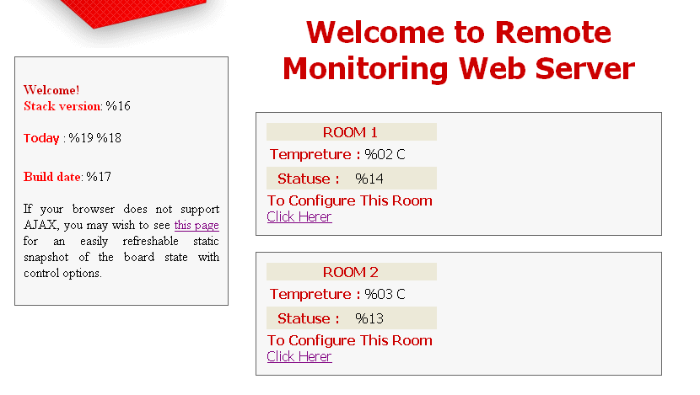
#define DAY (0x19)

Now when the page is viewed by the client it will automatically request that CGI %18 %19 ,when the PIC sees that value it sends the value of the variable back that 18 and 19 represents , this will make it clear :
case TIME:
*val = time2[(BYTE)ref];
if(time2[(BYTE)ref] == '\0')
return HTTP_END_OF_VAR;
else if(time2[(BYTE)++ref] == '\0' )
return HTTP_END_OF_VAR;
return ref;

case DAY:
*val = day[(BYTE)ref];
if(day[(BYTE)ref] == '\0')
return HTTP_END_OF_VAR;
else if(day[(BYTE)++ref] == '\0' )
return HTTP_END_OF_VAR;
return ref;

.
pages design :

we used the AJAX technology due to its self refreshing that will help us so that the AJAX send the requests to pic so it will send back the data so that the data will be always up to date .

other thing is to write the CGI variables so that the pic can understand the needed data as follow:
// conf.CGI
<tr><form method=GET action="set.cgi" >
<td>Sunday</td>
<input type="hidden" name="d" value="sun">
<td><input type="submit" value=%38 name="8" ></td>
<td><input type="submit" value=%39 name="9" ></td>
<td><input type="submit" value=%3A name="10" ></td>
<td><input type="submit" value=%3B name="11" ></td>
<td><input type="submit" value=%3C name="12" ></td>
<td><input type="submit" value=%3D name="13" ></td>
<td><input type="submit" value=%3E name="14" ></td>
<td><input type="submit" value=%3F name="15" ></td>
</form></tr><tr>

Now any button that will submit the form its name and value will be sent with the URL that will request the set.CGI ,where this page will change a value in the pic then it will redirect to the conf.cgi that will show that the status of the room at this time will be changed as requested by the client .

The first page that will appear to the user when he open server is the login page (INDEX.CGI )that will show the user name and password fields to be filled , and then the page will send the request to the pic and the pic determine if the password and user name are correct then it will send a page to the client depending on the password and user name ,if they where correct it will redirect the page to INDEX2.HTM and if its wrong it will resend the login page again .

Put we couldn’t forbid the user from opining the other pages without applying the correct name and password that’s due to the pages are stored in the pic and it couldn’t check the user name and password without being loaded on the client side .we tried to solve this problem by the HTTP Authentication put we couldn’t .

Lets go to the interface of the web pages :

As the page is shown above there is two rooms each room has a light (or a fan) and a temperature and each one of them has its status shown and on the hardware side there exists a led, fane, sensor , and also on the web page there is a page for each room so that the user can configure the time that he needs the room light to be on and at what day as this figure shows:
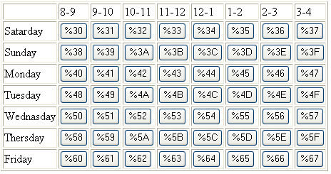

Now each CGI when the pic is available will display the status of the light at this time and date then if we want to flip it we just press the button and then it will change the value on the hardware side so that the fan will be on or off with respect to time as its stored to be on or off .

