

بسم الله الرحمن الرحيم

An-Najah National University

Faculty of Engineering

Computer Engineering Dept.

***Software Graduation Project Proposal***

***E-Pharmacy***

***(Web Based Application)***

***By: Fayez Haj Mohammad & Hasan Al-Nahawy.***

***2009-2010***

***Programming scripts:***

PHP, html, JavaScript , Ajax , And Jquery .

Interface programs : Photoshop, Macromedia flash , Dreamweaver.

***Introduction:***

In Our project we implemented an idea that talks about multiple pharmacies connected with multiple agents ,multiple officer and one administrator ,these agents work for multiple companies and all of them connected with each other ,our application deals with four kinds of users they are the admin of these pharmacies ,the officer of each pharmacy ,the agent and the visitor of the website ,our idea make it easy for the Admin of these multiple pharmacies to monitor and manage (users , transactions( purchases ,sales ,offers, requests) and stores) ,

So e-pharmacy make it easy for the officer to do anything and monitor anything about its pharmacies this is the main idea and we will tell you about the details at the next .

***Contents :***

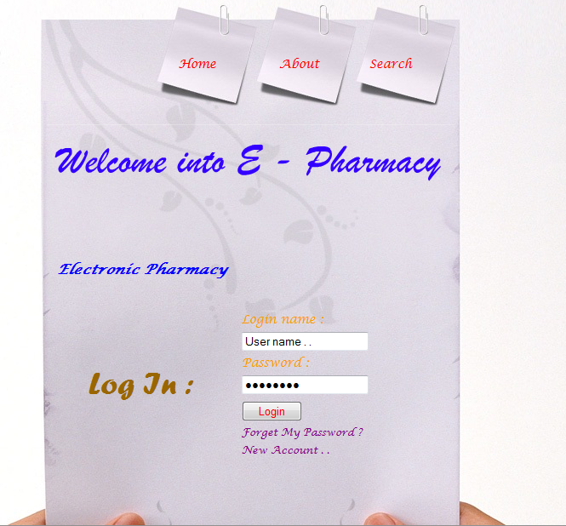

***Index Page*** : In this page you can create new account for you and the admin give you the appropriate permissions ,and any visitor for this page can search about any medicine we have .

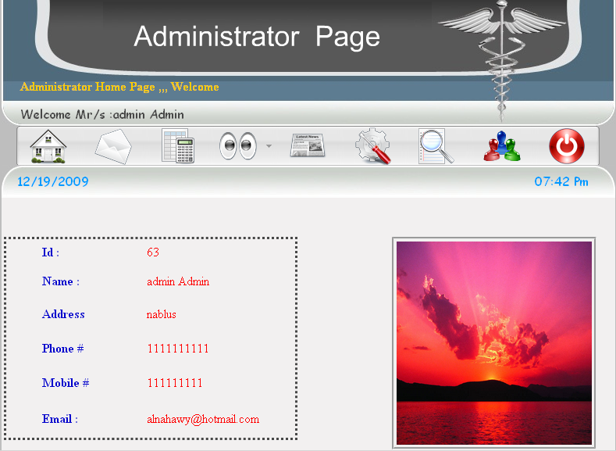

***Home Page***: Each user have this page with its own info as you can see in the picture above.

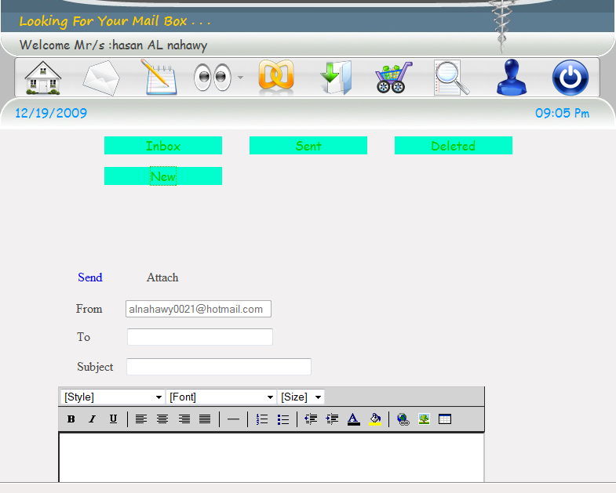

***Mail Page*** :Each User Have this page with its special info ,

From this page you can send and receive messages as you in the picture above.

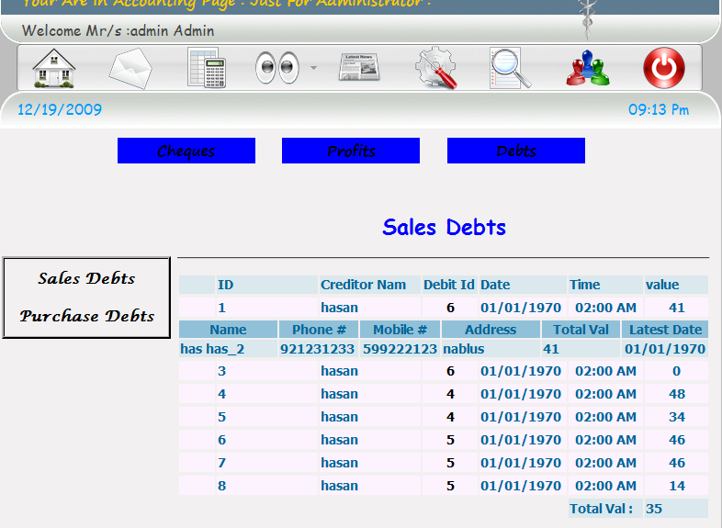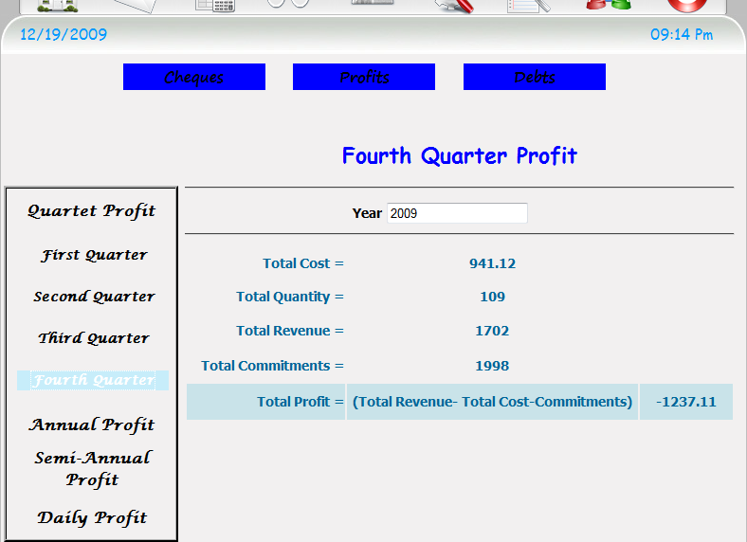

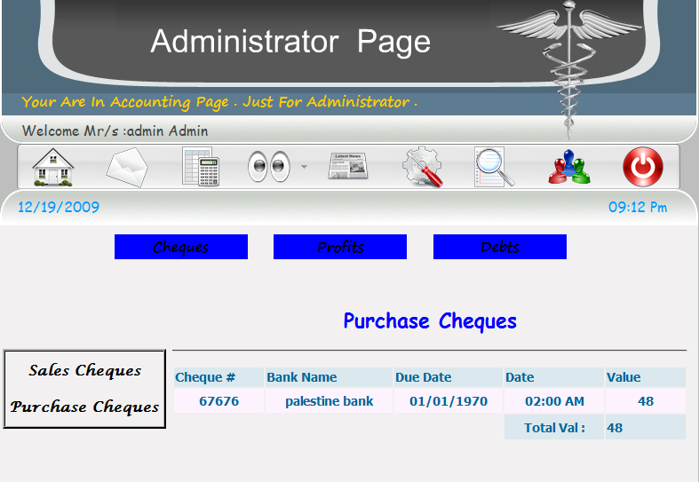

***Accounting page*** : This Page just for the administrator ,from this page administrator can check debts ,profits ,cheques, as you can see in the picture above.

***News Page*** : this page just for the administrator , from this page admin can add and edit news about the pharmacies and medicines , as you can see in the picture above.

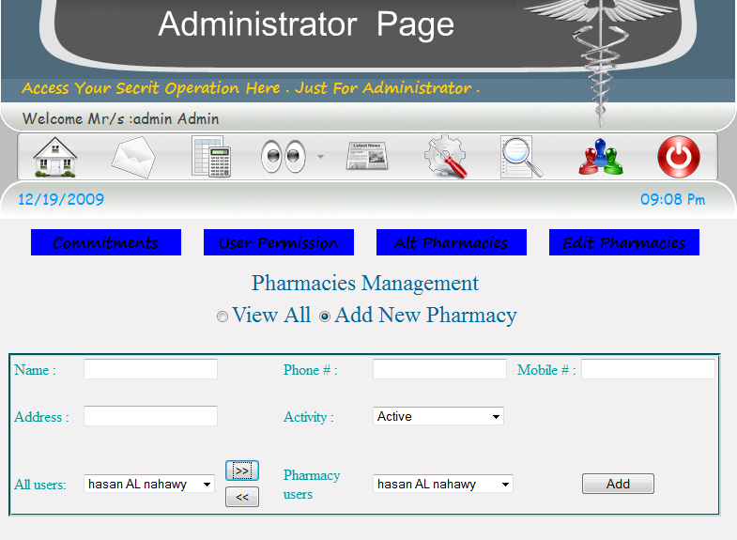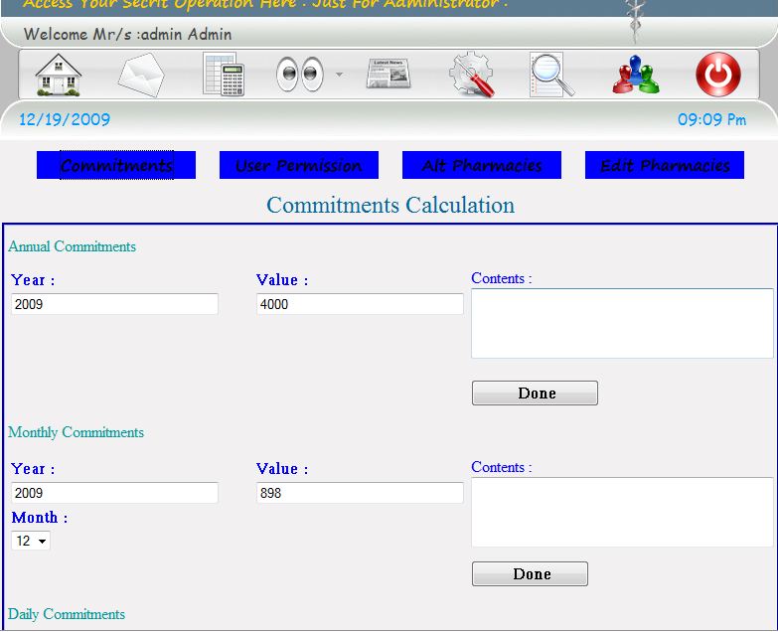

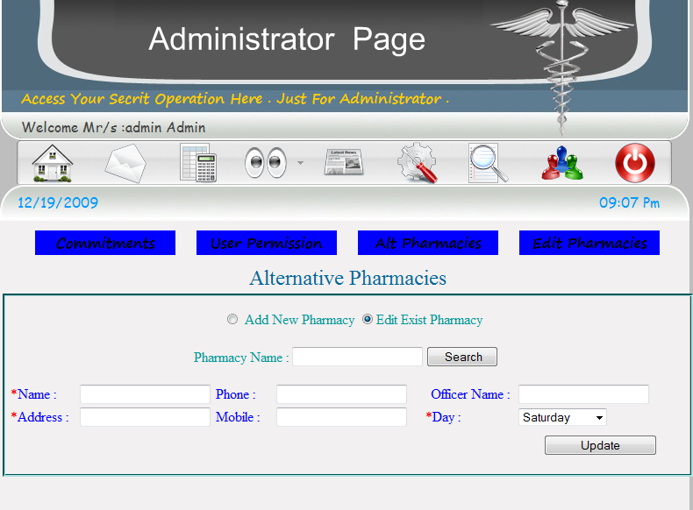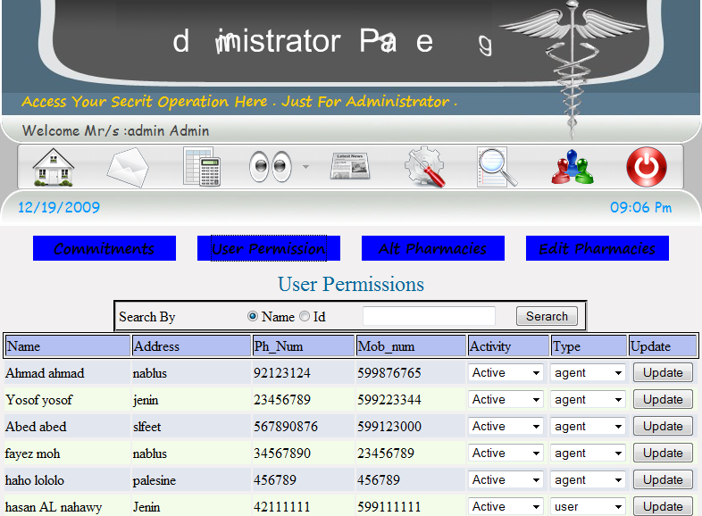***Control Page*** : this page just for the administrator ,from this page admin can access commitments, user permissions, alternative pharmacies and edit any pharmacy information , as you can see in the picture above.

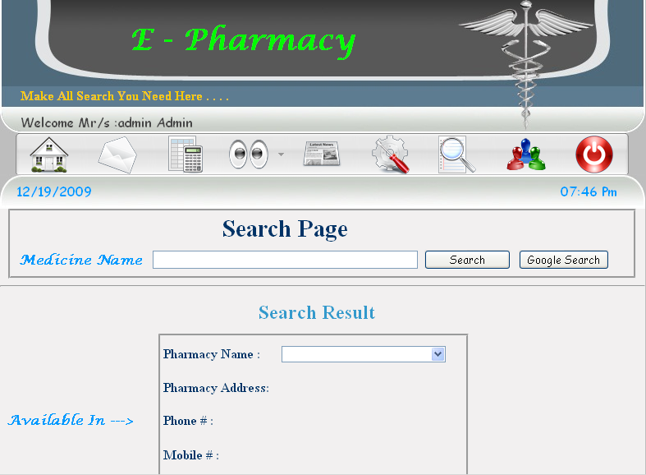

***Search Page*** : This page for all users ,from this page you can search about any medicine and you can see in which pharmacies this medicine exist and you will see the alternative and common side for this medicine , as you can see in the picture above.

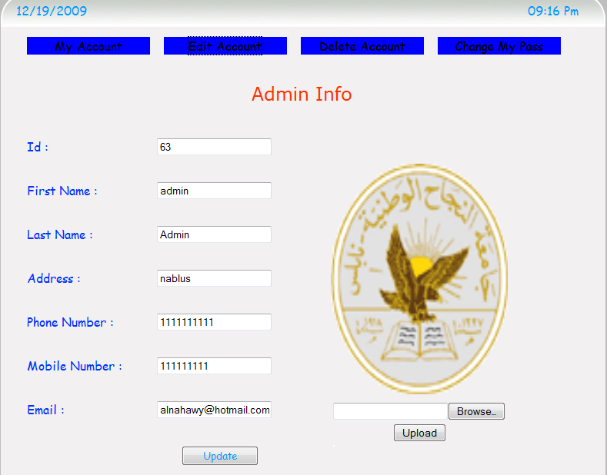

***My Account Page*** :This page for all users ,from this page you can show ,edit and delete your account and you can change your password , as you can see in the picture above.

***View Page*** : this page specified for each user : 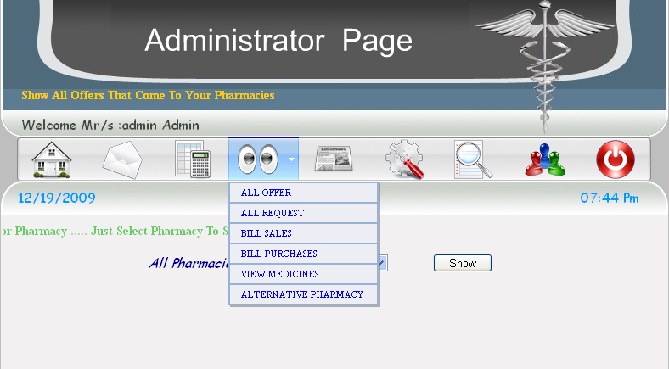

***Administrator*** : can view all offers ,all requests ,all purchase bills ,sale bills , medicines and alternative pharmacies and all of them depend on pharmacy name , as you can see in the picture above. 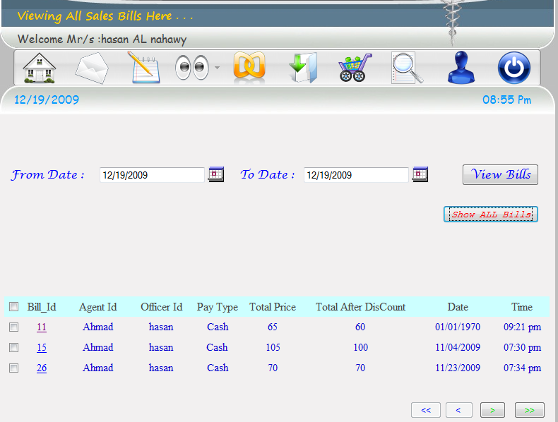

***Officer***: can view all offers, all requests, all purchase bills, sale bills, medicines and alternative pharmacies just for his pharmacy , as you can see in the picture above.

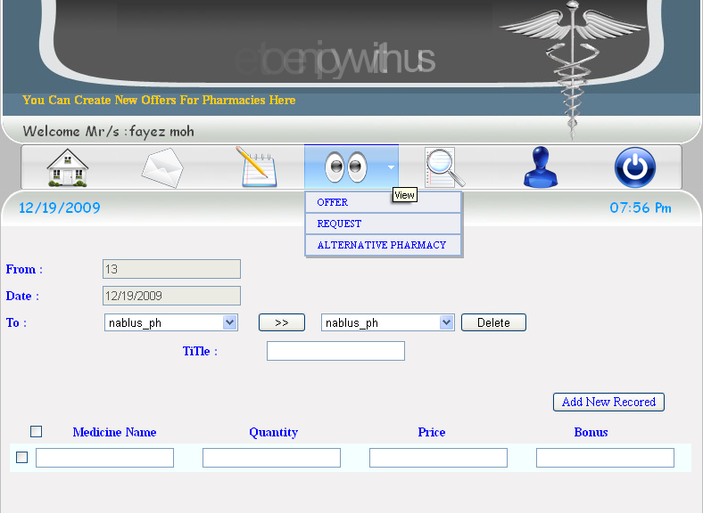

***Agent***: can view all offers, all requests and alternative pharmacies for all pharmacies that connected with them , as you can see in the picture above.

***Visitor*** : can view alternative pharmacies .

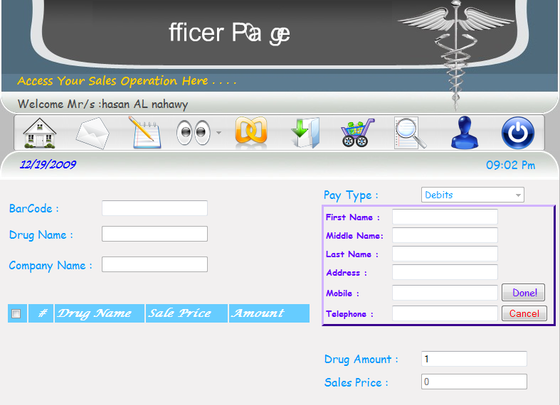

***Daily Sales Page*** :this page for the officer ,from this page he can access all operation about sales and he can sale in three ways cash, cheques and debts ,for debts and cheques officer must enter all information about customer , as you can see in the picture above.

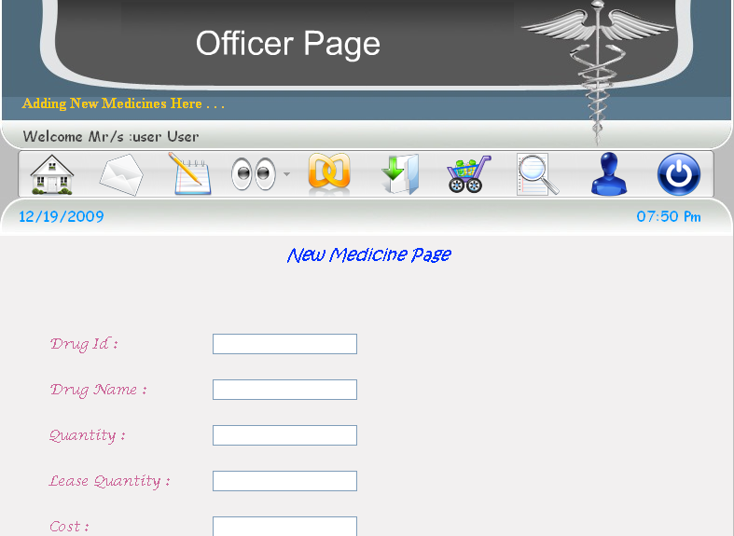

***Add New Medicine Page***: This page for officer ,from this page officer can add new medicine with all details about it , as you can see in the picture above.

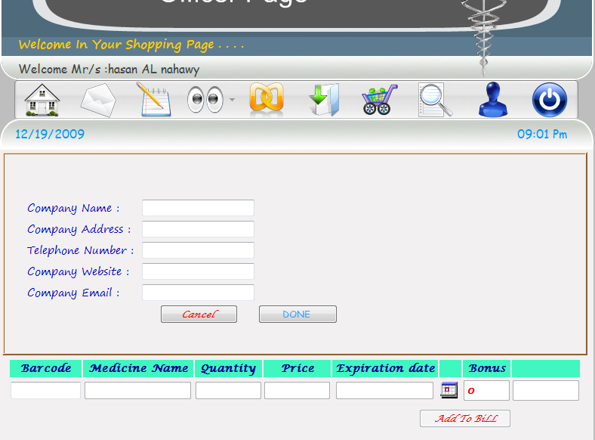

***Purchase page*** : this page for officer ,from this page officer can purchase new medicines or materials for his pharmacy and from this page he can add new agents and companies and he can print purchase bill , as you can see in the picture above.

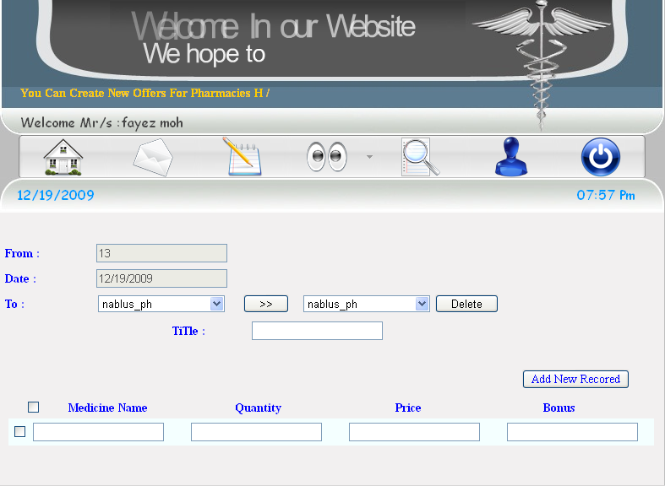

**New Offer**: This Page For agents, in this page agent can create new offer and send it for specific pharmacies connected with him , as you can see in the picture above.

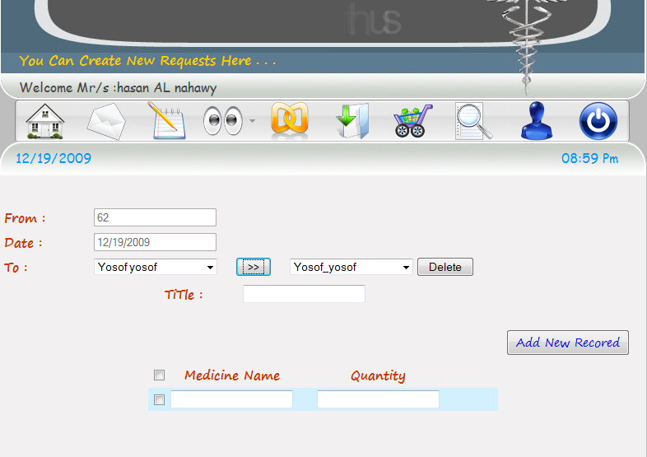

***New request*** : This page for officer ,from this page officer can send request for specific agents connected with him , as you can see in the picture above.

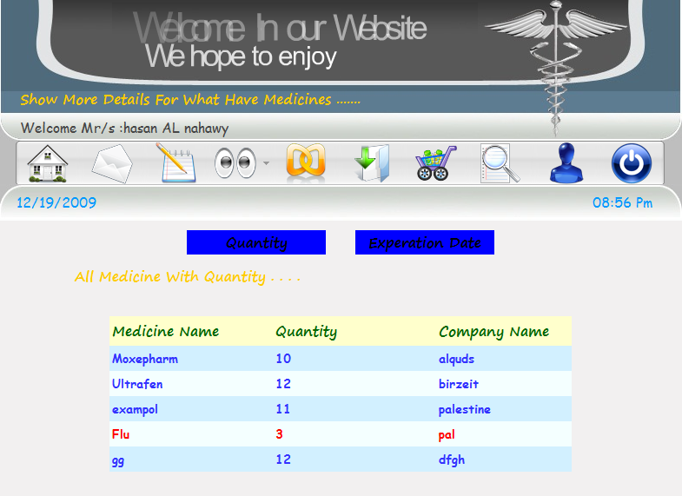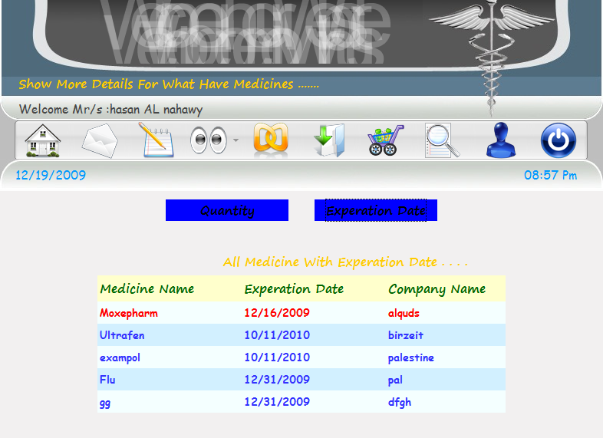

***View All Medicine Page*** :This page for administrator and officer ,from this page they can see all medicine they have with expire date and quantity , as you can see in the picture above……………………………etc