An–najah National University
Engineering Faculty
Computer Engineer Department

Software Graduation Project Documentation

Electronic Hotel
2006

Prepared by :

Abdallah Radi Mohammad Mustafa (101-25545)
Baha' Mohammad Mansor Atereh (101-27299)

Presented to :

Dr. Loai' Malhes
Dr. Raed Alqadi
Eng. Sufian Samarah
Eng. Haia samanrh

An-najah
2006

Introduction:

Electronic Hotel is designed to help the Manager of hotel, employee in reception and customer in room, which meets the customer's satisfaction.
The hotel that use classic way for dealing with its services it will spend long time and more cast, how over the customer from remote area face many problems with finding suitable hotel for him ,more that the time that customer waste it to get services in hotel , Not to mention the time employees would spend going back and forth to serve customers, so we decided to make this project to help managers and customers in hotels.
As the first step we start get information about E_Hotel System from Hotel department and web site and we see the advantage of this system.

C#.net Language is used to implement this project :

C# is a simple, modern, object oriented language derived from C++ and Java. it aims to combine the high productivity of Visual Basic and the raw power of C++. NET includes a Common Execution engine and a rich class library. Microsoft's JVM equiv .is Common language run, time (CLR).In C# Microsoft has taken care of C++ problems such as Memory management , pointers and etc.

Microsoft SQL Server 2000 is used to implement this project:

The SQL Server in .Net frameworks faster than any other connections, it's 70% faster than others connections. We used the stored procedure that is more security; reduce the code area, reusability and fast compilation.

ASP.NET Language is used to implement this project:

ASP.NET is programming framework that is built on the common language runtime.
ASP.NET can be used on a server to build powerful Web application. ASP.NET Web Forms provide an easy and powerful way to build dynamic Web user interfaces (UIs).A web form is the Web page that users view in a browser. An ASP.NET Web application comprises one or more Web Forms. A Web Form is a dynamic page that can access server recourses.
In addition , because an ASP.NET Web Form does not rely on client-side scripting, it is not dependent on the client's browser type or operating system. This independence allows you to develop a single Web Form that can be viewed on practically any device that has Internet access and Web browser.

The behavior of a System in over views of users :

• System from Receptions Employee Overview:

- Check for available and reserved rooms.
- Reserve room.
- Add invoice to guest and show it.
- Search for guest information.

• System from administrator Overview:

- This system allows adding new room in data base.
- This system allows adding new item in any restaurant in data base.
- This system allows adding new employee in data base.
- This system allows adding new VIP Guest in data base.

• System from Guest Overview:
- The guest request service or meal by using this system.

• System from Room Service Employee Overview:
- Provide employee to show order and execute it.

• System from customers Overview:
- Provide customers to show information of hotel.
- Provide VIP Guest to make reservation of available room.

Expression used in project and there meaning:

- Reserve: this use case allows customer to reserve in the hotel.

- Checking: this use case allows Reception employee and customer to check rooms' state.

- Payment: this use case allows Reception employee to calculate total cash for any guest.

- Login: this use case allows Reception employee to access System.
- Room management: this use case allows Reception employee
- Menu Item Management: this use case
- Request Service: this use case allows customer to request the services which he will be wanted it.
- Process Orders: this use case allows restaurant to knowledge orders.
- Employee management allows adding new employee.
- Customer management allows adding new customer.
Data base, tables, relations used in this project is as this figure bellow:

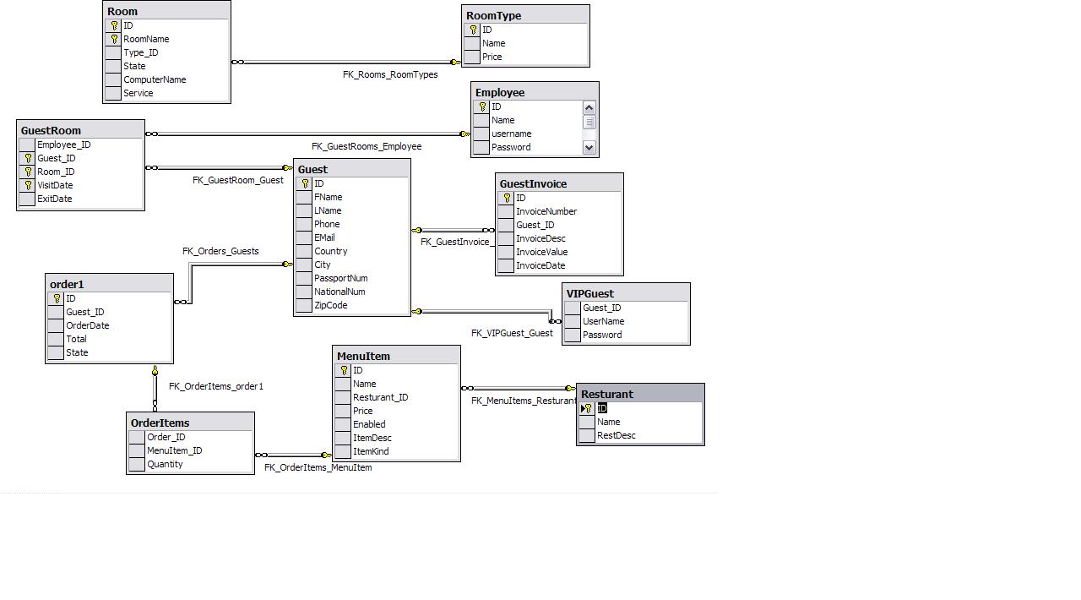

Main Topics in E-Hotel System :

Manager system :
This section can be considered as the basic system of all the electronic hotel system as it contain the following important sections and there details:

* Room Management.
* Menu Item Management.
* Employees Management.
*Customer Management.

This figure bellow shows the main manager system:

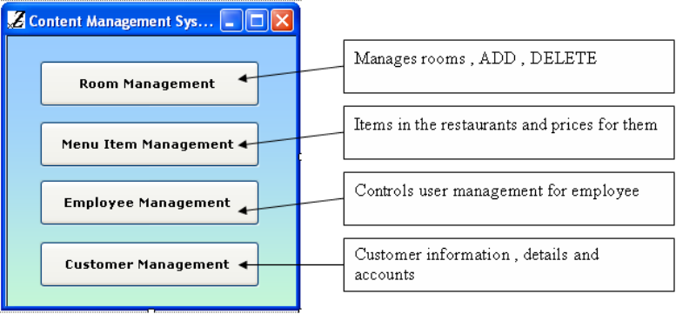

Reception system :
the reception system is responsible over all missions regarding the room and customers in hotel , the missions as the following :

* search engine, to describe all the rooms state either available or reserve.
* the history of each room.
* search the guest and there states.
* make reserve of any room.
* calculate the bills.
* show the room guest dialog.
* show the rooms reports.
* check out all the guests.
* show the guest history.
* show the invoices and bill of specific guest.

this figure show the main reception form used to enter the hole system you just have to press enter button to enter log in form:

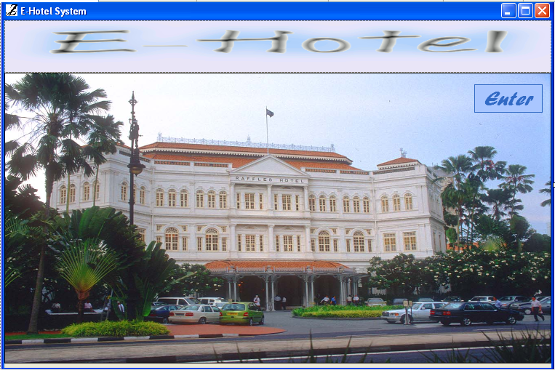

Customer room system:

this section can be placed in the customer room to request any services or any meals and to get the response as fast as it could, this section contain two main items the meal button and service button, the first can be used to request specific meal, the second can be used to request any service, as the following figure shows:
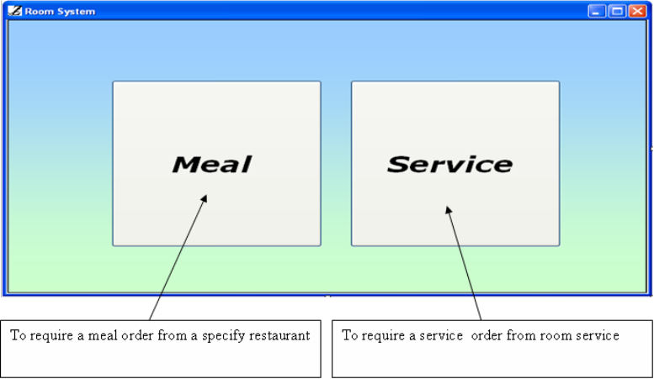

Services system:

This section enable the employees to serve the customers orders at once they request any service, as this system can be placed in the restrung.
As this figure bellow shows:

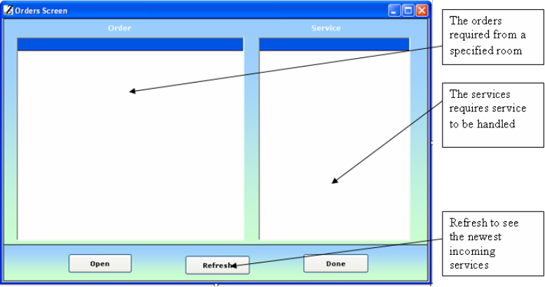

Reserve web screen:

This figure bellow shows the main screen in hotel web site :

