ARM9 Microcontroller Based SBC with Linux OS

By: Mwaffaq M. HajAli & Luai N. Qawariq

Graduation project documentation submitted in partial fulfillment of the requirements for the degree of Bachelor's of Science in the department of Computer Engineering, An-Najah National University.

May 5, 2008

Abstract

This is the first Single Board Computer (SBC) built at An-Najah National University using Surface Mount Technology (SMT) and running Linux as its operating system.

This project is intended to be the starting point for the use of Surface Mount Technology, Multi-layer PCB design and Embedded Linux Development at our university.

The SBC is based on the original designs of Darrell Harmon and Flavio Ribeiro.

A separate document shall be dedicated to explain the deficiencies in the PCB lab equipment that hindered the full utilization of the lab and the production of a 4-layer prototype of the board.

System Specifications
- 180 MHz, 200MIPS ARM9 processor (Atmel AT91RM9200)
- 2 MB Serial Flash (Used for Darrel's Loader)
- 32MB SDRAM
- USB 2.0 Full Speed Host Interface
- I²C Port
- 10/100 Ethernet interface
- 4 SPI interfaces
- 2 RS232 interfaces
- JTAG support
- XBee-Pro RF Module on a serial interface

What is ARM?
"The ARM, which stands for Advanced RISC Machine, is a family of processors maintained and promoted by ARM Holdings Ltd. Contrary to other chip manufacturers such as IBM, Motorola, and Intel, ARM Holdings does not manufacture its own processors. Instead, ARM designs the CPU cores for its customers based on the ARM core, charges customers licensing fees on the design, and lets them manufacture the chip wherever they see fit. This offers various advantages to the parties involved, but it does create a certain confusion to the developer approaching this architecture for the first time, as there does not seem to be a central producer of ARM chips on the market. There is, though, one unifying characteristic that is important to remember: all ARM processors share the same ARM instruction set, which makes all variants fully software compatible. This doesn't mean that all ARM CPUs and boards can be programmed and set up in the same way, only that the assembly language and resulting binary codes are identical for all ARM processors. Currently, ARM CPUs are manufactured by Intel, Toshiba, Samsung, and many others. The ARM architecture is very popular in many fields of application and there are hundreds of vendors providing products and services around it."
"In addition to the kernel port to the ARM, many projects have geared up for ARM support. First, hard real-time support is available from the RTAI project and a StrongARM RTLinux port is available at http://www.imec.be/rtlinux/. In addition, Java support is available from the Blackdown project.^{[2]} There is however no kernel debugger, since most developers who need to debug the kernel on an ARM system use a JTAG debugger."

Why ARM?
"By the year 2007, the mid-range car will have up to 70 Embedded Processors. Standardizing on a processor core and standard peripherals will help to manage the complexity, connectivity and compatibility of systems whilst decreasing the time and money spent during the development cycle.
- Reliability through mature, industry proven architecture – ARM’s industry leading 16/32-bit architecture is forward compatible and protects investments in hardware and software development.

- Supply chain efficiency – There are more than 10 leading microcontroller suppliers providing ARM based Microcontroller Solutions. The ARM network also offers a broad choice of application-specific intellectual property, including CANs, fault tolerant x-by-wire bus systems and OSEK solutions.

- Cost reduction – ARM 32-bit processors enable the highest system integration through performance and small die size and ARM Thumb®technology allows the use of cheaper memories. Lower development costs are also possible due to software standardisation and re-use.

- Core performance - Through a wide range of functionality and power, parts running from 1MHz to 1 GHz with architectural performance enhancements for media and Java.

- Tools of choice – ARM has the widest range of hardware and software tools support of any 32 bit architecture.

- Wide support - ARM is the best supported microprocessor architecture available. A wide range of OS, Middleware and tools support an extensive choice of multimedia codec solutions optimized for ARM processors, are available from the ARM Connected Community.

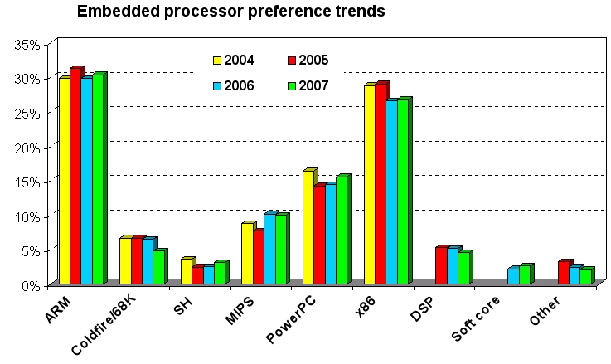

1.1. Why Linux?
"Because of the numerous economic and technical benefits, we are seeing strong growth in the adoption of Linux for embedded devices. This trend has crossed virtually all markets and technologies. Linux has been adopted for embedded products in the worldwide public switched telephone network, global data networks, wireless cellular handsets, and the equipment that operates these networks. Linux has enjoyed success in automobile applications, consumer products such as games and PDAs, printers, enterprise switches and routers, and many other products. The adoption rate of embedded Linux continues to grow, with no end in sight."

"At the time of this writing, Linux supports 10 distinct ARM CPUs, 16 different platforms, and more than 200 related boards. Given the quantity and variety of information involved, The complete and up-to-date list of ARM systems supported and their details is found at http://www.arm.linux.org.uk/developer/machines/. "
"Suffice it to say that Linux supports most mainstream CPUs and boards, such as Intel's SA1110 StrongARM CPUs and Assabet development boards. In case you need it, there is a method to add support for new hardware."
"Some of the reasons for the growth of embedded Linux are as follows:
- Linux has emerged as a mature, high-performance, stable alternative to traditional proprietary embedded operating systems.
- Linux supports a huge variety of applications and networking protocols.
- Linux is scalable, from small consumer-oriented devices to large, heavy-iron, carrier-class switches and routers.
- Linux can be deployed without the royalties required by traditional proprietary embedded operating systems.
- Linux has attracted a huge number of active developers, enabling rapid support of new hardware architectures, platforms, and devices.
- An increasing number of hardware and software vendors, including virtually all the top-tier manufacturers and ISVs, now support Linux.
For these and other reasons, we are seeing an accelerated adoption rate of Linux in many common household items, ranging from high-definition television sets to cellular handsets."

Three different host/target architectures are available for the development of embedded Linux systems:
- Linked setup
- Removable storage setup
- Standalone setup

The actual setup may belong to more than one category or may even change categories over time, depending on The requirements and development methodology.

Linked setup:

The target and the host are permanently linked together using a physical cable
- This link is typically a serial cable or an Ethernet link
- All transfers occur via the link

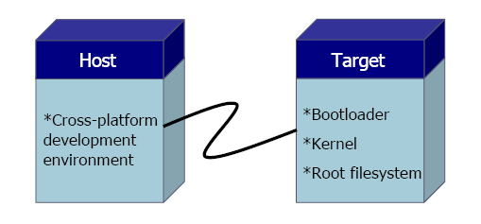

- The kernel could be available via Trivial File Transfer Protocol (TFTP)
- The root filesystem could also be NFS mounted instead of being on a storage media in the target
Using an NFS-mounted root filesystems actually perfect during
development, because it avoids having to constantly copy program
modifications between the host and the target.

- The physical link can also be used for debugging purposes
Many embedded systems provide both Ethernet and RS232 link capabilities.

Removable storage setup
- A storage device is written by the host, is then transferred into the target, and is used to boot the device
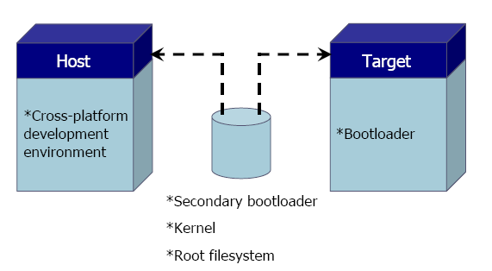

- The target contains only a minimal bootloader
The rest of the components are stored on a removable storage media, such
as CompactFlash, IDE device or any other type of drive.

- This setup is mostly popular during the initial phases of embedded system development

Standalone setup

- The target is a self-contained development system and includes all the required software to boot, operate, and develop additional software
This setup is similar to an actual workstation, except the underlying
hardware is not a conventional workstation but rather the embedded system
itself.
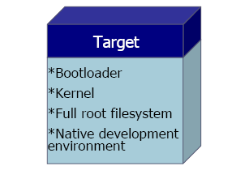

- This type of setup is quite popular with developers building high-end PC-based embedded systems, such as high-availability systems
They can use standard off-the-shelf Linux distributions on the embedded
system.
Once development is done, they then work at trimming down the
distribution and customizing it for their purposes.

- This gets developers around having to build their own root filesystemsand configure the systems' startup
It requires that they know the particular distribution they are using inside
out.
In our system we used the third type, but we use the first type at the begining, and we use it to build a big application for the target.
Tool Chain :
A collection of tools used to develop for a particular hardware target (e.g. embedded system) Often used in the context of building software on one system which will be installed or run on some other device (e.g. embedded system) the chain of tools sually consists of such items as a particular version of a compiler, libraries, assembler, special headers, etc.

Why do we need it?

Embedded system runs on a target computer, which is limited in resources and efficiency, and it may be a totally different processor architecture from our x86-based development workstation. We therefore need a cross-development tool chain that runs on the PC but generates code for a different processor. We also need a tool that will help us debug code running on the target.

The role of toolchain:

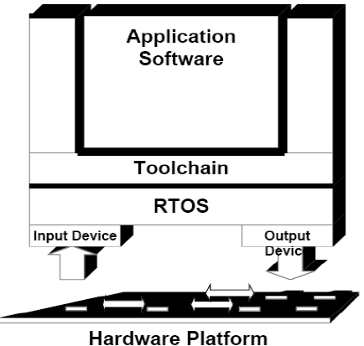

Considerations to take when building a toolchain:

The first step in building the toolchain is selecting the component versions we will use. This involves selecting a binutils version, a gcc version, and a glibc version. Because these packages are maintained and released independently from one another, not all versions of one package will build properly when combined with different versions of the other packages.

Patches may be needed to apply to some versions to get them to properly compile for the target.

gcc 3.4.5 , and glibc 2.3.6 are stable versions , so we used them in our project.

The following shell script used to build the toolchain ,the source can be downloaded
from : http://kegel.com/crosstool/#download
We used version crosstool-0.42 : http://kegel.com/crosstool/crosstool-0.42.tar.gz.

#!/bin/bash
set -ex

TARBALLS_DIR=$HOME/downloads
RESULT_TOP=$HOME/crosstool
GCC_LANGUAGES="c,c++"
PARALLELMFLAGS="-j2"
GDB_DIR=gdb-6.5

export GCC_LANGUAGES PARALLELMFLAGS TARBALLS_DIR RESULT_TOP GDB_DIR

mkdir -p $RESULT_TOP

# Create the toolchain. This will take a lot of time.
# Add --gdb to the next line if you are going to use GDB!
eval `cat arm-softfloat.dat gcc-3.4.5-glibc-2.3.6.dat` sh all.sh --notest
echo Done.

Compile flow chart:

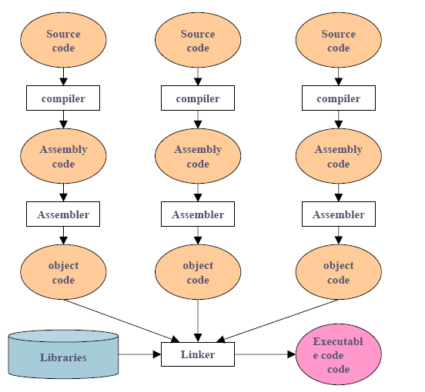

Boot Loaders

The microcontroller's ROM boot loader.

This is the Default Boot Program stored in the microcontroller's ROM. It downloads and runs an application from external storage media into the microcontroller's SRAM. In case no valid program is detected or no storage media is interfaced to the microcontroller, the boot uploader accepts a program through Serial communication on the DBGU port (XModem protocol).

The Bootloader is activated first. It looks for a sequence of eight valid ARM exception vectors in a DataFlash connected to the SPI, an EEPROM connected to the Two-wire Interface (TWI) or an 8-bit memory device connected to the external bus interface (EBI). All these vectors must be Bbranch or LDR load register instructions except for the sixth instruction. This vector is used to store information, such as the size of the image to download and the type of DataFlash device.

In our system, we used the Atmel AT45DB161D-TU DataFlash® (2 MB) to store the Darrell Loader, the U-Boot and the Linux Kernel Image.

Darrell's Loader

As stated by its author, Darrell Harmon, most of it is taken from the U-Boot project and reduced in size to fit in the AT91RM9200's SRAM.

The AT91RM9200's SRAM is 16KB, the ROM boot loader uses 4KB of it, and so Darrell's loader cannot exceed 12KB.

The purpose of Darrell's Loader is to accept programs uploaded through the serial port and store them into the DataFlash, as the AT91RM9200's ROM uploader is designed to only place a program into the SRAM and start it. The ROM Loader then can read the program stored in the DataFlash into the SRAM and start it.

Initially, there would be no program stored in the DataFlash, so the ROM uploader starts after it fails to detect a valid ARM reset vecrot in the DataFlash. The ROM uploader transmits the ASCII character 'C' over the DBGU port, indicating to the host PC to start transmitting a program using the XMODEM Protocol with 16 bit CRC. Any terminal application with XMODEM support can be used to upload the program (Kermit, Minicom,HyperTerminal in windows,..).

After uploading Darrell's loader, the ROM uploader starts it in the SRAM and terminates.

Darrell Loader is in control now, and we may use it to upload more programs to be stored into the DataFlash.

We upload the Darrell loader again through the DBGU port, and this time the running copy of Darrell Loader accepts the copy being upload and stores it into the DataFlash, so that next time the system starts, The Darrell Loader will be automatically started from the DataFlash by the AT91RM9200's ROM Loader.

Darrell Loader first copies the whole program being uploaded into the SDRAM, then stores it into the DataFlash after the upload is completed.

Note: the SDRAM is different from the SRAM. The AT91RM9200 has 16kB of internal Static RAM (SRAM) for program execution. Our system also has 32MB of Synchronous Dynamic RAM (SDRAM) interfaced to the AT91RM9200. the SDRAM chip we used is the MICRON MT48LC16M16A2TG-75:D TR.

The Darrell Loader is also used to upload the U-Boot and the Kernel Image to the DataFlash.

Note: The Jumper J1 connected to the RESET# pin of the DataFlash is used to prevent the ROM Loader from loading the program stored in the DataFlash. In that case, the ROM Uploader starts to accept a new program though the DBGU Serial Port, as if there were no program stored on the DataFlash. It's used when we need to replace the program stored on the DataFlash.

The main benefits of darrell’s loader is giving the user a menu with options to load a new u-boot or kernel, or use the stored ones on data flash. Which makes loading modified u-boot and kernel easy to data flash in a develpment projects.

Das U-Boot (The U-Boot) Loader

The boot loader is the piece of software that starts executing immediately after the system is powered on. The boot loader is an important part of the development process and one of the most complicated ones too.

In our case it is loaded by darrell’s loader from falsh into SDRAM to be executed.
The following table presents the open source bootloaders that can be used with Linux and the architectures they support. For each bootloader, the table also indicates whether the bootloader provides monitor capabilities, and provides a short description of the bootloader.
 |  |  | Architectures
Bootloader | Monitor | Description | x86 | ARM | PowerPC | MIPS | SuperH | m68k
LILO | No | The main disk bootloader for Linux | X
GRUB | No | GNU's successor to LILO | X
ROLO | No | Loads Linux from ROM without a BIOS | X
Loadlin | No | Loads Linux from DOS | X
Etherboot | No | ROMable loader for booting systems through Ethernet cards | X
LinuxBIOS | No | Linux-based BIOSreplacement | X
Compaq's bootldr | Yes | Versatile loader mainly intended for Compaq iPAQ |  | X
blob | No | Loader from the LART hardware project |  | X
PMON | Yes | Loader used in Agenda VR3 |  |  |  | X
sh-boot | No | Main loader of the LinuxSH project |  |  |  |  | X
U-Boot | Yes | Universal loader based on PPCBoot and ARMBoot | X | X | X
RedBoot | Yes | eCos-based loader | X | X | X | X | X | X

Form the table above we chose u-boot, which supports arm processor, and contains
definitions for many devises.

The mandatory boot loader functionalities are:
1. Initializing the hardware: This includes the processor, the essential controllers
such as the memory controller, and the hardware devices necessary
for loading the kernel such as flash.

2. Loading the kernel: The necessary software to download the kernel and
copy it to the appropriate memory location.

The following figure shows the flow of boot loader:

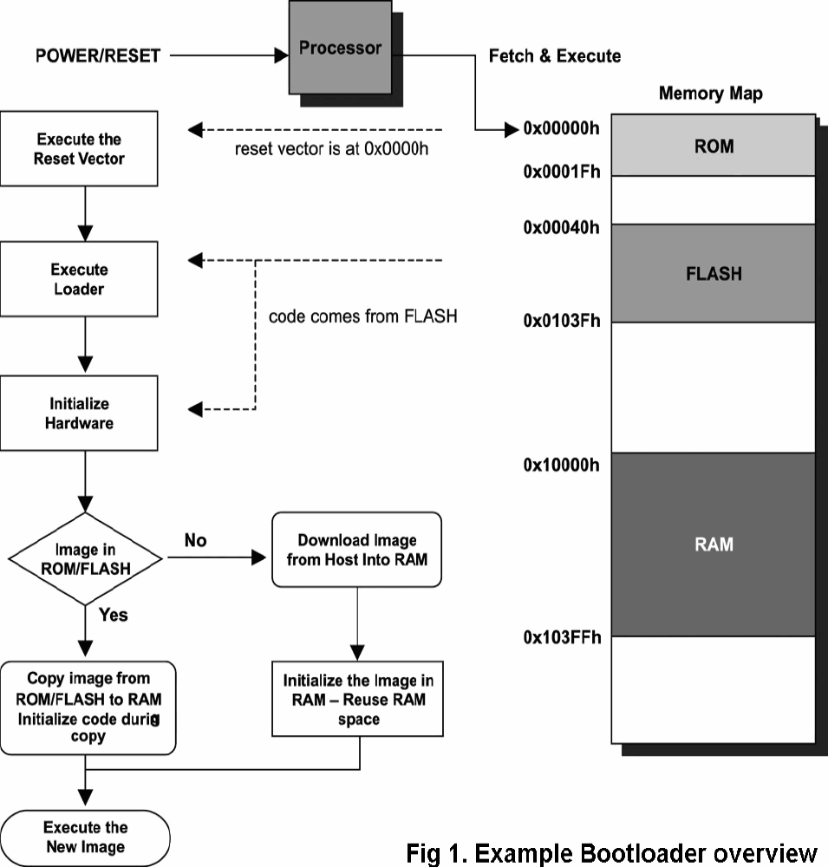

The Linux Kernel

The kernel version we used is 2.6.21.6, it is open source, we downloaded the source from:
http://ftp.kernel.org/pub/linux/kernel/v2.6/linux-2.6.21.6.tar.bz2

And we downloaded the patches, which is necessary for the kernel to work properly.
http://maxim.org.za/AT91RM9200/2.6/2.6.21-at91.patch.gz
http://svn.arhuaco.org/svn/src/emqbit/ECB_AT91_V2/linux-kernel/2.6.21/ecb_at91_2.6.21.patch

commands used to build the kernel:
After we extracted the kernel source, we applied the patches:
zcat 2.6.21-at91.patch.gz | patch -p1
cat ecb_at91_2.6.21.patch | patch -p1

We exported the cross-tool we have built.
export PATH=$PATH:$HOME/crosstool/gcc-3.4.5-glibc-2.3.6/arm-softfloat-linux-gnu/bin/
alias crossmake='make ARCH=arm CROSS_COMPILE=arm-softfloat-linux-gnu- '

Then we configured the kernel to the specific board ecbat91
crossmake ecbat91_defconfig

Then we updated the configuration of the kernel for our needs, such as the processror to be AT91RM9200.
crossmake menuconfig

Then we made the kernel image:
crossmake -j2 vmlinux

Now we need to prepare the kernel image, so we type:
arm-softfloat-linux-gnu-objcopy -O binary -R .note -R .comment -S vmlinux linux.bin

and generate a compressed file:
gzip -c -9 linux.bin > linux.bin.gz

Then we use the mkimage tool generated when building the u-boot, to make image which will be trnsmitted to the target, u-boot generates the image because it will extract it in the target.

$HOME/u-boot-1.1.4.patched/tools/mkimage \
-A arm -O linux -T kernel -C gzip -a 0x20008000 -e 0x20008000 \
-n "Linux Kernel Image" -d linux.bin.gz ecb_at91.img

The image will be extracted at address 0x20008000 in RAM.

We upload it, and save it in the flash.

The Root File System

Definition
The root filesystem is the filesystem that is contained on the same partion on which the root directory is located, and it is the filesystem on which all the other filesystems are mounted (i.e., logically attached to the system) as the system is booted up (i.e., started up).
A partition is a logically independent section of a hard disk drive (HDD). A filesystem is a hierarchy of directories (also referred to as a directory tree) that is used to organize files on a computer system. On Linux and and other Unix-like operating systems, the directories start with the root directory, which contains a series of subdirectories, each of which, in turn, contains further subdirectories, etc. A variant of this definition is the part of the entire hierarchy of directories (i.e., of the directory tree) that is located on a single partition or disk.
The exact contents of the root filesystem will vary according to the computer, but they will include the files that are necessary for booting the system and for bringing it up to such a state that the other filesystems can be mounted as well as tools for fixing a broken system and for recovering lost files from backups. The contents will include the root directory together with a minimal set of subdirectories and files including /boot, /dev, /etc, /bin, /sbin and sometimes /tmp (for temporary files).
Building the Root File System
There are three techniques that can be used for making a root file system:

- Using the initrd/initramfs.

- Mounting the root file system over the network using NFS: This makes sense
during the development stages; all changes can be done on the development
(host) machine and the root file system can be mounted across the
network from the host. The details of how to mount the root file system
using NFS can be obtained from the documentation that is part of the
kernel source tree under Documentation/nfsroot.

- Burning the root file system into flash: This is done during the production
stage. The image of the root file system to be run on the target (such as
JFFS2 or CRAMFS) is created on the host and is then burned to flash.

A various methods used such as buildroot to create images in the last
technique .

We used the last technique for making the root file system, using buildroot, but instead of burning the root file system on flash, we burned it on USB flash, as the size of flash on the board is limited.

GPIO

The set of Parallel I/O (PIO) controllers multiplex the peripheral input/output lines with general-purpose data I/Os for maximum flexibility in device configuration. An input change interrupt, open drain capability and programmable pull-up resistor is included on each line.

The GPIO controllers can be accessed either from the kernel (by writing a kernel driver) or from user space (using memory mapped I/O). We modified the testgpio.c program written by Andres Calderon from emQbit to access the GPIO Port from user space.

Serial Interfaces

The AT91RM9200 has 5 serial ports (nodes ttyS0 through ttyS4 in /dev/ ).
Darrel-Loader, U-Boot and the Kernel are configured to use ttyS0 as the console. It's possible to configure the Kernel to use a different serial port as the console. it's also possible to configure the kernel to use more than one serial port as console devices.

We do not have to re-build the kernel each time we want to alter this configuration. Rather, the configurations are passed to the kernel from U-Boot through setting the 'bootargs' environment variable.
This is achieved by executing the following command in U-Boot:

Setenv bootargs 'rootfstype=ext2 rw panic=10 root=/dev/sda1 console=ttyS0,115200n8 rootdelay=5'

- The console parameter tells the kernel to use ttyS0 as the system's console, and to configure the serial port to use 115200 baud rate, no parity, 8 data bits, one start bit and one stop bit.

- Rootfs indicates the root file system on the USB flash memory stick. Any linux root file system can be used, provided the kernel is configured to support it. This has to be done when building the kernel.

- Rw means that the file system can be read and written.

- The panic parameter tells the kernel to reboot the system after 10 seconds in case the system panics.

- The root parameter tells the kernel that the root file system is found on /dev/sda1, which is the USB flash stick. 1 is the partition number.

- The rootdelay parameter tells the kernel to wait 5 seconds before mounting the root file system. This is necessary because USB flash memories take time to be mounted.

To save the new configurations into the DataFlash, the 'saveenv' command is used.

As a simple demonstration application, we interfaced a ZigBee RF Module at serial port /dev/ttyS2 and used it to communicate with a remote PIC microcontroller with another ZigBee RF Module interfaced at its serial port.

Bill of Materials

# | Symbol | Value/Descryption | QTY | Manufacturer Part #
1 | R | 100k | 1 | MCR18EZHF1003
2 | R | 100 , 1% | 5 | MCR18EZPF1000
3 | R | 1k | 3 | MCR18EZPF1001
4 | R | 10k | 3 | MCR18EZPF1002
5 | R | 10 | 2 | MCR18EZPF10R0
6 | R | 1.96k | 1 | MCR18EZHF1961
7 | R | 1.27k | 1 | MCR18EZHF1271
8 | R | 50 1% | 5 | MCR18EZHF49R9
9 | R | 1.5k | 2 | MCR18EZPF1501
10 | R | 6.49 1% | 1 | MCR18EZPF6491
11 | R | 22.1k | 1 | MCR18EZPF2212
12 | R | 2k | 2 | MCR18EZPF2001
13 | R | 47k | 1 | MCR18EZPF4702
14 | R | 4.7k | 1 | MCR18EZPF4701
15 | R | 220 | 2 | MCR18EZPF2200
16 | C | 100nF | 52 | GRM188R71C104KA01D
17 | C | 10uF,16V | 11 | EEV-HA1C100R
18 | C | 0.1uF | 2 | GRM155R71C104KA88D
19 | C | 4.7nF | 1 | GRM155R71H472KA01D
20 | C | 470pF | 1 | GRM033R71C471KD01D
21 | C | 22pF | 2 | GRM1885C2A220JA01D
22 | C | 5.6nF | 1 | GRM188R71H562KA01D
23 | C | 680pF | 1 | GRM155R71H681KA01D
24 | C | 33pF | 4 | GRM0335C1E330JD01D
25 | C | 22uF | 2 | UWX1C220MCL1GB
26 | L | Ferrite Bead | 10 | HZ0805C202R-10
27 | D | Diode | 4 | STPS340U
28 | LEDs | Green, Red | 7 | LTST-C170KGKT, SML-LX0603SRW-TR
29 | RS-232 | MULTICHANNEL RS-232 LINE DRIVER/RECEIVER | 1 | MAX3223EIDBR
30 | USBDF | EMI Filter and line termination for USB downstream ports | 1 | USBDF01W5
31 | SDC | SD/MMC Connector | 1 | CCM05-5761LFT (not deployed)
32 | SDRAM | 32MB SDRAM | 1 | MT48LC16M16A2TG-75:D TR
33 | FLASH | 16M bit DataFlash | 1 | AT45DB161D-TU
34 | REG | 5V Regulator | 1 | LM1117MP-5.0/NOPB
35 | REG | 3.3V Regulator | 1 | LM1117MP-3.3/NOPB
36 | REG | 1.8V Regulator | 1 | LM1117MP-1.8/NOPB
37 | POR | Power-On-Reset Chip | 1 | MCP130T-300I/TT
38 | MCU | ARM920T-based  Microcontroller | 1 | AT91RM9200-QU-002
39 | XTAL | 18MHz |  | ECS-184-20-5P-TR
40 | XTAL | 3.87KHz |  | ECS-3X8
41 | XTAL | 25MHz |  | ECS-250-20-28A-F-TR
42 | CONN | Ethernet Connector | 1 | SI-50170
43 | PHY | 10/100BASE-TX/FX MII Physical Layer Transceiver | 1 | KSZ8721BL

System Booting

.

.

.

Darrell's loader - Thanks to the u-boot project

Version 1.0. Build Apr 2 2008 23:49:06

RAM:32MB

1: Upload Darrell's loader to Dataflash

2: Upload u-boot to Dataflash

3: Upload Kernel to Dataflash

4: Start u-boot

5: Upload Filesystem image

6: Memory test

DataFlash:AT45DB161

Dataflash read successful: Starting U-boot

U-Boot 1.1.6 (Oct 22 2007 - 10:35:14)

DRAM: 32 MB
Atmel: Flash: 0 kB
DataFlash:AT45DB161
Nb pages: 4096
Page Size: 528
Size= 2162688 bytes
Logical address: 0xC0000000
Area 0: C0000000 to C000317F (RO) Darrell loader
Area 1: C0003180 to C001F73F (RO) U-boot
Area 2: C001F740 to C002183F Environment
Area 3: C0021840 to C01ACFFF Kernel
Area 4: C01AD000 to C020FFFF (RO) Filesystem
In: serial
Out: serial
Err: serial
I am checking if it is connected
Hit any key to stop autoboot: 2 1 0
## Booting image at c0021840 ...
Image Name: Linux Kernel Image
Image Type: ARM Linux Kernel Image (gzip compressed)
Data Size: 1584472 Bytes = 1.5 MB
Load Address: 20008000
Entry Point: 20008000
Verifying Checksum ... OK
Uncompressing Kernel Image ... OK

Starting kernel ...

Linux version 2.6.21.6 (root@linux-s2) (gcc version 3.4.5) #8 PREEMPT Sun Apr 27 02:17:47 NPT 2008
CPU: ARM920T [41129200] revision 0 (ARMv4T), cr=c0003177
Machine: emQbit's ECB_AT91 V1
Memory policy: ECC disabled, Data cache writeback
Clocks: CPU 179 MHz, master 59 MHz, main 18.432 MHz
CPU0: D VIVT write-back cache
CPU0: I cache: 16384 bytes, associativity 64, 32 byte lines, 8 sets
CPU0: D cache: 16384 bytes, associativity 64, 32 byte lines, 8 sets
Built 1 zonelists. Total pages: 8128
Kernel command line: rootfstype=ext2 rw panic=10 root=/dev/sda1 console=ttyS0,115200n8 rootdelay=5
AT91: 96 gpio irqs in 3 banks
PID hash table entries: 128 (order: 7, 512 bytes)
Console: colour dummy device 80x30
Dentry cache hash table entries: 4096 (order: 2, 16384 bytes)
Inode-cache hash table entries: 2048 (order: 1, 8192 bytes)
Memory: 32MB = 32MB total
Memory: 29076KB available (2992K code, 278K data, 92K init)
Mount-cache hash table entries: 512
CPU: Testing write buffer coherency: ok
NET: Registered protocol family 16
Generic PHY: Registered new driver
SCSI subsystem initialized
usbcore: registered new interface driver usbfs
usbcore: registered new interface driver hub
usbcore: registered new device driver usb
NET: Registered protocol family 2
IP route cache hash table entries: 1024 (order: 0, 4096 bytes)
TCP established hash table entries: 1024 (order: 1, 8192 bytes)
TCP bind hash table entries: 1024 (order: 0, 4096 bytes)
TCP: Hash tables configured (established 1024 bind 1024)
TCP reno registered
NetWinder Floating Point Emulator V0.97 (double precision)
io scheduler noop registered
io scheduler anticipatory registered (default)
at91_spi: Baud rate set to 5990400
AT91 SPI driver loaded
AT91 Watchdog Timer enabled (5 seconds, nowayout)
atmel_usart.0: ttyS0 at MMIO 0xfefff200 (irq = 1) is a ATMEL_SERIAL
atmel_usart.1: ttyS1 at MMIO 0xfffc0000 (irq = 6) is a ATMEL_SERIAL
atmel_usart.2: ttyS2 at MMIO 0xfffc4000 (irq = 7) is a ATMEL_SERIAL
atmel_usart.3: ttyS3 at MMIO 0xfffc8000 (irq = 8) is a ATMEL_SERIAL
atmel_usart.4: ttyS4 at MMIO 0xfffcc000 (irq = 9) is a ATMEL_SERIAL
loop: loaded (max 8 devices)
nbd: registered device at major 43
usbcore: registered new interface driver ub
LXT970: Registered new driver
LXT971: Registered new driver
Fixed PHY: Registered new driver
Device 'fixed@100:1' does not have a release() function, it is broken and must be fixed.
BUG: at drivers/base/core.c:109 device_release()
Device 'fixed@10:1' does not have a release() function, it is broken and must be fixed.
BUG: at drivers/base/core.c:109 device_release()
PPP generic driver version 2.4.2
PPP Deflate Compression module registered
PPP BSD Compression module registered
PPP MPPE Compression module registered
NET: Registered protocol family 24
SLIP: version 0.8.4-NET3.019-NEWTTY (dynamic channels, max=256) (6 bit encapsulation enabled).
CSLIP: code copyright 1989 Regents of the University of California.
SLIP linefill/keepalive option.
eth0: Link down.
eth0: AT91 ethernet at 0xfefbc000 int=24 10-HalfDuplex (00:00:00:00:00:5b)
eth0: Micrel KS8721 PHY
HDLC support module revision 1.21
Cronyx Ltd, Synchronous PPP and CISCO HDLC (c) 1994
Linux port (c) 1998 Building Number Three Ltd & Jan "Yenya" Kasprzak.
DLCI driver v0.35, 4 Jan 1997, mike.mclagan@linux.org.
usbcore: registered new interface driver zd1211rw
usbcore: registered new interface driver zd1201
SCSI Media Changer driver v0.25
kobject_add failed for at91_spi with -EEXIST, don't try to register things with the same name in the same directory.
at91_ohci at91_ohci: AT91 OHCI
at91_ohci at91_ohci: new USB bus registered, assigned bus number 1
at91_ohci at91_ohci: irq 23, io mem 0x00300000
usb usb1: Product: AT91 OHCI
usb usb1: Manufacturer: Linux 2.6.21.6 ohci_hcd
usb usb1: SerialNumber: at91
usb usb1: configuration #1 chosen from 1 choice
hub 1-0:1.0: USB hub found
hub 1-0:1.0: 1 port detected
Initializing USB Mass Storage driver...
usb 1-1: new full speed USB device using at91_ohci and address 2
usb 1-1: Product: Cruzer Micro
usb 1-1: Manufacturer: SanDisk Corporation
usb 1-1: SerialNumber: 20051737820C7A303B67
usb 1-1: configuration #1 chosen from 1 choice
scsi0 : SCSI emulation for USB Mass Storage devices
usbcore: registered new interface driver usb-storage
USB Mass Storage support registered.
usbcore: registered new interface driver libusual
usbcore: registered new interface driver hiddev
usbcore: registered new interface driver usbhid
drivers/usb/input/hid-core.c: v2.6:USB HID core driver
usbcore: registered new interface driver catc
drivers/usb/net/catc.c: v2.8 CATC EL1210A NetMate USB Ethernet driver
usbcore: registered new interface driver kaweth
pegasus: v0.6.14 (2006/09/27), Pegasus/Pegasus II USB Ethernet driver
usbcore: registered new interface driver pegasus
drivers/usb/net/rtl8150.c: rtl8150 based usb-ethernet driver v0.6.2 (2004/08/27)
usbcore: registered new interface driver rtl8150
usbcore: registered new interface driver asix
usbcore: registered new interface driver cdc_ether
usbcore: registered new interface driver net1080
usbcore: registered new interface driver cdc_subset
usbcore: registered new interface driver zaurus
mice: PS/2 mouse device common for all mice
at91_rtc at91_rtc: rtc core: registered at91_rtc as rtc0
AT91 Real Time Clock driver.
i2c /dev entries driver
at91_i2c at91_i2c: AT91 i2c bus driver.
AT91 MMC: 4 wire bus mode not supported by this driver - using 1 wire
TCP cubic registered
NET: Registered protocol family 1
NET: Registered protocol family 17
ieee80211: 802.11 data/management/control stack, git-1.1.13
ieee80211: Copyright (C) 2004-2005 Intel Corporation <jketreno@linux.intel.com>
Waiting 5sec before mounting root device...
scsi 0:0:0:0: Direct-Access SanDisk Cruzer Micro 0.1 PQ: 0 ANSI: 2
SCSI device sda: 4001760 512-byte hdwr sectors (2049 MB)
sda: Write Protect is off
sda: assuming drive cache: write through
SCSI device sda: 4001760 512-byte hdwr sectors (2049 MB)
sda: Write Protect is off
sda: assuming drive cache: write through
sda:<7>usb-storage: queuecommand called
sda1
sd 0:0:0:0: Attached scsi removable disk sda
sd 0:0:0:0: Attached scsi generic sg0 type 0
VFS: Mounted root (ext2 filesystem).
Freeing init memory: 92K

INIT: version 2.86 booting

Activating swap.
Checking root file system...
fsck 1.37 (21-Mar-2005)
/dev/shm/root: clean, 14693/250368 files, 56132/499960 blocks
Cannot access the Hardware Clock via any known method.
Use the --debug option to see the details of our search for an access method.
System time was Thu Jan 1 00:00:16 UTC 1970.
Setting the System Clock using the Hardware Clock as reference...
Cannot access the Hardware Clock via any known method.
Use the --debug option to see the details of our search for an access method.
System Clock set. System local time is now Thu Jan 1 00:00:16 UTC 1970.
Cleaning up ifupdown...done.
Checking all file systems...
fsck 1.37 (21-Mar-2005)
Setting kernel variables ...
... done.
Mounting local filesystems...
Cleaning /tmp /var/run /var/lock.
Setting up networking...done.
Setting up IP spoofing protection: rp_filter.
Configuring network interfaces...eth0: Setting MAC address to aa:bb:cc:00:11:22
eth0: Link down.
done.

Setting the System Clock using the Hardware Clock as reference...
Cannot access the Hardware Clock via any known method.
Use the --debug option to see the details of our search for an access method.
System Clock set. Local time: Wed Dec 31 21:00:20 BRT 1969

Initializing random number generator...done.

INIT: Entering runlevel: 2

Starting internet superserver: inetd.
Starting OpenBSD Secure Shell server: sshd.

Debian GNU/Linux 3.1 (none) ttyS0

(none) login: root
Last login: Wed Dec 31 21:00:28 1969 on ttyS0
(none):~# cd /
(none):/# ls
bin etc initrd media proc serial sys var
boot gpio lib mnt root serial console tmp
dev home lost+found opt sbin srv usr
(none):/# shutdown -h now

Broadcast message from root (ttyS0) (Wed Dec 31 21:00:37 1969):

The system is going down for system halt NOW!

INIT: Switching to runlevel: 0

INIT: Sending processes the TERM signal

(none):/#
INIT: Sending processes the KILL signaStopping internet superserver: inetd.
Stopping OpenBSD Secure Shell server: sshd.
Saving the System Clock time to the Hardware Clock...
Cannot access the Hardware Clock via any known method.
Use the --debug option to see the details of our search for an access method.
Hardware Clock updated to Wed Dec 31 21:00:48 BRT 1969.
Sending all processes the TERM signal...done.
Sending all processes the KILL signal...done.
Saving random seed...done.
Unmounting remote and non-toplevel virtual filesystems...done.
Deconfiguring network interfaces...done.
Cleaning up ifupdown...done.
Deactivating swap...done.
Unmounting local filesystems...done.
System halted.

Resources:

- Building Embedded Linux Systems, Karim Yaghmour, O'Reilly, April 2003, ISBN:0-596-00222-X .

- Embedded Linux Primer: A Practical, Real-World Approach, By Christopher Hallinan, Prentice Hall, September 18, 2006, ISBN-10: 0-13-167984-8, ISBN-13: 978-0-13-167984-9 .

- EMBEDDED LINUX SYSTEM DESIGN AND DEVELOPMENT, P. Raghavan • Amol Lad • Sriram Neelakandan, Auerbach Publications, Taylor & Francis Group, 6000 Broken Sound Parkway NW, Suite 300, Boca Raton, FL 33487-2742, 2006.

- http://www.linux.org
- http://www.denx.de/wiki/view/Training/BootingEmbeddedLinux
- http://www.slideshare.net/emcelettronica/embedded-linux-on-a-r-m
- http://www.linfo.org/root_filesystem.html
- http://penguinppc.org/embedded/howto/root-filesystem.html
- http://etbe.coker.com.au/2008/04/16/resizing-the-root-filesystem
- http://www.emqbit.com
- Darrell Harmon's web page : URL: http://www.dlharmon.com
- http://groups.google.com/group/ecbat91

