AN-NAJAH NATIONAL UNIVERSITY

FACULTY OF ENGINEERING

COMPUTER ENGINEERING DEPARTMENT

Graduation Project

Hospital System
Prepared By: Ayman Wahbeh

Supervisors: Dr. Luai Malhis

Dr. Raed al-Qadi

Eng: Ashraf Armoush

Eng: Samer Arandi

To build the online hospital system we need two component:
First : The language to write the web pages like asp, HTML, xml and php
The last choice will be good as we take the basic in the Advance Network with Dr:Raed Al-Qadi in the previous semester, The next factor that lead me to the PHP is the available of Tutorials over the internet;
Second: I will need a database to store the patient information, and the staff information so their was Oracle. As I will learn the PHP why not to learn new database MySql is the alternative for Oracle in my project it is free to use where you can download it from www.mysql.com/downloads

Three-Tier Architectures
This project describes web database applications built around a three-tier architecture model, shown bellow At the base of an application is the database tier, consisting of the database management system that manages the database containing the data users create, delete, modify, and query. Built on top of the database tier is the complex middle tier, which contains most of the application logic and communicates data between the other tiers. On top is the client tier, usually web browser software that interacts with the application.
The three-tier architecture model of a web database application
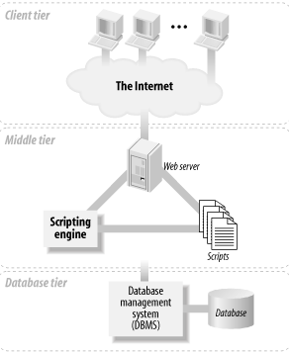

When we use the term "the Web," we mean three major, distinct standards and the tools based on these standards: the Hypertext Markup Language (HTML), the Hypertext Transfer Protocol (HTTP), and the TCP/IP networking protocol suite. HTML works well for structuring and presenting information using a web browser application. TCP/IP is an effective networking protocol that transfers data between applications over the Internet and has little impact on web database application developers. The problem in building web database applications is interfacing traditional database applications to the Web using HTTP. This is where the complex application logic is needed.

1.2 The Client Tier

The client tier in the three-tier architecture model is usually a web browser. Web browser software processes and displays HTML resources, issues HTTP requests for resources, and processes HTTP responses. As discussed earlier, there are significant advantages to using a web browser as the thin-client layer, including easy deployment and support on a wide range of platforms.
There are many browser products available, and each browser product has different features. The two most popular windowing-based browsers are Netscape and Internet Explorer. they have a common basic set:

All web browsers are HTTP clients that send requests and display responses from web servers (usually in a graphical environment).
All browsers interpret pages marked up with HTML when rendering a page; that is, they present the headings, images, hypertext links, and so on to the user.
Some browsers display images, play movies and sounds, and render other types of objects.
Many browsers can run JavaScript that is embedded in HTML pages. JavaScript is used, for example, to validate a < form > or change how a page is presented based on user actions.
Selected web browsers can run components developed in the Java or ActiveX programming languages. These components often provide additional animation, tools that can't be implemented in HTML, or other, more complex features.
Several browsers can apply Cascading Style Sheets (CSS) to HTML pages to control the presentation of HTML elements.

There are subtle "and sometimes not so subtle" differences between the capabilities different browsers have in rendering an HTML page. Lynx, for example, is a text-only browser and doesn't display images or run JavaScript. MultiWeb is a browser that renders the text on a page as sound (the spoken word) providing web access for the vision-impaired. Many subtle but annoying differences are in the support for CSS and the features of the latest HTML standard, HTML 4.
Web browsers are the most obvious example of a user agent, a software client that requests resources from a web server. Other user agents include web spiders—automated software that crawls the Web and retrieves web pages—and proxy caches, software systems that retrieve and locally store web pages on behalf of many other user agents.

The Middle Tier
In most three-tier web database systems, the majority of the application logic is in the middle tier. The client tier presents data to and collects data from the user; the database tier stores and retrieves the data. The middle tier serves most of the remaining roles that bring together the other tiers: it drives the structure and content of the data displayed to the user, and it processes input from the user as it is formed into queries on the database to read or write data. It also adds state management to the HTTP protocol. The middle-tier application logic integrates the Web with the database management system.
In the application framework used in this book, the components of the middle tier are a web server, a web scripting language, and the scripting language engine. A web server processes HTTP requests and formulates responses. In the case of web database applications, these requests are often for programs that interact with an underlying database management system. The web server I use throughout this project is the Internet Information Server IIS
I use the PHP scripting language as middle-tier scripting language. PHP is particularly suited to web database applications because of its integration tools for the Web and database environments. In particular, the flexibility of embedding scripts in HTML pages permits easy integration with the client tier. The database-tier integration support is also excellent, with more than 15 libraries available to interact with almost all popular database management systems.

Web Scripting with PHP

PHP has emerged as a component of many medium- and large-scale web database applications. This isn't to say that other scripting languages don't have excellent features. However, there are many reasons that make PHP a good choice, including:
PHP is open source, meaning it is entirely free. As such, community efforts to maintain and improve it are unconstrained by commercial imperatives.
One or more PHP scripts can be embedded into static HTML files and this makes client-tier integration easy. On the down side, this can blend the scripts with the presentation
There are over 15 libraries for native, fast access to the database tier.
Fast execution of scripts. With the new innovations in the Zend engine for script processing, execution is fast, and all components run within the main memory space of PHP (in contrast to other scripting frameworks, in which components are in distinct modules). Empirical evidence suggests that for tasks of at least moderate complexity, PHP is faster than other popular scripting tools.
Platform and operating-system flexibility PHP runs integrated with web servers such as IIS.
PHP is suited to complex systems development. It is a fully featured programming language, with more than 50 function libraries.

The Database Tier

The database tier is the base of a web database application. Understanding system requirements, choosing database-tier software, designing databases, and building the tier are the first steps in successful web database application development.

MySQL and SQL
In this Document, I will introduce the MySQL database management system (DBMS) and the SQL database query language for defining and manipulating databases.
MySQL Command Interpreter
The MySQL command interpreter is commonly used to create databases and tables in web database applications and to test queries. Throughout the remainder of this Documentation I discuss the SQL statements for managing a database. All these statements can be directly entered into the command interpreter and executed. The statements can also be included in server-side PHP scripts, as discussed in later.
Once the MySQL DBMS server is running, the command interpreter can be used. The command interpreter can be run using the following command from the command window:

C:\mysql\bin>mysql -u root -p
Enter password: ****
Running the command interpreter displays the output:
Welcome to the MySQL monitor. Commands end with ; or \g.
Your MySQL connection id is 359 to server version: 3.23.57-nt
Type 'help;' or '\h' for help. Type '\c' to clear the buffer.
mysql>
The command interpreter displays a mysql> prompt and, after executing any command or statement, it redisplays the prompt. For example, you might issue the statement:
mysql> SELECT NOW( );
This statement reports the time and date by producing the following output:

+---------------------+
| NOW( ) |
+---------------------+
| 2002-01-01 13:48:07 |
+---------------------+
1 row in set (0.00 sec)

mysql>
As with all other SQL statements, the SELECT statement ends in a semicolon. Almost all SQL command interpreters permit any amount of whitespace—spaces, tabs, or carriage returns—in SQL statements, and they check syntax and execute statements only after encountering a semicolon that is followed by a press of the Enter key. We have used uppercase for the SQL statements throughout this Documentation. However, any mix of upper- and lowercase is equivalent.
On startup, the command interpreter encourages the use of the help command. Typing help produces a list of commands that are native to the MySQL interpreter and that aren't part of SQL. All non-SQL commands can be entered without the terminating semicolon, but the semicolon can be included without causing an error.

3.4.1 Creating Databases
The CREATE DATABASE statement can create a new, empty database without any tables or data. The following statement creates a database called test:

mysql> CREATE DATABASE test;
To work with a database, the command interpreter requires the user to be using a database before SQL statements can be issued. Different command interpreters have different methods for using a database and these aren't part of the SQL standard. In the MySQL interpreter, you can issue the command:
mysql> use test

3.4.2 Creating Tables
After issuing the use test command, you then usually issue commands to create the tables in the database, Let's look at creation of one table, the customer table. The statement that created this table is shown bellow:
Creating the customer table with SQL

CREATE TABLE customer (
cust_id int(5) DEFAULT '0' NOT NULL auto_increment,
surname varchar(50) NOT NULL,
firstname varchar(50) NOT NULL,
initial char(1),
title varchar(10),
addressline1 varchar(50) NOT NULL,
addressline2 varchar(50),
addressline3 varchar(50),
city varchar(20) NOT NULL,
state varchar(20),
zipcode varchar(5),
country varchar(20) DEFAULT 'palestine',
phone varchar(15),
fax varchar(15),
email varchar(30) NOT NULL,
salary int(7),
birth_date date( ),
PRIMARY KEY (cust_id),
KEY names (surname,firstname)
);

The CREATE TABLE statement has three parts:
Following the CREATE TABLE statement is a free-form table name—in this case customer.
Following an opening bracket is a list of attribute names, types, and modifiers.
After the attribute list is a list of keys; that is, information defining what attributes satisfy the uniqueness constraints of a primary key and what attributes are to be indexed for fast access.
3.4.3 Altering Tables and Indexes
Indexes can be added or removed from a table after creation. For example, to add an index to the customer table, you can issue the following statement:
ALTER TABLE customer ADD INDEX cities (city);
To remove an index from the customer table, use the following statement:
ALTER TABLE customer DROP INDEX names;
The ALTER TABLE statement can also be used to add, remove, and alter all other aspects of the table, such as attributes and the primary index.

3.4.4 SHOW command
Details of databases, tables, and indexes can be displayed with the SHOW command. The SHOW command isn't part of the SQL standard and is MySQL-specific. It can be used in several ways:

SHOW DATABASES
Lists the databases that are accessible by the MySQL DBMS.
SHOW TABLES
Shows the tables in the database once a database has been selected with the use command.
SHOW COLUMNS FROM tablename
Shows the attributes, types of attributes, key information, whether NULL is permitted, defaults, and other information for a table. For example:
SHOW COLUMNS FROM customer
shows the attribute information for the customer table. DESCRIBE table produces the same output.

SHOW INDEX FROM tablename
Presents the details of all indexes on the table, including the PRIMARY KEY. For example:
SHOW INDEX FROM customer
shows that there are two indexes, the primary index and the names index.
SHOW STATUS
Reports details of the MySQL DBMS performance and statistics.

Inserting Data
Having created a database and the accompanying tables and indexes, the next step is to insert data. Inserting a row of data into a table can follow two different approaches. We illustrate both approaches by inserting the same data for a new customer, new customer.
Consider an example of the first approach using the customer table:
INSERT INTO customer
VALUES (NULL,'new','customer', 'M','Mr',
'171 Nablus l0','','','Nablus','Nablus',
'7608','Palestine','(059)63576028','',
'email@hotmail.com','1969-11-08',35000);
The Second approach is like the following:
INSERT INTO customer
SET surname = 'new',
firstname = 'customer',
initial='M',
title='Mr',
addressline1='171 Nablus 10',
city='Nablus',
state='nablus',
zipcode='7608',
country='palestine',
phone='(059)63576028',
email='email@hotmail.com',
birthdate='1969-11-08',
salary=35000;

Deleting Data
There is an important distinction between dropping and deleting in SQL. DROP is used to remove tables or databases; DELETE is used to remove data.
The statement:
DELETE FROM customer;
deletes all data in the customer table but doesn't remove the table. In contrast, dropping the table removes the data and the table.
A DELETE statement with a WHERE clause can remove specific rows; WHERE clauses are frequently used in querying. Consider a simple example:
DELETE FROM customer WHERE cust_id = 1;
This deletes the customer with cust_id=1. Consider another example:
DELETE FROM customer WHERE surname = 'Ayman';
This removes all rows for customers with the surname Ayman.
3.5.3 Updating Data
Data can be updated using a similar syntax to that of the INSERT statement. Consider an example:
UPDATE customer SET email = lower(email);
This replaces the string values of all email attributes with the same string in lowercase. The UPDATE statement is also often used with the WHERE clause. For example:
UPDATE customer SET title = 'Dr' WHERE cust_id = 7;
This updates the title attribute of customer #7. Consider a second example:
UPDATE customer SET zipcode = '960' WHERE city = 'Amman';
This updates the zipcode of all rows with a city value Amman
Opening and Using a Database Connection
We introduced the MySQL command interpreter. In PHP, there is no consolidated interface. Instead, a set of library functions are provided for executing SQL statements, as well as for managing result sets returned from queries, error handling, and setting efficiency options. We overview these functions here and show how they can be combined to access the MySQL DBMS.
Connecting to and querying a MySQL DBMS with PHP is a five-step process. next code shows a script that connects to the MySQL DBMS, uses the test database, issues a query to select all the records from the customer table, and reports the results as preformatted HTML text. The example illustrates six of the key functions for connecting to and querying a MySQL database with PHP. Each function is prefixed with the string mysql_. We explain the function of this script in detail in this section.

<!DOCTYPE HTML PUBLIC
"-//W3C//DTD HTML 4.0 Transitional//EN"
"http://www.w3.org/TR/html4/loose.dtd">
<html>
<head>
<title>Customer</title>
</head>
<body><pre>
<?php
// (1) Open the database connection and use the test
// database
$connection = mysql_connect("localhost","root","password");

mysql_select_db("test", $connection);

// (2) Run the query on the test through the
// connection
$result = mysql_query ("SELECT * FROM
customer", $connection);

// (3) While there are still rows in the result set,
// fetch the current row into the array $row
while ($row = mysql_fetch_row($result))
{
// (4) Print out each element in $row, that is,
// print the values of the attributes
for ($i=0; $i<mysql_num_fields($result); $i++)
echo $row[$i] . " ";

// Print a carriage return to neaten the output
echo "\n";
}
// (5) Close the database connection
mysql_close($connection);
?>
</pre>
</body>
</html>

The five steps of querying a database are numbered in the comments in the previous example, and they are as follows:
Connect to the DBMS and use a database. Open a connection to the MySQL DBMS using mysql_connect( ). There are three parameters: the hostname of the DBMS server to use, a username, and a password. Once you connect, you can select a database to use through the connection with the mysql_select_db( ) function. In this example, we select the test database.
Let's assume here that MySQL is installed on the same server as the scripting engine and therefore, we can use localhost as the hostname.
The function mysql_connect( ) returns a connection handle. A handle is a value that can be used to access the information associated with the connection. As discussed in Step 2, running a query also returns a handle that can access results.
Run the query. Let's run the query on the test database using mysql_query(). The function takes two parameters: the SQL query itself and the DBMS connection to use. The connection parameter is the value returned from the connection in the first step. The function mysql_query( ) returns a result set handle resource; that is, a value that can retrieve the output—the result set—of the query in Step 3.
Retrieve a row of results. The function mysql_fetch_row( ) retrieves one row of the result set, taking only the result set handle from the second step as the parameter. Each row is stored in an array $row, and the attribute values in the array are extracted in Step 4. A while loop is used to retrieve rows until there are no more rows to fetch. The function mysql_fetch_row( ) returns false when no more data is available.
Process the attribute values. For each retrieved row, a for loop is used to print with an echo statement each of the attributes in the current row. Use mysql_num_fields( ) is used to return the number of attributes in the row; that is, the number of elements in the array. For the customer table, there are six attributes in each row: wine_id, wine_name, type, year, winery_id, and description.
The function mysql_num_fields( ) takes as a parameter the result handle from Step 2 and, in this example, returns 6 each time it is called. The data itself is stored as elements of the array $row returned in Step 3. The element $row[0] is the value of the first attribute , $row[1] is the value of the second attribute, and so on.
The script prints each row on a line, separating each attribute with a single space character. Each line is terminated with a carriage return using echo "\n" and Steps 3 and 4 are repeated.
Close the DBMS connection using mysql_close( ), with the connection to be closed as the parameter.

Passing Data with URLs
The first technique that passes data from a web browser to a web server is manual entry of a URL in a web browser.
Consider an example user request with a parameter. In this example, the user types the following URL directly into the Location box in the Location toolbar of a explorer browser:
http://localhost/main.php?no=150
The URL specifies that the resource to be retrieved is main.php with a query string parameter of no=150 appended to the resource name. The user then presses the Enter key to issue an HTTP request for the resource and to use the GET method that passes the parameter to the resource. The query string parameter consists of two parts: a parameter name no and a value for that parameter of 150.
The script resource main.php is shown bellow. Before the script is processed by the PHP scripting engine, variables associated with any parameters to the resource are initialized and assigned values. In this code, a variable $no, which has the same name as the URL parameter name, is automatically initialized by the PHP engine and assigned the value 150 that was passed in the URL. This variable and its value are then accessible from within the script, making the data passed by the user available in the middle tier.
Printing the value of a parameter passed to the script with an HTTP request
<!DOCTYPE HTML PUBLIC
"-//W3C//DTD HTML 4.0 Transitional//EN"
"http://www.w3.org/TR/html4/loose.dtd">
<html>
<head>
<title>Parameter</title>
</head>
<body>
<?php
include 'db.inc';

echo "Number is " . $no . "\n";
?>
</body>
</html>
As a result of running the script, the following HTML document is created with the value of the query string parameter printed as part of the output:
<!DOCTYPE HTML PUBLIC
"-//W3C//DTD HTML 4.0 Transitional//EN"
"http://www.w3.org/TR/html4/loose.dtd">
<html>
<head>
<title>Parameter</title>
</head>
<body>
Number is 150
</body>
</html>
In practice, as discussed later , this data might be used as part of a clause in an SQL query.
Automatic variable initialization from parameters is one of the best features of PHP. PHP automatically initializes each variable that has the same name as a parameter in an HTTP request, and the parameter values are automatically assigned to the variables. No additional programming is required to access query string parameters.
More than one parameter can be passed with an HTTP GET request by separating each parameter with an ampersand character. For .
To pass two parameters city and color with the values Nablus and Red, respectively, the following URL can be created:
http://localhost/test.php?city=Nablus&color=Red
The values of these parameters can then be printed in the script test.php using the fragment:
echo $city;
echo $color;

Now After These Brief discussion about the PHP and MySQL lets we move to the hospital system.

What is The Project:
Full Hospital system will be available for the hospitals ,it contain the regular parts of the hospital, The Doctors and the Nurse, the site is managed in a power full way. The doctor enter to his account by his number and a password , and access the database in a simple way to serve his patients, the Administrator "Top Manager" is added in order to employee the doctors, Nurse, Financials, Pharmacist, Lab researcher and The giants for the hospital So he will be an important part of the online hospital system. Follow the Administrator in important is the Medical directory whom responsible for the relation between the Doctors and the Patients "Assign Doctors For the patient", He is also responsible for Inserting the patient to the hospital , If he has a previous profile about the patient, Or create a profile to him which allow the patient to Enter the hospital, as the medical directory "MD" insert and retrieve the patient from the hospital, So he will be able to update the patient profile.
Next the Financial department. Here the patient will pay his fess for stay in the hospital and he will pay for the medicine he need,
The financial department didn’t serve the patient only but the hospital staff also has also taken in consideration the financial department will be a small bank for the staff, each one work in the hospital will have an account in which the his salary will be inserted and he can make the banks transaction(Insert, Withdraw), and can check his balance.
Next The Pharmacy:
Pharmacy is The medicine container from which the patient will came and take their described medicine after bay in the financial department, In the pharmacy the pharmacist will be able to insert new medicine, sell to the patient.
Lab Researcher:
Their job is to make the research that the doctors need for any patient and send the test result to the doctor.
Doctors:
Doctor will be able to assign Medicine and write Reports for the patient health state, and request any necessary test for them, He can see any previous report he have been write about a specific patient.
Nurse:
Nurse is responsible for taking care about the patient in the hospital write the patient state in each seeking on them, medicine he take and so on.

Let we start with the administrator.
Administrator should have access to every one in the hospital from the staff and to the patient and to the other parts of the hospital.
The Administrator has a special username and password allow hem to enter the Administrator site which look like the following:
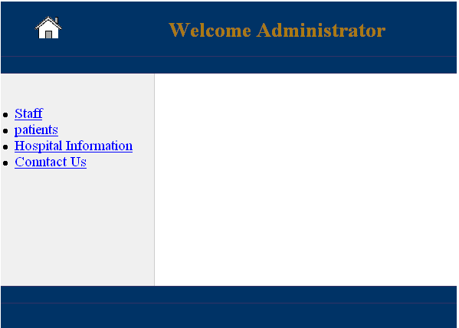

This is The Administrator main menu.
From this menu he can access the staff of the hospital or the patient by pressing the hyperlink.
Now when we move inside the administrator site he have an access to the Doctors, Nurses, Pharmacist, Financials, Lab Researcher and all have the same functionality, So if we take lets say the Doctors it will be sufficient about the staff.
By choosing the staff hyper link we will move to a menu of the staff choosing the Doctors we now on the doctor site control which look as bellow:
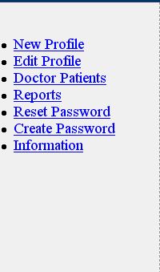

From The doctor site control we have the following
Option to do against the doctors
New Profile :Her we Add A new Doctor to The
Hospital.
Edit Profile: Here we can get a list of all the doctors
In the hospital from this menu we can update or delete a specific Doctor
Doctor patient :From this menu we can get all the doctor choosing the doctor we need to see his patient
And click the link Patient we will see a list of the
Doctor patient
Report: In this we will get a full report about the doctors the reports is containing all available data about that doctor

Reset Password :from this link we will get to a menu in witch the available doctor in the hospital and have a password in the database and beside each name there is a checkbox if we want to reset this doctor it checked. The menu look as bellow:
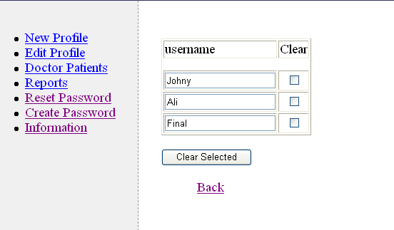
Now The create password Link is to create password for the new doctors. After the doctor profile is created by the manager the manager will be able to create to him a password by click the hyperlink create Password the menu is like;
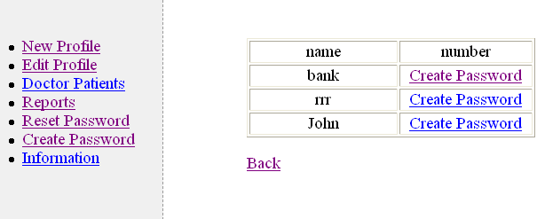
Now After we create the password we will go to the reports page, In the report page the administrator is seeking for the doctor and by clicking the report Link the report will be created as follow:
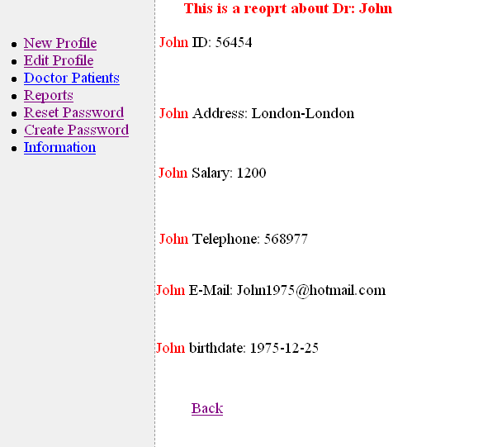
Now The Edit Menu will be as bellow:
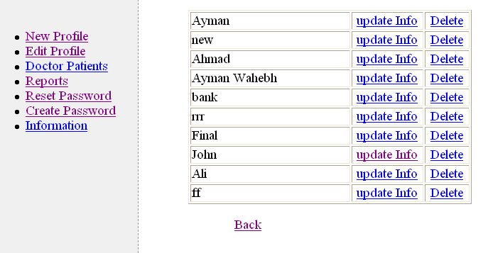

From this Menu we can Update the doctor profile or we can delete the doctor profile
If we choose to delete a confirm page will be appear to confirm the doctor delete:
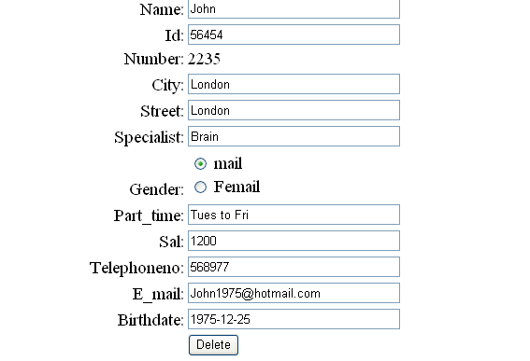
With The delete we came to the end of the doctor site in the Administrator page, The next about the Nurse's, Pharmacist, Financials ,Lab Researcher, Giants Is the Same as The Administrator .
Now as we finish the administrator we towards the Medical directory
Medical directory is logged in with his Username and Password so after he logged in the following Menu will appear :
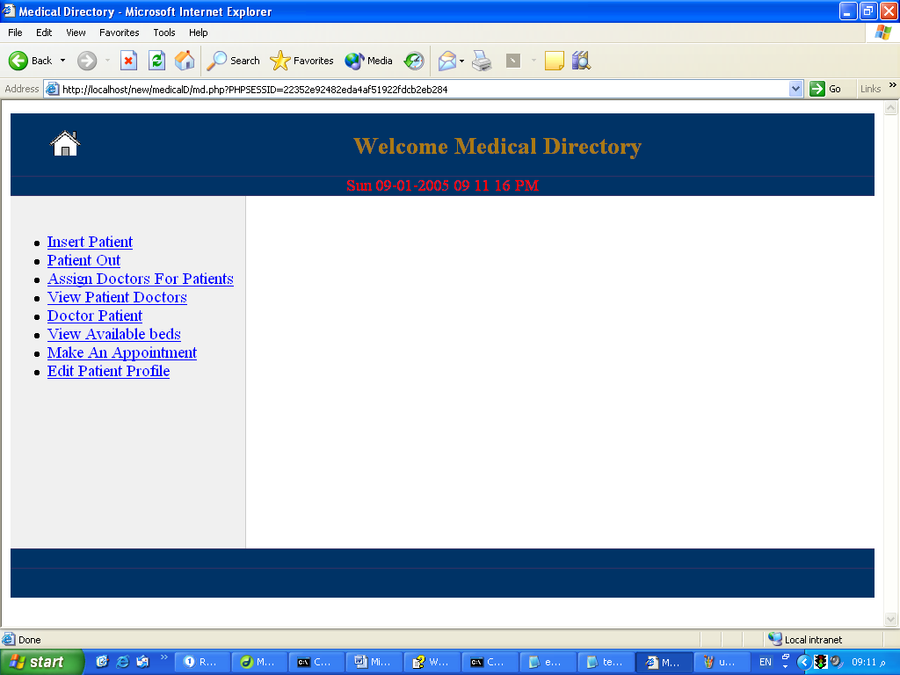
From this main menu we will get the functionality of the medical Directory
Insert Patient : This allow the medical directory to enter a patient to the hospital first
If the patient has a profile in the hospital the medical just enter his number in the form and press the insert button or he can create a new profile by press on the Link New Patient The insert patient looks Like:
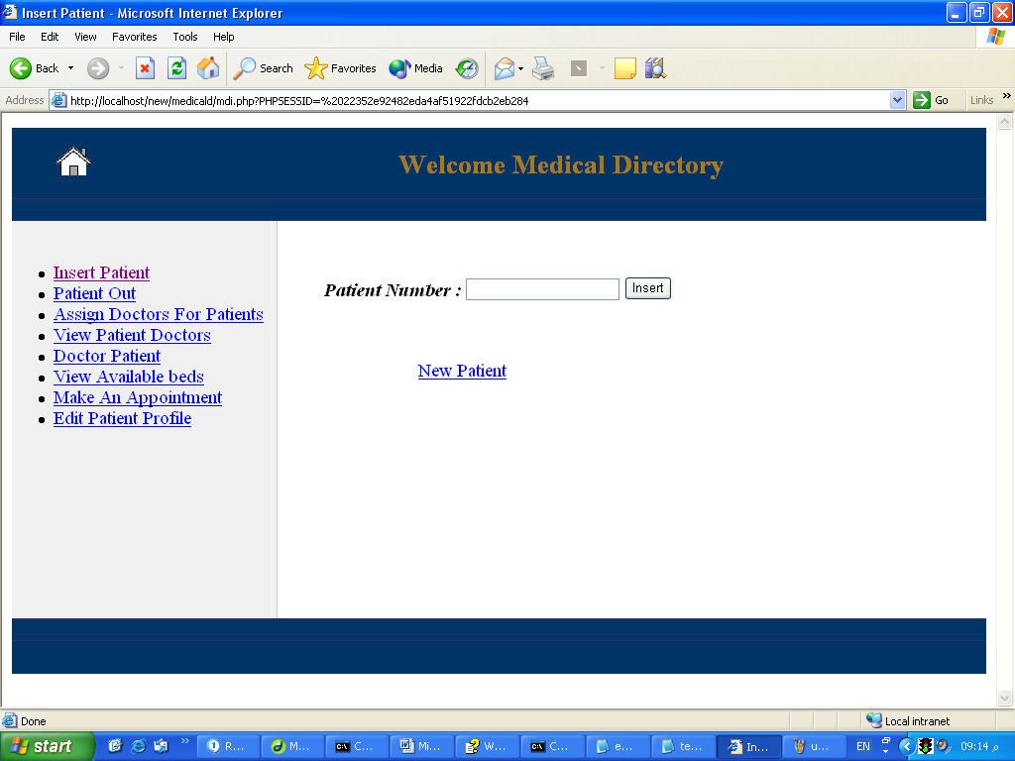
From the patient Number the number entered is checked in the database to verify the number if exists and return the result
If the MD insert Invalid number the databases will print the message:
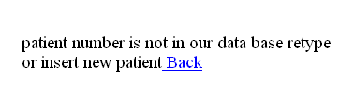
So if he try another one in the hospital he will be notify about that
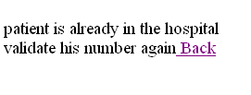
And if it's correct number and not in the hospital the patient will be inserted to the hospital
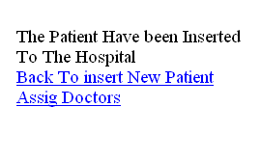

Now we will move to the next functionality Patient Out:
This will provide us with a list of patient inside the hospital and beside each patient there is a checkbox and he patient we want to let him out just check the checkbox and he will be assign as leaved the hospital.
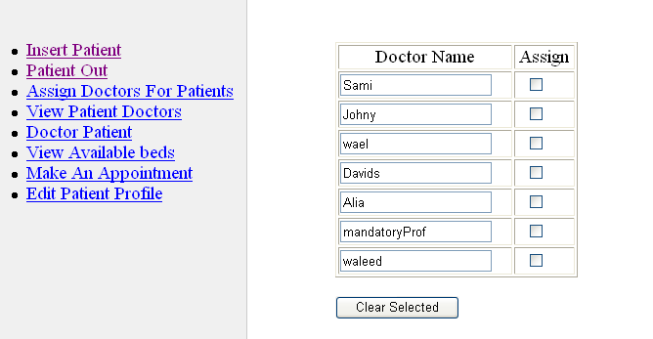
Now we go to the main job "Inside Inserting patients " The Assigning of the doctors to the patients.
In the hospital we have two parts of patients one is patient with no doctor assigned to them "they are the new inserted to the hospital" and the second part is the patient with doctors assigned to them
So we need to pick if the patient we want to assign doctor to is new or not
The menu is simple and looks like:
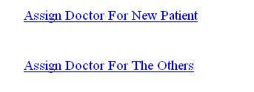
Now if new Patient clicked a list of all new entered patient will appear
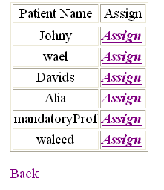

Now we Pick the patient we need to assign doctor to him by press the assign hyperlink to go to the assign page
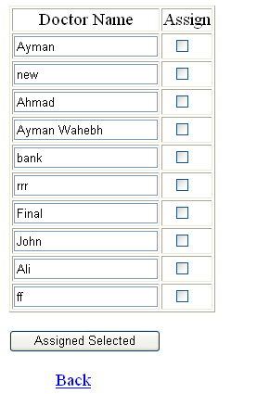
By Checked The checkbox beside each doctor the patient will be assigned as one of that doctor patient.
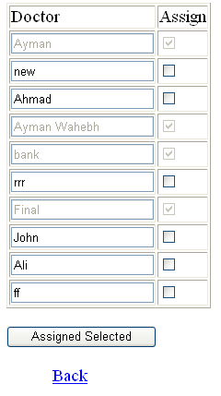
Now for The previously assigned patient we will get the same list of the patients names with link beside each one to assign:
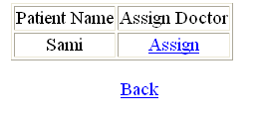

By click the hyperlink we will go to the assigned
doctor menu the patient doctor will be disabled:

Now we have done with the doctor assigning, we go to the appointment function.
In this function the patient will be able to make an appointment with a doctor in a specific date he choose.
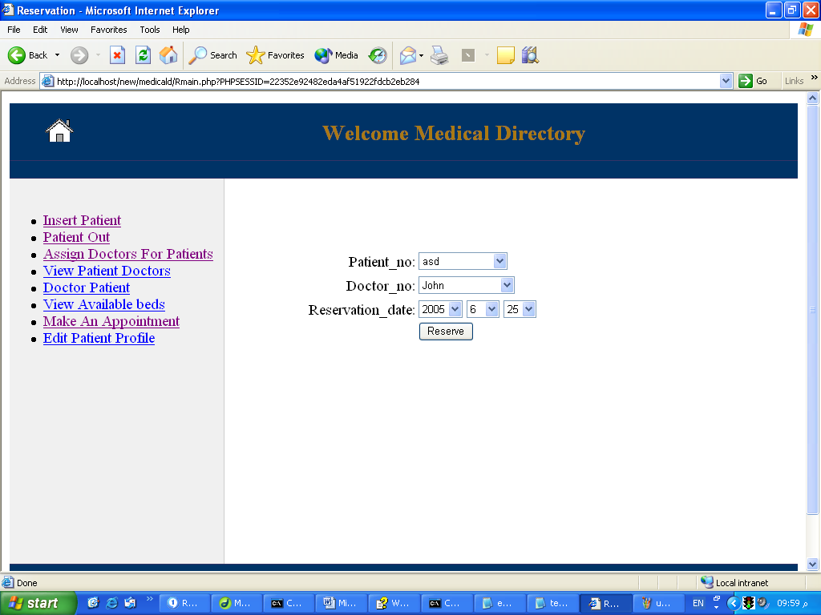
The Final option in the MD is the EDIT .
In the EDIT the MD will be able to modify Patient profile the edit is :
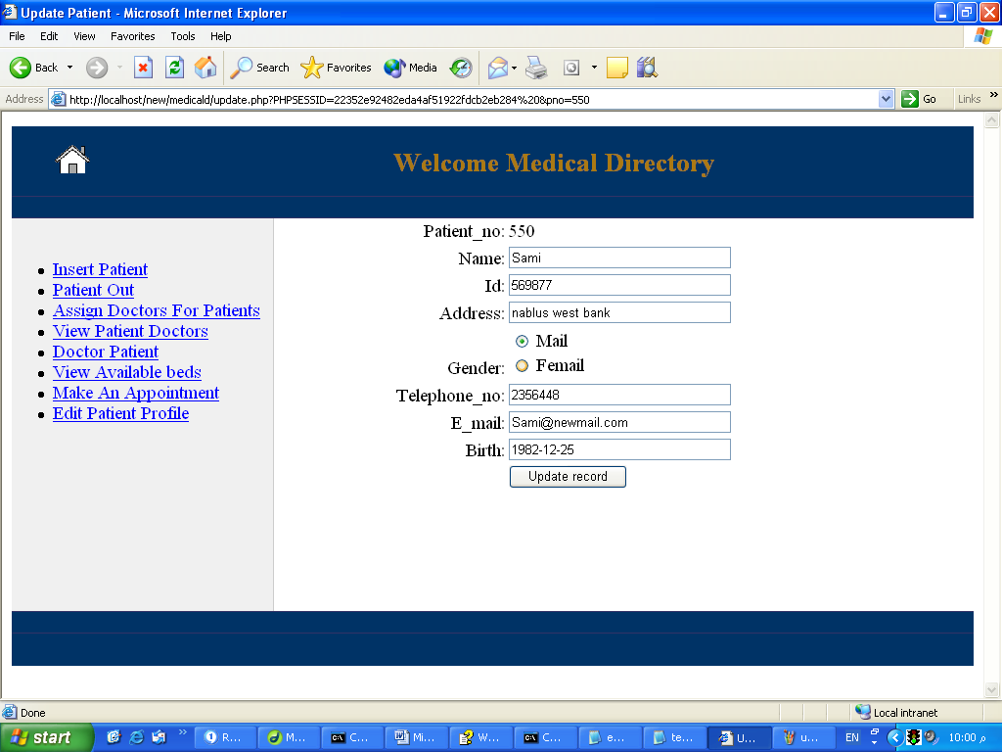

Now we go to the Doctors site in this site each doctor is access his database by login with his number and a password he may able to change;
The main menu is.
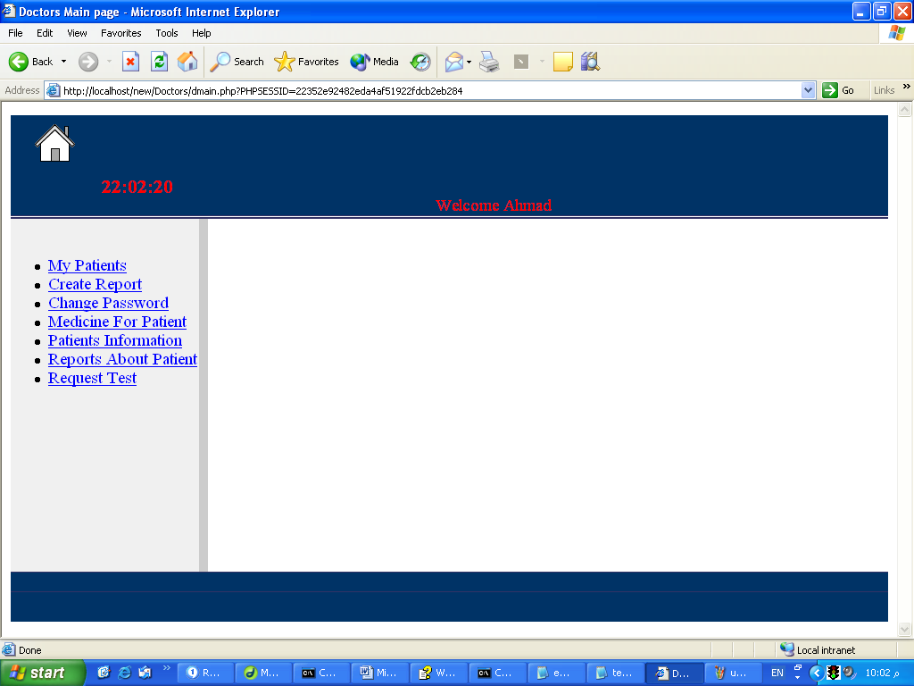
From The doctor Menu The doctors will be able to see his patients
The functionality of the doctor page:
Create Report: In this Link the doctor will be available with his patient name and beside each one of his patient there is a hyperlink called create report this will leave the doctor in a form with a text area for the report and filled information about his number and the patient number so he fill the report he want to make about the patient health and write it to database
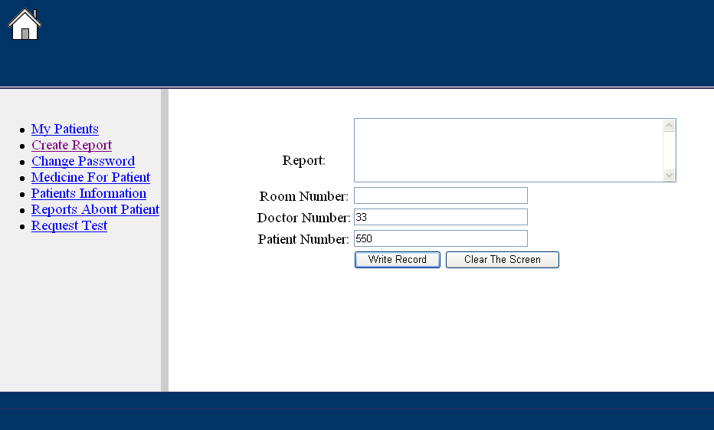
The following is the assigned the medicine for his patient it’s the same as create a report but for medicine:
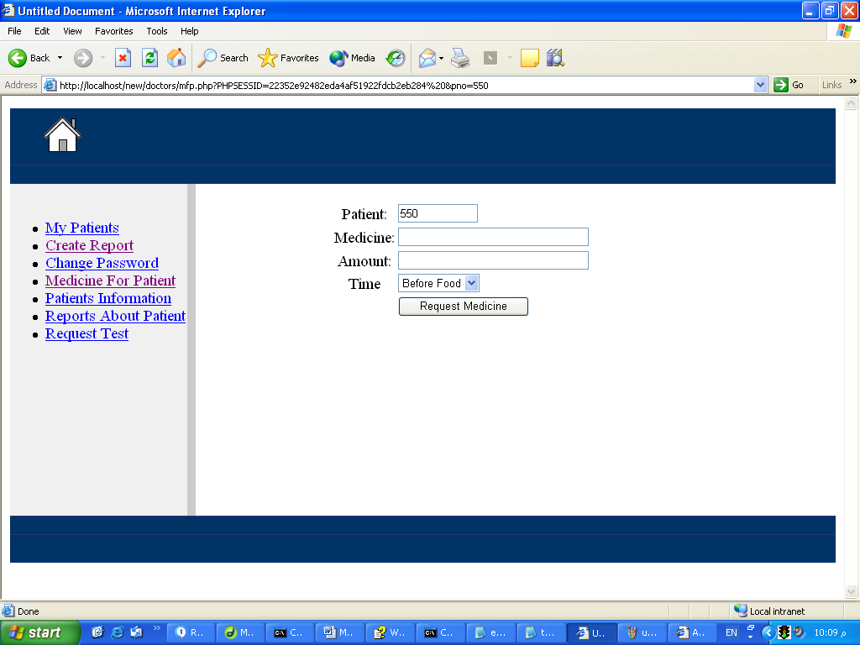
The Doctor insert medicine name and the amount that the patient need in order to let him bay it from pharmacy.
The Patient Information: As The doctor is related to his patient he may need to know a specific information about them this functionality is available to the doctors but without availability to changing in the patient profile .
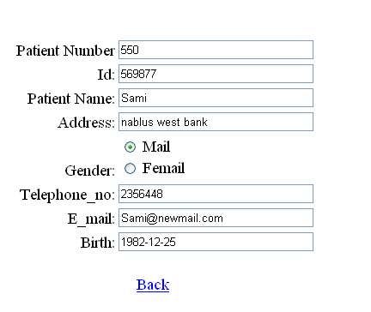

Now The Doctor need to know the patient doctors and the previous report he was made about one of his patient the Report About Patient is do This after the doctor linked the patient report he will get list of his patient click the link beside any one he will get the following screen;
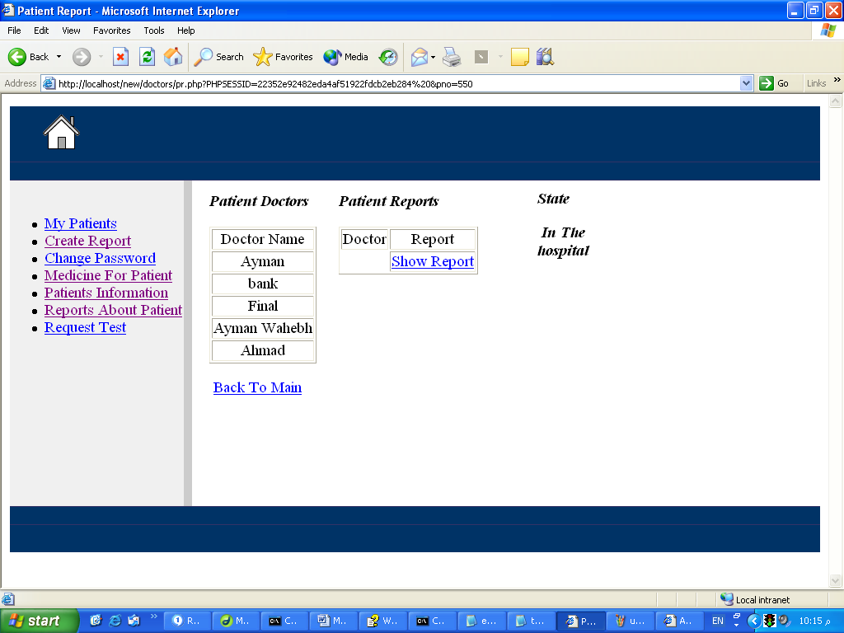
Which describe his state and his doctor and any previous report by the doctor for this patient.
Now moving to change My password this functionality allow the doctors to change their password for more security.
The doctor is asked to enter the password and the confirm in order to change also both the password and the confirm must be the same.
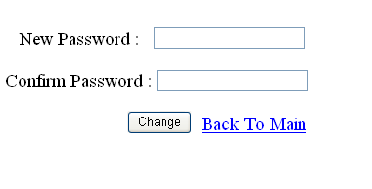
If change done successfully the following message will be seen :
If any error the message appear will show that error
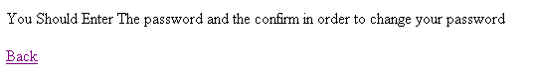

As the Doctor need test for the patient the Request Test is add to make this easier, In the request test the doctor is fill a form with the test name and the patient number and send it to the lab
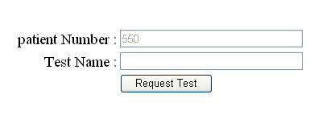
Now After we have done in doctors page we will move to the financial department in this department the financials staff will enter the financial site and make the financials movement there are two parts of the finance department the patient part and the staff part in the patient part the patient will be able to pay to his stay in the hospital and also pay the medicine price so he can get it from the pharmacy.
The second is the staff there it's looks like a small bank with the basic transaction from insert and withdraw.
The financial department main page is :
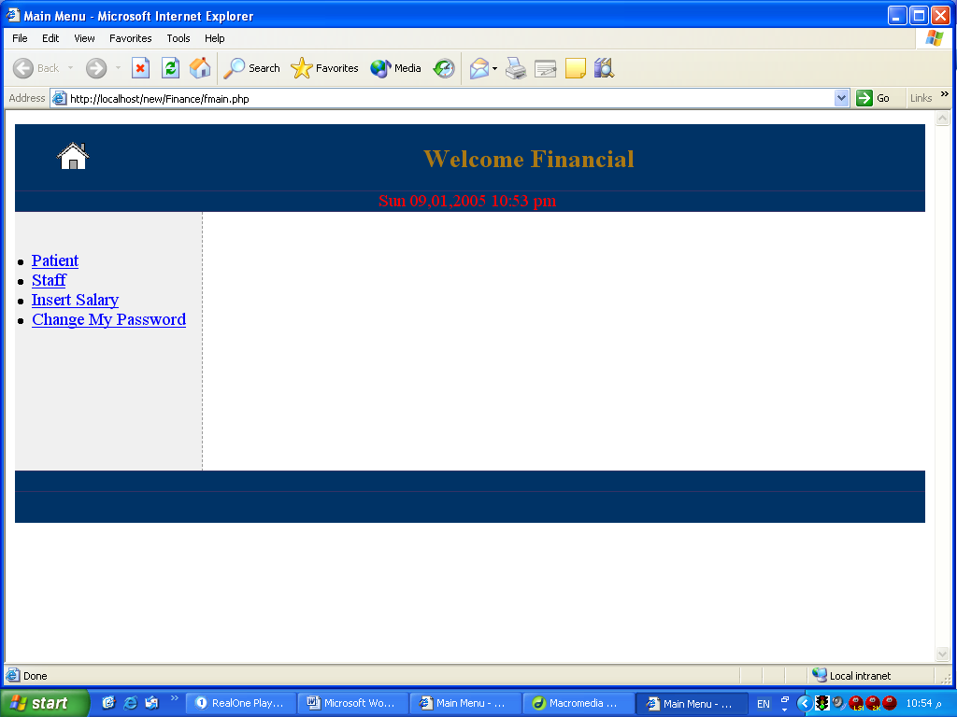
Now lets we start in the patient site
As mention above the patient page is to let the patient pay his fees and the medicine price.
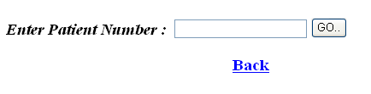
Now entering the patient number and test to validate it, after that the paid page will appear as bellow
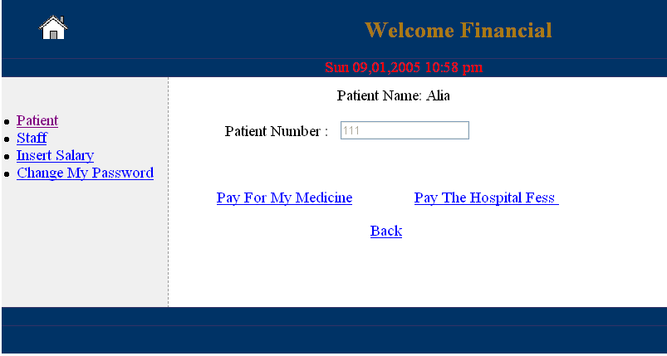
Now Medicine For patient will get us to a list of all the patient medicine that the doctors assigned to him only the medicine that is available in the pharmacy will be enabled as shown;
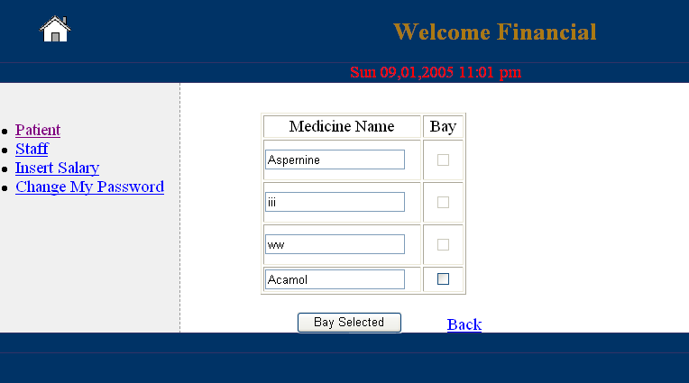
Check the medicine and press the bay button in order to calculate the price and remove the medicine from the patient medicine

Now we will go to the staff finance page in this page the financials staff will be able to make the transaction for the staff account, the staff may be able to insert money for their account or withdraw from the account and the salary will be add to the balance of each staff when the financials checked their names from the insert page

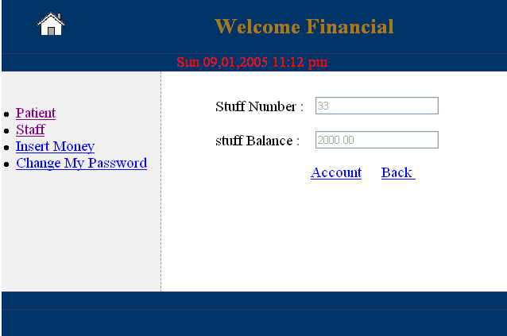
From which we can access the account of the staff
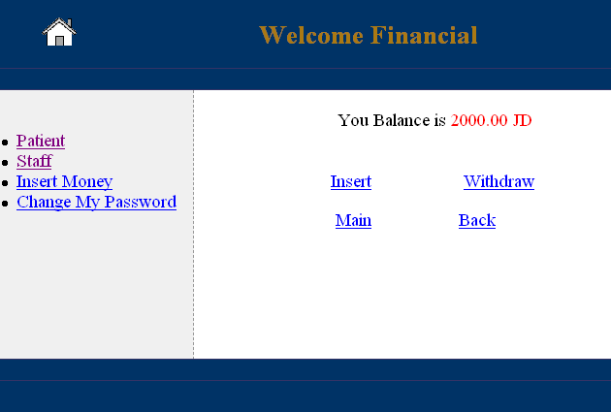

We have the functions insert and withdraw let we start in the insert.
The Insert amount should be positive so if you try to insert a negative number the transaction will be dropped and you will be notify about that.
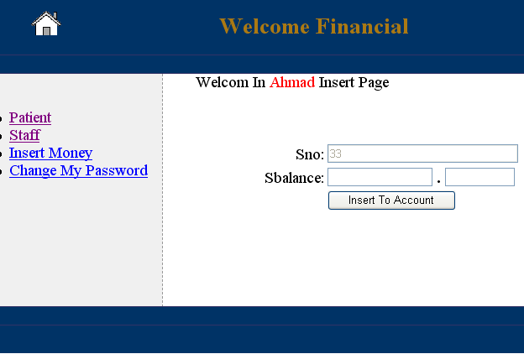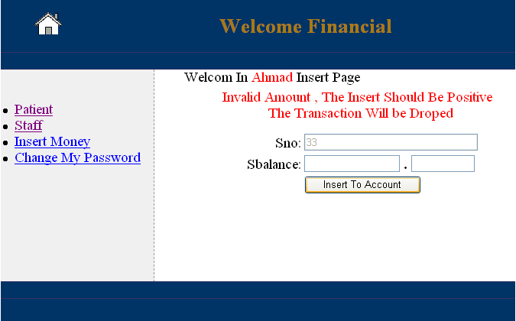
Now the same in the withdraw page but the withdraw amount should be less or equal the balance of the staff. If staff try to withdraw amount grater than his balance the transaction will be dropped.
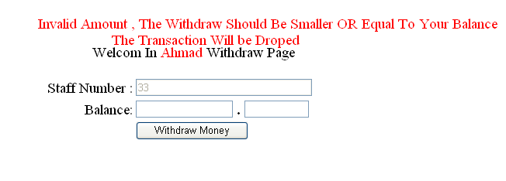
Moving to insert salary option.
Salary will be inserted individually for doctors, Nurses, Financials, pharmacist for each salary can be inserted all or individual .

