بسم الله الرحمن الرحيم



Faculty Of Engineering

Computer Engineering Department

Graduation Project(1)
(software)

Documentation

By:
1-Sadiq saeed Al-Hajj
2-Othman Omar

Instructor:

Eng. Haya Sama’neh

2006/2007

Introduction:

nowadays we notice that the work of municipality become large and required a lot of time and more work due to the large population hose required to deal with the municipality to have its services.
These will make more pressure to the customers and the employee of the municipality
For these reasons we try to make the work easy and more efficient by using the computer and internet.

Objectives

my project try to computerized this work to save time and effort, in fact my project is a website for this work.

Language supported :

- ASP.NET 2005 (with C#).
- SQLServer2000.

Website outline

This website available for costumer, employees in the municipality, the manger of the municipality with many conditions (such as security to Log in to the website and the website will know the type of user which is log in and open to him his own page… )

Pages of the website :

- Log In page :this page do the security work and determine the next page to open according to user type.

- Costumer page: this help the costumer to see his accounts (water, electricity ) and his bill at certain date(month and year) also if he has any technical problem with water or electricity or in his account he can sent a message to his municipality employees asking for help.
- Auditor page: this page can used by the auditor and the manger which contain many links for other pages like accounting page, reading page….etc.
this website help the auditor to do his work such as create users, create accounts for any user, insert reading for the counters, accounting and keep contact with his costumers.

- Manger page : only for the mangers, by using this page he can do the auditor work and also he can add employees or remove them from his municipality.

- Create users page: used by the auditor and manger of the municipality to add new costumers.

- Create accounts : used by the auditor and manger of the municipality to create accounts for each costumer.

- Accounting page: this page is sample accounting can auditor use it.

- Reading page: help auditor to insert any reading for the counters this page tell the auditor if this is the first reading to insert the price for it or if this reading is not the first time it calculate the price by it self.

- Edit reading page : if the auditor want to edit any reading for any account he can use this page.

- Messages page: this page can used by all users how are use the website to see their messages and sent messages.

This is the main pages for this website
are shown following:

Log in page
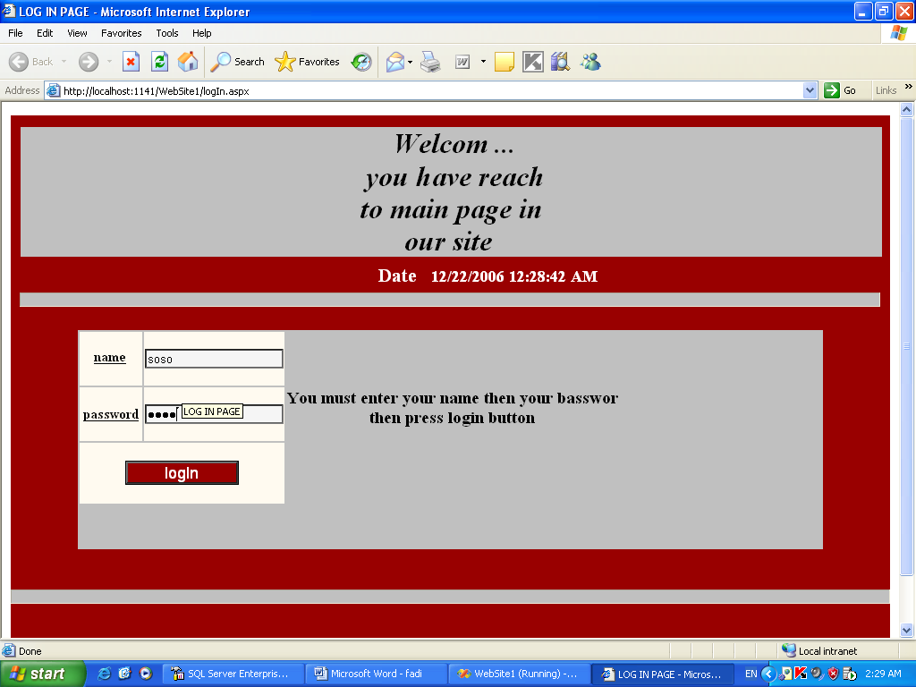

Costumer page

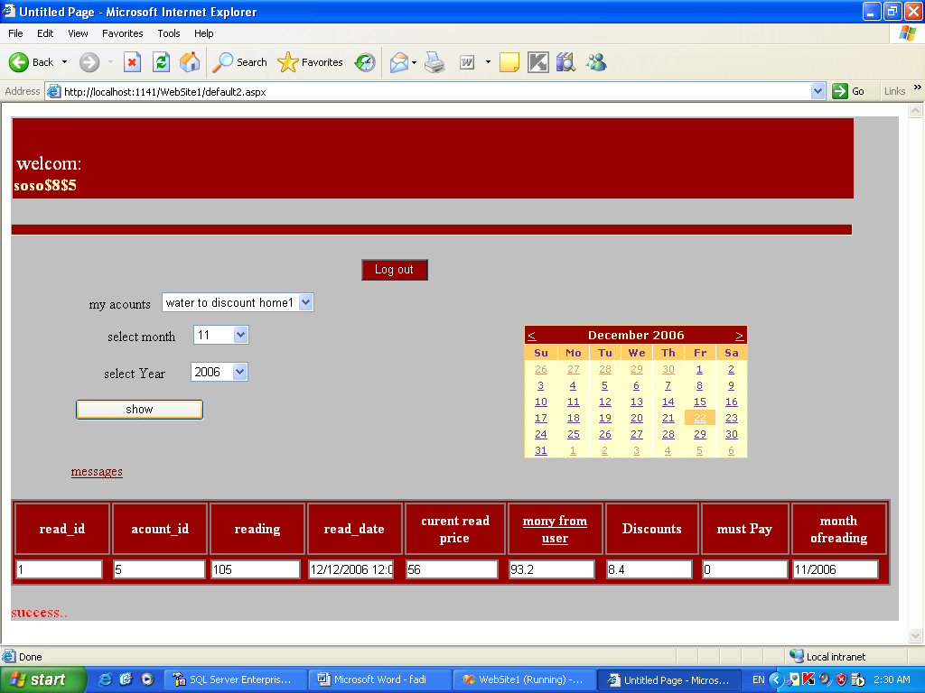

Auditor Page
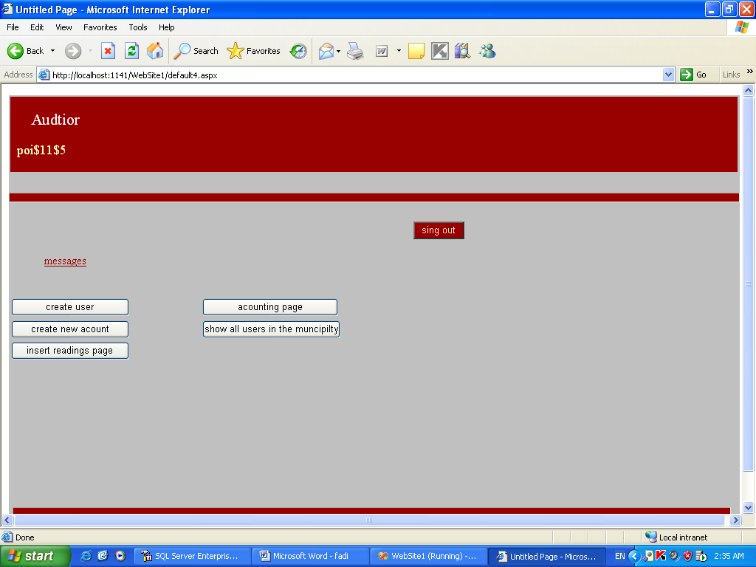

Create user page

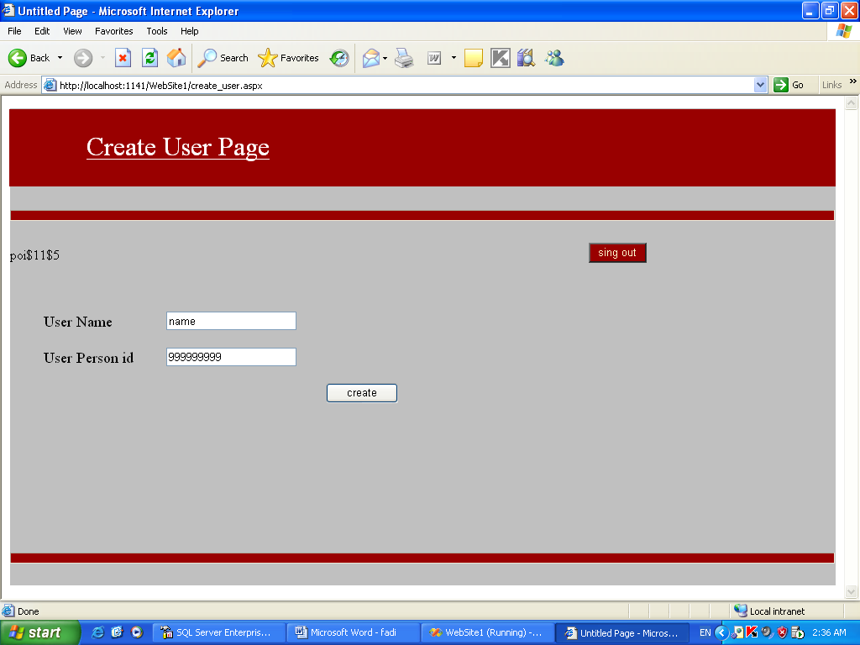

Create account page
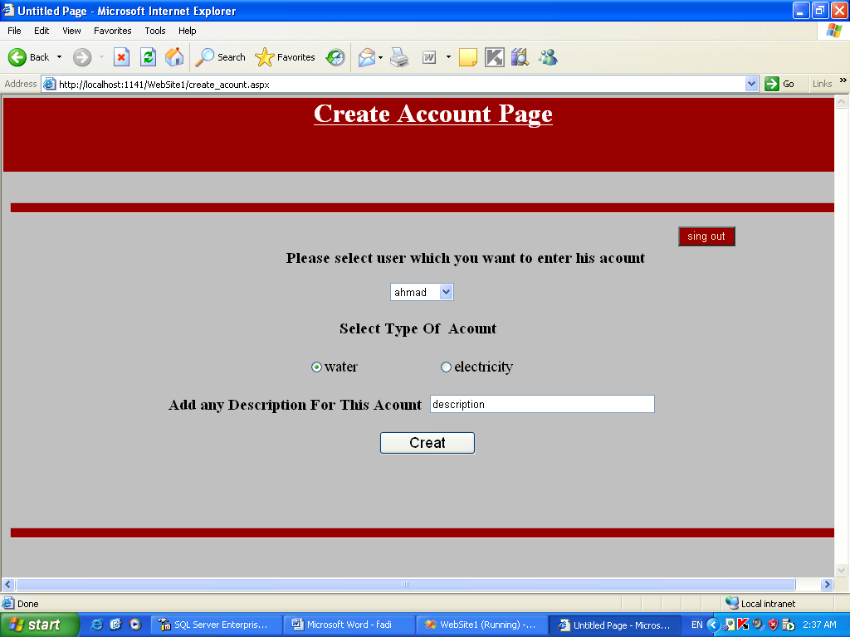

Reading page

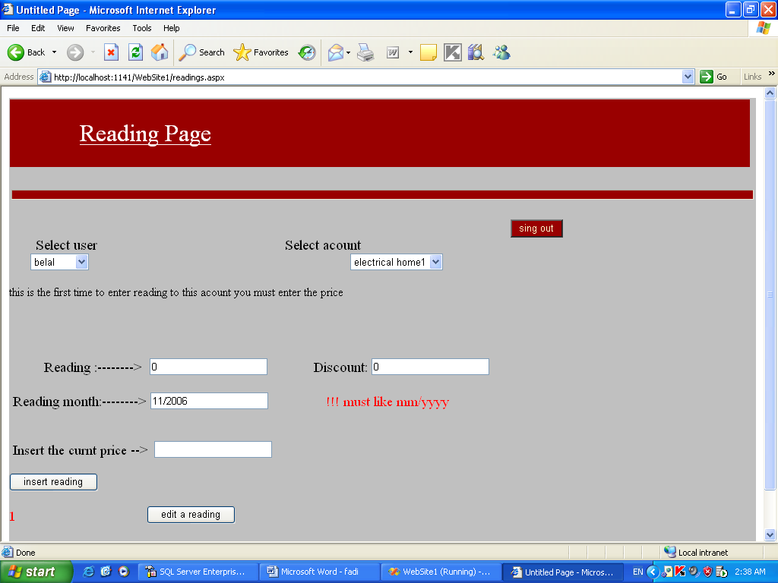

Edit reading page
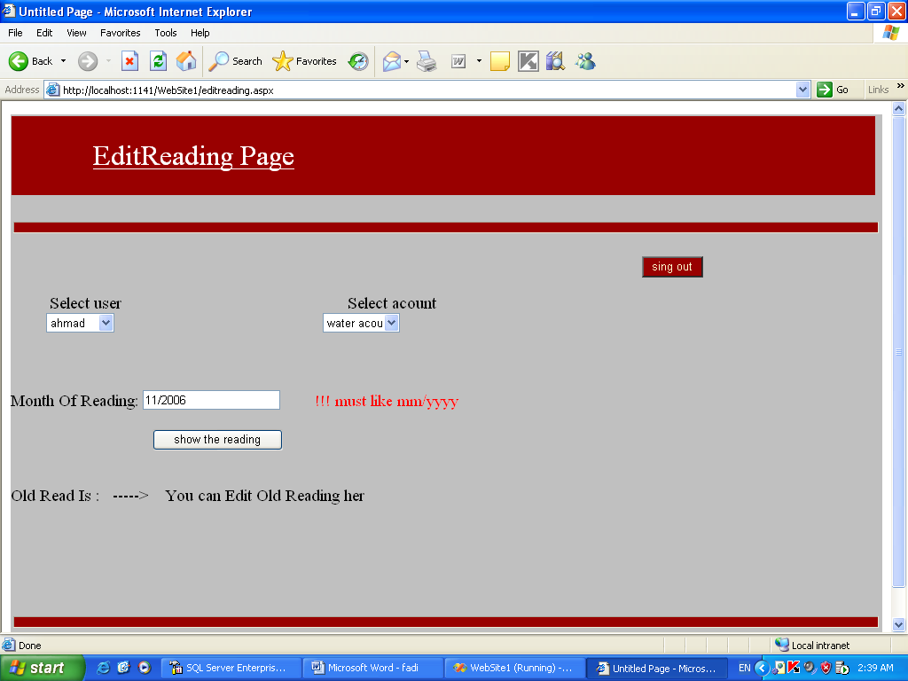

Accounting page

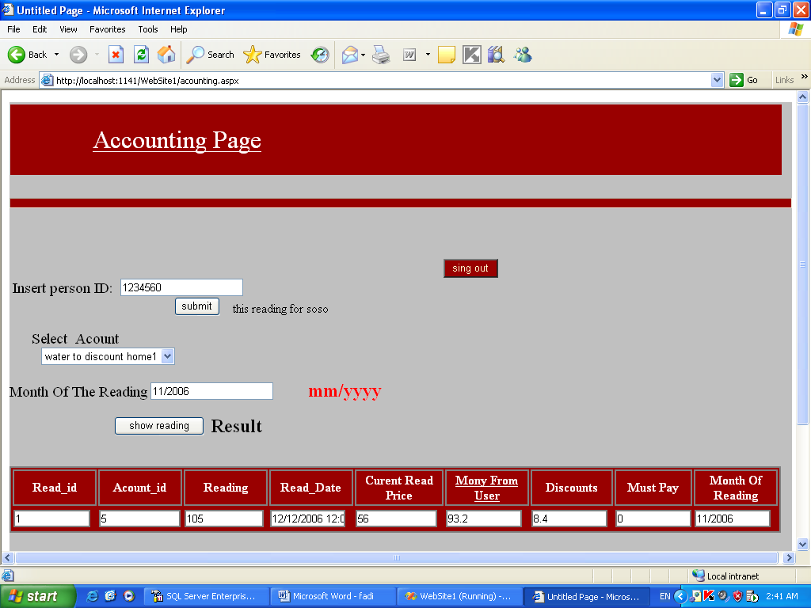

Manger page
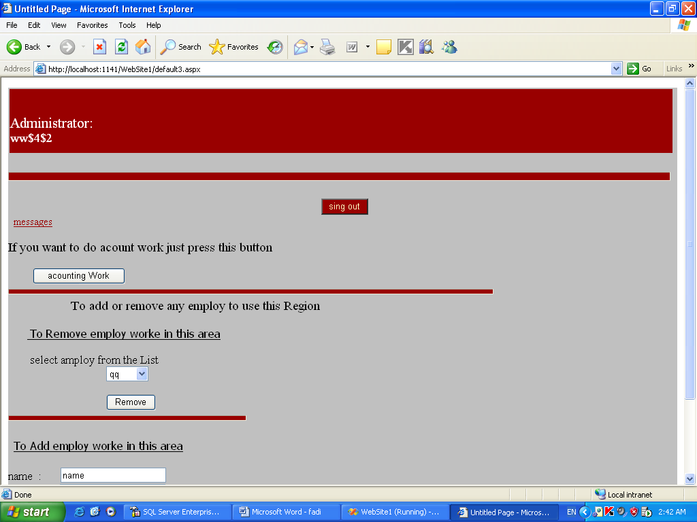

Messages page

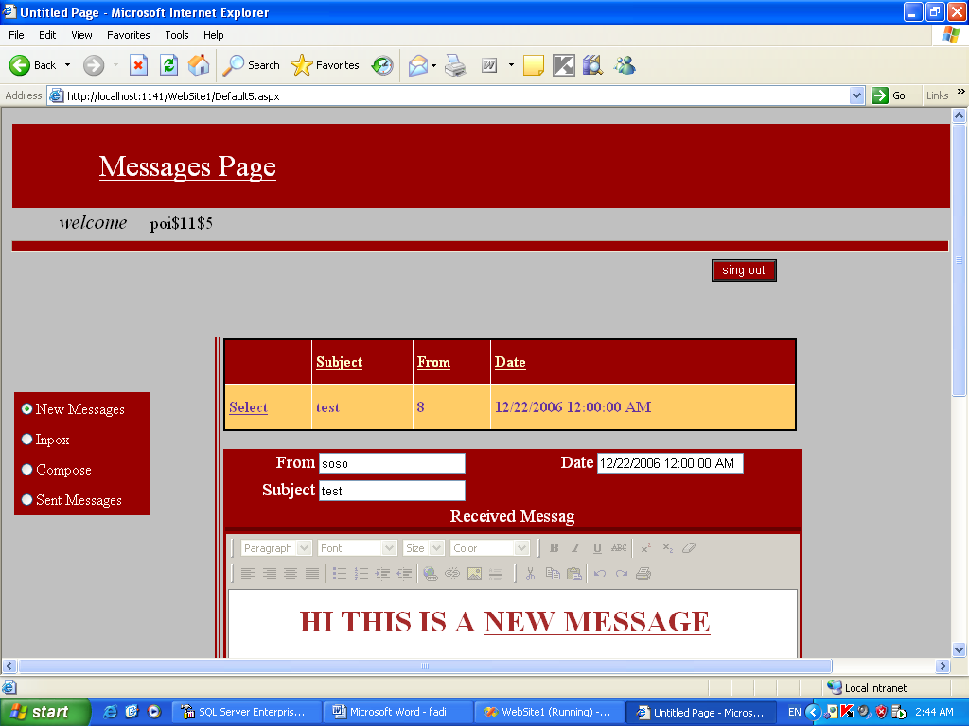

Procedure:

The work is done by many stages which is described blow :

1-collection data which is required to perform the objectives and determined main problems that we try to eliminated it’s effects.

2- setup the programs required to help us in programming as .NET2005 and SQLServer2000.

3- start in work as following:

- Design the Data Base which is contain many tables:

* Table for users which has the information about them(name,
personal ID, his municipality, password….etc).

* Table for the municipalities (municipality name, prices, city..).

* Table for cities (city name, it’s ID).

* Table for the accounts which has simple info about each account.

* Table for the readings of a counters of water and electricity
also has info for each reading.

* The last table is for the messages which is receives from users
and also their own, this table has many columns (message ID,
it’s subject, sender, receiver…).

The relationships between this tables as follow :

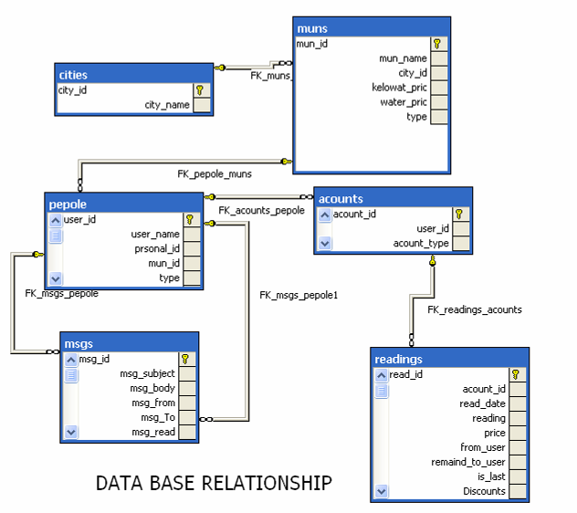

- Then start programming the website pages(log in, costumer page,…etc.) with ASP.NET using C#, this is the most important step for my website
In this step I have face a lot of problems specially on connecting to the SQLServer and to it’s data base …..etc

- Design the pages interface to be more comfortable for the user and easy to use the website in correct way

4- Final step is testing the website and it’s functionality to be sure that it have achieves our objectives.

