Conferences Camera Control

Ibrahim Imad Dwaikat Aladdin Sweidan
An-Najah National University

Abstract
Voice processing has been an attractive filed for research and experiments, and our project (Conf-Cam) is one of our experiments in this field. The project aims to construct a smart conference room in especially when it comes to its sound system. The idea is to automate the movement of a camera centralized in the middle of the room in response to the speaker voice. The project tries to achieve satisfying results, and examine the various difficulties that student would find in this field of projects.

1. Introduction

The project idea is simple, it aims to make it easier for people to manage video conferences. It is supposed that a camera is placed somewhere in the middle of the conference room. The camera will be connected to three microphones within 50 cm around the camera in a triangular way. These microphones will be sensitive to the human voice, and will be connected to a microcontroller (PIC).
The microcontroller will process the data received by the microphones and determine the direction the voice came from, this will be sufficient for the PIC to give orders to stepper motor connected to it and to the base of the camera and rotates it into the right direction. Also a wireless modules is connected to the system to let the conference manager to manually rotate the camera.

2. High-Level Design

The design was made in an easy and effective way. The system interface consists of a camera centered between the three microphones’ circuits which make a triangle with equal legs. The camera is attached into a stepper motor which is responsible for moving the camera to the wanted angle. Our system has two operation modes to move the camera: Automatic mode, and Manual Mode.
In the Automatic Mode, the three microphones are responsible of collecting voice samples from the surrounding area, the three microphones are actually three copies of a complete microphone circuit: microphone driver, high pass filter and an amplifier, the microphones collects data and passes it to the Analog to Digital Converter [ADC] of the microcontroller, the microcontroller then decides the first microphone which heard the voice, and though chooses the angle into which the stepper will rotate. [More details later].
The manual mode was created to add more flexibility to the system, in case the boss or the director of the meeting decided to point the camera to the person manually independent of the speaker voice. The remote has three buttons which control the rotation direction: Left, Right, and Off. [More details later].
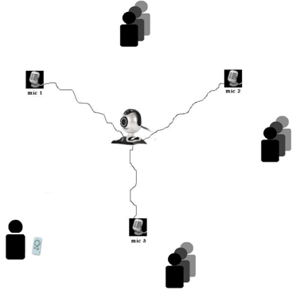
Fig.1

3. Microcontrollers Usage
In the project we used two microcontrollers; the first one is for the main system itself, which listens to sounds and makes the calculations, determine the angle and rotate the motor, and receives the signal from RF receiver and decide what to do.

For the main system part we used PIC18F46 which works on 20MHz crystal frequency. This Microcontroller has many features which is good for our project which is:
• Two Capture/Compare/PWM (CCP) modules, we used one for the automatic mode and the other for decoding data from RF wireless
• 10-Bit, up to 13-Channel Analog-to-Digital (A/D) which is used to connect the microphones circuits.
• 64Kbytes of Flash Memory for program memory
• 3986 bytes of SRAM for Data memory
• 1024 bytes of EEPROM for data memory
For the RF transmitter circuit we used PIC16F877 which works on 4 MHz crystal frequency. We used this model because we don’t need much processing or much RAM. This microcontroller has a characteristic which is suitable for us like:
• 8Kbytes of FLASH Program Memory.
• 368 bytes of Data Memory.
• 256 bytes of EEPROM Data Memory

4. Microphone Circuit

In this circuit, the main goal was to achieve a filtered and amplified output from the tiny small voltage [about 10 mv] produced from the microphone itself.
So there were two steps: filtering, and amplifying.
Filtering: We needed to filter the incoming signal frequency of the microphone in a way in which we reject the noise and accept the human voice frequency [about 300 Hz-3K Hz]. So, a high pass filter was built with a cutoff frequency of 300 Hz. See Fig. 1.

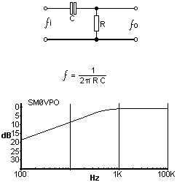
Fig.2

Amplifying: the output of the high pass filter was entered into a non-inverting operational amplifier, with a gain of 180. We used the LM358 OP-Amp. See Fig.2
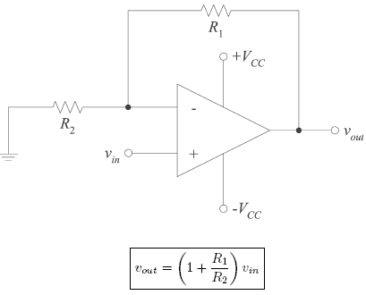
Fig.3

5. Stepper Motor Circuitry
Stepper motors effectively have multiple "toothed" electromagnets arranged around a central gear-shaped piece of iron. The electromagnets are energized by an external control circuit, such as a microcontroller. To make the motor shaft turn, first one electromagnet is given power, which makes the gear's teeth magnetically attracted to the electromagnet's teeth. When the gear's teeth are thus aligned to the first electromagnet, they are slightly offset from the next electromagnet. So when the next electromagnet is turned on, and the first is turned off, the gear rotates slightly to align with the next one, and from there the process is repeated. Each of those slight rotations is called a "step." In that way, the motor can be turned a precise angle.
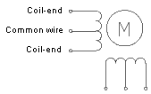
Fig.4

In our project we used stepper motor to rotate the camera , we used a gear to put the camera on which gives use more mechanical power and more accuracy because the ratio between the stepper motor rotation and the gear is 1:5 (each 5 degrees of the stepper motor gives us 1 degree for this gear). We used ULN2003 to drive the stepper motor

6. Processing

We constructed three copies of the microphone circuits. Each microphone was connected to one of the circuits, and the circuits were 50 cm away from each other in a triangular way. The output of each circuit was connected to an analogue input in the microcontroller, PIN A was used, A0,A1 and A2 were the pins chosen.
The signal enters into the analogue pin was converted to digital value [0-255]. An important issue was that we needed the conversion time to be less than the time needed for the signal to reach the other microphone[which is about 1.5 ms (0.5m divided by 344m/s). this was a key reason why we chose PIC18F4620 microcontroller, with an aquisation time of about 2 microseconds. [More details in Software section].

7. Software Design

As we’ve mentioned earlier, our system consists of two modes, and so is our code. The initial state of our system is considered to be in manual mode. The system then is being switched from manual mode to automatic mode and vice versa according to the remote button [on/off].
Manual Mode: the wireless remote has 3 buttons: Left, Right and Off. The Left button is responsible for rotating the camera left as long as it’s been pressed, and Right button is responsible for rotating the camera right as long as the button is pressed. When either the Left or Right button is pressed, this means that the Automatic mode is mastering the system, and it’s ON. The Off button is responsible for turning the Manual Mode Off.
There has been the encoding part [at the sender microcontroller] and the decoding part [at the receiver microcontroller]. The encoding/decoding was constructed on the idea of pulse width variation. Each command was given different pulse width determined in the sender part. The receiver receives the wireless data on CCP2 pin, it detects each falling edge, and using a counter, it calculates the period length of each signal received, and accordingly determines the command. When the receiver makes sure what the command is, the microcontroller rotates the stepper motor in the received direction, and keeps doing that until the sender stops sending the command, or changes the command.

7.1. Automatic Mode

We decided to sample the voice received at 8 KHz (1 sample every 125 microsecond). To do so, we used the CCP1 (compare mode) by putting a constant value of 125 into CCP1 register, when match, an interrupt occur and the voice is sampled [read into ADC] from the three microphones sequentially, with total time less than 10 microsecond. This operation is done 500 times to read to read 500 values for each microphone.
When done, we take the average of each microphone data, and the smallest index of each microphone at which the signal has surpassed the threshold [1.7 volts = 90]. The difference between the indices is calculated, which considered as the time difference between the arrival of the signal into each microphone.
The arrival time is then used to index an array of angles generated by Matlab R2007a to determine what the angle the stepper should rotate to.

7.2. Manual Mode
Because the director or the leader of the conference may need to control the camera manually we added the manual control via wireless communication. We used simplex communication, which consists of one sender and one receiver in one direction.

7.2.1 Transmitter
We used RT4 transmitter from Telecontrolli, Thus module is an hybrid circuit that allows to realize a complete radio transmitter adding a coding circuit. It works at frequency of 433.92 MHz and works on 5V power supply. We build a small printed circuit board which consists basically from PIC16F877 Microcontroller, RT4 transmitter, power circuit and some buttons. The PIC16F877 Microcontroller is used to get which button is pressed and encode the data and send it to the transmitter.
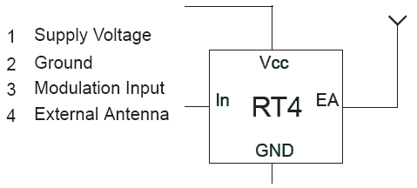
Fig.5

There are three commands that can be sent: Rotate right ,Rotate Left and Automatic Mode. The automatic mode lets the camera to work in automated mode (listen to sounds).There is a LED indicator which goes on when the system is on the manual mode, and off if the system is on the automatic mode. This means (when the light is on) that the control is with you and you can move the camera manually and it will not listen to sounds. Another indicator is placed on the camera which is opposite.
We used an antenna of 17.3 cm because the frequency is 433.29 MHz , this length is calculated from the formula:
Length = (Speed of light/Frequency)/4
Length = (300,000,000 / 433920000) / 4
= 0.1728 meters = 17.28 cm
We used Pulse Width modulation to send the data via Wireless because it is simple and we need simple data transfer which is three commands.

7.2.2. Receiver
We used RR3 receiver from Telecontrolli. It is a super regenerative data receiver. Sensitivity typically exceedes -100dBm (2.2uVrms) when matched to 50 ohm. It shows high frequency stability also in presence of mechanical vibrations, manual handling and in a wide range of temperature. It also works at frequency of 433.92 MHz and works on 5V power supply.

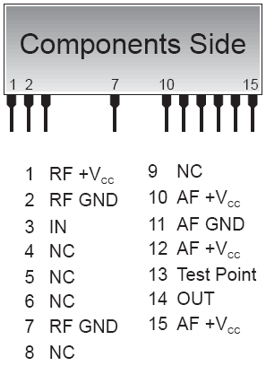
Fig.6

This module is connected by a different voltage source (9 V battery) to avoid noise. The output is connected to CCP2 pin of PIC18F4620. It receives the signal send by the transmitter, then the mode change from automatic to manual and vice versa.

8. Arrival time calculations

The three microphones are placed at equal distances (50 cm) and one microphone is chosen as the first microphone. To find the location of the sound source, the difference in the arrival time of the signal at the microphones is calculated according to the equations shown below in Figure 3.

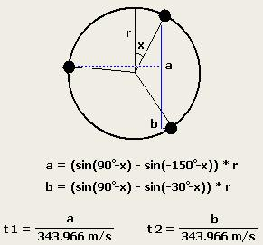
Fig.7

To calculate the angle of the source with respect to the first microphone, a lookup table containing arrival times and angles is used. The arrival times in the lookup table are calculated using the speed of sound at Ithaca's altitude (343.966 m/s) and the distance between microphone one and the other microphones on the plane of the sound wave fronts for each angle in the table. This table maps the time differences t1 and t2 to a specific angle with an accuracy of 1 degree. Once the arrival times are observed, an angle is chosen based on the closeness of the relative arrival times to t1 and t2.

9. Problems we faced

First we faced some problems in finding a good Microcontroller that has enough RAM and its frequency is high, we waited more than two weeks for the delivery that contains PIC18F4620. The real and big problem was in the amplification and filtering. At first we designed a circuit using LM358 and resistors and capacitors with filtering the frequencies between 300 Hz and 3 KHz. The filter circuit worked as expected, but the amplification circuit didn’t work as we need. We tried this circuit using wire wrapping connections.
After that we modified the amplification circuit and we used TL074 operational amplifier. The amplification was good at the first and the second stages, but a huge noise appeared at the third stage. We expected that if we print the circuit and made it printed circuit board we will remove the noise, but after printing it the noise remained. Actually that circuit was big and contains a large number of components.
Then, after searching on the internet we found a good circuit which was very sensitive. But the problem with that circuit was the output is negative. We tried to fixed that many times and using many methods, but after a long time and many failed tries we left this circuit.
We consumed a lot of time for amplification issue, finally we tested another circuit and the results were relatively satisfying. The maximum voltage amplitude for the output of this circuit was 3.5 V and the filtering was (0Hz - 100Hz) because the most effective noise is in this region.
The last problem in this topic was in microphones sensitivity. We tried to get a different models and types of microphones but the leakage of the resources in our country prevented us from getting a good microphones.
Another problem was in Wireless RF, the noise appeared in the receiver side, and we solved that by using a different voltage source for the Wireless Receiver module.

10. Recommendations

We recommend adding the following features for the system:
• LCD and control buttons on the main system and on the Wireless sender to control the speed of the motor rotation and to reinitialize the position of the motor.
• Making the main board of the system as printed circuit board.
• Getting bigger stepper motor that can hold the big cameras.
The main cause of this leakage was the time limitations.

11. Special Thanks

• Dr. Loai Malhis.
• Dr. Ra'ed Al-Qade.
• Eng. Haya Sammaneh.
• Eng. Othman Othman.
• Eng. Alaaddin Mnawwar
• Eng. Muna Qanadeelo
• Eng. Obada Saleh (Architecture Engineering)

12. References

[1] http://ams2000.com/stepping101.html
[2] http://www.telecontrolli.com
[3]http://www.rc-cam.com/forum/index.php?showtopic=117
[4] http://www.rogercom.com/pparalela/LptWireless.htm
[5] http://web.telia.com/~u85920178/begin/opamp00.htm
[6]http://instruct1.cit.cornell.edu/courses/ee476/ FinalProjects/

[7] Introduction to the Operational Amplifier. Dr. Sai Kiran.

