An Najah National University
Faculty of Engineering
Computer Engineering Dept.

Graduation Project Documentation

"Management Studio"
WMI and SNMP tools

Prepared By :
Alaa Ibrahim Daher
Supervisor:
Dr. Loui Malhis

First Semester 2006-2007

Scope:
    - Windows Application / Computer Management / Networks

Description:
    - To manage (get information) about computers connected to a LAN.
    - Using SNMP protocol and WMI API
    - Through a server application which can collect management data.
    - SNMP agents will be running on hosts to provide data.

Environment:
    - The Application will work on MS Windows NT + PC's on a Ethernet LAN
    - The pre-requisite is MS dot NET Framework at least for the Server

Designing & Programming Languages:

    - MS Visual C# 2003
    - And suitable programs for help files and manuals and packaging.
Schedule Time Table for performing the project:

Period | Task | Days | Place
1/10 - 2/10 | preparing PCs | 2 | Net Lab
3/10 - 4/10 | preparing Network | 2 | Net Lab
7/10 - | Study SNMP commands | 2
 | Writing Simple testing codes | 2 | HOME & Lab
 | Study WMI classes commands | 2
 | Writing Simple testing codes | 2
1/11 - | Designing the project outline | 2 | HOME
 | deciding the protocols and methods | 1
 | dividing into modules | 1
 | planning how to implement modules | 1
 | considering time
8/11 - | Launch - start implementation | 30 | Net Lab
8/12 - | Writing Documantation and Manuals | 3 | HOME
 | Packaging Software | 1 | Net Lab
Windows Management Instrumentation (WMI)

WMI provides an application programming interface (API) for developers to access and submit data to this central data store. It provides the capability to write simple scripts that can also perform complex management tasks through the WMI scripting API. WMI also provides administrators with a powerful remote administration tool that is capable of managing objects anywhere on an enterprise network. The WMI framework caters for management applications that need to be notified of events and managed objects that may need to notify a management application of that event. It adds WMI code to the Windows Driver Model (WDM) to enable managed objects to communicate with WMI from the driver level.
WMI offers a powerful set of services, including query-based information retrieval and event notification. We shall explore WMI in detail in coming chapters.

Simple Network Management Protocol (SNMP)

The SNMP is an open network management protocol designed to monitor and control network components such as servers, gateways, and routers. SNMP is an Internet standard defined by the IETF and is part of the TCP/IP suite of protocols. It was developed to transmit management information stored in a repository called a management information base or MIB. MIBs are managed by SNMP agents and reside on each of the managed objects such as the server or router. Management stations issue queries to these agents across the network for system information. SNMP agent software commonly is found integrated into popular brands of dedicated network hardware such as routers.
SNMP is formally specified in a series of requests for comments (RFCs) submitted to the IETF. Requests for comments are documents written about computing or computer communications that usually refer to networking protocols, programs, concepts, or procedures. They can be written by anybody and may be submitted directly to either the IETF or the RFC editor. They are not accepted as a standard until they have been thoroughly reviewed and evaluated by the IETF, which then releases them to the community at large as an RFC.
SNMP was defined formally in RFC 1157 in May 1990 and is used commonly in enterprise networks to manage network components
The SNMP MIB Tree:

The MIB Browser in the Project Retrieves the MIB tree from the RFC's Library files.

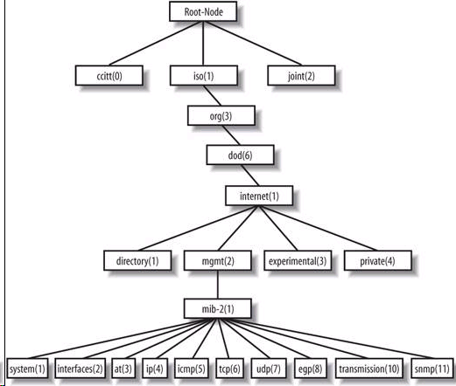
When we require any SNMP operation, a PDU is created and sent a request to the agent,

And we wait for a response:

The SNMP Manager Host/ Router /Switch
(NMS)
