AN-Najah National University
Faculty Of Engineering
Department of Computer

Graduation Project

Project Name: Tarneeb game (one player or two players over Network).

Supervisor: M.haya Samaanee

From :
- Othman Shuqir
- Abdulrhman Salama

Tarneeb
Introduction

This game is popular in Palestine, Lebanon and in other places of the Middle East.

The Role of the game

Players, Cards and Deal
There are four players in partnerships of two and a standard 52 card pack is used, each suit ranking in
the usual way from ace (high) down to two (low). The game is played anticlockwise.

The first dealer is chosen at random and after each hand the turn to deal passes
to the right. The cards are shuffled and cut, and are all dealt out, one at a time, so
that everyone has 13 cards.

The Bidding:

The bidding begins with the dealer and continues anticlockwise.

A bid consists of a number of tricks above six (from 1 to 7) and a suit or "no
trumps", so that possible bids would be "one clubs", "two hearts", "three no
trumps", etc. A bid of more tricks outranks any bid of fewer tricks. Also, when
comparing bids for the same number of tricks, the five denominations rank in the
same order as at Bridge: no trumps is highest, then spades, hearts, diamonds,
clubs (lowest).

At your turn you can either pass or bid higher than the previous bidder - either by
bidding more tricks, or by bidding the same number of tricks in a higher
denomination. The bidding continues until all four players pass in
succession.

If all four players pass on their first turn to speak, the hand is thrown in and
Redealt.

When a bid is followed by four passes, the last (and highest) bidder becomes
the declarer and the trump suit (if any) for the hand is determined by the
declarer's final bid. The declarer's site must achieve at least the number of tricks bidded.

The Playing
Each player's objective is to take at least the number of tricks that they bid, and if
possible to hinder the other players from doing so.

The declarer leads to the first trick. Players must follow suit if they can; a player
who has no cards of the suit led can play any card. A trick is won by the highest
trump in it, if any. If there are no trumps in the trick, the highest card of the suit led
wins it. The winner of a trick leads to the next.

The Scoring
When all 13 tricks have been played, the scores of the two sides are
calculated by adding the number of tricks each player won.

Scoring is as follows:
For the declarer's side:
-If they collected less than their call they subtract the bidding call
-If they collected more or equal than their call they add the bids they made
For the non-declarer's side:
-If the declarer's side collected less than their call they add the bids they made
-If the declarer's side collected more or equal than their call they score 0.

Additionally, if the declarer's side called 13 tricks then:
-If managed to collect 13 tricks they score 26 points (additional +13)
-If failed, they score -16 points (additional -3)
For the non-declarer's side, if the declare's side called 13 tricks then:
-If the declarer's side managed to collect 13 tricks they score 0
-If the declarer's side failed, they score 26 points (additional +13)

If the declarer's side has not called 13 tricks but managed to collect 13 tricks then they score 16 points (additional +3)

A cumulative total score is kept for each team.
End of the Game
In this software the game ends when a team equals or exceeds the agreed target score (61) and the team with the highest total score is the winner.

Our Project:

Programming language: c#

Other programs used: Adobe Photoshop 8.0 to draw the cards and the backgrounds.

Installation Requirement: Dotnet Framework 2.0

We divide our project into 7 classes main form, players, cards, networks, configuration, start, and scores.

Card class :

contains the picture of the cards and information about the card s.t size and location .

Players class:

contains the AI of the game and the function of bidding (talbee) and the function of calculating the max bidding and function to calculate the winner and other small functions .

Network class:

contains the TCP connection between server and client and the function for receiving and sending for both client and server ,we use threads in order to prevent blocking because the receive function do block until receive .

The class has mainly start listener for server ,connect for client, server send ,client send, server receive and client receive ,we use a simple protocol to communicate between server and client ,when the client connect to server connect to notify server that there is a player and then the server send “New Game” to the client and wait for ACK , if it receive ACK it begin to send the cards to client after each card received by the client the client send “OK” to ensure that the card is received and then it sends and receives other information about the game s.t bidding (talbee) and so they has a connection between them they can send and receive any information .

Scores class :

has a function to calculate the score of the two team and show the score on the form.

Configuration class:

used to deal with Network configuration such that IP, port number ,It help the user to enter the IP of the running server.

Starts class:
it show the initializing form at the beginning of the game .

Main form:
is the where we add the cards and the menu and where the player can play .

Getting Started of the Game

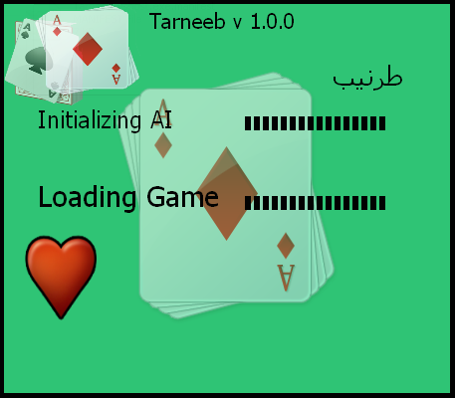

This form is the initializing Game Form, which appear to the user when he opens the game.
This form will Load the game, and initialize components needed

The main form:
This form contains the cards that user use to play the game, menus to facilitate the game, and other components like pictures, buttons to choose the tarneeb type.

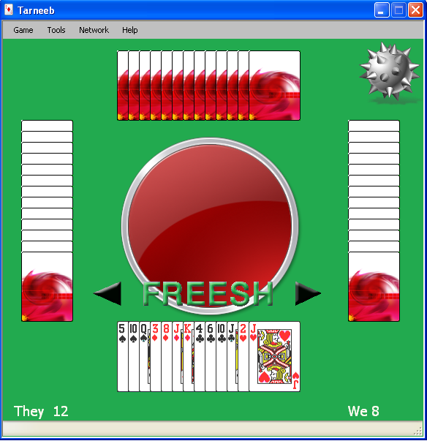

Internal Structure:

C# is an Object Oriented Programming language that uses Classes Definition to Program.

We partitioned the main program into four main classes, first the cards Class to define cards and images for each card and the value used in other classes to make calculations about the game state.

In the main form we used an array of objects from the card class this array contains 52 cards represents the game cards.
The Players Class, which initiated by the Main form for each player, the player object takes a reference of 13 card chosen randomly by the main form.

Players Class contains Public functions, to make calculations related to players like:

- Calculate Maximum bidding, which represents the maximum bidding that the player can reach during the game.
- Calculate current biding, which depends on other players bidding and your friend bidding
- Choosing the Tarneeb type if the player win during bidding
- Playing cards, which is the most important part in Players Class, because it depend on cards still in player hand and cards out of the game and cards on ground.

Network class:
This class Specialized for two players mode, by using TCP Protocol, It contains functions to connect client side to server side, listening for the server side, sending and receiving for both client and server.

Communicating between server and client:-

We developed a simple protocol to ensure reliability between both sides.
Each side receives commands from the other side and converts this commands to it its corresponding events.
Because of this we have faced many problems with blocking \Non blocking because the receive function have to make changes (some times non expected changes) to the GUI this will cause problems so we used LOCKS, in addition to use threads to handle this problem.

