Chapter one

Introduction

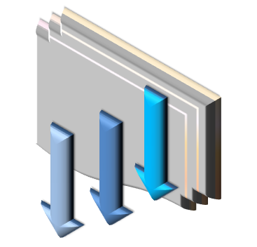

* 1. **General:**

Development in construction is considered as an important feature of the development of any country. This is clear in some cities of Palestine especially in Nablus, (Hayat Nablus) is project suggested to clarify this development.

* 1. **Project Description :**

Hayat Nabulus construction composed of three blocks, **Block A** Consist of Two-stories. The first floor is composed of equal surface area of 732 meters square and at an altitude of 9 meters. Consists of a closed-door swimming pool for women, and rooms services.

The second floor is the banqueting hall is large; there is no internal columns and area equal to 716 meters square. To clarify the details, see **Appendix A**.

**Block B** Consists of three-storey spaces, altitudes and various operational functions. The first floor consists of a steam room and Jacuzzi in addition to the rooms of clothing, massage rooms, administration building, reception, with total area equal to 961 square meters. See **Appendix A,** as for the second level includes a recreation section contains Aragel, billiard, video games and annexes health, the third floor is a secondary hall, occupying an area of 296 square meters, can be exploited banqueting hall or conference room.

Final section **Block C,** Consists of an open swimming pool, as well as water tanks underneath, and operating rooms, car garage. **Appendix A.**

most type of slabs were used as, One way Rib & Solid ,Two way Rib, Waffle &Solid slabs, also drop beam were used.

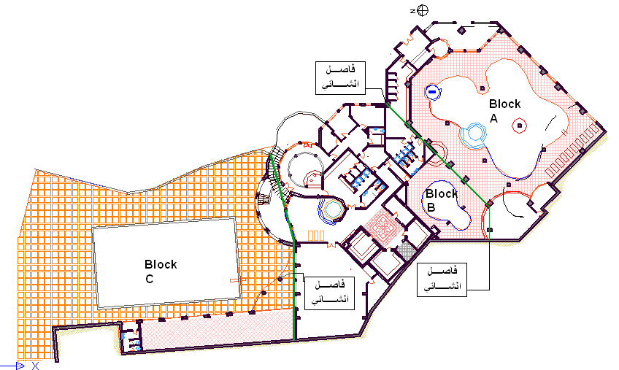

Fig (1-1): Plan for whole structure.

**Block A:**

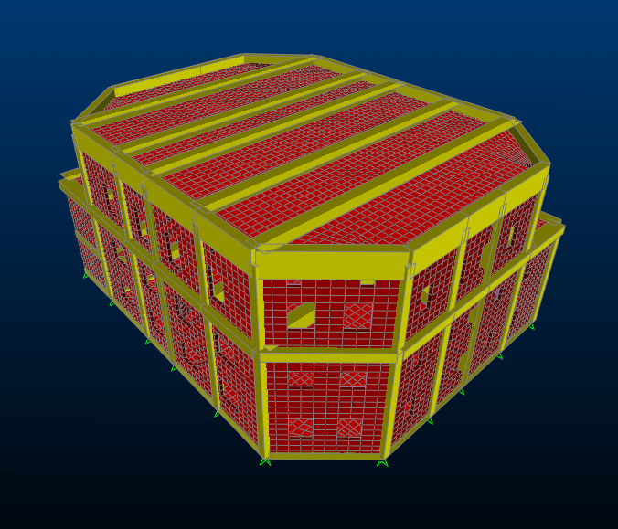

Fig (1-2): Block A .

**Block B:**

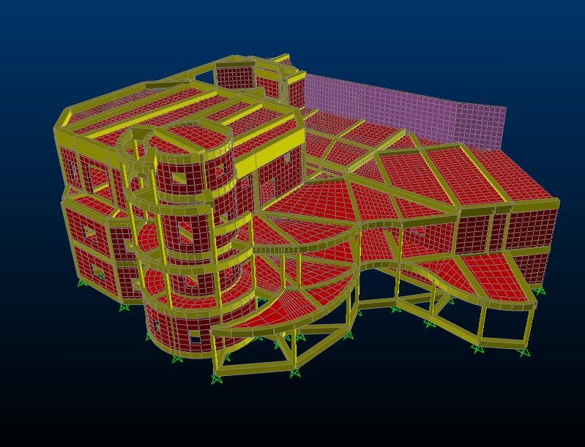

Fig (1-3): Block B.

**Block C:**

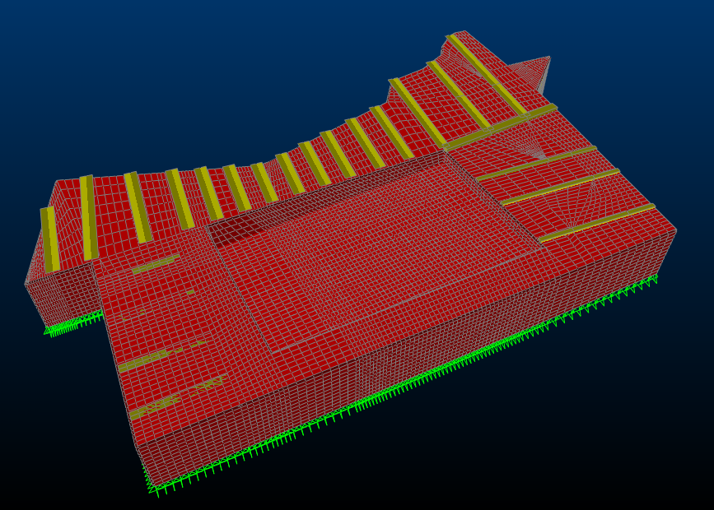

Fig (1-4): Block C .

* 1. **Philosophy of analysis and design:**

The building was analysis and designed by computer program (sap2000 version9) which depends on finite elements. Also, hand calculation has been used for preliminary calculation to check the program design and find preliminary dimensions.

* 1. **About SAP 2000 Computer Program:**

**SAP 2000** is integrated software for structural analysis and design, which provides linear and nonlinear, static and dynamic analysis and design of **3D** structures.

* 1. **Material:**

Selection of required material depends on availability in the local resources and economical factors, material used are:

1. **Reinforced concrete:**
2. Slabs and beams: the cylinder compressive strength at 28days, 𝒇'***c***=240kg/cm2 **(B300).**
3. Columns: the cylinder compressive strength at 28 days

𝒇'***c*** =240kg/cm2 **(B300).**

1. For all structural elements the yield strength of steel bars, **ℱy**=4200kg/cm2 (high strength steel).
2. **Blocks:**

**Y tong** block, light weight with dimensions (40*25*24) ρ=1.4ton/m3 & (40*25*17) ρ=.55ton/m3. Are Used in slabs

* 1. **Loads:**

The project is designed for gravity loads only, dynamic analysis is done to check period of the structure for stability.

1. Live load: it is not permanent load .It comes from the people machines and any movable objects in the buildings. The amount of live load depends on the type of the structure, thus live load in structure design to be special place (home).
2. Dead load: it is associated with the own weight of the structure and any permanent component.
   1. **Foundations:**

The allowable bearing capacity of soil is taken as (2kg/cm2); this value has been founded from the soil test.

* 1. **Code:**

The American Code **ACI 318 - 02** of concrete design.

**1.9 Combinations:**

**Ultimate load=1.2D+1.6L**

Where:

**D**: dead load.

**L**: live load due to included use and occupancy.