
An-Najah National University
Engineering Faculty
Computer Engineering Department

Software Graduation Project:
Class Net Exchange
(CNX)

Team: Supervisors:
Asma Afeefy. Dr.Raed Al-qadi.
Lama Yassin. Ms.Haya Samaneh.

-2009-

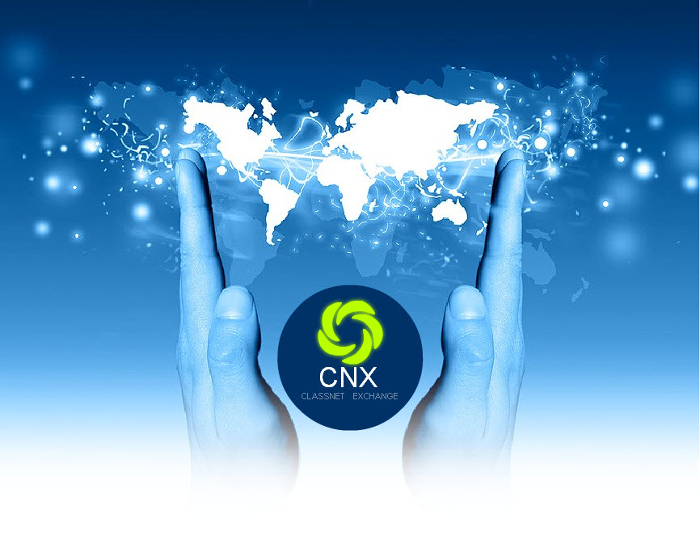

Introduction :
CNX : Class Net Exchange
Enjoy your lesson wherever you are
Using CNX you can participate in the lesson , even if you are at home, all what you have to do is to download the student version of the program and enter the lesson and even you can ask the teacher to help you with your computer.
Our project is a network application that allows students every where to learn, share, and also ask the teacher to help them with their computers , this makes the work easier and more organized up to the level of current advanced technology
Programming Language used :
- We implement this project using JAVA.
- NetBeans 6.7.1 IDE (Integrated Environment Development) .
- PHP (Hypertext Preprocessor).
- Database was created using MySQL Sarver.

Why JAVA :
We used the java language because it is platform independent, so it is easy for a user having linux operating system or mac to download our project and enjoy.

Technologies used in our project :
Java API:
An API is an Interface which is used for accessing an application or a service from a program. An API makes it possible to use programs from within programs, therefore it is the foundation for modular systems with clearly defined Interfaces between separate components. In a way, an API can be regarded as the local equivalent of a Protocol, because it is used for the same purposes and defines the same things (the possible interactions between components, and the data that is exchanged while interacting). However, traditionally APIs are used for Interfaces on one computer, while Protocols are used for distributed scenarios.

Java Sound API :
The Java Sound API is based on the concept of lines and mixers.
A mixer is an audio device with one or more lines. It need not be designed for mixing audio signals. A mixer that actually mixes audio has multiple input (source) lines and at least one output (target) line. The former are often instances of classes that implement SourceDataLine, and the latter, TargetDataLine. Port objects, too, are either source lines or target lines. A mixer can accept prerecorded, loopable sound as input, by having some of its source lines be instances of objects that implement the Clip interface.
A line is an element of the digital audio "pipeline," such as an audio input or output port, a mixer, or an audio data path into or out of a mixer. The audio data flowing through a line can be mono or multichannel (for example, stereo). ... A line can have controls, such as gain, pan, and reverb.

Problems faces us:
- Network connectivity :
As our project is a network project , the overhead on the network was an important issue so we used what is called pixel grabber to take the picture as pixels and compare between images to decide when to send image and when not to, but of course sending the position of the mouse was continues.
The PixelGrabber class implements an ImageConsumer which can be attached to an Image or ImageProducer object to retrieve a subset of the pixels in that image.

BufferedImage myImage = null;
int size =imgHeight * imgWidth;
myImage= new BufferedImage(imgWidth, imgHeight, BufferedImage.TYPE_BYTE_GRAY);

PixelGrabber grabber = new PixelGrabber(myImage, 0, 0, imgWidth , imgHeight , pixels , 0, imgWidth);

try {
grabber.grabPixels();
}
catch (InterruptedException e) {
System.out.println(e);
}

- Full control of student computer . i.e: mouse and keyboard.
We faced a problem in controlling the computer of the student because in java it is not easy to deal with the operating system, so we fixed this problem by using special commands in our protocol to tell the computer what to do , this includes moving the mouse , pressing the mouse , pressing a key on the keyboard .
- Transferring sound :
We faced a problem in selecting the audio format :
- Cell phone GSM (13.2KBit/s - Modem)
- Telephone ulaw (64KBit/s - ISDN)
- FM quality mono (352.8KBit/s - ADSL)
- CD quality mono (705.6KBit/s - LAN)
We used Telephone ulaw (64KBit/s - ISDN) with sampling rate 8000sample/sec,
Every sample 8 bits ,so we transferred 1k(1024) bit each second
targetDataLine = (TargetDataLine)mixer.getLine(dataLineInfo);
targetDataLine.open(audioFormat);
targetDataLine.start();

we used AudioInputStream to capture the sound from the mic and then we sent the voice in an output stream

