
An Najah National University
Faculty of Engineering
Electrical Department

Analysis of Electrification of Remote Villages in Palestine
by using: PV, Diesel, and Extension Electrical Network

Prepared By:
Ayman M Shtaya
Qais T Samara

Subervised by:
Dr Imad Ibrik

May 2009
Palestine - Nablus

Abbreviations:
PV: photovoltaic systems
DG: diesel generators
IEC : Israeli Electrical Company
PA : Palestinian Authority
G_{r} : solar radiation intensity KWh/m² per day
PSH : Peak sunshine hours
Wp : peak watts
STC :Standard Test Conditions
AM: air mass
Voc :open circuit voltage
Isc :short circuit current
MPP : maximum power point
NOCT : the normal operating cell temperature
n : speed (rpm)
f : frequency
P : number of poles
Ah : Ampere– hour
Wh : Watt–hour
ηAh :The Ampere–hour efficiency of a battery cell
H : head (m2)
V : flow rating water (m³/day)
P_{max} :max power
kwh/d : energy consumption per day
E_{h} : hydraulic energy
ρ: density of water=1000kg/m³,
g:gravitational acceleration =9.81m/s²
TDH: total dynamic head
η_{v}: efficiency of inverter
η_{c}: efficiency of regulator battery
S_{f}: safety factor
C_{wh}: Wh capacity of the battery (kwh)
Ad: autonomy day
η_{B}: efficiency of batteries
DOD:depth of discharge of the battery
P_{v}: power of the inverter (kw)
P_{c}: power of the charge battery controller (kw)
A_{L}: the area of the land (m²)
a= area for 1kwp=7.055m²
P_{pv}: peak power (kWp),
E_{h}: hydraulic energy consumption (kwh/d)
η_{m}: efficiency motor-pump
MHP: motor horsepower (hp)
LPD: liter water per day
η_{p}: overall efficiency of the pump
1d/h: liter diesel per hour
h/d: operating hour per day.
h/y : operating hour per year
DHP :diesel horsepower DE :diesel engine
P_{r} : power of controller rectifier
RE%_{month}: reduction percentage of energy in battery per month
RE_{month}: reduction energy in battery per month
RE_{year} is reduction energy in battery per year .
η_{r} = efficient of controller rectifier
S_{max} : max apparent power PF: power factor
K_{gf}: growth factor of the village
V_{TL} : Transmission line voltage
A_{c}: Cross sections area of the conductor
V: is the voltage of the conductors (kv)
S_{T} : Transformer capacity
L.F :load factor
DB : Distribution Board capacity
LCC : life cycle cost
Acost : the cost annuity
Pa is the cumulative present worth factor.
S_{V} :salvage value

Summary
This study conclude of feasibility study to electrify remote village in Palestine by several methods (PV alone, diesel alone, hybrid PV-diesel, and extension electrical network) and then we choose the most economical method that get the min unit cost $/kwh. This study applied on three types of loads: residential (centralized & decentralized), telecommunication tower (AC, DC, and AC/DC systems) and water pumping (at various percentage of load). This study attend of applying the research in many alternatives for each method (PV: at various tilt angle) to get the best of it.
After this study we discover that extension electrical network of the chosen village is less than other alternatives at least by 50% ($/kwh = 0.346- but it is preventive), so we interest on other alternatives for each type of loads: the PV-decentralized systems at tilt angle 20,32 on residential, the hybrid PV-diesel at 32 tilt angle of DC system on telecommunication tower, and diesel system at 100% load on water pumping: are the best alternatives of all.

Contents
Chapter 1: Background………………………………………………….…………….……….5
1.1 Geographical location of Palestine………………………………………....……….7
1.2 Purposes……………………………………………….………………...……………9
Chapter 2: Scope………………………………………….……………..…………………….10
2.1 PV alone system………………………………………………...…………………...11
2.2 DG alone systems…………………………………………………………………...27
2.3 Hybrid PV-DG systems…………………………………………………………….31
2.4 Expansion electrical network……………………………...…….…………………33
Chapter 3: studying load………………………………………………………………….…..34
  - Study of the loads existing in Froosh Biet Dajan village……………...…………..35
3.2 Study and management energy…………………………….…………..……….....37
Chapter 4: The Sizing of the systems………………….………………………….……….…40
4.1 PV alone system………………………………………………………….………….41
4.2 DG alone systems……………………………………………………...…...…..…...52
4.3 Hybrid PV-DG systems……………………………………………..….….……….54
4.4 Expansion electrical network………………………………………..…….…….…60
Chapter 5: Economical study…………………………………………………..…..….……...65
5.1 Introduction of LCC……………………………………………..……….…..…….66
5.2 Cost Annuity & Unit Price………………………………………………….……...67
5.3 PVPAL Program……………………………..…………………………….……….68
5.4 Criteria…………………………………….…..…………………………………….70
5.5 Results………………………………………….…………………...……………….73
5.6 Conclusion………………………………………….……………………………….76
References………………………………………………….………………………………..…77
Appendix……………………………………………………………………………………….78

Chapter 1:
Background

The electricity is one of the most important things in the life. If it is at anyplace, it indicates that is an advance society. Without electricity you don’t convoy other world, don’t able to watch TV, use computers, have communications,...etc.
Palestine suffers from:
- A non-secure electrical network, because the Israeli occupation control of it by Israeli Electrical Company (IEC).
- Palestinian Authority (PA) does not have any independence network in the West Bank, and this point creates a lot of problems in Palestinians areas, special in remote areas.
- The electrical loads are increased, but the grid does not expand, so the people in it use diesel generators for limited period every day, in order to cover their loads. After increasing the price of diesel, they reduce the hour operations of generators, and then they live without electricity.

1.1 Geographical location of Palestine
- Palestine is located between the longitudes 34.15° and 35.40° east and between the latitudes 29.30° and 33.15° north as shown in Figure 3.1.
Fig 1.1: map of Palestine country
- Palestine has a high solar energy potential, where the daily average of solar radiation intensity (G_{r}) on horizontal surface is about 5.74 kWh/m2, while the total peak sunshine hours (PSH) amounts to about 3000 and this is enough to produce solar energy in a sustainable way.
- Availability of a large number of rural villages, settlements and public utilities isolated from the electric grid that will not be connected to it in the near future.
- High fuel cost in Palestine that makes PV more feasible than diesel powered electric generators in supplying power to different applications in rural areas.

1.2 Purposes
- Primary: economics comparison among photovoltaic system (PV), diesel generator (DG), hybrid PV-DG, and expansion electrical network that may become available in the future.
- Secondary: 1-Trial to feed more areas of electricity.
2-Reduce the phenomenon of immigration from rural areas to cities & congestion in cities.
3-Reduce the pollution of the atmosphere from diesel generators & product CO2.

Chapter 2:
Scope

We have many alternatives to electrify this village as PV, DG, wind, hybrids, extension electrical network,...etc. But we chose four alternatives only: PV alone, DG alone, hybrid PV-DG and extension electrical network.
2.1 PV alone system
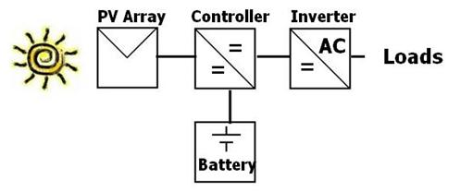
Fig 2.1: PV-alone system
PV systems are solar energy systems that produce electricity directly from sunlight, & produce clean, reliable energy without consuming fossil fuels. It usually consists of: PV array, charge battery controller, inverter, and battery.
2.1.1 Definitions
- solar radiation (Gr)
A general term for the visible and near visible (ultraviolet and near-infrared) electromagnetic radiation that is emitted by the Sun. It has a spectral, or wavelength, distribution that corresponds to different energy levels; short wavelength radiation has a higher energy than long-wavelength radiation.
We can capture and convert solar radiation into useful forms of energy, such as heat and electricity, using a variety of technologies. The technical feasibility and economical operation of these technologies at a specific location depends on the available solar radiation or solar resource.
- Peak sun hours (PSH)
The equivalent number of hours per day when solar irradiance averages 1 kW/m². For example, six peak sun hours means that the energy received during total daylight hours equals the energy that would have been received had the irradiance for six hours been 1 kW/m².
- Sun tracking & tilt angle
Sun tracking by tilting the PV – array allows to receive the maximum solar radiation. Moreover it limits the difference between the maximum and minimum of the power output of PV-array. Tilt angle is the angle between the surface of the PV-array and the horizontal axis, where as the azimuth angle is the angle between the normal of the tilted array and the geographic south. Fixing tilt angle at a certain angle all year to the latitude value (L= 32º) in Palestine increase the solar energy collected by modules. Seasonal changes of tilt angle of solar modules collect higher solar energy than those of the fixed solar modules.
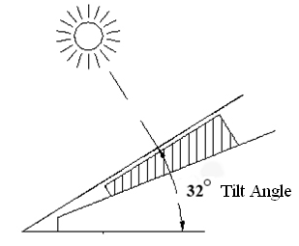
Fig 2.2: PV module with tilt angle 32
The tilted angle β is advised to fix seasonally as follows:
β =L+10 =32 +10 =42 during winter period.
β =L=32 during spring and autumn period.
β = L-10 =32-10=22 during summer period.
2.1.2 PV operating principle
A PV cell is made of at least two layers of semiconductor material. One layer has a positive charge, the other negative. When light strikes the surface of the cell, some of the photons from the light are absorbed by the semiconductor atoms, freeing electrons from the cell’s negative layer to flow through an external circuit and back into the positive layer. This flow of electrons produces electric current. Figure 4.3 shows the solar cell construction, the sandwich of semiconductor materials produce electricity directly from the sunlight without any moving parts.
Fig 2.3: main components of PV cell
- STC and I-V curve
The rated power of a solar cell or a module is basically reported in “peak watts” [Wp] and measured under internationally specified test conditions, namely Standard Test Conditions (STC), which refers to global radiation 1000 W/m2 incident perpendicularly on the cell or the module, cell temperature 25 °C and AM 1.5 (AM: air mass). Photovoltaic modules have current voltage relationship which is represented in I-V curve.
Figure 2.4 shows a single 100 cm2 silicon PV cell connected to a variable electrical resistance R, together with an ammeter to measure the current (I) in the circuit and a voltmeter to measure the voltage (V) developed across the cell terminals. Let us assume the cell is being tested under standard test conditions.
Fig 2.4: PV cell connected to variable resistance, with Ammeter and Voltmeter to measure variations in voltage and current as resistance varies
When the resistance is infinite (i.e. open circuited) the current in the circuits at its minimum (zero) and the voltage across the cell is at its maximum, known as the ‘open circuit voltage’ (Voc). At the other extreme, when the resistance is zero, the cell is in effect ‘short circuited’ and the current in the circuit then reaches its maximum, known as the ‘short circuit current (Isc).
If we vary the resistance between zero and infinity, the current (I) and voltage (V) will be found to vary as shown in Figure 2.5, which is known as the ‘I-V characteristic’ or ‘I-V curve’ of the cell. It can be seen from the graph that the cell will deliver maximum power (i.e. the maximum product of voltage and current) when the external resistance is adjusted so that its value corresponds to the maximum power point (MPP) on the I-V curve .
Fig 2.5: (I-V) characteristics of a typical silicon PV cell at STC
- Effect of solar radiation on PV performance
The irradiance will affect the current generated by a solar cell, the higher the irradiance the higher the current. The effect of irradiance on voltage is minimal. The change in Irradiance can be calculated, the manufacturer’s standards will provide the user with a short-circuit current
Figure 1.6 shows the effect of radiation variation at PV module consisting of 36 cells of mono crystalline silicon [Siemens, SR50] at constant temperature.
Fig 2.6: IV curve & effect of radiation variation at PV module
Fig 2.7: PV module (P-V) curve with variation of Gr and constant temperature
- Effect of temperature on PV performance
Solar cells vary under temperature changes; the change in temperature will affect the power output from the cells. The voltage is highly dependent on the temperature and an increase in temperature will decrease the voltage. Each solar module will have manufacturing standards; the normal operating cell temperature (NOCT) should be among these standards. The NOCT is the temperature the cells will reach when operated at open circuit in an ambient temperature of 20ºC at AM 1.5 irradiance conditions, G = 0.8 kW/m2 and a wind speed less than 1 m/s.
Figure 2.8 shows the effect of temperature variation at PV module consisting of 36 cells of mono crystalline silicon [Siemens, SR50] at constant radiation.
Fig 2.8: IV curve & effect of temperature variation at PV module
Fig 2.9: PV module (P-V) curve with variation of temperature
- PV-cell types
There are many types of PV cells for instance mono-crystalline, polycrystalline, amorphous silicon, compound thin-film, and thick-film and high-efficiency cells. The figure 2.10 illustrates some examples of commercially available PV cells.
Fig 2.10: PV-cell types
Main characteristics of different PV cell types
- Single-crystal silicon
– 15% efficient, typically
– expensive to make (grown as big crystal)
- Poly-crystalline silicon
– 10–12% efficient
– cheaper to make (cast in ingots)
- Amorphous silicon (non-crystalline)
– 4–6% efficient
– cheapest per Watt
– called “thin film”, easily deposited on a wide range of surface types
– efficiency degradation with time
2.1.3 Storage battery in PV power system
Except in PV powered water pumping systems, storage batteries are indispensable in all PV power systems operating in standalone mode to act either as a power buffer or for energy storage. The PV generator is neither a constant current nor a constant voltage source. The maximum power output of the generator varies according the solar radiation and temperature conditions.
In the early morning or late afternoon, the PV generator may not be able to meet the load demands especially with short high current peaks such as during motor-startup. A battery which is constant voltage source acting as a power buffer between the PV generator and the load, will compensate for the limitation of the generator. When solar radiation is higher than needed to meet the load requirement, excess energy is stored in the battery to supply power to the load during night and cloudy days of low solar radiation [15].

- Battery types
The two battery types that have been used for PV systems are lead–acid and nickel–cadmium. Due to higher cost, lower cell voltage (1.2 V), lower energy efficiency and limited upper operating temperature (40 ◦C), Nickel – cadmium batteries have been employed in relatively few systems. Their use is based mainly on their long life with reduced maintenance and their capability of standing deep discharge without damage . The lead– acid battery will remain the most important storage device in the near future, especially in PV systems of medium and large size.
- Lead acid battery
The lead-acid battery is still the most common for relatively economical storage of relatively large quantities of electrical energy, and will probably remain so for at least for the next few years.
- Lead acid battery function and structure
A battery is made up of two or more electrochemical cells interconnected in an appropriate series/parallel arrangement to provide the required operating voltage and current levels. The familiar 12V lead–acid battery used in automobiles consists of six 2-V cells connected in series and packaged .in a rubber or plastic case .
Battery has two electrodes, in the charged state, the positive electrode consists of lead dioxide Pbo2 and the negative electrode of pure lead (Pb), a membrane embedded in a plastic box separates the two electrodes. Diluted Sulphuric acid (H₂SO₄) fills the empty space between the two electrodes, a fully charged lead -acid battery has an acid density of about 1.24 Kg/liter at temperature of 25Co, and the density changes with the temperature and charge state .
The overall reaction is given by the following equation.
Pb + PbO₂+ 2H₂SO₄➔ 2PbSO₄ + 2H₂O
Fig 2.11: Charge and discharge of the lead-acid cell
- Lead acid battery characteristics
The nominal voltage of a lead–acid cell is 2V, while the upper and lower limits of discharging and charging open circuit voltage at 25 ◦C cell temperature are 1.75 and 2.4V, which corresponds to 10.5 and 14.4V for a 12V battery (respectively). The maximum acceptable battery cell voltage decreases linearly with increasing cell temperature as illustrated in Figure 2.12 .
Fig 2.12: Battery cell voltage in function of cell temperature
- DOD and SOC
The depth of discharge (DOD) is the obverse of state-of-charge. Cell voltages almost linearly with depth of discharge until a point called cut-off voltage is reached .Battery cells should not be operated beyond the cut off voltage, because further discharge will result in increasing the internal resistance of the battery and can result in permanent damage. On other hand, overcharging the batteries until gassing leads also to cell damage. So we must use charge controller or regulator.
- Self of discharge
Lead–acid battery cells are available with either pure lead or lead–calcium grids to minimize the self-discharge rate. All lead–acid cells have some loss in capacity on standing due to internal chemical reactions. Figure 2.13 presents typical self discharge rates for a cell containing antimony or calcium grids. Self-discharge rate, increases with increasing cell temperature and remain relatively low for cell with lead calcium grids.
Fig 2.13: Lead–acid battery self discharge rate in function of cell temperature
- Storage capacity and efficiency
Batteries are commonly rated in terms of their Ampere– hour (Ah) or Watt–hour (Wh) capacity. Ah-capacity is the quantity of discharge current available for a specified length of time valid only at a specific temperature and discharge rate. For example, a 12V battery rated at 100 Ah over 20 h can deliver 5 Ah for 20 h (C20 rate) is equivalent to 1.2 kWh of energy (12V × 100 Ah). At 5 h discharge rate, the same battery will deliver a maximum of 70 Ah equivalents to 0.8 kWh of energy (C5 rate). The discharge curve in Figure 2.14 illustrates the relationship between Ah capacity and discharge current for a typical 100 Ah/12V lead–acid battery. High discharge current would result in reduction of the battery capacity and will shorten its life . In addition, the Watt–hour capacity (Wh) or energy capacity is the time integral of the product of discharge current and voltage from full charge to cutoff voltage. Battery capacity increases about 1% for every 1º C increase in temperature.

Figure 2.14: The Ampere–hour capacity of a lead–acid battery in function of the discharge current
Lower temperature results in decreasing the capacity due to slower chemical reactions. The Ampere–hour efficiency of a battery cell (η_{Ah}) is the ratio of the number of Ampere–hours obtainable during discharge to that required to restore it to its o regional condition.
- Battery life cycle time
Battery lifetime in cycles depends on the depth of discharge during normal operation. Figure 2.15 shows how the depth of discharge affects the number of operating cycles of a deep discharge battery
Fig 2.15: Lead-acid battery lifetime in cycles vs. depth of discharge per cycle
Deep discharged lead acid batteries can be cycled down to 20% of their initial capacity .
2.1.4 Battery charge controller
In nearly all systems with battery storage, a charge controller is an essential component to protect the battery against deep discharge and excessive overcharge. The charge controller must shut down the load when the battery reaches a prescribed state of discharge and must shut down the PV array when the battery is fully charged.
The controller should be adjustable to ensure optimal battery system performance under various charging, discharging and temperature conditions. Battery terminal voltage under various conditions of charge, discharge and temperature has been presented in Figure 4.22.
Fig 2.16: Battery charge controller
2.1.5 Inverter
Depending on the requirements of the load, a number of different types of inverters are available. Selection of the proper inverter for a particular application depends on the waveform requirements of the load and on the efficiency of the inverter. Inverter selection will also depend on whether the inverter will be a part of a grid-connected system or a stand-alone system. Many opportunities still exist for the design engineer to improve the inverters, since inverter failure remains one of the primary causes of PV system failure.
Fig 2.17: Inverter
Some systems don’t use inverter because it have only DC loads, on another hand, some systems don’t use batteries such as pumping water because it works only in the day.

2.2 DG alone systems
Diesel generators are widely used as alternative energy sources for remote off-grid areas mainly due to their low capital costs.
DG systems are consuming diesel to produce electrical energy -every liter diesel produce approximately 3.5kwh-. DG pollutes the atmosphere and increases the percentage of contamination.
2.2.1 Diesel generator operating characteristics
- Rotation speed
The Corresponding speeds of 50 Hz generators are 3000 rpm and 1500 rpm synchronous generators obtained from the following equation.
120 x f = n x P (4-6)
Where: n : speed (rpm), f : frequency , P : number of poles
The 3000 rpm units are 2-pole machines and are of simpler construction, resulting in lower acquisition cost. The 1500-rpm machines are 4-pole machines and are somewhat more expensive, but more common in the larger sizes or heavy duty units.
In general, the higher the rpm, the more wear and tear on the bearings. This means more frequent maintenance requirements. Two-pole generators are thus most convenient for use in relatively light duty applications that require less than 400 hours per year of operation. Four-pole generators are recommended when more than 400 hours of operation per year are anticipated.

- Fuel types
Diesel engines differ from gasoline engines in that they do not have sparkplugs to ignite the fuel mixture, and work at much higher pressures. Diesel engines need less maintenance that gasoline engines, and they are more efficient .
- Efficiency and fuel consumption
Electrical and mechanical losses are present in all generators. However, the greatest losses in a generator system are attributable to the prime mover engine. The efficiency of diesel generator is proportional to the size of the operated load by the diesel generator .Manufactures endeavor to produce maximum efficiency at somewhere between 80-90 % of rated full load.
Figure 2.18 shows approximate plots of efficiency vs. percent of rated electrical load
Fig 2.18: Diesel generator overall efficiency vs. rated load.
As seen in Figure 2.18 the efficiency of a diesel generator is higher at the higher loading rate, and is lower at the lower loading rate.
- Life cycle of diesel and regular maintenance requirements
A diesel generator can operate for between 5000–50 000 hours (average 20000 hours), depending on the quality of the engine.
- Regular maintenance
Diesel engines require routine maintenance for long –life service. The normal maintenance requirements are about the same as owing a diesel powered vehicle –oil, oil filter and fuel filter in tropical and cold climates. It is advisable to have a water fuel separation filter system installed, water or moisture in diesel fuel can be damaging to a diesel engine because the water properties create advanced ignition and accelerated detonation. The engine will need oil change every 100 to 250 hours depending on the dust conditions. Companies recommend to change the oil filter every time where engine oil will be changed. Air filter need to be changed as required depending on how much dust is in the air, Diesels need a lot of clean air to operate properly and will collapse if the air filter is dirty. Manufacturers recommend checking the air filter at least every 100 hours .In industrial environment checking is recommended each 50 hours. Fuel filter are normally changed every 200 to 250 hours depending on how clean the fuel and dust condition .
- Low load operation.
Other factor affects the diesel generator life is the low load operation which defined as when the engine operates for a prolonged period of time below 40–50% of rated output power . During periods of low loads, the diesel generator will be poorly loaded with the consequences of poor fuel efficiency and low combustion temperatures. The low temperatures cause incomplete combustion and carbon deposits (glazing) on the cylinder walls, causing premature engine wear. Therefore To avoid glazing we operate the diesel generator near its full rated power.
- Pollutant emissions
Number of kg of CO2 produced per liter of fuel consumed by the diesel generator depends upon the characteristics of the diesel generator and of the characteristics of the fuel, and it is usually falls in the 2.4–2.8 kg/L range .

2.2.2 Diesel water pumping system
The diesel pumping system is widely used in the remote areas. Because of the availability of the diesel and may it operate at any places and conditions.
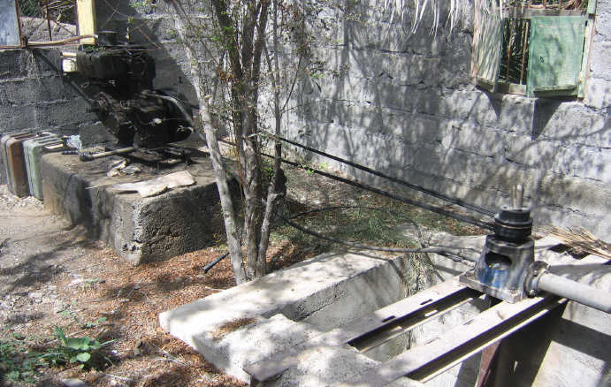
Figure 2.19: The diesel pumping system widely used in remote areas.

2.3 Hybrid PV-DG systems
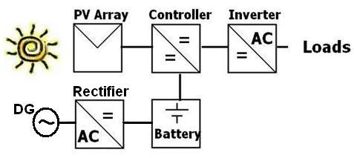
Fig 2.20: Hybrid PV-DG system
Hybrid PV-DG systems combine between PV & DG to make stable systems, because sometimes the Gr does not able to charge the battery, then the battery does not able to cover the loads, so DG compensate the lack of energy.
This system usually consists of: PV array, charge battery controller, inverter, battery, DG, and controller rectifier.
- Controller rectifier
An electrical device for converting alternating current (AC) to direct current (DC), as in a battery charger or converter.
2.3.1 Series hybrid system
We many alternatives of PV-DG hybrid systems, but we chose series hybrid system Figure 2.21, and it mostly common type and simple.
In the series hybrid system, energy from diesel generator and a PV array are used to charge a battery bank. The diesel generator is connected in series to the rectifier to supply the load. The diesel generator cannot supply the load directly. The rectifier converts DC voltage from the battery to AC voltage and supplies it to the load. The capacity of the battery bank and inverter should be able to meet the peak load demand. The capacity of diesel generator should also be able to meet the peak load and charge the battery simultaneously.
Fig 2.21: series hybrid system

2.4 Expansion electrical network
The expansion electrical network will requires many devices and equipments as: conductors, pin insulators, strength insulators, towers, truss, transformer, switch gears… etc.
It is more stable, but it is rarely existing on remote village.
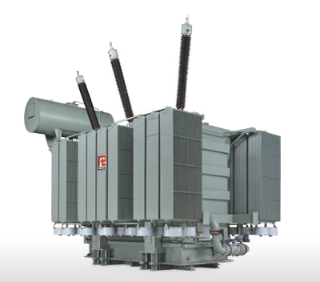
Fig 2.22: transformer ( main device on expansion electrical network)

Chapter 3:
Studying Load

We apply this study on a non-electrification village is: Froosh Beit Dajan. This village is located in the Jordan valley at east of Nablus (40km), their population about 769 inhabitants in 100 houses & there is Masjid, school, farmer society, & municipality. It suffers from some of problems as preventive build any cement or wood buildings since 1967, confiscation of lands and water for settlements; it is around of three settlements, and no electrical network despite of IEC pass through it. The nearest point of medium voltage 33KV return to PA far 6km at Aien Sheply village.
  - Study of the loads existing in Froosh Biet Dajan village
    - Residential loads: it has two main areas Abbas (60 houses, 20 street lighting, Masjid, school and municipality) & Shaka (30 houses, 10 street lighting), every area cover their loads by DG 66KVA, 33KVA respectively. DG works about 4 hours every day (H/d) only and consume 16,7 liters of diesel respectively every hour (ld/h), then it is not enough of the all requirements in the village.
    - Telecommunication tower loads (Jawwal tower): it has two DG 18KVA work 12 hours every day for each DG. Every DG consumes 4 ld/h.
    - Water Pumping loads: it has 5 main pumps Ibasi, Jaleel, Shaheen, Masri and Shaka with various head (H) and flow rating (V) m³/day. They work from May to October every year, and they pump by using diesel engine, then the farmers suffer when the price of diesel increase.

3.2 Study and management energy
A PV system designer can minimize a PV system cost by efficiently using the energy available. A designer should thoroughly analyze the energy requirements to identify energy conserving opportunities.
Designers should also be able to suggest using more efficient appliances within a PV system.
We study the actual loads by explain the actual energy for every load per day, and this energy must cover all requirements of the loads.
3.2.1 Residential loads:
Load |  | P (w) | number | h/d | period
One Street lighting (SL) |  | 100 | 1 | 10 | 18-4
House | Kitchen light | 18 | 1 | 3 | 16-19
House | Living room lights | 18 | 1 | 4 | 16-20
House | Bedroom lights | 18 | 2 | 1 | 6-7 + 21-22
House | Bathroom light | 18 | 1 | 1 | 6-7 + 21-22
House | Refrigerator | 84 | 1 | 10 | 10--20
House | TV | 36 | 1 | 3 | 18-21
House | Washing Machine | 72 | 1 | 1 | 16-17
School | Classes | 18 | 13 | 5 | 8--13
School | TV | 36 | 1 | 2 | 10--12
School | Video | 30 | 1 | 1 | 11--12
School | Audio Amplifier | 25 | 1 | 1 | 7--8
Masjid | Lamp | 18 | 4 | 2
Masjid | Audio Amplifier | 25 | 1 | 2
Municipality | Lamp | 18 | 6 | 1 | 15-16
Table 3.1: management of Residential power
Now we get the daily load curve for each load and for Abbas and Shaka Area as centralized systems.
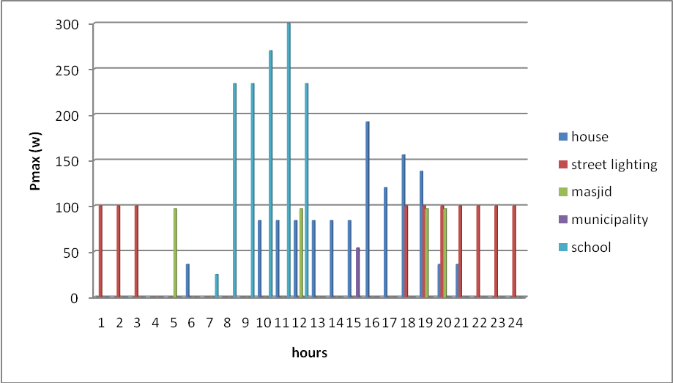
Fig 3.1: daily load curve for every residential load
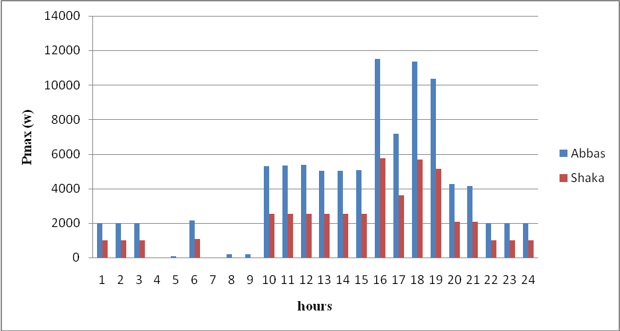
Fig 3.2: daily load curve for Abbas & Shaka areas.
from fig 3.1 & 3.2 and table 3.1 we get max power of the load (P_{max}) and energy consumption per day (kwh/d).
Load | SL | house | school | Masjid | Municipality | Abbas Area | Shaka Area
P_{max} (w) | 100 | 192 | 300 | 100 | 60 | 11520 | 5760
E (kwh/day) | 1 | 1.2 | 1.297 | 0.194 | 0.108 | 99.57 | 48.94
Table 3.2: P_{max} & daily energy of Residential loads
Where, E=∑ P * number * h/d, P_{max} from curves
3.2.2 Jawwal Tower:
In Jawwal tower, we must know the loads at the tower, and these loads distribute to AC & DC loads. After studied this loads we find that we can distribute the loads depending how they work (AC or DC) to three systems
- AC system: this situation is existing now on the tower and they use rectifier ton feed Radio Base Station (RBS).
- DC system: because RBS id DC, and the air conditioner (A/C) can be replaced by another operates on DC.
- AC/DC system: in this situation we distribute loads to operate on DC (RBS) and AC (other devices).

Load | number | Pmax (kw) |  |  | h/d
Load | number | AC | AC / DC | DC | h/d
RBS | 1 | 3.360 (rectifier) | 2.200 | 2.200 | 24
A/C | 2 | 1.500 | 1.500 | 1.500 | 24
cabinet light | 2 | 0.018 | 0.018 | 0.018 | 24
out lights | 1 | 0.018 | 0.018 | 0.018 | 15
Large light | 3 | 0.500 | 0.500 | 0.500 | 15
Table 3.3: management of tower loads
Now we get P_{max} (because the loads of tower work together we get P_{max}=∑Number*P) and kwh/d.
System | P_{max} (kw) | E (kwh/d)
P_{AC} | 6.42 | 187.32
P_{AC/DC} | 5.26 | 148.29
P_{DC} | 4.96 | 142.64
Table 3.4: P_{max} & daily energy of towe
3.2.3 Water Pumping loads:
The actual energy consumption on water pumping loads is hydraulic energy (E_{h}), is obtained as follows [3.1]:
Where, ρ: density of water=1000kg/m³,g: gravitational acceleration =9.81m/s²
TDH: total dynamic head = static head plus losses, Ξ 1.05*H

Pump | H (m) | V (m³/day) | E_{h} (kwh/d)
Ibasi | 110 | 877.5 | 276.18
Jalel | 170 | 845 | 411.02
shaheen | 110 | 450 | 141.63
Masri | 139 | 1,000.00 | 397.71
Shaka | 146 | 220 | 91.9
Table 3.5: management of pump power

Chapter 4:
The Sizing of the systems

This chapter will explain all requirements of each system and how we got it.
4.1 PV alone
4.1.2 Residential
The residential loads on PV alone can be divided to centralized: as in sec, and decentralized: each load (houses, street lighting school, Masjid, and municipality)is working alone without any connection with other loads.
- Sizing of PV generator (P_{pv}):
Fig 4.1: PV generator system loads of residential load
The most appropriate PV generator system loads illustrated in fig 4.1, and the P_{pv} (kw_{p})is obtained as follows [4.1]:
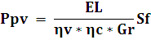
Where , E_{L}: actual energy consumption (kwh/d)
η_{v}: efficiency of inverter= 92%; we use pure sine inverter because the loads interact from harmonics.
η_{c}: efficiency of regulator battery= 95%
S_{f}: safety factor= 1.2
G_{r}: solar radiation- we apply various G_{r} resulting from varying on tilted angle as in the table 4.1.
tilt angle | G_{r}
0 | 5.743
20 | 6.240
32 | 6.238
45 | 5.988
Table 4.1: average Gr at various tilt angle
- Sizing of storage battery:
The most appropriate capacity of storage block battery is obtained as follows [4.2]:
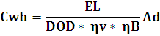
Where, C_{wh}: watt hour capacity of the battery (kwh), Ad: autonomy day=1.5
η_{B}: efficiency of batteries= 85%, DOD: depth of discharge of the battery= 75%
- Sizing of battery charge controller & sine inverter:
The size of battery charge controller & sine inverter depend on the P_{max} and they are obtained as follows [4.3]:
Where, P_{v}: power of the sine inverter (kw), P_{c}: power of the charge battery controller (kw)

After apply this equations we get this results:
Area | tilt | P_{pv} | C_{wh} | P_{c} | P_{v}
Abbas | 0 | 23.8 | 254.65 | 14 | 14
Abbas | 20 | 21.91 | 254.65 | 14 | 14
Abbas | 32 | 21.92 | 254.65 | 14 | 14
Abbas | 45 | 22.83 | 254.65 | 14 | 14
Shaka | 0 | 11.7 | 125.17 | 7 | 7
Shaka | 20 | 10.77 | 125.17 | 7 | 7
Shaka | 32 | 10.77 | 125.17 | 7 | 7
Shaka | 45 | 11.22 | 125.17 | 7 | 7
Table 4.2: sizing of centralized residential system

 | tilt | P_{pv} | C_{wh} | P_{c} | P_{v}
House | 0 | 0.287 | 3.069 | 0.25 | 0.25
House | 20 | 0.264 | 3.069 | 0.25 | 0.25
House | 32 | 0.264 | 3.069 | 0.25 | 0.25
House | 45 | 0.275 | 3.069 | 0.25 | 0.25
School | 0 | 0.31 | 3.317 | 0.4 | 0.4
School | 20 | 0.285 | 3.317 | 0.4 | 0.4
School | 32 | 0.285 | 3.317 | 0.4 | 0.4
School | 45 | 0.297 | 3.317 | 0.4 | 0.4
Street lighting | 0 | 0.22 | 2.353 | 0.12 | Non
Street lighting | 20 | 0.202 | 2.353 | 0.12 | Non
Street lighting | 32 | 0.202 | 2.353 | 0.12 | Non
Street lighting | 45 | 0.211 | 2.353 | 0.12 | Non
Masjid | 0 | 0.043 | 0.456 | 0.12 | Non
Masjid | 20 | 0.039 | 0.456 | 0.12 | Non
Masjid | 32 | 0.039 | 0.456 | 0.12 | Non
Masjid | 45 | 0.041 | 0.456 | 0.12 | Non
Municipality | 0 | 0.024 | Non | 0.1 | Non
Municipality | 20 | 0.022 | Non | 0.1 | Non
Municipality | 32 | 0.022 | Non | 0.1 | Non
Municipality | 45 | 0.023 | Non | 0.1 | Non
Table 4.3: sizing of centralized residential system

4.1.3 Telecommunication tower
In this section we have three systems: AC, AC/ DC, and DC, then we apply the same equation on residential loads, but there is one different on the G_{r}. Because the telecommunication tower is very important thing to link areas, and we must get that the system works full day for all time of the year. Then we design this system on min G_{r} of the months at each tilt angle.
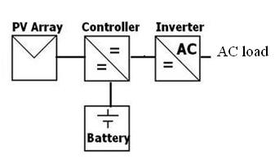
Fig 4.2: AC system of PV alone tower
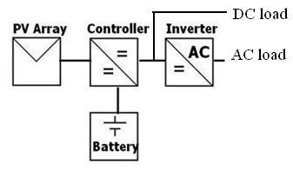
Fig 4.3: AC/Dc system of PV alone tower

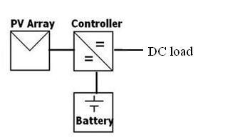
Fig 4.4: DC system of PV alone tower
tilt angle | min G_{r}
0 | 2.94
20 | 4.04
32 | 4.52
45 | 4.84
Table 4.4: min Gr at various tilt angle
- Sizing of P_{pv}, C_{wh}, P_{c}, P_{v}:
We apply the same equation on sec , but we don’t use inverter on DC system, and on AC & DC system the Pv less than the same value of AC system by the power of the RBS (2202w).
- Sizing of land require:
Because the land of the tower is rented (not personal land as residential and water pumping), so we add the size of land on the requirements as follows [4.4]:
Where, A_{L}: the area of the land (m²), a= area for 1kwp=7.055m², Sf: safety factor

system | tilt | P_{pv} | A_{L} | C_{wh} | P_{c} | P_{v}
AC | 0 | 87.48 | 740 | 479.08 | 9.5 | 9.5
AC | 20 | 63.66 | 540 | 479.08 | 9.5 | 9.5
AC | 32 | 56.9 | 480 | 479.08 | 9.5 | 9.5
AC | 45 | 54.26 | 560 | 479.08 | 9.5 | 9.5
AC/DC | 0 | 73.67 | 623 | 403.48 | 8.1 | 5.5
AC/DC | 20 | 53.61 | 455 | 403.48 | 8.1 | 5.5
AC/DC | 32 | 47.92 | 405 | 403.48 | 8.1 | 5.5
AC/DC | 45 | 45.7 | 387 | 403.48 | 8.1 | 5.5
DC | 0 | 61.28 | 520 | 335.62 | 7.4 | 7.4
DC | 20 | 44.6 | 378 | 335.62 | 7.4 | 7.4
DC | 32 | 39.86 | 338 | 335.62 | 7.4 | 7.4
DC | 45 | 38.01 | 324 | 335.62 | 7.4 | 7.4
Table 4.5: sizing of tower system
4.1.4 Water pumping
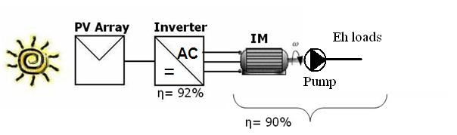
Fig 4.5: PV alone system for water pumping
We chose one pump from the village to apply this study on it was: Ibasi water pumping.

- Sizing of P_{pv}:
The most appropriate PV generator system loads illustrated in fig. , and the power P_{pv} is obtained as follows [4.5]:
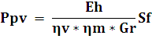
Where , P_{pv}: peak power (kWp), E_{h}: hydraulic energy consumption (kwh/d)
η_{v}: efficiency of square inverter= 92%, η_{m}: efficiency motor-pump= 90%,
Note: we use square wave inverter because the induction motors rarely interact from harmonics and it has less cost from sine inverter.
S_{f}: safety factor= 1.2
G_{r}: we take the average of G_{r} on the months that the water pumping work on it ( six months from May to October)
tilt angle | G_{r}
0 | 7.37
20 | 7.513
32 | 7.228
45 | 6.64
Table 4.6: average Gr from May to October
- Sizing of Induction Motor (IM):
The size of IM depend on the head and the flow rate of water, the it is obtained as follows [4.6]:
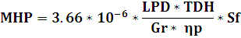
MHP: motor horsepower (hp), LPD: liter water per day, η_{p}: overall efficiency of the pump= 95%:
- Sizing of square inverter:
The size of inverter depend on the MHP, and it is obtained as follows [4.7]:
Where k: factor to convert from hp to kw and it= 0.746 kw/hp
Now, we know the size of each devices, then we apply these equations of different percentages of E_{h}.

E_{h} | tilt | P_{pv} | P_{v} | MHP | E_{h} | P_{pv} | P_{v} | MHP
10% | 0 | 5.43 | 5 | 7 | 80% | 43.42 | 40 | 56
10% | 20 | 5.32 | 5 | 7 | 80% | 42.56 | 40 | 56
10% | 32 | 5.53 | 5 | 7 | 80% | 44.24 | 40 | 56
10% | 45 | 6.02 | 5 | 7 | 80% | 48.16 | 40 | 56
20% | 0 | 10.85 | 10 | 14 | 90% | 48.85 | 45 | 63
20% | 20 | 10.64 | 10 | 14 | 90% | 47.88 | 45 | 63
20% | 32 | 11.06 | 10 | 14 | 90% | 49.77 | 45 | 63
20% | 45 | 12.04 | 10 | 14 | 90% | 54.18 | 45 | 63
40% | 0 | 21.7 | 20 | 28 | 100% | 54.27 | 50 | 70
40% | 20 | 21.28 | 20 | 28 | 100% | 53.2 | 50 | 70
40% | 32 | 22.12 | 20 | 28 | 100% | 55.3 | 50 | 70
40% | 45 | 24.08 | 20 | 28 | 100% | 60.2 | 50 | 70
60% | 0 | 32.65 | 30 | 42
60% | 20 | 31.92 | 30 | 42
60% | 32 | 33.18 | 30 | 42
60% | 45 | 36.12 | 30 | 42
Table 4.7: results of PV-alone water pumping system
Note: we don’t use storage battery on this system, because the water pumping operates only in the day, so it doesn’t need battery.

4.2 DG alone
This section will get the number of hours that the existing DG operates every year, and how much it consume diesel also.
4.2.1 Residential
We know that tow DG work in this village for about 4 h/d and to determine how much it consume diesel every year (ld/y) is obtained as follow [4.8]:
1d/y = 1d/h * 365 * h/d
Where 1d/h: liter diesel per day, 365: numbers of day per year. h/d: operating hour per day.
And the operating hours every year, is obtained h/y = h/d * 365
Where h/y : operating hour per year
area | KVA | h/d | ld/h | ld/d | ld/y | h/y
Abbas | 66 | 4 | 16 | 64 | 23360 | 1460
Shaka | 33 | 4 | 7 | 28 | 10220 | 1460
Table 4.8: size of DG on the residential loads
4.2.2 Telecommunication tower
The towers has two DG work for 12 h/d for each, and they consume 4 l/h , then we determine the ld/y & h/y for each DG.
KVA | h/d | ld/h | ld/d | ld/y | h/y
18 | 12 | 4 | 48 | 17520 | 4380
18 | 12 | 4 | 48 | 17520 | 4380
Table 4.8: size of DG tower AC loads
4.2.3 Water pumping
We design the diesel water pumping -for Ibasi- on the different percentage of Eh, the diesel horsepower (DHP) has the same values of the MHP on the same percentages.
Note: the percentage of Eh effect on the percentage of consuming diesel liters per day at the same period every day (6.5 h/d).
Water pumping works on diesel engine (DE) and we take different percentages of E_{h}.
percentage | DHP (hp) | ld/y
10% | 7 | 2,106
20% | 14 | 4,212
40% | 28 | 8,424
60% | 42 | 12,636
80% | 56 | 16,848
90% | 63 | 18,954
100% | 70 | 21,060
Table 4.9: size of DG-alone pump

4.3 Hybrid PV-DG
4.3.1 Residential
- Sizing of P_{pv}, P_{c}, P_{v}:
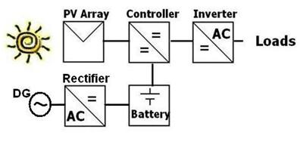
Fig 4.6: hybrid system of residential load
It is the same value of getting on PV-alone, because the parameters is the same.
- Sizing of C_{wh}:
In hybrid systems we made one change from PV alone, it was the Ad, so we use one autonomy day only.
- Sizing of diesel generator (P_{G}):
The DG on this systems operate to cover the reduction percentage of C_{wh}, also this DG work to cover the max power on the loads, that means DG capacity depend on the load, and P_{G} (kw) is obtained as follow [4.9]:
Where, S_{f}= 1.2, P_{max}: is max load of the system
Then we chose the above closest standard value of DG.
- Sizing of controller rectifier (P_{r}):
To get appropriate value of P_{r} (kw) we obtained as follows [4.10]:
Where S_{f}=1.2
- Ld/y & h/y for DG:
This required data depend on the reduction percentage of energy in block battery, and this percentage depend on the value of G_{r} for each month. That means the DG must operate when GR per month less than average G_{r}.
This percentage is obtained as follows [4.11]:
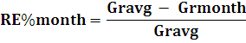
Where, RE%_{month}: reduction percentage of energy in battery per month, Gr_{avg}: average Gr, Gr_{month}: Gr per month
Month tilt | 1 | 2 | 3 | 4 | 10 | 11 | 12
0 | 0.46 | 0.37 | 0.14 | 0 | 0.06 | 0.32 | 0.49
20 | 0.341 | 0.3 | 0.107 | 0 | 0 | 0.16 | 0.353
32 | 0.27 | 0.26 | 0.09 | 0 | 0 | 0.073 | 0.28
45 | 0.2 | 0.21 | 0.06 | 0.02 | 0 | 0 | 0.19
Table 4.10:reduction percentage of energy in battery per month at various tilt angle

Then we calculate the actual energy for each month that DG cover it as follows [4.12]:
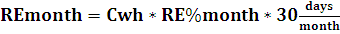
Where. RE_{month}: reduction energy in battery per month
Finally, we calculate the energy for all year [4.13]:
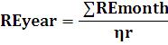
where RE_{year} is reduction energy in battery per year .
η_{r} = efficient of controller rectifier = 97%
tilt | 0 | 20 | 32 | 45
Abbas | 9382 | 6413 | 4531 | 3455
Shaka | 4610 | 3152 | 2227 | 1698
Table 4.11: reduction energy in battery per year and that DG cover it.
Now we can calculate the required data h/y and ld/y as follows [4.14]:
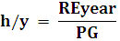
and , where K_{d} = 3.5, it means that every liter diesel produce 3.5 kwh

area | tilt | 0 | 20 | 32 | 45
Abbas | h/y | 581.6 | 384.01 | 271.32 | 206.89
Abbas | ld/y | 2680.6 | 1832.3 | 1294.6 | 987.14
Abbas | C_{wh} | 169.77
Abbas | P_{G} | 16.7
Abbas | P_{r} | 20.04
Shaka | h/y | 394.02 | 269.4 | 190.34 | 145.13
Shaka | ld/y | 1317.1 | 900.57 | 636.29 | 485.14
Shaka | C_{wh} | 83.44
Shaka | P_{G} | 11.7
Shaka | P_{r} | 14.04
Table 4.15: other sizing of hybrid residential loads
4.3.2 Telecommunication tower
On this case we have one different from PV alone, it is G_{r}. In PV alone we used the min G_{r} to keep system working all times in the year. But now we used DG to keep it, then we used the average G_{r}.
Then, We apply the same equations on sec 4.3.1 to get the required data as follows:
tilt | 0 | 20 | 32 | 45
AC | 17649 | 12065 | 8523 | 6500
AC/DC | 14863 | 10160 | 7178 | 5474
DC | 13439 | 9187 | 6490 | 4950
Table 4.16: reduction energy in battery per year of tower loads
Then, PG for all systems= 11.7kw and Pr= 14.04kw
area | tilt | 0 | 20 | 32 | 45
AC | Ppv | 44.78 | 41.22 | 41.23 | 42.95
AC | AL | 340 | 410 | 410 | 425
AC | h/y | 1508.3 | 1031.2 | 728.5 | 555.6
AC | ld/y | 5042.6 | 3447.3 | 2435.1 | 1857.1
AC | Cwh | 319.39
AC | Ppv | 37.72 | 34.71 | 34.72 | 36.17
AC | AL | 380 | 354 | 354 | 366
AC | h/y | 1270.3 | 868.4 | 613.5 | 467.9
AC | ld/y | 4246.6 | 2902.9 | 2050.9 | 1564
AC | Cwh | 268.99
AC | Ppv | 31.37 | 28.87 | 28.88 | 30.09
AC | AL | 326 | 305 | 305 | 315
AC | h/y | 1148.6 | 785.2 | 554.7 | 423.1
AC | ld/y | 3839.7 | 2624.9 | 1854.3 | 1414.3
AC | Cwh | 223.75
Table 4.17: other sizing of hybrid residential loads
4.3.3 Water pumping
Water pumping differ in hybrid system from residential and tower, because no storage battery used in water pumping system, so the diesel pumping used to compensate the percentage of Eh covered by PV. That means, in this section we cover 100% of Eh by two systems: PV and diesel, so we used two pumps for each.
Note: to make hybrid we use results from sec & sec (e.g.: when the percentage of PV is 10% then the percentage of diesel is 90%)
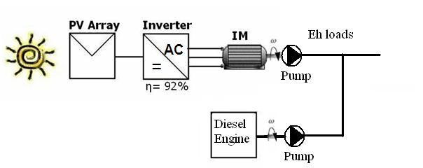
Fig 4.7: hybrid system for water pumping
PV | diesel | tilt | P_{pv} | Pv | MHP | DHP | ld/y | PV | diesel | P_{pv} | Pv | MHP | DHP | ld/y
10% | 90% | 0 | 5.43 | 5 | 7 | 63 | 18945 | 60% | 40% | 32.65 | 30 | 42 | 28 | 8424
10% | 90% | 20 | 5.32 |  |  |  |  |  |  | 31.92
10% | 90% | 32 | 5.53 |  |  |  |  |  |  | 33.18
10% | 90% | 45 | 6.02 |  |  |  |  |  |  | 36.12
20% | 80% | 0 | 10.85 | 10 | 14 | 56 | 16848 | 80% | 20% | 43.42 | 40 | 56 | 14 | 4212
20% | 80% | 20 | 10.64 |  |  |  |  |  |  | 42.56
20% | 80% | 32 | 11.06 |  |  |  |  |  |  | 44.24
20% | 80% | 45 | 12.04 |  |  |  |  |  |  | 48.16
40% | 60% | 0 | 21.7 | 20 | 28 | 42 | 12636 | 90% | 10% | 48.85 | 45 | 63 | 7 | 63
40% | 60% | 20 | 21.28 |  |  |  |  |  |  | 47.88
40% | 60% | 32 | 22.12 |  |  |  |  |  |  | 49.77
40% | 60% | 45 | 24.08 |  |  |  |  |  |  | 54.18
Table 4.18: results of hybrid PV-DE pump

4.4 Expansion electrical network
When electrical network will be expanded, all loads in the village will be benefited from it.
- Determination of S_{max} of the village
Main loads in the village are explained as:
Load | P_{ml} (kw) | S_{max} (KVA) | E (kwh/year)
Abbas area | 16.2 | 17.6 | 36343.05
Shaka area | 8.4 | 9.1 | 17863.1
Jawwal tower | 10 | 10.9 | 68371.8
Ibasi pump | 67.14 | 73.0 | 49,713
Masri pump | 89.52 | 97.3 | 86,400
Shaheen pump | 35.8 | 38.9 | 83,700
Jaleel pump | 89.52 | 97.3 | 29,700
Shaka pump | 22.38 | 24.3 | 49,713
 |  | ∑S_{max}= 368.4 | ∑E= 421803.53
Table 4.19: S_{max} of the village
And the max apparent power (S_{max}) of the village is obtained as follows [4.15 & 4.16 respectively]:
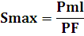
Where, PF: power factor, must equal 0.92 to bypass the penalties, S_{f}=1.2,
K_{gf}: growth factor of the village= 1.2
- Transmission line voltage (V_{TL})
The nearest point of PA electrical network is about 6km from center of Froosh Beit Dajan, then to determine V_{TL} as follows [4.17]:
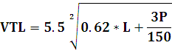
Where, L: length (km), 3P: is the three phase max power of the village (kw)
Then we get V_{TL}= 13.67kv, and the closest standard voltage of it is 33kv (and it existing at Aien Sheply)
- Cross sections area of the conductor (A_{c}):
According to map of Froosh Beit Dajana fig 4.8 , we can see that the loads on the village to five main points as follows:
A: Aien Sheply
B: center of Froosh Beit Dajana and on this point we put the transformer (33/.4 kv)
C: center of (Shaka area, and Shaka, Shaheen, Jaleel, Ibasi water pumping)
D: Masri water pumping and Jawwal tower
E: Abbas Area
To determine the Ac from between this points, we must calculate the max current (Imax) pass on them, as follows [4.18]:
Where, V: is the voltage of the conductors (kv)
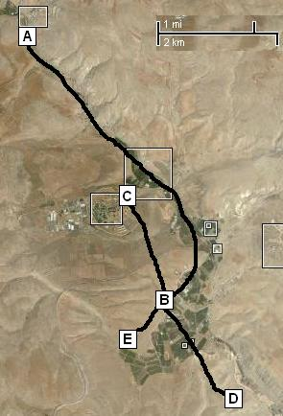
Fig 4.8: map Froosh Biet Dajan village and main points on it.
conductor | length | V (KV) | Ac (mm) | number | Ac of earth
A➔B | 6000 | 33 | 50 | 3 phase | 35
B ➔C | 2000 | 0.4 | 150 | 4 phase + 1 nutral | 50
B ➔D | 2000 | 0.4 | 50 | 5 phase + 1 nutral | 35
B ➔E | 600 | 0.4 | 50 | 6 phase + 1 nutral | 35
Table 4.20: illustrated of main points in the village
- Transformer capacity (S_{T}):
The S_{T} (KVA) depend on load factor (L.F) and it must be (65%- 75%) to be the transformer on max efficiency is obtained as follows [4.19]:
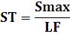
Where LF=65%
Then, ST= 566KVA and the closest standard value of it is 630KVA
Note: we must put the transformer in the center of the loads (point B)
- Distribution Board capacity (DB)
Capacity of DB depend on the all max current after the transformer as follows [4.20]:
where V = 0.4 KV
Then we cross it by S_{f} =1.2 , that get the max current of DB is equal I_{DB} =637.4 A

- Other equipments:
Equipment | Details | Number
Tower | Every 4 truss and on corners and main points | 35
Truss | Every 100m | 90
Strength insulators | 6 per tower | 210
Pin insulators | 3 per truss | 270
Electrode | About 2 per tower and truss | 255
Isolator switch | 2 per points (A.B.C,D,& C) | 10
Support | Every tower and truss | 125
Autorecloser switch | On point A only | 1
Surge arrestors | 2 per points (A.B.C,D,& C) | 10
arms | 3 per tower & 1 per truss | 198
Table 4.21: illustrated of other equipments of extension electrical network
Note: An autorecloser is a circuit breaker equipped with a mechanism that can automatically close the breaker after it has been opened due to a fault.

Chapter 5:
Economical study

5.1 Introduction of LCC
The life cycle cost (LCC) for a project or a piece of equipment is its total cost of purchase and operation over its entire service life.
This total cost includes the cost of acquisition, operation including energy costs, maintenance and disposal. Most of these costs occur at some future time beyond the purchase data, and must be analyzed using the time value of money.
- Three different types of costs concluded in LCC are analyzed and these are:
1. Initial capital cost of purchasing equipment and installation;
2. Recurring costs that occur every year of operation such as fuel and Maintenance costs.
3. Non-recurring costs that may occur on an irregular basis, such as equipment replacement or repairs.

5.2 Cost Annuity & Unit Price
The cost annuity converts all net cash flows without inclusion of income in the calculation; it can only be used for evaluating the relative favorability of investment projects on the basis of costs per annum or per unit production. The annuity cost is obtained as follows [5.1]
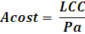
Where, Pa is the cumulative present worth factor.
Then to get unit price ($/kwh) we applied this equation [5.2]:
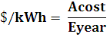
Where Eyear is the actual energy consumption per year.
Note: we made this study at 10% interest.

5.3 PVPAL Program
We design a program that get the unit cost of PV alone system (residential, pump, and tower) using Visual Basic language, and the loads on this program designed with respect to our project.
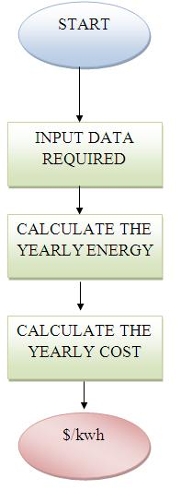
Fig 5.1: flow chart of PVPAL program
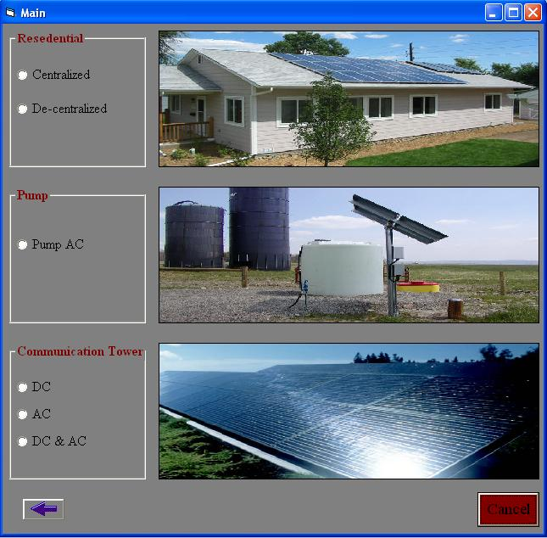
Fig 5.2: main page of PVPAL

5.4 Criteria
5.4.1 Normal case
The normal case that all systems PV, DG, hybrid and extension electrical network applied without any considerations of existing DG in the village.
Finally, the main equipment and devices that must be purchased to apply the this system is:
5.4.1.1 PV alone:
- Residential: PV modules, controller, battery, sine inverter.
- Towers :
- AC and (AC/DC): PV modules, controller, battery, sine inverter.
- DC: PV modules, controller, battery.
- Water pump : PV modules, square inverter, induction motor.
5.4.1.2 DG alone:
- Residential : DG, employee, fuel, maintenance, filters, oils.
- Tower: two DG, employee, fuel, maintenance, filters, oils.
- Water pumping: diesel engine, employee, fuel, maintenance, filters, oils, gear.
5.4.1.3 Hybrid PV-DG:
- Residential : PV modules, controller, battery, sine inverter, rectifier, DG, employee, fuel, maintenance, filters, oils.
- Tower:
- AC and AC/DC: PV modules, controller, battery, sine inverter, rectifier, DG, employee, fuel, maintenance, filters, oils.
- DC: PV modules, controller, battery, rectifier, DG, employee, fuel, maintenance, filters, oils.
- Water pumping: PV module, square inverter, IM, diesel engine, employee, fuel, maintenance, filters, oils, gear.
5.4.1.4 Extension grid:
Towers, truss, conductors, insulators, arms, electrodes, isolator switch, transformer, distribution board, autorecloser switch, surge arrestors and electrical motor for pumps.
5.4.2 Replacement case:
we applied this case with consider of existing DG in the village, and this consideration means the existing DG enters economical study as salvage value (S_{V})
We know that these DG worked for s about 4 years, then we consider that salvage value equal 40% of the cost of existing DG (Ce) as follows [5.3]:
then this S_{V} subtract from present cost
Note: we applied replacement case for all systems except the system of rater pumping.
Finally, the equipment and devices that must be purchased to apply this system as in previous section, but with consideration of salvage value.

5.4.3 Continuing case
It means that DG existing now work on hybrid system to charge battery instead of purchasing new DG to charge it, This case applied on hybrid system special: residential tower loads only.
Finally, the equipment and devices that must be purchased to apply this system as in previous section, but without the present cost of DG .

5.5 Results
After applying the previous method to get $/kwh and with consideration of all prices on Appendix we got the following:
5.5.1 PV alone:
System |  |  | 0 | 20 | 32 | 45
Abbas | Centralized | normal | 0.759 | 0.727 | 0.727 | 0.742
Abbas | Centralized | replacement | 0.739 | 0.707 | 0.707 | 0.722
Abbas | Decentralized | normal | 0.710 | 0.681 | 0.681 | 0.695
Abbas | Decentralized | replacement | 0.691 | 0.661 | 0.661 | 0.675
Shaka | Centralized | normal | 0.760 | 0.728 | 0.728 | 0.743
Shaka | Centralized | replacement | 0.727 | 0.695 | 0.695 | 0.711
Shaka | Decentralized | normal | 0.710 | 0.681 | 0.681 | 0.695
Shaka | Decentralized | replacement | 0.678 | 0.648 | 0.648 | 0.663
Tower | AC | normal | 1.326 | 1.054 | 0.977 | 0.946
Tower | AC | replacement | 1.310 | 1.038 | 0.960 | 0.930
Tower | AC/DC | normal | 1.406 | 1.116 | 1.034 | 1.002
Tower | AC/DC | replacement | 1.385 | 1.096 | 1.013 | 0.981
Tower | DC | normal | 1.222 | 0.971 | 0.900 | 0.873
Tower | DC | replacement | 1.201 | 0.950 | 0.879 | 0.851
Pump | 10% |  | 0.734 | 0.721 | 0.747 | 0.806
Pump | 20% |  | 0.731 | 0.714 | 0.743 | 0.803
Pump | 40% |  | 0.727 | 0.714 | 0.740 | 0.799
Pump | 60% |  | 0.739 | 0.726 | 0.752 | 0.812
Pump | 80% |  | 0.726 | 0.713 | 0.738 | 0.798
Pump | 90% |  | 0.728 | 0.715 | 0.741 | 0.800
Pump | 100% |  | 0.723 | 0.710 | 0.736 | 0.795
Table 5.1: $/kwh for PV alone

5.5.2 DG alone
Abbas |  | 0.865
Shaka |  | 0.916
Tower |  | 0.800
Pump | 10% | 0.933
Pump | 20% | 0.726
Pump | 40% | 0.621
Pump | 60% | 0.598
Pump | 80% | 0.565
Pump | 90% | 0.566
Pump | 100% | 0.556
Table 5.2: $/kwh for DG alone
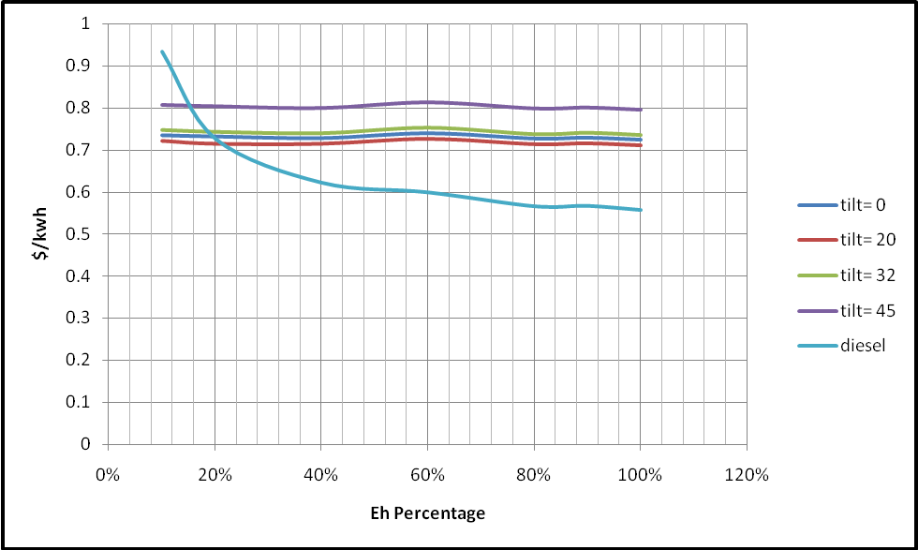
Fig 5.3: comparison of $/kwh for Ibasi pump DG alone & PV alone at different percentage of Eh

5.5.3 Hybrid PV-DG
 |  |  | 0 | 20 | 32 | 45
Abbas |  | normal | 0.828 | 0.769 | 0.751 | 0.755
 |  | replacement | 0.808 | 0.750 | 0.731 | 0.735
 |  | continuing | 0.815 | 0.755 | 0.738 | 0.743
Shaka |  | normal | 0.899 | 0.837 | 0.817 | 0.822
 |  | replacement | 0.867 | 0.804 | 0.785 | 0.789
 |  | continuing | 0.859 | 0.798 | 0.780 | 0.785
Tower | AC | normal | 0.898 | 0.826 | 0.805 | 0.813
Tower | AC | replacement | 0.882 | 0.810 | 0.789 | 0.804
Tower | AC | continuing | 0.883 | 0.810 | 0.789 | 0.798
Tower | AC/DC | normal | 0.963 | 0.886 | 0.865 | 0.873
Tower | AC/DC | replacement | 0.943 | 0.866 | 0.843 | 0.851
Tower | AC/DC | continuing | 0.879 | 0.805 | 0.784 | 0.791
Tower | DC | normal | 0.861 | 0.791 | 0.770 | 0.777
Tower | DC | replacement | 0.840 | 0.770 | 0.749 | 0.755
Tower | DC | continuing | 0.839 | 0.771 | 0.750 | 0.757
Pump | 10%PV + 90% diesel |  | 0.583 | 0.582 | 0.584 | 0.590
Pump | 20%PV + 80% diesel |  | 0.598 | 0.596 | 0.601 | 0.613
Pump | 40%PV + 60% diesel |  | 0.650 | 0.645 | 0.655 | 0.679
Pump | 60%PV + 40% diesel |  | 0.691 | 0.683 | 0.699 | 0.735
Pump | 80%PV + 20% diesel |  | 0.726 | 0.716 | 0.736 | 0.783
Pump | 90%PV + 10% diesel |  | 0.749 | 0.737 | 0.76 | 0.813
Table 5.3: $/kwh for hybrid PV-DG
5.5.4 Extension electrical network:
normal | 0.346
replacement | 0.333
Table 5.3: $/kwh for extension network
5.6 Conclusion
The most economical alternative to electrify the village is extension electrical network (normal= 0.346 $/kwh and replacement= 0.333 $/kwh), but we know that is prevented since 1967.
The second most economical alternatives:
5.6.1 Residential loads:
- The most economical alternative to electrify the loads is the PV alone decentralized system at tilt 20 or 32 (normal= 0.681 $/kwh)
- The 2nd economical alternative to electrify Abbas area is the hybrid system at tilt angle= 32, and it is more than reliable PV (normal= 0.751 $/kwh)
5.6.2 tower loads:
- The most economical alternative to electrify the tower is the hybrid with DC system at tilt 32 (normal= 0.770 $/kwh), and it more than reliable PV
5.6.3 water pumping loads:
- The most economical alternative to electrify the pump is the diesel water pumping (100% load= 0.556 $/kwh) as existing now.

References
- Census Final Results in The West Bank, Palestinian Central Bureau of Statistics
- COMPUTER – AIDED DESIGN AND PERFORMANCE EVALUATION OF PV-DIESEL HYBRID SYSTEM, Mo'ien Ali Ahmad Omar
- Experience results and techno economic feasibility of using photovoltaic generators instead of diesel motors for water pumping from rural desert wells in Jordan, M. Mahmoud
- Photovoltaic Systems Engineering, SECOND EDITION Roger A. Messenger, Jerry Ventre
- Renewable and Efficient Electric Power Systems, Gilbert M. Masters
- Techno economic evaluation of electrification of small villages in Palestine, Bassam A.Abdel-Ghani
- Techno economic feasibility of energy supply of remote villages in Palestine by PV-systems, diesel generators and electric grid, Marwan M Mahmoud & Imad H. Ibrik

Appendix
Type | Price
Ppv | 5500 $/kwp
sine inverter | 1000 $/kw
square inverter | 500 $/kw
charge battery controller | 150 $/kw
Battery | 300 $/kwh
controller rectifier | 150 $/kw
Table A: cost of PV system component
hp | price of Diesel engine with Gear
13.5 | 7000
20 | 8000
27 | 9000
40 | 11200
55 | 12200
60 | 12200
70 | 14500
80 | 15500
100 | 16500
Table B: cost of DHP

equipments | $
tower | 2500
truss | 1500
150mm | 3.2
50mm | 1.2
35mm | 0.65
strength insulato | 60
pin insulator | 50
arms | 250
electrode | 20
isolator switch | 750
transformer 630kva | 20000
DB | 15000
support | 600
autorecloser switch | 25000
surge arrestors | 750
kva | 40
Table C: cost of network equipments

fuel cost | 1.15 $/ld
oil cost | 50 $/250h
oil filter | 100$/500h
air filter | 350$/3000
fuel filter | 50$/750h
overhaul | 15% fixed cost/6000h
lifetime | 24000h
employee | 1200$/year
Table D: The diesel generator data
Cost of DG: http://www.generatorjoe.net/store.asp
Cost of MHP: http://www.usmotors.com

