An-Najah National University
Engineering Faculty
Computer Department

Graduation Project

Presented To :
Dr : Raed Al-Qadi.
Dr : Loai Malhis.
Dr : Ashraf Armosh.

Prepared By :
Eng: Najah Sadder.
Eng : Hanan Abd-Allah.

Our Project is an educational one; it is built according to the Palestinian curriculum of science for the sixth grade.
We choose the educational environment in order to facilitate distance learning for the students and to help them to understand the material without a teacher, we do it by taking the units of the student's book one by one, and for each unit we display its lessons with there all contents including text, activities and picture to help student to understand the text contents.
We used Macromedia Flash to design the activities, and to display lesson text contents. We also used Microsoft Visual Studio.Net environment to control displaying this lesson and do not make the student confused from the scatter.

Body of the Project:

We began the project with this welcome form::
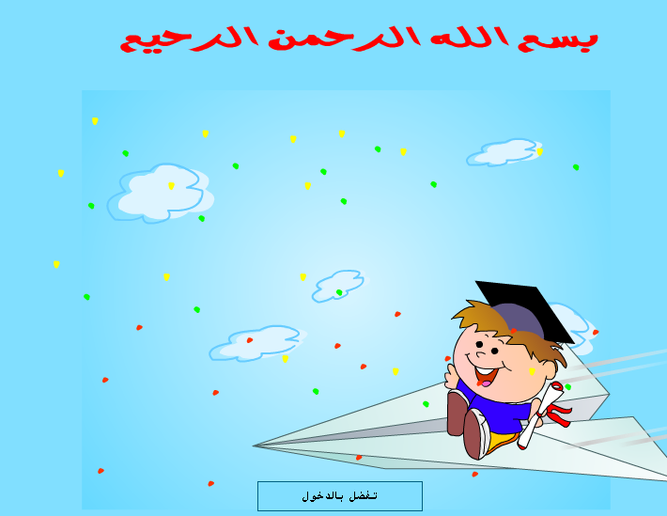

We also allow the student to choose the unit he/she wants to study within this form

The first unit talked about the human body, this is the contents and the shape of it.
The first lesson in the first part was :
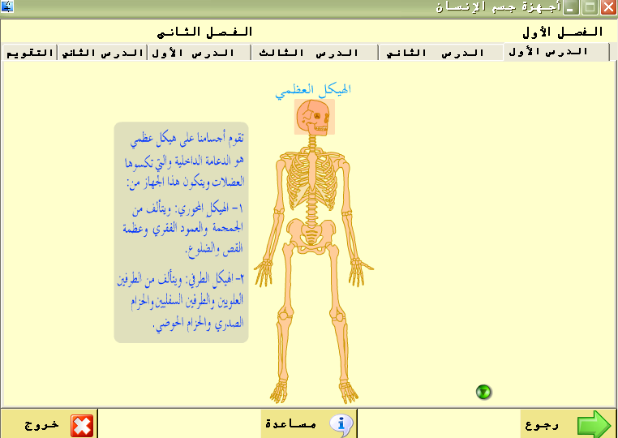

The second lesson in part one:
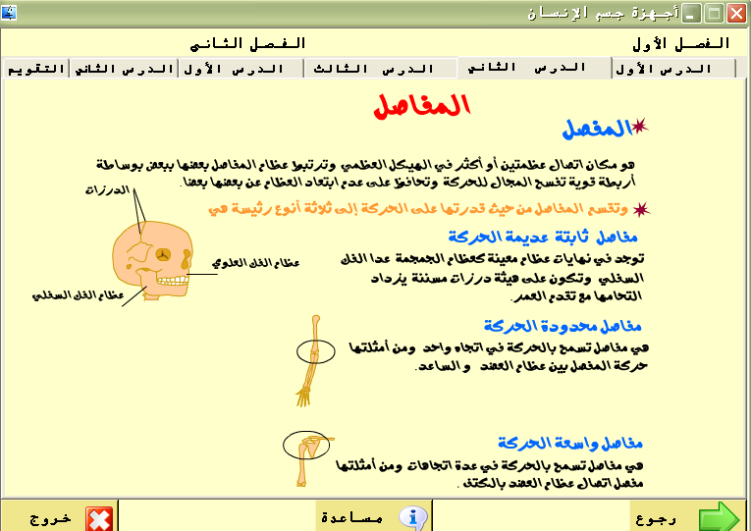

The Third lesson in first part:
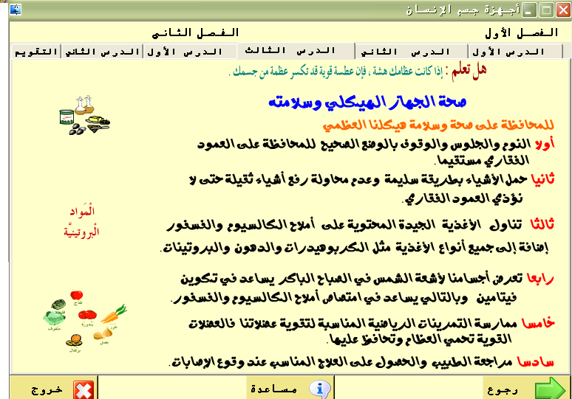

The first lesson in the second part:
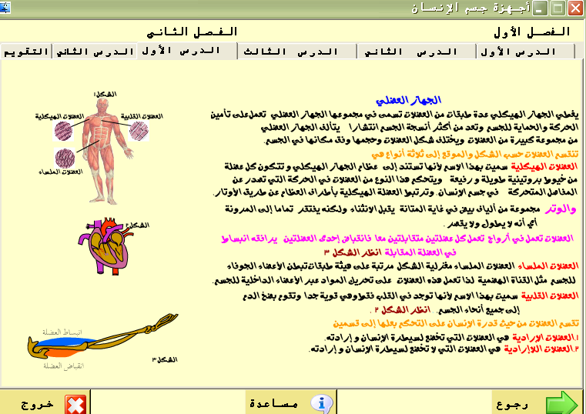

The second lesson in the second part:

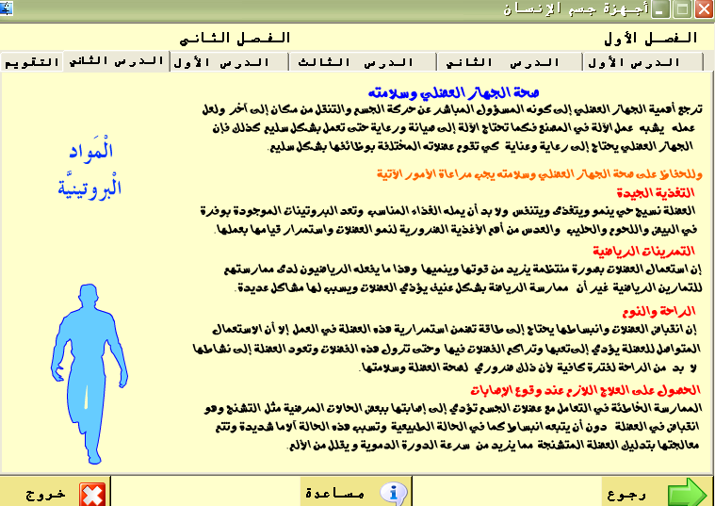

The Quiz Part :
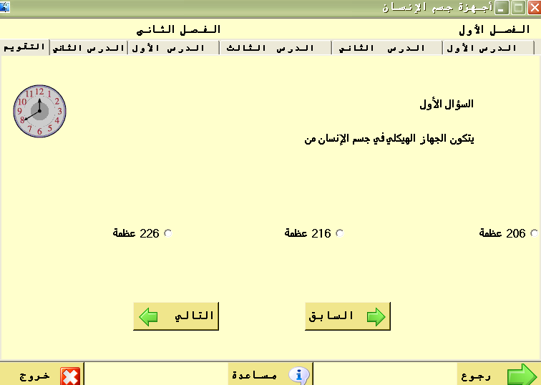
The second unit :
It consists of five lesson some of them contain activities.

The First lesson

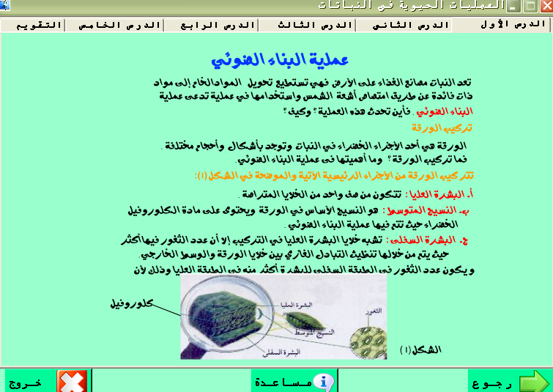

The second lesson:

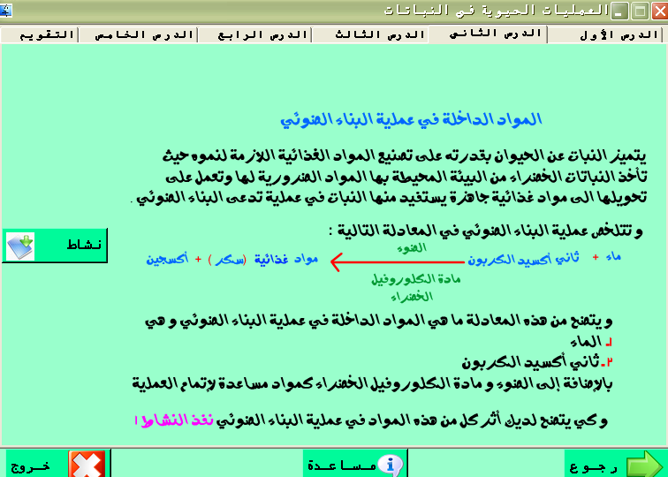

The activity of the lesson:

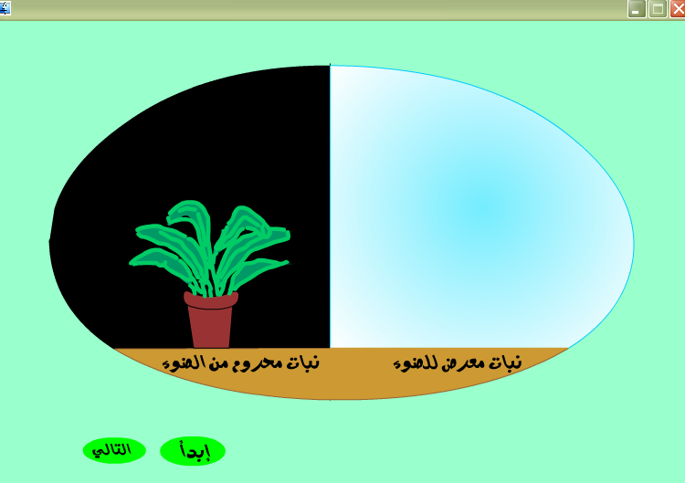

The third lesson:

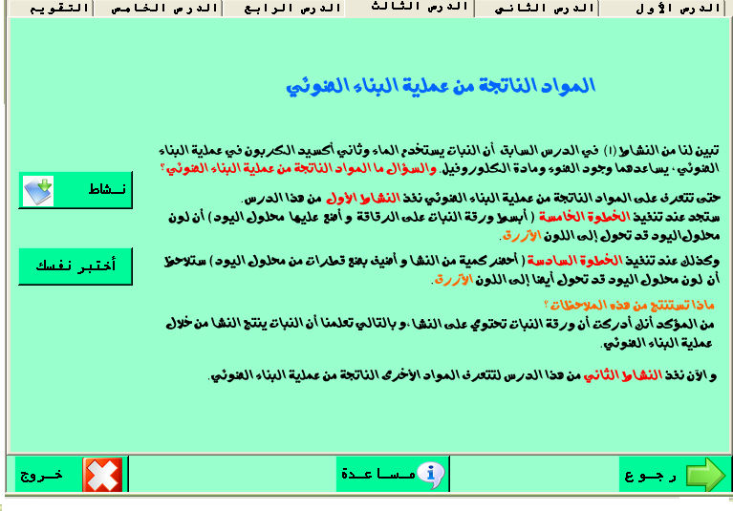

The activity of the lesson:

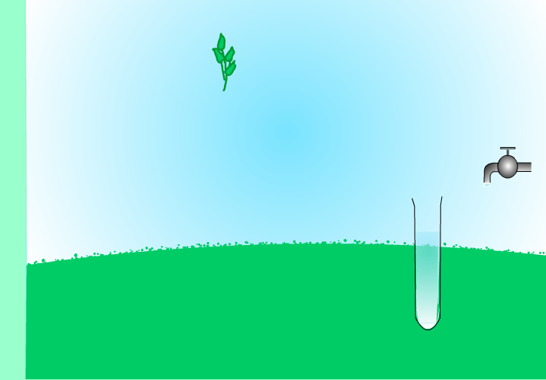

Simple Quiz of lesson:

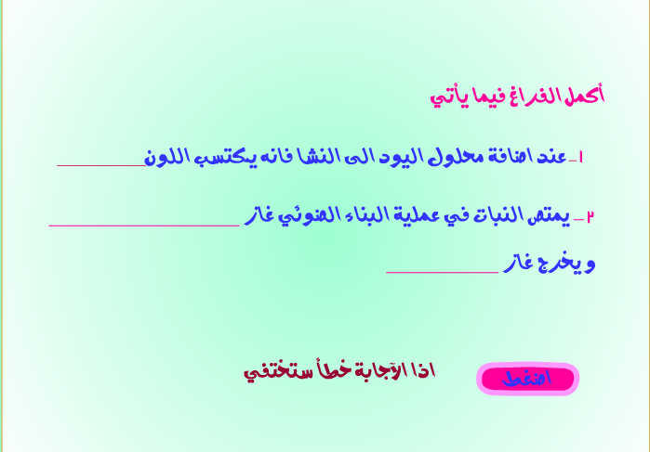

The Forth Lesson:

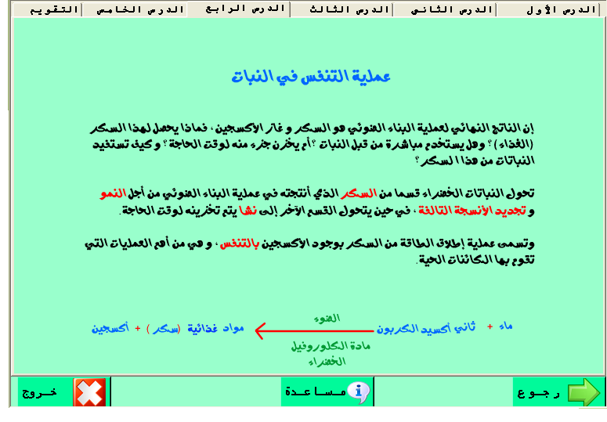

The Fifth Lesson:

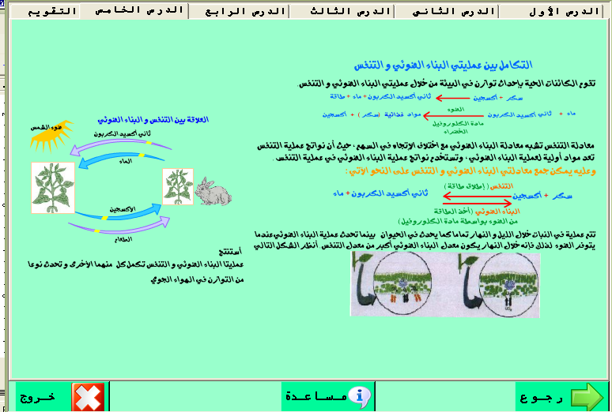

The Quiz Part:

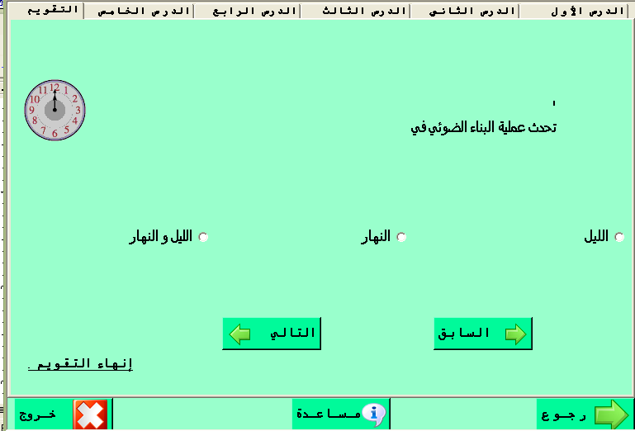

The Third Unit:
The First Lesson:

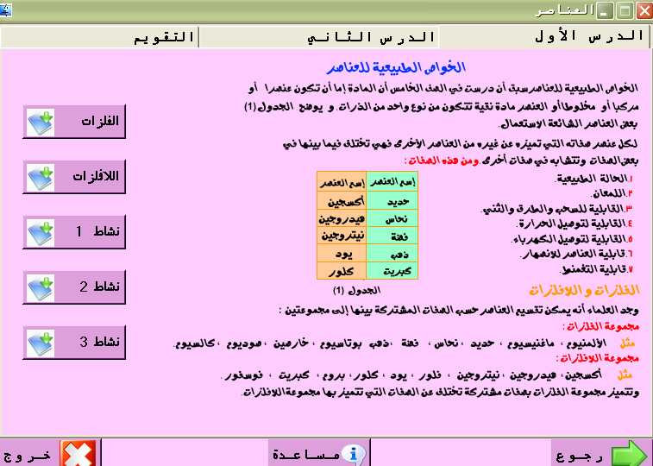
The Second Lesson:

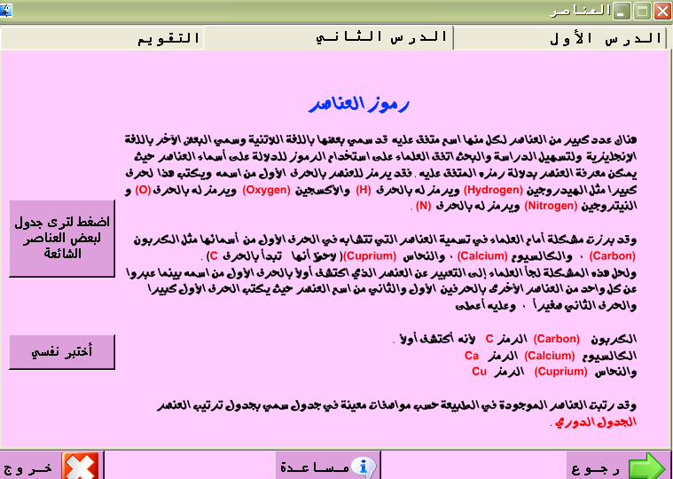
Unit Four :
The first lesson in the first part:
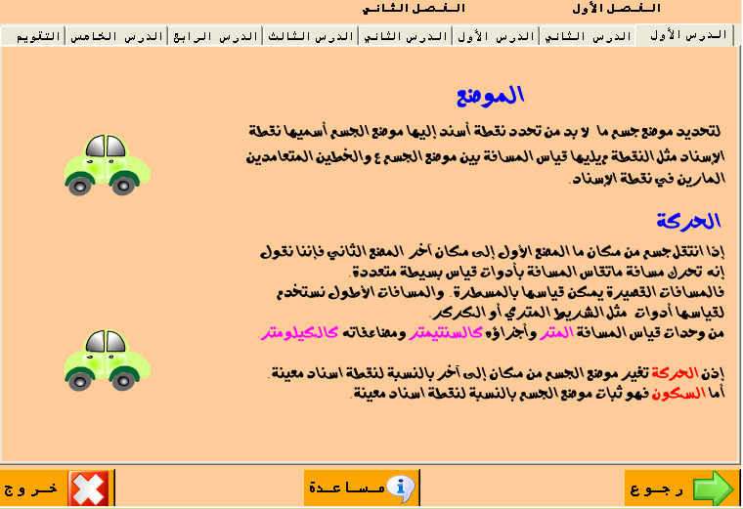

The second lesson in the first part:

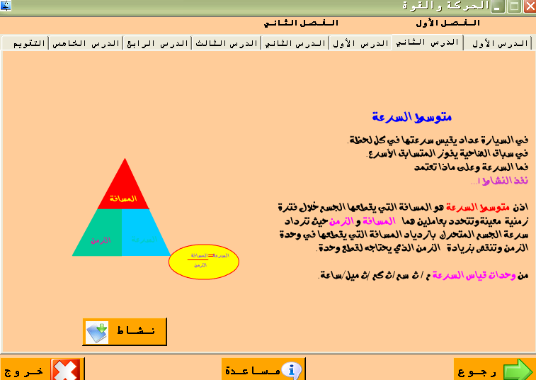

The First Lesson in the Second Part:
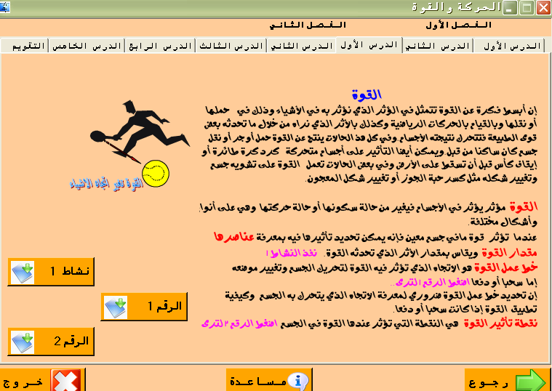

The Second Lesson in the Second Part: 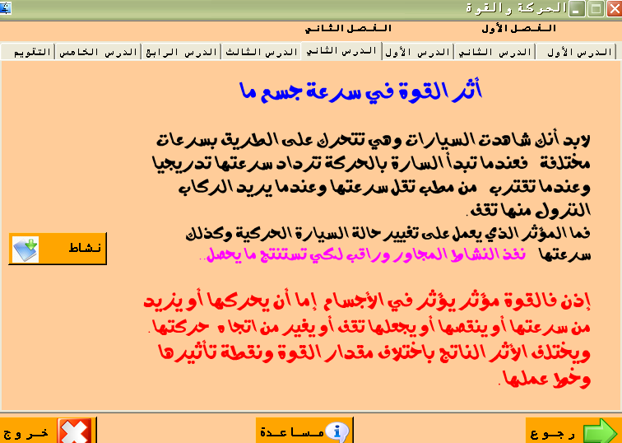

The Third Lesson in the Second Part:

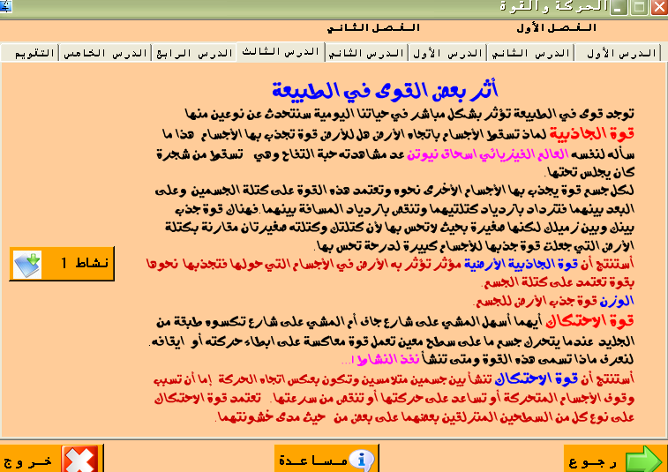

The Fourth Lesson in the Second Part:

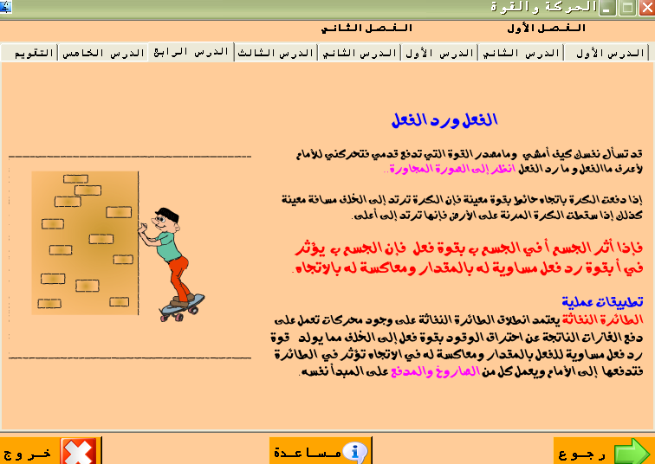
The Fifth Lesson in the Second Part:
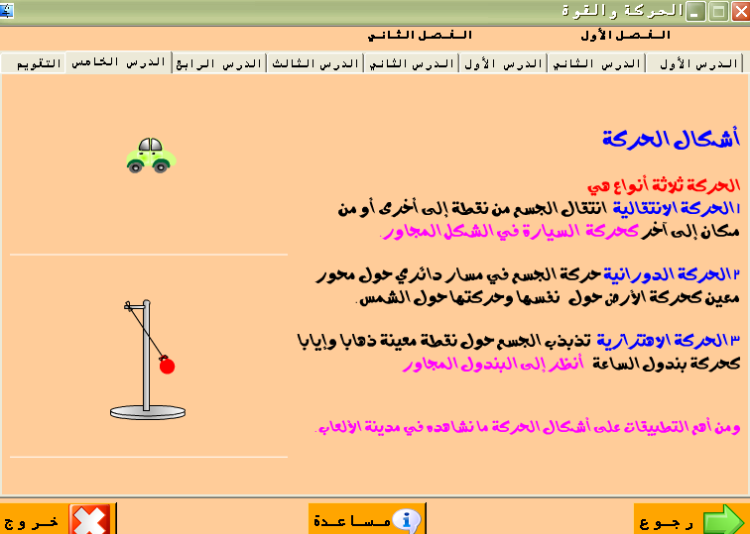

Unit Five:
The First Lesson of Part One:

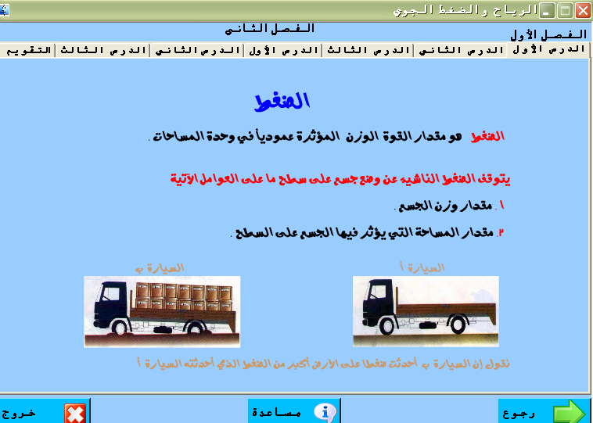
The Second Lesson of Part One:

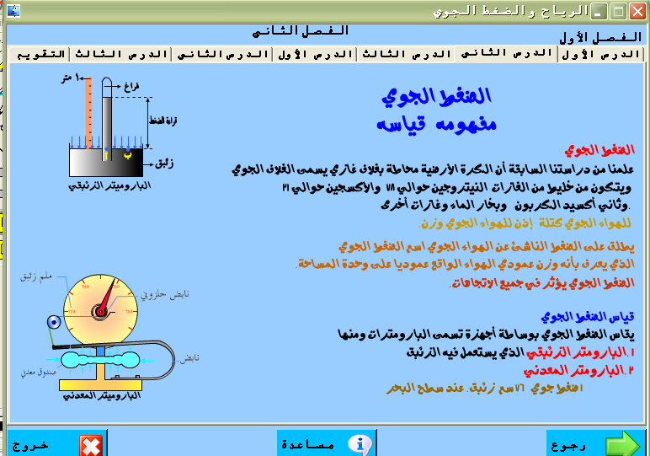

The Third Lesson of Part One:

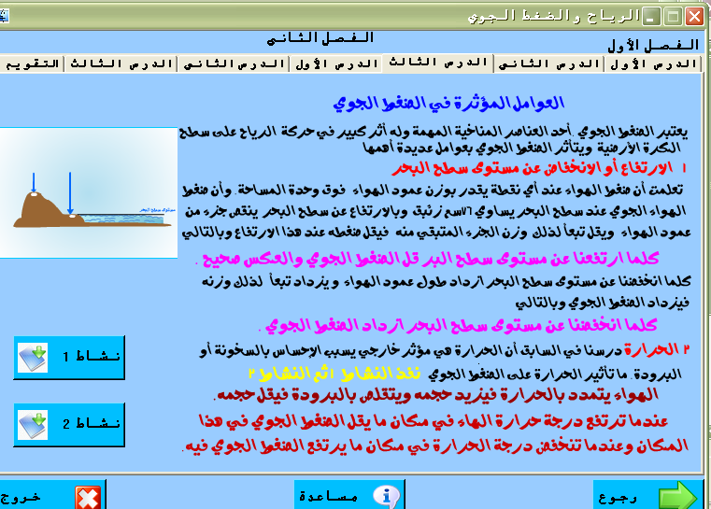
The First Lesson of Part Two:

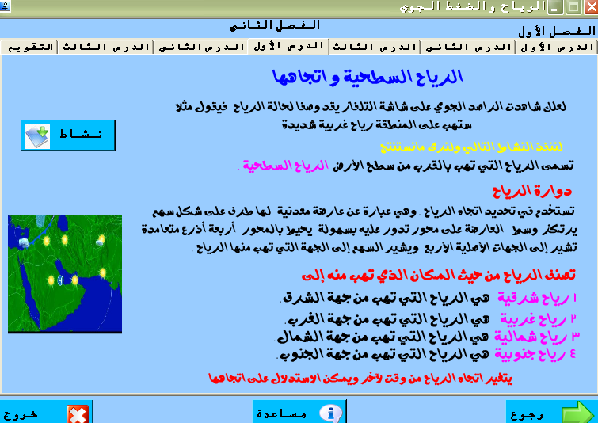

The Second Lesson of Part Two:
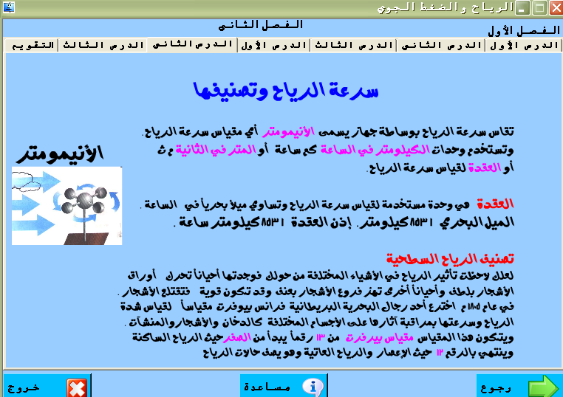

The Third Lesson of Part Two:

