An-najah National University



Documentation for Graduation Project
E-Blood Bank

Made By:
Marwah Abu-El Ola
Noor Diyab.

Introduction

Almost all serious health issues use blood donated by people to save lives. Blood that is donated last a little more than 40 days. Then it must be disposed of. That means we need to constantly replenish the blood so it is there when someone needs it.
It is a gift we all have inside of us to give to those who are injured, sick, or in need.
So Donate Blood, Use this site as a platform to register yourself. Needy people can post their blood requirement here also they can search blood donor's data.
This project also help employees in the blood bank to regulate their work in recording donors and patients and their Lab Examination and their related information.
Another goal of this project to help in communication between the central blood bank and other hospitals that are in the country, such as if a branch blood bank in some hospital need some blood units and there it ask the central blood bank to supply it with the needed blood units, in rare condition if the central does not have sufficient blood it redirect the bank who request the blood units to other blood bank were the blood units available there.
That means the blood bank is keep connected to the branches which depend on it for supplying blood units. The central know the count of each blood unit in each blood bank.
Other feature of this web application is the warning system, such that if the count of blood units in the blood bank has become less than certain number (in our case 40). A warning message appears , and if one of the blood units or more has been expired this also will cause a warning and the blood unit will be deleted from the database.

The Aim of our project:
- Manage the donation process in all its steps .

Tools and programming language that we use

- Asp.Net
- MySql for database

Our project consists of two web application:

- Central Blood Bank(E Blood Bank)
- Hospital web site

Central Blood Bank:
- Normal Users
- Employees (operators)
- Administrator

Users:
- Search for blood units in the central blood bank.
- Search for blood units in the branches blood banks that connected to the central.
- Contact us, Blood facts, Tips of Donation and other links.

Employee:
- Search for Blood Units in the central and in the branches blood banks.
- Start Donation Process.
- Continue the donation process to laboratory examination.
- Expired blood units delete atomically from the database and the employee knows about that.
- Keep track with database and if account of one blood unit or more had been less than significant number this will appear on his pages
- Then he can send sms's to the donors to start donation process.
- He can handle any request come from any branch blood bank.
- Add, delete, and Edit any blood unit.
- Find Donors.
- Do the Lab Examination

Administrator Can:
- Do every can be done by users or employees.
- Add, edit and delete any blood units.
- Search for blood units.
- Find donors.
- Manage staff (edit, delete, and add) any staff member.
- Manage branches (add, edit, or delete any branch blood bank).

Hospital
Features:
- Doctors
- Patients
- Admin
- Branch Blood Bank

Doctors:
- Manage Patients:
- Add new patient.
- View and edit complete record for each patient.
- Appointments management system.
- Access to the branch blood bank in the hospital web application and complete control to it.
- Find donor
- Find blood units
- Manage donation process
- Add , edit , and delete any blood unit

Patients:
- Register to the hospital web site.
- View his/her complete medical report.
- Book an appointment.
- Find doctors and book an appointment .
- View complete information about hospital and its services.
- View complete information about donating blood.

The hospital web site contain also :
Branch Blood Bank:

Users:
- Search for blood units in the central blood bank.
- Search for blood units in the branches blood banks that connected to the central.
- Contact us, Blood facts, Tips of Donation and other links.

Employee:
- Search for Blood Units in the central and in the branches blood banks.
- Start Donation Process.
- Continue the donation process to laboratory examination.
- Expired blood units delete atomically from the database and the employee knows about that.
- Keep track with database and if account of one blood unit or more had been less than significant number this will appear on his pages
- Then he can send sms's to the donors to start donation process.
- He can handle any request come from any branch blood bank.
- Add, delete, and Edit any blood unit.
- Find Donors.
- Do the Lab Examination

Administrator Can:
- Do every can be done by users or employees.
- Add, edit and delete any blood units.
- Search for blood units.
- Find donors.
- Manage staff (edit, delete, and add) any staff member.
- Manage branches (add, edit, or delete any branch blood bank).

Communication Flow Chart

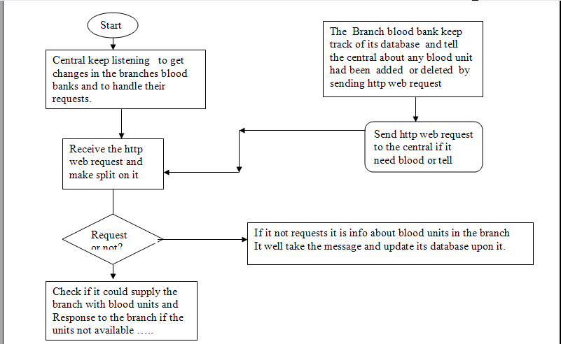

Problems that faced us:

- We did not have enough time to finish all features we had planned to do.
- Network Difficulties .

- We had to learn new languages in short time by our self such as:asp.net, sql for database

