

**An-Najah National University**

**Chemical Engineering Department**

**Preparation Of Biodegradable Polycaprolactone Microcapsules by Membrane Emulsification**

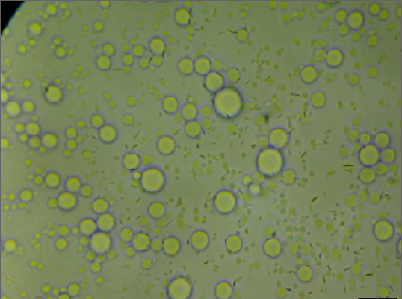

***Submitted by:***

**Alaa Kaabneh Amani Abd-Allah**

**Aysha Hilo Olfat Khatatbeh**

***Supervisor:***

**Dr. Hassan Sawalha**

A Graduation Project Submitted to Chemical Engineering Department in Partial Fulfillment of the Requirements for B.S.c/Degree in Chemical Engineering.

December, 2012

**DISCLAIMER**

This report was written by : Alaa Kaabneh, Amani Abd-Allah, Aysha Hilo and Olfat Khatatbeh at the chemical engineering department, Faculty of engineering, An-Najah National University. It has not been altered or corrected, other than editorial corrections, as a result of assessment and it may contain language as well as content error. The views expressed in it together with any outcomes and recommendations as solely those of the students. An-Najah National University accepts no responsibility or liability for the consequences of this report being used for a purpose other than the purpose other than for which it was commissioned.

Contents

Abstract………………………………………………………………………….5

Chapter1 (Introduction)………………………………………………………….6

* 1. Biodegradable polymer …………………………………………………..…6
  2. Polycaprolacton………………………………………………………….…10
  3. Polymer microcapsules preparation through emulsification………….……11

1.4 Type of Membrane emulsifications………………………………………..14

Chapter 2 (Materials and methods)……….…………………………………….17

2.1 Materials:……………………………………………………………………17

2.2 Methods:…………………………………………………………………….17

2.2.1Screening of sand beads:…………………………………………………..17

2.2.2 Membrane –sand beads bed system:………………………………………17

2.3 Preparation of microcapsules:……………………………………………….18

2.4 Average size measurements………………………………………………....19

Chapter 3 (Results and discussion)……………………….……………………..20

3.1 Effect of premix emulsification……………………………………………..21

3.2 Effect of the height of the sand Bed:……………………………………..…21

3.3 Effect of the size of sand beads:…………………...……………………..…24

3.4 Effect of mixing 3 sizes in one bed:…………………..……………………..26

Conclusion …………… …………………………………………………….…..29

Recommendation………………………………………………………………...29

References………………………………………………………………….……30

Appendix………………………………………………………………………...32

**LIST OF TABLES:**

|  |  |
| --- | --- |
| Table | Page number |
| (P1): Sizes of PCL microcapsules prepared by sand beads of 150 µm (average size and at 2 cm bed height). The sizes shown in the table were measured from the microscopic photographs. | 32 |
| (P2): Sizes of PCL microcapsules prepared by sand beads of 300 µm (average size and at 2 cm bed height). The sizes shown in the table were measured from the microscopic photographs. | 36 |

**LIST OF FIGUREE:**

|  |  |
| --- | --- |
| Figure | Page number |
| (1.1): produce (PCL) using caprolactone monomer and suitable catalyst. | 10 |
| Figure(1.2): The tin (II) ethylhexanoate catalyst. | 10 |
| (1.3): schematic representation of the evaporation immersion precipitation process of hollow PCL micro particle | 13 |
| (1.4): Different membrane emulsification (ME) methods. | 14 |
| (2.1): packed bed emulsification system: bed feed1, the sand beads layer 2, the filter from which the emulsion leaves 3. | 19 |
| (3.1): the size of microcapsules (a) before passing through the membrane, (b) after passing through the membrane. | 20 |
| (3.2): Microscopic photographs of PCL microcapsules prepared using a bed of sand beads 150µm at different bed heights at a) 2 cm, b) 3 cm ,c) 4 cm and d) 6 cm . | 22 |
| (3.3): The relationship between the average size and thickness for size 150µm. | 22 |
| (3.4): Microscopic photographs of PCL microcapsules prepared using a bed of sand beads 300 µm at different bed heights: a) 2 cm, b) 3 cm , c) 4 cm and d) 6 cm. | 23 |
| (3.5): The relationship between the average size and thickness for size 300µm. | 23 |
| (3.6): the relationship between the sand size and the average size of particles at the thickness 2cm of sand | 24 |
| (3.7): the relationship between the sand size and the average size of particles at the thickness 3cm of sand. | 25 |
| (3.8): the relationship between the sand size and the average size of particles at the thickness 4cm of sand. | 25 |
| (3.9): The relationship between the sand size and the average size of particles at the thickness 6cm of sand. | 26 |
| (3.10): Sand size gradually increase (a), sand size gradually decrease (b), mix of three sizes (c). | 28 |
| (3.11): Average size resulted when three sizes of sand used in the bed. | 28 |

**ABSTRACT**

Polymeric biodegradable microcapsules have received much attention in the recent years because of their potential applications in the pharmaceutical field. The objective of the current study is to prepare biodegradable polymer microcapsules using premix membrane emulsification. In this method, a polymer solution consists of biodegradable polymer (polycaprolactone) /solvent (dichloromethane) /poor solvents (decane) mixed with continuous phase that consists of non-solvent (water) and surfactant to get primary (premix) emulsion. The premix emulsion is then pressed through aporous bed of sand beads for several cycles. This causes large droplets to divide inside the porous media and slowly reduce the size. The size of the resulting microcapsules was analyzed using optical microscope and the results showed that the size of the capsules decreased after passing the premix emulsion through the sand beads. The effect size of the sand particles and the thickness of the sand bed were investigated and the results showed that decreasing the size of the sand particles or increasing the bed height decreases the size of the microcapsules. The resulted average sizes of microcapsules at different sizes of sand 150 µm, 300 µm, 600 µm were (4.7 µm), (6.1µm), (3.9 µm) respectively. In another way, mixtures of the three different sizes of the beads were used to make a bed of 4 cm total height., where size of particles gradually increased or decreased(i.e 3layers with 1.3 cm for each, bottom layer of 150 µm and the upper one of 600 micro) or a random mixture of the 3 sizes. it was found that the average size of the microcapsules prepared with a bed of random mixture of sand beads was ( 5.9µm), and for the beads which arranged by gradual decrease configuration was (7.3µm) while for and gradual increase configuration was (3.5µm).

**CHAPTER 1: INTRODUCTION**

***1.1 Biodegradable polymer***

The term polymer denotes a molecule made up by the repetition of some simpler unit, the mer or monomer. The elemental composition of a polymer, the chemical groups present (ether, ester, hydroxyl, etc.), or the manner of synthesis (chain propagation, Trans esterification, ring opening, etc.) may be used as a means of classifying polymers. Polymers generally are held together as large molecules by covalent bonds, while the separate molecules, or segments of the same molecule are attached to each other by "intermolecular forces," also termed "secondary" or "van der waals" forces. Although ionic and other types of bonds can occur in polymeric systems. [1] Polymeric products are generally produced by melt or solution processing. During melt processing, the polymer is heated above its melting point, shaped, and then solidified by cooling. Different techniques have been proposed in the literature and much effort has been put into optimizing the processing conditions. For solution processing, the polymer is dissolved in a solvent, shaped into the desired product, and then solidified by evaporation of the solvent to air or extraction to an external non solvent, which induces phase separation. In both methods, additives may be used to improve the physical and chemical properties of the resulting materials, including other polymers, plasticizer, and fillers. [2]

A biomaterial can be defined as a material intended to interface with biological systems to evaluate, treat, or replace any tissue, organ or function of the body.[3]The last two decades of the twentieth century saw paradigm shift from bio stable biomaterials to biodegradable (hydrolytically and enzymatically degradable) biomaterials for medical and related applications.[4]

Biomaterials play an important role in human health. Biopolymers are the main type of biomaterials. According to their degradation properties, biopolymers can be further

classified into biodegradable and non-biodegradable biopolymers. Biopolymers with diverse specific properties are needed for in vivo applications because of the diversity and complexity of in vivo environments. [3] Some of the important properties of a biodegradable biomaterial can be summarized as follows:

1. The material should not evoke a sustained inflammatory or toxic response upon implantation in the body.
2. The material should have acceptable shelf life.
3. The degradation time of the material should match the healing or regeneration process.
4. The material should have appropriate mechanical properties for the indicated application and the variation in mechanical properties with degradation should be compatible with the healing or regeneration process.
5. The degradation products should be non-toxic, and able to get metabolized and cleared from the body.
6. The material should have appropriate permeability and processibility for the intended application.

Some of the inherent properties of polymeric biomaterials that can have an effect on their biocompatibility include: material chemistry, molecular weight, solubility, shape and structure of the implant, hydrophilicity/hydrophobicity, crystallinty, glass transition temperature, lubricity, surface energy, water absorption, and degradation and erosion mechanism. [4]

Both synthetic polymers and biologically derived (or natural) polymers have been extensively investigated as biodegradable polymeric biomaterials. Biodegradation of polymeric biomaterials involves cleavage of hydrolytically or enzymatically sensitive bonds in the polymer leading to polymer erosion. Depending on the mode of degradation, polymeric biomaterials can be further classified into hydrolytically degradable polymers and enzymatically degradable polymers. Most of the naturally occurring polymers undergo enzymatic degradation. Natural polymers can be considered as the first biodegradable biomaterials used clinically. The rate of in vivo degradation of enzymatically degradable polymers however, varies significantly with the site of implantation depending on the availability and concentration of the enzymes. Chemical modification of these polymers also can significantly affect their rate of degradation. Natural polymers possess several inherent advantages such as bioactivity, the ability to present receptor-binding ligands to cells, susceptibility to cell-triggered proteolytic degradationand natural remodeling. The inherent bioactivity of these natural polymers has its own downsides. These include a strong immunogenic response associated with most of the polymers, the complexities associated with their purification and the possibility of disease transmission.[3]Synthetic biomaterials on the other hand are generally biologically inert, they have more predictable properties and batch-to-batch uniformity and they have the unique advantage having tailored property profiles for specific applications, devoid of many of the disadvantages of natural polymers. Hydrolytically degradable polymers are generally preferred as implants due to their minimal site to-site and patient-to-patient variations compared to enzymatically degradable polymers. [4]

Nowadays, synthetic biopolymers have become attractive alternatives for biomedical applications for the following reasons: (1) although most biologically derived biodegradable polymers possess good biocompatibility, some may trigger an immune response in the human body, possibly one that could be avoided by the use of an appropriate synthetic biopolymer.

(2) Chemical modifications to biologically derived biodegradable polymers are difficult.

(3) Chemical modifications likely cause the alteration of the bulk properties of biologically derived biodegradable polymers. [3]

Synthetic biodegradable polymers have attracted considerable attention for applications in medical devices, and will play an important role in the design and function of medical devices. The general criteria of polymer materials used for medical devices include mechanical properties and a degradation time appropriate to the medical purpose. In addition, the materials should not evoke toxic or immune responses, and they should be metabolized in the body after fulfilling their tasks. According to these requirements, various synthesized biodegradable polymers have been designed and used. [3]

Biodegradable polymers with reactive groups or responsive characteristics have been widely investigated for applications drug delivery and control release. Biodegradable polymers, such as poly (-malic acid), with reactive pendant carboxyl groups, can conjugate drugs (via ester or amide bonds) to form a biodegradable macromolecular prodrug to reduce the side-effects of free drugs. Drugs can be released via the degradation of biodegradable polymers. [3]

An important application of biodegradable polymer is preparation of microcapsules. Polymeric microcapsules have attracted a great deal of interest because of their application in different fields such as medicine, catalysis, cosmetics, and foods. In biomedical field, biodegradable microcapsules have been used to encapsulate drugs for controlled and sustained release. Biodegradable hollow microcapsules prepared from poly lactide (PLA) were successfully used as ultrasound contrast agents (UCAs). Many biodegradable polymers used to produce microcapsules such as polycaprolactone. [2] Polycaprolactone is one of the widely used biodegradable polymers due to its good drug permeability and bio- compatibility.

***1:2 polycaprolacton:***

Polycaprolactone (PCL) is biodegradable polyester used in medical devices and disposable tableware. It is produced using the caprolactone monomer and a suitable catalyst as shown below:  
  
**[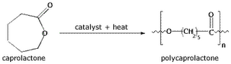](http://www.gophoto.it/view.php?i=http://2.bp.blogspot.com/--GgslqwQJIs/TZka8MWCkAI/AAAAAAAAAK4/WiA-Mrusjoc/s1600/pcl-synthesis.gif)**

Figure (1.1):produce (PCL) using caprolactone monomer and suitable catalyst.  
The catalyst used to help bring about this polymerization reaction is usually an organic tin-based catalyst such as tin (II) ethylhexanoate:  
**[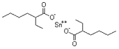](http://www.gophoto.it/view.php?i=http://1.bp.blogspot.com/-86M5BwiFx6A/TZkaet_LJxI/AAAAAAAAAKw/bgf96-zCYS0/s1600/stannousoctoate.gif)**

Figure (1.2): The tin (II) ethylhexanoate catalyst.

The tin (II) ethylhexanoate catalyst is highly toxic and has to be disposed of appropriately.[5]

Among the commercialized biodegradable plastics, polycaprolactone has received much attention due to its high flexibility and biodegradability as well as its hydrophobic nature. [6]

The specific characteristics of PCL such as low melting point and mechanical properties, and solubility in a wide range of solvents are disadvantages in many practical applications. To expand its applicability, PCL is blended with polymers or other reinforcing materials. [7]

***1.3 Polymer microcapsules preparation through emulsification:***

Emulsification is an important unit operation used in the pharmaceutical, food, and cosmetic industries. Membrane emulsification (ME) is a relatively new membrane technology which allows the production of emulsion droplets under controlled conditions with a narrow droplet size distribution. [8]

Membrane emulsification is a process that forms emulsion by injecting a pure dispersed phase or premix through a micro porous membrane into the continuous phase. In the former case, fine droplets are produced directly at the /continuous phase interface, whereas in the latter case, pre-existing droplets are homogenized by passing premix through the membrane. [9] The rate of mixing should be high enough to provide the required tangential shear on the membrane surface, but not too excessive to induce further droplet break up. [8]

In this study, micro particles made of the polyaprplactone (PCL) with well defined size, size distribution structure and mechanical properties. Preparation of micro particles through solvent extraction/evaporation method starts with emulsification of homogenous polymer solution. [10] The polymer (i.e polycaprolactone) is first dissolved in a mixture of a good solvent (e.g. dichloromethane, DCM) and a poor solvent (oil, since it is usually higher alkane). The polymer/solvent/oil mixture is emulsified in to non-solvent phase (water or water alcohol mixture) which is immiscible with solvent and contains stabilizer (e.g. polyvinyl alcohol), to keep the droplet apart. [2] after emulsification, the solvent slowly diffuse out of the particles and through no solvent bath, and then evaporates at the surface of the bath (see the Figure1.1), as the good solvent (DCM) is slowly diffuse out of the droplet and evaporates, the concentration of polymer and oil become higher and higher, since the oil is not volatile, until the solution become unstable. The oil now forms a droplet inside the original droplet. While the polymer will be in internal oil droplet and outside nonsolvent bath. This will ultimately form a solid shell around the oil droplet. Removal the solvent causes the polymer to solidify by glassification or

Crystallization. [10]

In premix membrane emulsification, course premix emulsion of the casting solution in the non-solvent continues phase is pressed through a complex network of branching and joining micro channel (e.g. a porous membrane matrix).The branching of the channel causes large droplet to divide over the channel, and slowly reduce in size, approximately down to the diameter of the channel. Passage of the emulsion through the membrane is repeated several times. The shell properties are dependent on precipitation process which strongly determined by the solvent removal rate and the choice of oil. [10]

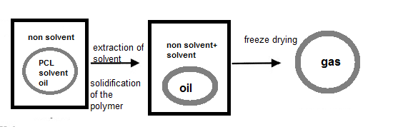

Figure (1.3): schematic representation of the evaporation immersion precipitation process of hollow PCL micro particle. [2]

There are new methods for emulsification using micro structured systems like; cross-flow membrane emulsification, premix membrane, and micro channel emulsification have received much attention.

***1.4 Type of Membrane emulsifications***



  
**(a)Cross flow system (b) Stirred cell –tube membrane**



**(c) Premix ME**

Figure (1.4): Different membrane emulsification (ME) methods. [10]

1- Pre mix membrane emulsification seems to be the method of choice for microcapsule production because of its simplicity, versatility, productivity, ease of application on small scales. In premix ME shown in (Figure 1.2c); fine droplets are produced by passing premix through the membrane or porous bed of uniform particles. The method involves mixing of the ingredients and repeated passage through a porous membrane. The microcapsules that are produced have a relatively sharp distribution, because of repeated passage through the membrane. If the membrane surface is wetted by the dispersed phase of the original emulsion, a phase inversion may occur during the process, leading to the formation of W/O emulsion from an O/W premix or vice versa. To achieve additional droplet size reduction and improve droplet size uniformity, emulsion can repeatedly be passed through the same membrane. The advantages of premix over direct membrane emulsification are in smaller droplet sizes and higher droplet throughputs that can be achieved. [10]

2- cross-flow membrane emulsification in which the disperse phase (e.g., oil) is directly pressed through the membrane pores to obtain droplets. In a Cross-flow Membrane Emulsification (CME), the droplets, formed at the pore mouth, grow until a critical dimension; then they are carried away with the continuous phase (e.g., water), flowing parallel to the membrane surface. However, emulsions with droplet diameters above 0.1 μm, generally require some additional substances, i.e., emulsifiers or stabilizers, to protect the droplets against coalescence.

The droplet size in a CME depends on several parameters. Among these, the most important are: (i) trans-membrane pressure, (ii) continuous phase cross-flow velocity, (iii) membrane pore size and morphology, (iv) hydrophobicity or hydrophilicity of the membrane surface, (v) dynamic interfacial tension. [11]

3- Micro-channel emulsification (MCE) is a relatively new and promising technique to produce uniform droplets with a coefficient of variation (CV) of typically below 5%. MCE chips consist of MC arrays with many parallel microgrooves and a terrace or many through-holes. In MCE, droplet generation is driven by spontaneously transformation of the dispersed phase that has passed through the channels.

The flow of the dispersed phase is the most important process parameter affecting droplet generation for MCE, since the gentle flow of the continuous phase used to collect the resultant droplets is negligible in such droplet generation. Moreover, the size and uniformity of droplets generated by MCE are not sensitive to the velocity of the dispersed phase below the critical value, which is suitable for readily performing emulsification. The current MCE chips enable generating uniform (fine) droplets of 1 to 200 µm. Uniform droplets generated by MCE are also useful templates for producing uniform food grade microspheres and microcapsules. [12]

In conventional direct ME, droplets are produced in situ by injecting a pure liquid (the dispersed phase) through the membrane into a second immiscible liquid (the continuous phase). Hydrophobic and hydrophilic membranes are needed to produce water in- oil (W/O) and oil-in-water (O/W) emulsions, respectively. At low production rates, droplets can be formed in the absence of any shear on the membrane surface.

The most commonly used membranes for ME are Shirasu Porous Glass (SPG) membrane, and micro sieve membranes. However, many other micro porous materials have been used including ceramic membranes fabricated by sintering of fine inorganic oxide powders, and polymeric hollow fiber membranes. [9]

The present study aims at preparation of polycaprolactone microcapsules using premix membrane emulsification technique. The membrane system used consists of porous bed of sand bead sin which the a premix emulsion of polymer solution (polycaprolactone/DCM/ decane ) dispersed in nonsolvent solution (water and surfactant) is pressed through this bed several times to produce polymer droplets of small and uniform size. The sand beads were screened and separated into different sizes 150, 300 and 600 µm which were then packed in the bed at several heights 2, 3, 4 and 6 cm. The size of the microcapsules was analyzed using optical microscopy technique.

**CHAPTER 2: MATERIALS AND METHODS**

***2.1 Materials:***

Poly (caprolactone), (Molecular weight 70000-90000 g/mol) was provided by ALDRICH (Nablus, Palestine). Dichloromethane (DCM), (CH2CL2), (Molecular weight 84.93g/mol), HPLC, gradient gradel was supplied by FRUTAROM (Palestine) and used as a solvent for polymer. Decane used as poor solvent for the polymer. Sodium dodecyl sulfate (SDS), provided by SIGMA-ALDRICH (Nablus, Palestine) was used as surfactant.

***2.2 Methods:***

***2.2.1 Screening of sand beads:***

At the first the sand was washing with water and then separated by using standard sieves (Mesh stainless steel, made by MaTest) into three different sizes 600 µm, 300µm, and 150 µm.

***2.2.2 Membrane –sand beads bed system:***

The sand of different sizes 150, 300 and 600µm were used in making the membrane system consists of sand beads bed in several ways. First the membrane consist of a bed of beads of the same size but at different heights (i.e sand beads size of 150 µm and heights of 2, 3, 4 and 6 cm). In another way, mixtures of the three different sizes of the beads were used to make a bed of 4 cm total height, where size of particles gradually increased or decreased (i.e 3 layers with 1.3 cm for each, bottom layer of 150 µm and the upper one of 600 micro) or a random mixture of the 3 sizes.

To compact the sand beads layer and make the size of pores more uniform, the bed was sonicated using ultra sound device (power sonic 420, Lab Tech).

***2.3 Preparation of microcapsules:***

In this study, premix membrane emulsification was used to prepare microcapsules.

The polymer solution was prepared by dissolved (0.4) g of PCL in(19.2)g DCM to get 2% (w/w ). To 3 g of polymer solution, 0.6 g of decane (oil) and 16.4 g of (10 %wt/w) SDS-water solution was added and the solutions were mixed for 1 hour with a magnetic stirrer at 600 rpm to form the premix solution. To reduce the size of polymer particles and to make them more uniform, the premix emulsion is forced through a porous sand beads bed (at different height) placed in the metallic membrane module as shown Figure (2.1) using pressurized air. The passage of the premix through the porous bed was repeated for about 10 times, after that, the resulting microcapsules were visualized with an optical microscope to measure their size and size distribution. The size of microcapsules was observed by optical light microscope. In order to show the particles and its diameter, small droplet was dropped on the glass slide.

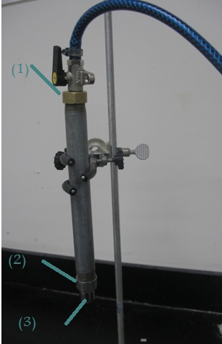

Figure (2.1): packed bed emulsification system: bed feed1, the sand beads layer 2, the filter from which the emulsion leaves 3.

***2.4 Average size measurements:***

A photograph pictures from microscope of the microcapsules was taken as a sample to make our calculations on it, where each picture was nearly contains 50-100 micro capsules. The average size was measured using the following equation:

Average size = $\frac{ԑ(Ni*Di)}{ԑNi}$

Where Di is the diameter of particle and Ni is the number of particles.

**CHAPTER 3: RESULTS AND DISCUSSION**

***3.1 Effect of premix emulsification:***

Figure (3.1) shows the size of the PCL microcapsules before and after passing the emulsion through the porous bed. The results show that the size of the microcapsules decreases after passing the emulsion thorough the membrane. In addition, the microcapsules are more uniform after being passed through the membrane as can be seen in figure (3.1, b). Passing the emulsion through the membrane breaks up the big droplets into smaller ones and repeating this process for several times leads to more uniformity in the size distribution of the capsules. For instance, passing the emulsion through the membrane reduces the average size from 9.8µm to 5.5µm

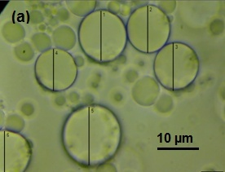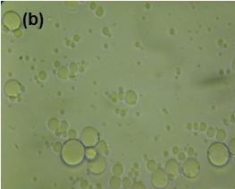

Figure (3.1): the size of microcapsules (a) before passing through the membrane, (b) after passing through the membrane.

***3.2 Effect of the height of the sand Bed:***

To investigate the effect of the thickness of the sand layer, premix emulsion was prepared and forced through a porous bed of sand beads which has the same particle size but at different height. The height of the bed of the sand beads was studied at 2cm, 3cm, 4cm, and 6 cm for each of the three sand sizes (150, 300 and 600µm). Figure (3.2) shows samples of microscopic photographs of the microcapsules prepared using a bed of 150 µm sand beads with different bed heights. The average size of the particles visualized by the microscope was measured for different bed heights and the results at 2, 3, 4, 6 cm is shown in figure (3.3). It was found that increasing the height of the bed decreases the average size of the particles. Microscopic photographs of the microcapsules prepared using a bed of larger sand beads (300 µm) with different bed heights are shown figure (3.4).The average size of the particles shown was measured and the results are shown in the figure (3.5). As was observed with the 150 µm beads, the average size of the PLC microcapsules decreases with increasing the bed height; for instance the average size of the particles prepared with 2 cm bed was ~ 7.5 µm compared with 5.5 µm for the particles prepared with a bed of 6 cm height. The decrease in the average particle size of the microcapsules with increasing the bed height may be attributed to fact that the length of the pores within the bed increases with increasing the bed height. This means that the coarse droplets of the premix emulsion will stay longer time inside the bed which give them greater chance to pass through pores and branches and consequently to break up into smaller droplets.

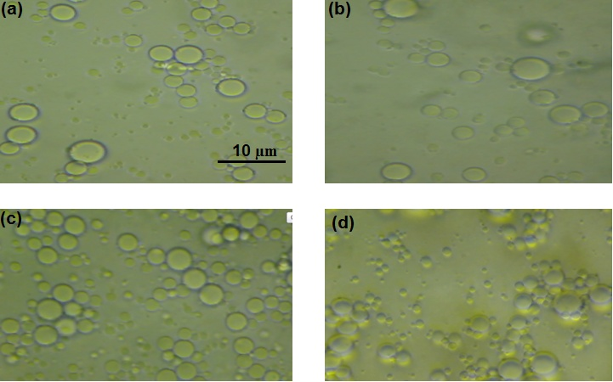

Figure (3.2): Microscopic photographs of PCL microcapsules prepared using a bed of sand beads 150µm at different bed heights at a) 2 cm, b) 3 cm ,c) 4 cm and d) 6 cm .

Figure (3.3): The relationship between the average size and thickness for size 150µm.

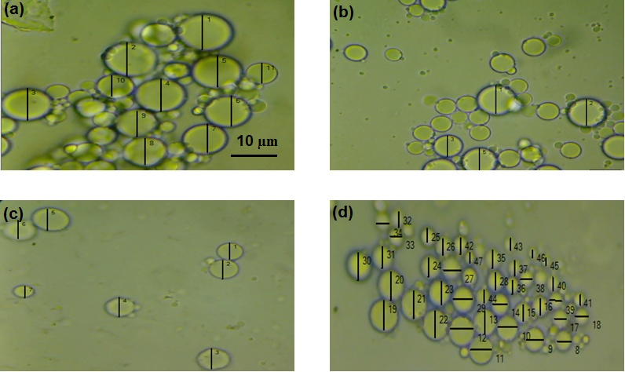

Figure (3.4): Microscopic photographs of PCL microcapsules prepared using a bed of sand beads 300 µm at different bed heights: a) 2 cm, b) 3 cm , c) 4 cm and d) 6 cm.

Figure (3.5): The relationship between the average size and thickness for size 300µm.

***3.3 Effect of the size of sand beads:***

The effect of the size of the sand beads on the average size of the microcapsules was investigated using three sand sizes (150, 300 and 600µm). Figures ( 3.6_3.9) show the average size of the microcapsules prepared with different sizes of the sand particles. As can be seen in the figures, the average size of microcapsules was increased as the size of sand particles increased. This may be explained as follows: as the size of the sand bead decreases the porosity of the bed is expected to decrease which consequently decreases the pore sizes within the sand bed. The shear and mechanical forces applied on large droplets when passing through small pores are higher than large pores which consequently increases the probability of breaking up the large droplets in a smaller ones. This was the case for 150 and 300 µm beads, however, the size of microcapsules prepared with 600µm were somehow smaller than those prepared with 300 µm which may be ascribed to the non-reproducibility of the results obtained with 600 µm or to some experimental errors occurred during the tests .

Figure (3.6): the relationship between the sand size and the average size of particles at the thickness 2cm of sand

Figure (3.7): the relationship between the sand size and the average size of particles at the thickness 3cm of sand.

Figure (3.8): the relationship between the sand size and the average size of particles at the thickness 4cm of sand.

Figure (3.9): The relationship between the sand size and the average size of particles at the thickness 6cm of sand.

***3.4 Effect of sand beads arrangement:***

The effect of the configuration of the sand beads in the bed on the average size of the microcapsules was investigated. To do that, sand bead layers of different particle sizes were arranged in three different configuration: in the first configuration, a 1.3 cm layer of 150 µm sand beads was placed at the bottom of the bed followed by another layer of the same height but with 300 µm sand beads and finally a layer of 600 µm beads was put on the top to form a bed with a total height of 3.9 cm. The second configuration was obtained by reversing the first configuration i.e. the 600 µm beads were placed in the bottom followed by 300 µm and 150 µm respectively. The last configuration was a random mixture of the three different sizes. Figure (3.10) shows photographs of the particles prepared with different bed configuration. The results showed that the gradual increasing of the sand bed sizes from the bottom to the top (first configuration) renders the smallest average size of the particles (~ 3.5 µm) followed by the random beads mixture (~5.5 µm average microcapsules size) and then with gradual decrease of the sand bed sizes from the bottom to the top (~7.3 µm average microcapsules size).

As show in figure (3.11) from the results it can be considered that the first configuration is the most efficient one as said that when small size beads used the size of pores become smaller and as the solution passing through the bed from the layer of big size sand beads to smaller ones the chance to break up the microcapsules increase. While in the second configuration absolutely the opposite thing happened. when the coarse particles were placed in the bottom and fine ones the top, It is expected that small ones will fall down within the voids of the big ones during shakin with the ultrasound, which reduces the effective bed height and the pore length and consequently increases the size of the microcapsules.

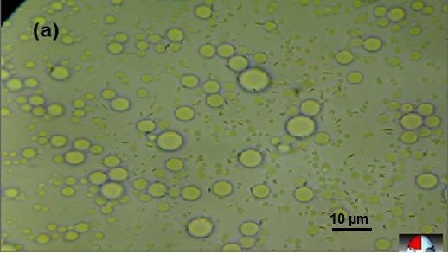

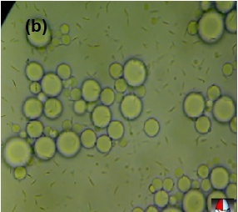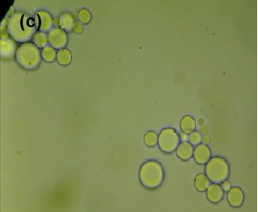

Figure (3.10): Sand size gradually increase (a), sand size gradually decrease (b), mix of three sizes (c).

Figure (3.11): Average size resulted when three sizes of sand used in the bed.

**CONCLUSION:**

Biodegradable polycaprolactone microcapsules were successfully prepared by premix membrane emulsification of biodegradable polymer (polycaprolactone) /dichloromethane/ decane oil in SDS-water mixtures using a packed bed of sand beads. The passage of the emulsion through the membrane reduces the size of the microcapsules and makes them more uniform. The effect size of the sand particles and the height of the sand bed on the average size of PCL microcapsules were investigated. It was found that decreasing the size of the sand particles or increasing the bed height to 4cm decreases the size of the microcapsules and any increase in hight of be above 4 cm will adversely affect the size of microcapsules . In addition, the configuration of the sand beads within the bed highly affected the average size of the microcapsules.

The main conclusion of this study is that the average size of the PCL microcapsules could be optimized through the controlling the size of the sand beads, the bed height and the configuration of the sand beads within the bed.

**Recommendation:**

1. Working on a membrane of sand cause some problems, we could not get 100% pure sand, there was always impurities.
2. when small size sand use it was fall down with premix solution while it passes through the membrane these problem can get rid of maybe if glass particles used.
3. To improve the microcapsules prepared solvent, non solvent and the polymer properties can be studied and compared with other.

**REFERENCES:**

1. Rodriguez, F., Principles of Polymer Systems, 1970 by McGraw-Hill.
2. Sawalha, H., Shroën, K.,andBoom, R., Biodegradable polymeric microcapsules: Preparation and properties, Chemical Engineering Journal 169 (2011) 1-10.
3. Tian, H., Tang, Z., Zhuang, X., Chen, X.,and Jing, X., Biodegradable synthetic polymers: Preparation, functionalization and biomedical application, Progress in polymer science 37 (2012) 237-280.
4. Nair, L., Laurencin, C., Biodegradable polymers as biomaterials, Progress in polymer science 32 (2007) 762-798.
5. http://auseblog.blogspot.com. 24 december 2012.
6. Ken-jer wu, Chin-san Wu, Jo-Shu Chang., Biodegradability and mechanical properties of polycaprolactone composites encapsulating phosphate –solubilizing Bacterium bacillus sp.PG01.,Process Biochemistry 42(2007)669-675.
7. Khalid Saeed , Soo-young park., Preparation and Properties of Polycaprolactone/Poly (Butylene Terephthalate ) Blend., Iran.j Chem. Chem. Eng Vol .29,No.3,2010
8. Goran T. Vladisavljevic, Richard A. Williams, Recent developments in manufacturing emulsions and particulate products using membranes, Advances in Colloid and Interface Science 113 (2005) 1 – 20.
9. Vladisavljevic, G. T., Isao Kobayashi and Mitsutoshi Nakajima, Production of uniform droplets using membrane, microchannel and microfluidic emulsification devices, DOI 10.1007/s10404-012-0948-0.
10. Sawalha, H., Polylactide microcapsules and films: preparation and properties, PhD thesis, Wageningen University, the Netherlands, 2009.
11. Luca, G., and Drioli, E., Force balance conditions for droplet formation in cross-flow membrane Emulsifications. Journal of Colloid and Interface Science 294 (2006) 436–448.
12. Kobayashi, I., Neves, M., Wada, Y., Uemura, K., and Nakajima., M., Large microchannel emulsification device for producing monodisperse fine droplets. Procedia Food Science 1 (2011) 109 – 115.

**APPENDIX: Sample calculations:**

Table P1: Sizes of PCL microcapsules prepared by sand beads of 150 µm (average size and at 2 cm bed height). The sizes shown in the table were measured from the microscopic photographs.

|  |  |
| --- | --- |
| Size of particle (mm) | Number of particle |

|  |  |
| --- | --- |
| 1 | 6.28 |
| 2 | 6.63 |
| 3 | 6.28 |
| 4 | 5.41 |
| 5 | 6.63 |
| 6 | 3.67 |
| 7 | 3.84 |
| 8 | 3.67 |
| 9 | 9.52 |
| 10 | 5.76 |
| 11 | 5.23 |
| 12 | 4.41 |
| 13 | 4.19 |
| 14 | 4.19 |
| 15 | 4.19 |
| 16 | 3.14 |
| 17 | 2.61 |
| 18 | 3.14 |
| 19 | 3.66 |
| 20 | 3.65 |
| 21 | 2.09 |
| 22 | 2.09 |
| 23 | 2.09 |
| 24 | 2.61 |
| 25 | 2.62 |
| 26 | 3.66 |
| 27 | 4.19 |
| 28 | 4.91 |
| 29 | 3.14 |
| 30 | 4.19 |
| 31 | 4.19 |
| 32 | 4.19 |
| 33 | 2.61 |
| 34 | 2.09 |
| 35 | 3.14 |
| 36 | 2.61 |
| 37 | 2.61 |
| 38 | 4.71 |
| 39 | 5.76 |
| 40 | 3.66 |
| 41 | 3.66 |
| 42 | 3.14 |
| 43 | 2.61 |
| 44 | 2.09 |
| 45 | 10.3 |
| 46 | 4.54 |
| 47 | 6.11 |
| 48 | 7.85 |
| 49 | 8.9 |
| 50 | 5.58 |
| 51 | 4.71 |
| 52 | 5.24 |
| 53 | 4.54 |
| 54 | 4.71 |
| 55 | 5.23 |
| 56 | 3.49 |
| 57 | 4.53 |
| 58 | 5.23 |
| 59 | 6.11 |
| 60 | 4.71 |
| 61 | 6.45 |
| 62 | 6.55 |
| 63 | 7.06 |
| 64 | 2.52 |
| 65 | 3.03 |
| 66 | 4.54 |
| 67 | 5.04 |
| 68 | 7.06 |
| 69 | 2.52 |
| 70 | 2.02 |
| 71 | 7.06 |
| 72 | 2.03 |
| 73 | 7.06 |
| 74 | 7.06 |
| 75 | 7.56 |
| 76 | 6.55 |
| 77 | 7.06 |
| 78 | 4.04 |
| 79 | 3.03 |
| 80 | 3.53 |
| 81 | 3.56 |
| 82 | 4.04 |
| 83 | 5.54 |
| 84 | 6.05 |
| 85 | 5.04 |
| 86 | 4.04 |
| 87 | 4.54 |
| 88 | 4.79 |
| 89 | 3.03 |
| 90 | 4.54 |
| 91 | 8.91 |
| 92 | 11.18 |
| 93 | 8.03 |
| 94 | 9.08 |
| 95 | 10.65 |
| 96 | 8.73 |
| 97 | 9.25 |
| 98 | 7.51 |
| 99 | 6.64 |
| 100 | 7.51 |
| 101 | 4.89 |
| 102 | 8.39 |
| 103 | 6.99 |
| 104 | 6.29 |
| 105 | 7.69 |
| 106 | 3.49 |
| 107 | 4.89 |
| 108 | 3.49 |
| 109 | 4.19 |
| 110 | 6.29 |
| 111 | 7.69 |
| 112 | 5.59 |
| 113 | 4.19 |
| 114 | 3.49 |
| 115 | 9.78 |
| 116 | 6.99 |
| 117 | 8.39 |
| 118 | 6.29 |
| 119 | 8.4 |
| 120 | 6.99 |
| 121 | 6.29 |
| 122 | 3.49 |
| 123 | 6.99 |
| 124 | 6.99 |
| 125 | 6.29 |
| 126 | 7.5 |
| 127 | 7.69 |
| 128 | 4.19 |
| 129 | 2.8 |
| 130 | 2.1 |
| 131 | 9.6 |
| 132 | 9.43 |
| 133 | 7.33 |
| 134 | 9.08 |
| 135 | 7.51 |
| 136 | 9.6 |
| 137 | 6.29 |
| 138 | 7.33 |
| 139 | 8.91 |
| 140 | 7.68 |
| 141 | 6.98 |
| 142 | 9.43 |
| 143 | 8.38 |
| 144 | 5.76 |
| 145 | 4.71 |
| 146 | 3.14 |
| 147 | 2.62 |
| 148 | 7.33 |
| 149 | 4.19 |
| 150 | 3.19 |
| 151 | 3.66 |
| 152 | 3.14 |
| 153 | 3.66 |
| 154 | 3.66 |
| 155 | 5.76 |
| 156 | 3.14 |
| 157 | 3.14 |
| 158 | 8.38 |
| 159 | 4.19 |
| 160 | 3.66 |
| 161 | 5.76 |
| 162 | 3.66 |
| 163 | 4.62 |
| 164 | 2.6 |
| 165 | 2.09 |
| 166 | 5.76 |
| 167 | 3.19 |
| 168 | 3.66 |
| 169 | 2.1 |
| 170 | 4.71 |
| 171 | 5.76 |
| 172 | 4.71 |
| 173 | 4.71 |
| 174 | 4.19 |
| 175 | 3.66 |
| 176 | 3.14 |
| 177 | 4.71 |
| 178 | 3.14 |
| 179 | 10.99 |
| 180 | 4.8 |
| 181 | 4.71 |
| ∑(size of particles) | 953.25 |
| Average size | 5.3 |

Table P2: Sizes of PCL microcapsules prepared by sand beads of 300 µm (average size and at 2 cm bed height). The sizes shown in the table were measured from the microscopic photographs.

|  |  |
| --- | --- |
| Size of particle (mm) | Number of particle |
| 10.13 | 1 |
| 8.73 | 2 |
| 7.86 | 3 |
| 6.81 | 4 |
| 7.86 | 5 |
| 8.03 | 6 |
| 11 | 7 |
| 9.08 | 8 |
| 8.73 | 9 |
| 8.55 | 10 |
| 8.38 | 11 |
| 9.78 | 12 |
| 8.73 | 13 |
| 6.04 | 14 |
| 6.04 | 15 |
| 3.36 | 16 |
| 6.04 | 17 |
| 6.05 | 18 |
| 5.37 | 19 |
| 4.03 | 20 |
| 6.05 | 21 |
| 4.37 | 22 |
| 4.7 | 23 |
| 6.72 | 24 |
| 6.72 | 25 |
| 4.7 | 26 |
| 5.04 | 27 |
| 3.02 | 28 |
| 12.75 | 29 |
| 12.39 | 30 |
| 11.87 | 31 |
| 12.05 | 32 |
| 11.5 | 33 |
| 11.17 | 34 |
| 10.65 | 35 |
| 9.78 | 36 |
| 9.43 | 37 |
| 7.68 | 38 |
| 7.5 | 39 |
| 5.36 | 40 |
| 8.03 | 41 |
| 6.03 | 42 |
| 4.02 | 43 |
| 3.35 | 44 |
| 6.69 | 45 |
| 7.36 | 46 |
| 6.03 | 47 |
| 5.36 | 48 |
| 6.69 | 49 |
| 5.02 | 50 |
| 3.35 | 51 |
| 375.98 | ∑ (size of particle) |
| 7.4 | Average size of particle |