
AN-NAJAH NATIONAL UNIVERSITY
FACULTY OF ENGINEERING
ELECTRICAL ENGENEERING DEPARTEMENT
Project name:
Traffic Guide using Wireless Radio

Prepared by :
- Diana Qassam
- Razan Ghannam
- Heyam Shamasneh
Supervised by:
- Dr. Allam Mousa
Date: 24/12/2008
Acknowledgment
First and last, we would thank ALLAH for enabling us to complete this project.
And we dedicate Dr. Allam Mousa with our special thanks and appreciation for his for his support and help, and supervision the construction of this project.

Other thanks to our university, our lecturers, and every person help us during this work.

We would also thank our friends who encouraged us to perfectly finish this project.

Very deep thanks to our families and kindhearted parents who continuously prayed and stood besides us.

الى........
الى كلمة الحق التي بدت غريبة في عالم الظلام....

الى أرض مجدي, وبيت جدي, ودماء شعبي.....

الى دمعة أمي, ودعاء أبي, وحلم وطني......

الى صديق رافقني, شعر بألمي, ودعا لي في سره.....

الى جامعتي, وكليتي التي حملت ذكرياتي, وحضنت شبابي.....
الى كل دكتور وأستاذ شجعني ودعمني.....

لكم جميعا نهدي عملنا

Chapter one
Introduction
Traffic jam is one of the most global problems that faced all over the world in the last 50 years, and its not concerned in several country, it is found everywhere we go, there must be a traffic problem in all cities in the world.
Traffic shows a great problem in the capitals of the countries. As an example is Palestine, the traffic is a very serious problem that can't be ignored, the problem increased in unusual way, this is because the rapid increase of the vehicles number and the little size and poor quality of streets.
However this project seems to be a little solution for traffic problem, the main idea of the project is to reduce the traffic jam on the streets, circles and traffic lights by guiding drivers where the traffic jam is found. As a result driver could avoid going through the traffic jam and use another way if it is applicable.

The guiding process tool will be the car radio which will be used as a receiver for the information that should guide the driver to the roads he should follow up to avoid streets traffic jamming.

This idea should be applied as collaboration with the traffic police; since they are the main source of knowing the situation of roads and where the traffic jam can be found as they are spread around the cities and main roads, by this mean they could guide the drivers to the streets they should follow up to avoid the traffic jam.

There is two main parts for the project:

First part:
- Collect roads information by police officers, this information should be transmitted to the main police station.
- Separate this information as their coverage areas, each 2 or 3 km's area should have its specific information. After separation process this information has to be transmitted to substations that have a coverage area of 2 or 3 km.
- Transmit this information from substations to access points that have to be distributed on the roads, circles and where the traffic is found. These access points basically a transceiver system.
- Transmit the information from access points using FM in MHz. This process must have permission from telecommunication regulatory commission in palstine to hold a free channel in FM range; this is because there is no way to transmit anything in the range of MHz without having permission.

Second part:
To achieve this feature of guiding tool, a development to the car radio should be made to have the capability to receive the transmitted information for roads and give it the highest priority of receiving; this should be done by building a circuit which consists of:
- Antenna
- FM receiver
- PIC (Programmable Interface Circuit)
- Car radio

The idea of the circuit is to program the PIC to give the police traffic channel the highest priority of receiving, figure shows the system of traffic guide using wireless radio
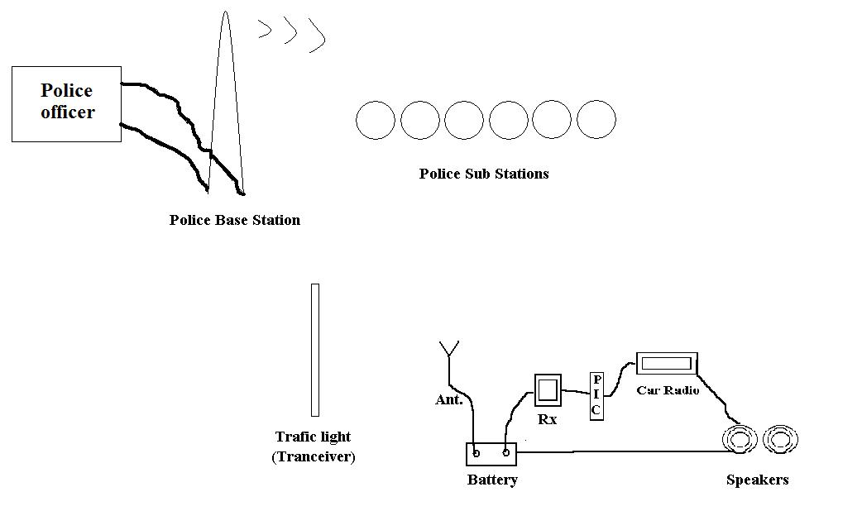
Fig 1.1: Traffic Guide using Wireless Radio

Chapter two
FM modulation

1.2 Introduction:
It is a form of modulation that represents information as variations in the instantaneous frequency of a carrier wave in analog applications; the carrier frequency is varied in direct proportion to changes in the amplitude of an input signal. Digital data can be represented by shifting the carrier frequency among a set of discrete values, a technique known as frequency-shift keying.
FM is commonly used at VHF radio frequencies for high-fidelity broadcasts of music and speech, Normal (analog) TV sound is also broadcast using FM. A narrowband form is used for voice communications in commercial and amateur radio settings. The type of FM used in broadcast is generally called wide-FM, or W-FM. In two-way radio, narrowband narrow-fm (N-FM) is used to conserve bandwidth. In addition, it is used to send signals into space.
FM is also used at intermediate frequencies by most analog VCR systems, including VHS, to record the luminance (black and white) portion of the video signal. FM is the only feasible method of recording video to and retrieving video from magnetic tape without extreme distortion, as video signals have a very large range of frequency components from a few hertz to several megahertz, too wide for equalizers to work with due to electronic noise below -60 dB. FM also keeps the tape at saturation level, and therefore acts as a form of noise reduction, and a simple limiter can mask variations in the playback output, and the FM capture effect removes print-through and pre-echo.
FM is also used at audio frequencies to synthesize sound. This technique, known as F synthesis, was popularized by early digital synthesizers and became a standard feature for several generations of personal computer sound cards.
Before showing the Frequency Modulation concept, the meaning of modulation and the other types will be reviewed.

2.2 Modulation and Demodulation:
Modulation is the process of varying a periodic waveform in order to use that signal to convey a message. Normally a high-frequency sinusoid waveform is used as a carrier signal. The three key parameters of a sine wave are its amplitude, phase, and frequency, all of which can be modified in accordance with a low frequency information signal to obtain the modulated signal.
The variation of these key parameters of the sinusoid wave produces three types of modulation: amplitude modulation, frequency modulation, and phase modulation. Each will be briefly described below.

2.3 Amplitude Modulation (AM):
Amplitude modulation (AM) is a technique used in electronic communication, most commonly for transmitting information via a radio carrier wave. AM works by varying the amplitude of the transmitted signal in relation to the information being sent.
Basic form, amplitude modulation produces a signal with power concentrated at the carrier frequency and in two adjacent sidebands. Each sideband is equal in bandwidth to that of the modulating signal and is a mirror image of the other. Amplitude modulation that results in two sidebands and a carrier is often called double sideband amplitude modulation (DSB-AM). Amplitude modulation is inefficient in terms of power usage and much of it is wasted. At least two-thirds of the power is concentrated in the carrier signal, which carries no useful information; the remaining power is split between two identical sidebands, though only one of these is needed since they contain identical information.
To increase transmitter efficiency, the carrier can be removed (suppressed) from the AM signal. This produces a reduced-carrier transmission or double-sideband suppressed-carrier (DSBSC) signal. A suppressed-carrier amplitude modulation scheme is three times more power-efficient than traditional DSB-AM.
Even greater efficiency is achieved—at the expense of increased transmitter and receiver complexity—by completely suppressing both the carrier and one of the sidebands. This is single- sideband modulation, widely used in amateur radio due to its efficient use of both power and bandwidth. A typical AM signal is shown in the following figure.
Figure 2.1: AM signal modulation

In Amplitude Modulation or AM, the carrier signal
has its amplitude
modulated in proportion to the message bearing (lower frequency) signal
to give
The magnitude of
is chosen to be less than or equal to 1, from reasons having to do with demodulation, i.e. recovery of the signal
from the received signal. The modulation index is then defined to be
Figures 1 and 2 are some matlab plots of what the modulated signal looks like for
The frequency of the modulating signal is chosen to be much smaller than that of the carrier signal. Try to think of what would happen if the modulating index were bigger than 1.
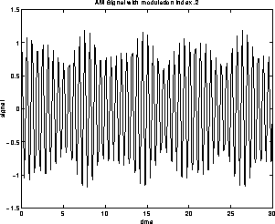
Figure 2.2: AM modulation with modulation index .2
Note that the AM signal is of the form
This has frequency components at frequencies
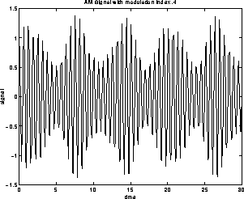
Figure 2.3: AM modulation with modulation index .4
2.4 Phase Modulation (PM):
Phase modulation (PM) is a form of modulation that represents information as variations in the instantaneous phase of a carrier wave.
Unlike its more popular counterpart, frequency modulation (FM), PM is not very widely used. This is because it tends to require more complex receiving hardware and there can be ambiguity problems with determining whether, for example, the signal has 0° phase or 180° phase.
Demodulation is the act of removing the modulation from an analog signal to get the original baseband signal back. Demodulating is necessary because the receiver system receives a modulated signal with specific characteristics and it needs to turn it back to the baseband form.
There are several ways of demodulation depending on what parameters of the baseband signal are transmitted in the carrier signal, such as amplitude, frequency or phase.
The following Figure shows the Phase Modulation
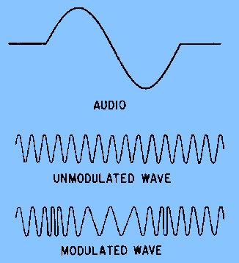
Figure 2.4 : phase modulation.

2.5 Frequency modulation (FM):

Frequency modulation uses the information signal, V_{m}(t) to vary the carrier frequency within some small range about its original value. Here are the three signals in mathematical form:
- Information: V_{m}(t)
- Carrier: V_{c}(t) = V_{c}(t) = V_{co} sin ( 2 π f_{c} t + φ )
- FM: V_{FM} (t) = V_{co} sin (2 π [f_{c} + (Δf/V_{mo}) V_{m} (t) ] t + φ)
We have replaced the carrier frequency term, with a time-varying frequency. We have also introduced a new term: Δf, the peak frequency deviation. In this form, you should be able to see that the carrier frequency term: f_{c} + (Δf/V_{mo}) V_{m}(t) now varies between the extremes of f_{c} - Δf and f_{c} + Δf. The interpretation of Δf becomes clear: it is the farthest away from the original frequency that the FM signal can be. Sometimes it is referred to as the "swing" in the frequency.
We can also define a modulation index for FM, analogous to AM:
β = Δf/f_{m}, where f_{m} is the maximum modulating frequency used.
The simplest interpretation of the modulation index, β is as a measure of the peak frequency deviation, Δf. In other words, β represents a way to express the peak deviation frequency as a multiple of the maximum modulating frequency, f_{m}, i.e. Δf =βf_{m}.
Here is a simple FM signal:
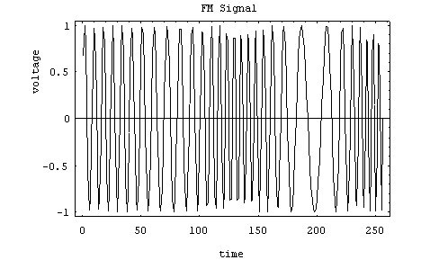
Figure 2.5: simple Fm signal
Here, the carrier is at 30 Hz, and the modulating frequency is 5 Hz. The modulation index is about 3, making the peak frequency deviation about 15 Hz. That means the frequency will vary somewhere between 15 and 45 Hz. How fast the cycle is completed is a function of the modulating frequency.
And here modulating wave implies an analog signal.
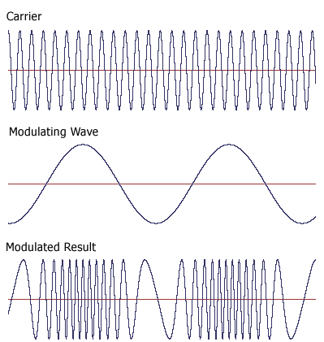

Figure 2.6: modulation wave analog signal

2.6 FM Spectrum:
A spectrum represents the relative amounts of different frequency components in any signal. Its like the display on the graphic-equalizer in your stereo which has leds showing the relative amounts of bass, midrange and treble. These correspond directly to increasing frequencies (treble being the high frequency components). It is a well-known fact of mathematics, that any function (signal) can be decomposed into purely sinusoidal components (with a few pathological exceptions) . In technical terms, the sines and cosines form a complete set of functions, also known as a basis in the infinite-dimensional vector space of real-valued functions (gag reflex). Given that any signal can be thought to be made up of sinusoidal signals, the spectrum then represents the "recipe card" of how to make the signal from sinusoids. Like: 1 part of 50 Hz and 2 parts of 200 Hz. Pure sinusoids have the simplest spectrum of all, just one component:
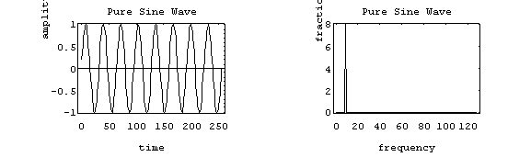
In this example, the carrier has 8 Hz and so the spectrum has a single component with value 1.0 at 8 Hz
The FM spectrum is considerably more complicated. The spectrum of a simple FM signal looks like:
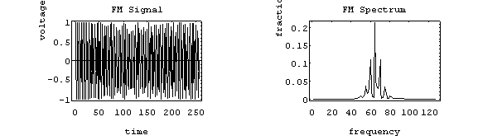
The carrier is now 65 Hz, the modulating signal is a pure 5 Hz tone, and the modulation index is 2. What we see are multiple side-bands (spikes at other than the carrier frequency) separated by the modulating frequency, 5 Hz. There are roughly 3 side-bands on either side of the carrier. The shape of the spectrum may be explained using a simple heterodyne argument: when you mix the three frequencies (f_{c}, f_{m} and Δf) together you get the sum and difference frequencies. The largest combination is f_{c} + f_{m} + Δf, and the smallest is f_{c} - f_{m} - Δf. Since Δf = β f_{m}, the frequency varies (β + 1) f_{m} above and below the carrier.
A more realistic example is to use an audio spectrum to provide the modulation:
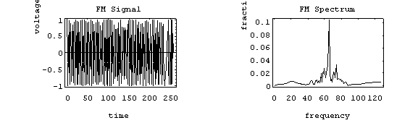
In this example, the information signal varies between 1 and 11 Hz. The carrier is at 65 Hz and the modulation index is 2. The individual side-band spikes are replaced by a more-or-less continuous spectrum. However, the extent of the side-bands is limited (approximately) to (β + 1) f_{m} above and below. Here, that would be 33 Hz above and below, making the bandwidth about 66 Hz. We see the side-bands extend from 35 to 90 Hz, so out observed bandwidth is 65 Hz.
2.7 Mathematical Analysis of FM:
A mathematical analysis of a high-frequency sine wave, modulated by a single tone or frequency, will be used to yield information about the frequency components in an FM wave, FM power relations, and the bandwidth of an FM signal.

From the definition of frequency deviation, an equation can be written for the signal frequency of an FM wave as a function of time:
……………………………. 1
And substitution of δ= k_{f} х E_{M} yields:

…………………………………………………….. 2

But this equation indicate seems to be saying that the frequency of the transmitter is varying with time, the truth that With AM, the signal appeared to be a sine wave that's amplitude was changing with time. At the time, it was pointed out that a sine wave, by definition, has constant peak amplitude, and thus cannot have peak amplitude that varies with time. And about the sine wave’s frequency, it also must be a constant and cannot be varying with time. As was the case with AM, where it turned out that our modulated wave is actually the vector sum of three sine waves, a similar situation is true for FM. An FM wave will consist of three or more frequency components vectorially added together to give the appearance of a sine wave that's frequency is varying with time when displayed in the time domain.
A somewhat complex mathematical analysis will yield an equation for the instantaneous voltage of an FM wave of the form shown here:
……………………………………………….3
Where E_{C} is the rest-frequency peak amplitude, ω_{C} and ω_{M} represent the rest and modulating frequencies, and m_{f} is the index of modulation. This equation represents a single low-frequency sine wave, f_{M}, frequency modulating another high-frequency sine wave, f_{C}. Note that equation indicates that the argument of the sine wave is itself a sine wave.

Example: FM Radio
FM radio uses frequency modulation, of course. The frequency band for FM radio is about 88 to 108 MHz. The information signal is music and voice which falls in the audio spectrum. The full audio spectrum ranges form 20 to 20,000 Hz, but FM radio limits the upper modulating frequency to 15 kHz (cf. AM radio which limits the upper frequency to 5 kHz). Although, some of the signal may be lost above 15 kHz, most people can't hear it anyway, so there is little loss of fidelity. FM radio maybe appropriately referred to as "high-fidelity."
If FM transmitters use a maximum modulation index of about 5.0, so the resulting bandwidth is 180 kHz (roughly 0.2 MHz). The FCC assigns stations ) 0.2 MHz apart to prevent overlapping signals (coincidence? I think not!). If you were to fill up the FM band with stations, you could get 108 - 88 / .2 = 100 stations, about the same number as AM radio (107). This sounds convincing, but is actually more complicated.
FM radio is broadcast in stereo, meaning two channels of information. In practice, they generate three signals prior to applying the modulation:
- the L + R (left + right) signal in the range of 50 to 15,000 Hz.
- a 19 kHz pilot carrier.
- the L-R signal centered on a 38 kHz pilot carrier (which is suppressed) that ranges from 23 to 53 kHz .
So, the information signal actually has a maximum modulating frequency of 53 kHz, requiring a reduction in the modulation index to about 1.0 to keep the total signal bandwidth about 200 kHz.

The main advantages of FM over AM are:
- Improved signal to noise ratio (about 25dB) w.r.t. to man made interference.
- Smaller geographical interference between neighboring stations.
- Less radiated power.
- Well defined service areas for given transmitter power.

Disadvantages of FM:
- Much more Bandwidth (as much as 20 times as much).
- More complicated receiver and transmitter.

Bandwidth
the bandwidth of a FM signal may be predicted using:
BW = 2 (β + 1 ) f_{m}
where β is the modulation index and,
f_{m} is the maximum modulating frequency used.
FM radio has a significantly larger bandwidth than AM radio, but the FM radio band is also larger. The combination keeps the number of available channels about the same.
The bandwidth of an FM signal has a more complicated dependency than in the AM case (recall, the bandwidth of AM signals depend only on the maximum modulation frequency). In FM, both the modulation index and the modulating frequency affect the bandwidth. As the information is made stronger, the bandwidth also grows.

Efficiency
The efficiency of a signal is the power in the side-bands as a fraction of the total. In FM signals, because of the considerable side-bands produced, the efficiency is generally high. Recall that conventional AM is limited to about 33 % efficiency to prevent distortion in the receiver when the modulation index was greater than 1. FM has no analogous problem.
The side-band structure is fairly complicated, but it is safe to say that the efficiency is generally improved by making the modulation index larger (as it should be). But if you make the modulation index larger, so make the bandwidth larger (unlike AM) which has its disadvantages. As is typical in engineering, a compromise between efficiency and performance is struck. The modulation index is normally limited to a value between 1 and 5, depending on the application.

Noise
FM systems are far better at rejecting noise than AM systems. Noise generally is spread uniformly across the spectrum (the so-called white noise, meaning wide spectrum). The amplitude of the noise varies randomly at these frequencies. The change in amplitude can actually modulate the signal and be picked up in the AM system. As a result, AM systems are very sensitive to random noise. An example might be ignition system noise in your car. Special filters need to be installed to keep the interference out of your car radio.
FM systems are inherently immune to random noise. In order for the noise to interfere, it would have to modulate the frequency somehow. But the noise is distributed uniformly in frequency and varies mostly in amplitude. As a result, there is virtually no interference picked up in the FM receiver. FM is sometimes called "static free, " referring to its superior immunity to random noise.

The Effect of Noise on FM
If random electrical variation added to the FM signal, noise still adds to the signal, but because the information resides in frequency changes instead of amplitude changes, the noise tends to have less of an effect. Expanding upon this idea a bit, one notes that the random electrical variations encountered by the FM signal will indeed cause distortion by jittering the frequency of the FM signal. However, the change in frequency modulation caused by the jittering usually turns out to be less than the change in the amplitude modulation caused by the same relative amplitude noise variations on an AM signal. Also unlike AM, the effect of the frequency jittering becomes progressively worse as the modulating frequency increases. In other words, the effect of noise increases with modulation frequency.

Chapter three
PIC Microcontroller

3.1 PIC Microcontroller
Microcontrollers have changed electronic design aspects. Instead of hard wiring a number of logic gates together to perform some function, we now use instructions to wire the gates electronically. The list of these instructions given to the microcontroller is called a program.

There is a variety of microcontrollers:
- Atmel – AT90S8535
- Motorola – 68HC11
- Intel - 8051
- Texas Instruments
- Microchip – PIC

PIC is the name for the microcontroller (MCU) family manufactured by Microchip, consisting of a microprocessor, I/O ports, timers and other internal integrated hardware. The main advantages are low external part count, wide range of chip sizes, great availability of compilers and source code, and ease of programming.
Traffic Guide using Wireless Radio uses the Microchip product (PIC16F877A) microcontroller. Figure 3.1 shows the PIC16F877A microcontroller.

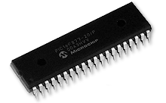

Figure 3.1: PIC16F877A

3.2 PIC16F877A Features
The 16F877A PIC microcontroller has the following features:
- High-performance RISC CPU (RISC: Reduced Instruction Set Computer).
- 8 Kbytes of FLASH Program Memory.
- 368 bytes of Data Memory (RAM).
- 256 bytes of EEPROM Data Memory.
- 33 input/output pins.
- 4 MHz operating speed (50 ns instruction cycle).
- Wide operating voltage range: 2.0V to 5.5V.
- Max. 25 mA current from an output pin.

3.3 PIC16F877A Description
The 16F877A is the core of the project that everything is completely done through it.
It consists of 40 pins, as shown in Figure 3.2; each pin might be multiplexed with more than one function.

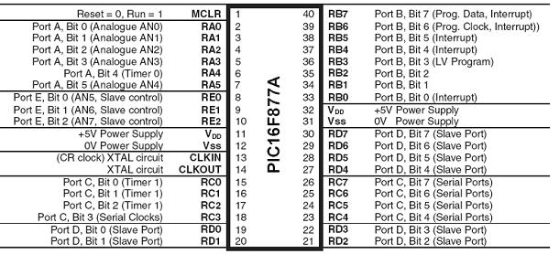
Figure 3.2: PIC16F877A Pin Layout

There are three memory blocks in PIC16F877A; the Program Memory, Data Memory (RAM), and EEPROM data memory.

3.4 Memory Organization
There are three memory blocks in PIC16F877A; the Program Memory, Data Memory (RAM), and EEPROM data memory.

3.4.1 Program Memory Organization:
The PIC16F877A has a 13-bit program counter capable of addressing an 8K x 14 program memory space. And has 8K x 14 words of FLASH, so by accessing a location above the physically implemented address will cause a wraparound. The reset vector is at 0000h and the interrupt vector is at 0004h.

3.4.2 Data Memory Organization
The data memory is partitioned into multiple banks which contain the General Purpose Registers (GPR) and the Special Function Registers (SFR). Bits RP1 (STATUS.6) and RP0 (STATUS.5) are the bank select bits, as shown in the following Table.

Table 3.1 Bank Selection
RP1:RP0 | Bank
00 | 0
01 | 1
10 | 2
11 | 3

Each bank extends up to 7Fh (128 bytes). The lower locations of each bank are reserved for the SFR and the ones above are for GPR, implementing a static RAM. All implemented banks contain Special Function Registers. Some “high use” Special Function Registers from one bank may be mirrored in another bank for code reduction and quicker access. These registers are illustrated in figure 3.3.

3.4.3 Special Function Registers (SFR):
The SFRs are used by the CPU and peripheral modules for controlling the desired operation of the device. These registers are implemented as static RAM.

3.4.4 General Purpose Registers (GPR):
The register file can be accessed either directly or indirectly through the File Select Register (FSR).

Figure 3.3: Memory Banks
3.4.5 Data EEPROM and Flash Program Memory
The data EEPROM and Flash program memory is readable and writable during normal operation (over the full V_{DD} range). This memory is not directly mapped in the register file space. Instead, it is indirectly addressed through the SFRs.
3.5 PIC 16F877A I/O Ports
It can be seen that most pins are used for input/output operations, and arranged in 5 ports: A(6), B(8), C(8), D(8) and E(3), giving a total of 33 I/O pins. These can all operate as simple digital I/O pins, but most have more than one function, and the mode of operation of each is selected by initializing various control registers within the chip.
Each port can be assigned as input or output, and each pin state can be identified by using the TRIS register.
- PORTA: PORTA is a 6-bit wide bi-directional port. The corresponding data direction register is TRISA. Setting TRISA bit to (1) will make the corresponding PORTA pins as input. Clearing TRISA bit (0) will make the corresponding PORTA pins as output. Reading the PORTA register reads the status of the pins, whereas writing to it will write to the port latch. All write operations are read-modify-write operations. Therefore, a write to a port implies that the port pins are read; the value is modified and then written to the port data latch.
- PORTB: PORTB is an 8-bit wide, bi-directional port. The corresponding data direction register is TRISB. Setting TRISB bit to binary ‘1’ will make the corresponding PORTB pins as input. Clearing TRISB bit to binary ‘0’ will make the corresponding PORTB pins as output.
- PORTC: PORTC is an 8-bit wide, bi-directional port. The corresponding data direction register is TRISC. Setting TRISC bit to binary ‘1’ will make the corresponding PORTC pins as input. Clearing TRISC bit to binary ‘0’ will make the corresponding PORTC pins as output. PORTC is multiplexed with several peripheral functions.
- PORTD: PORTD is an 8-bit port with Schmitt Trigger input buffers. Each pin is individually configurable as an input or output. PORTD can be configured as an 8-bit wide microprocessor port.
- PORTE: PORTE has three pins, which are individually configurable as input or output. These pins have Schmitt Trigger input buffers.

Hardware and Software Implementation
In order to use the microcontroller in a circuit, there are basically two facts one need to understand:
1. How to connect the microcontroller to the hardware?
2. How to write and program the code into the microcontroller?
PIC Connections:
The hardware connections that the PIC microcontroller need to function and the connections of PIC to the other components of the circuit are shown in figures 3.4.

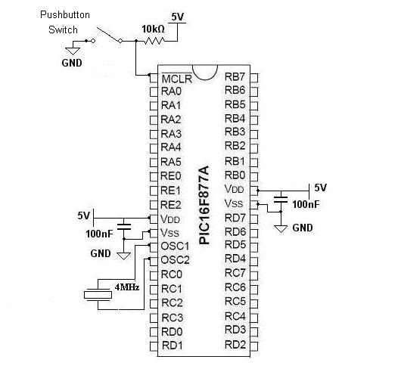
Figure 3.4: PIC connections in base circuit
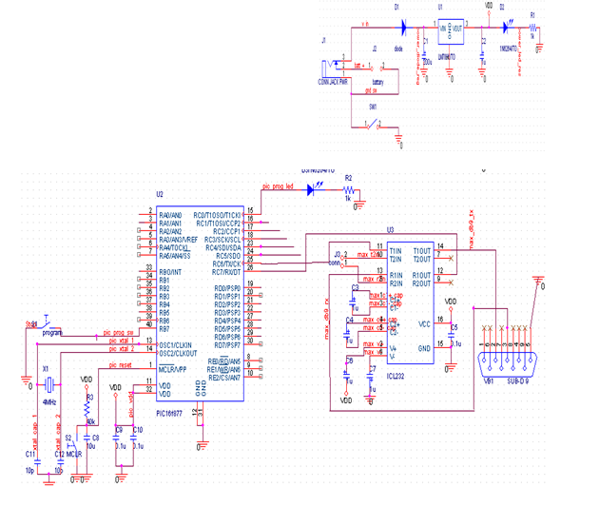
Figure 3.5: Basic circuit for the PIC.

Special Pins Connection
As shown before, the 40 pin 16F877A microcontroller has 33 pins as I/O, the rest seven pins have other functions and they are: MCLR/Vpp, OSC1, OSC2, 2-VDD and 2- VSS.
MCLR/Vpp:
MCLR (pin 1) is an active low reset pin; it is connected through a resistor to +5V supply.
Figure 3.5 shows the MCLR pin connection.
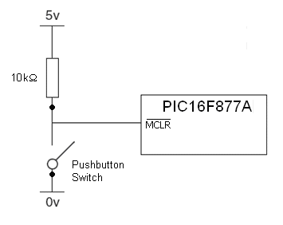
Figure 3.6: MCLR pin connection
When the switch is open, 5V, logic 1 is connected to the PIC (normal operation), and when the switch is closed, 0V, logic 0 is connected to the PIC (reset the PIC).
The reason of using the 10kΩ resistor:
- Each pin of the 16F877A is capable of driving 5V I/O, and maximum current of 20mA, by simple calculation we would see that
So the resistor limits the current entering the PIC.
- When MCLR is active, the 5V supply is shorted to the ground (0V), and then the resistor prevents that.
The components that attached to the PIC are:
- C₅ & C₃: These capacitors (Band Pass Filter) used to reduce the ripple of the power supply.
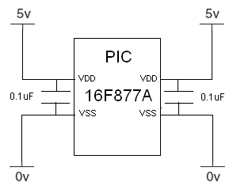
Figure 3.7: Power Circuit using Capacitors
100nF Capacitor is placed as closed to the chip as possible between VDD and VSS its role is to filter any electrical on the 5v power supply line to guarantee constant input voltage equal to 5v.
100nF Capacitor must always be connected to stop any noise affecting the normal running of the microcontroller.
- Crystal oscillator
The 4 MHz crystal oscillator connected to pin 13(CLK in) and 14(CLK out) of the PIC 16F877A produces the clock pulses that are required to step the microcontroller through the program and provide the timing pulses. Crystal oscillator connection is shown in figure 4.6.
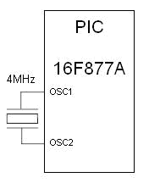
Figure 3.8: Crystal Connection
- Switch: An active low reset pin; it is connected through a resistor to +5V supply.
Figure 4.7 shows the MCLR pin connection.
Figure 3.9: MCLR Pin Connections
When the switch is open (5V), logic 1 is connected to the PIC (normal operation) and when the switch is closed (0V), logic 0 is connected to the PIC (reset the PIC).
Chapter four
Project description

Our project consists of two sides:
- The transmitter side which is a Wireless FM Microphone.
- The receiver side that should be done by building a circuit which consists of the following main parts:
- Antenna
- FM receiver
- PIC (Programmable Interface Circuit)
- Car radio
The following figure describes our project:
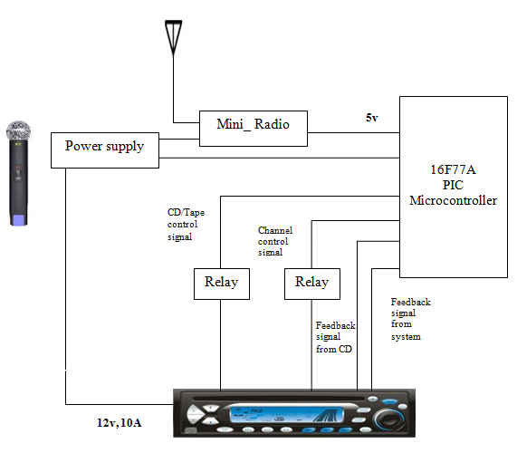
Figure 4.1: Practical Traffic Guide using Wireless Radio
As shown in the previous figure we have many components which will be discussed in the coming sections.
1. FM microphone
Wireless FM Microphone, FM MIC uses FM radio frequency and generate a signal with a frequency value (90 MHz.) we choose it as a police channel, this range is a free one and so we can transmit guiding signal without any permission, the MIC is used as a transmitter for guiding signal. So it solves the problem of how we can send information in MHz frequency range.
In our project we built the following FM transmitter which transmits at 90 GHz frequency.
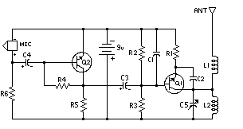
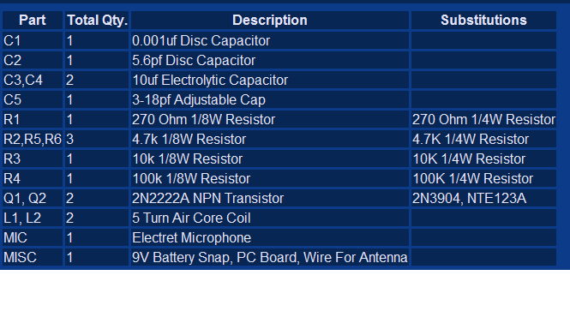
Fig 4.2: FM Transmitter

2. Mini radio
The mini radio is tuned on the police channel (90 MHz) to receive the transmitted signal which was sent by the FM MIC. The mini radio is used to give an indication to the PIC that there is a transmitted signal from FM MIC; the PIC will start executing the program depending on the feedbacks from the car radio.
3. Car radio
Car radio will be powered on using 12V, 10A power supply, on the car radio we will save the frequency of the police channel (for an example we save it in channel 1) which is not used by any station in Nablus. As the PIC powered on, the channel will changed automatically to channel 1 where the selected channel is saved and the car radio will also connected to an antenna and a speakers which we will hear the voice signal through it.
4. Relay
A relay is an electrically operated switch. Current flowing through the coil of the relay creates a magnetic field which attracts a level and changes the switch contacts. The coil current can be on or off so relays have two switch positions and they are double throw switches. Relays allow one circuit to switch a second circuit which can be completely separate from the first. The figure below shows the relay circuit.
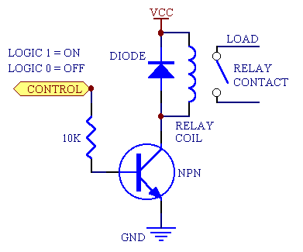
Figure 4.3: Relay Circuit

- When to use a relay?
Transistors cannot switch AC or high voltages (such as mains electricity) and they are not usually a good choice for switching large currents (> 5A). In these cases a relay will be needed, but note that a low power transistor may still be needed to switch the current for the relay's coil!
- Advantages of relays:
1. Relays can switch AC and DC, transistors can only switch DC.
2. Relays can switch high voltages, transistors cannot.
3. Relays are a better choice for switching large currents (> 5A).
4. Relays can switch many contacts at once.
- Disadvantages of relays:
- Relays are bulkier than transistors for switching small currents.
2. Relays cannot switch rapidly; transistors can switch in many times per second.
3. Relays use more power due to the current flowing through their coil.
4. Relays require more current than many chips can provide, so a low power transistor may be needed to switch the current for the relay's coil.
Relay is a controllable switch works as the car radio buttons, relay controlled by the PIC; so when the PIC gives A 5V signal for 500ms to the relay the inductor become a magnet so the switch is closed and the action take effect on the car radio.

- Circuit diagram of the project
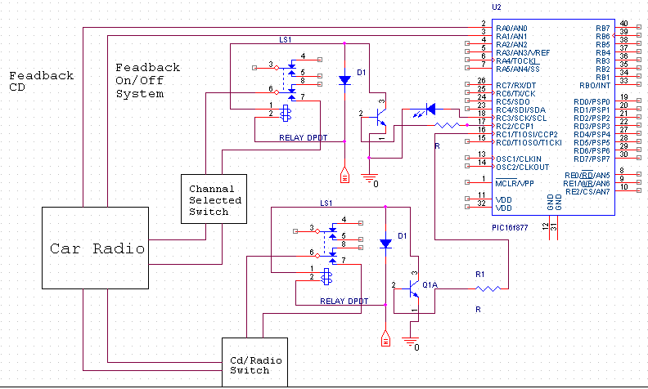

Figure 4.5: Circuit Diagram OF The Project.
PIC (Programmable Interface Circuit)
The main task of the PIC is to execute the written program to control the car radio, the PIC is used to control car radio whatever its status, the PIC is supplied by 5V from the power supply.
Programming the PIC has three options as there is a guiding signal from police guiding channel:
- If the radio is OFF, the radio status will be change to be ON.
- If tape mode was playing, the PIC will change its mode to the radio mode.
- If the radio is tuned on any other channel, the PIC will change the channel to the police guiding channel.
To guarantee that these steps are done correctly, there must be a feedback signals that give an idea about radio status. For this case a modern digital car radio will be used since it consists of buttons which could be easily controlled using electrical pulses signals, analog buttons were used, another way of controlling would be used such as a motor to tune between desired channels. These processes are shown on figure
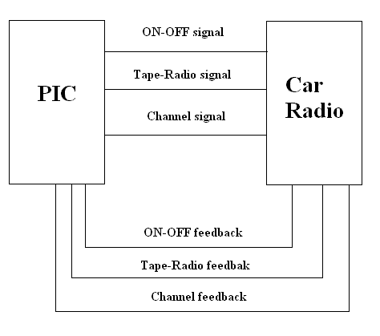
Figure 4.6: PIC signals and feedbacks.
- Mini radio
Works as a position sensor that as the car inters a coverage area when the transmitter is ON (there is a guiding signal) the light of tuning in the mini-radio is ON, the status of the light will give the PIC an induction if there is a guiding signal or not.
If there is a guiding signal, then the led is light (it gives 1.8v).
If there is no a guiding signal, then the led is off (it gives 0v), according to these values the PIC will start executing the program.
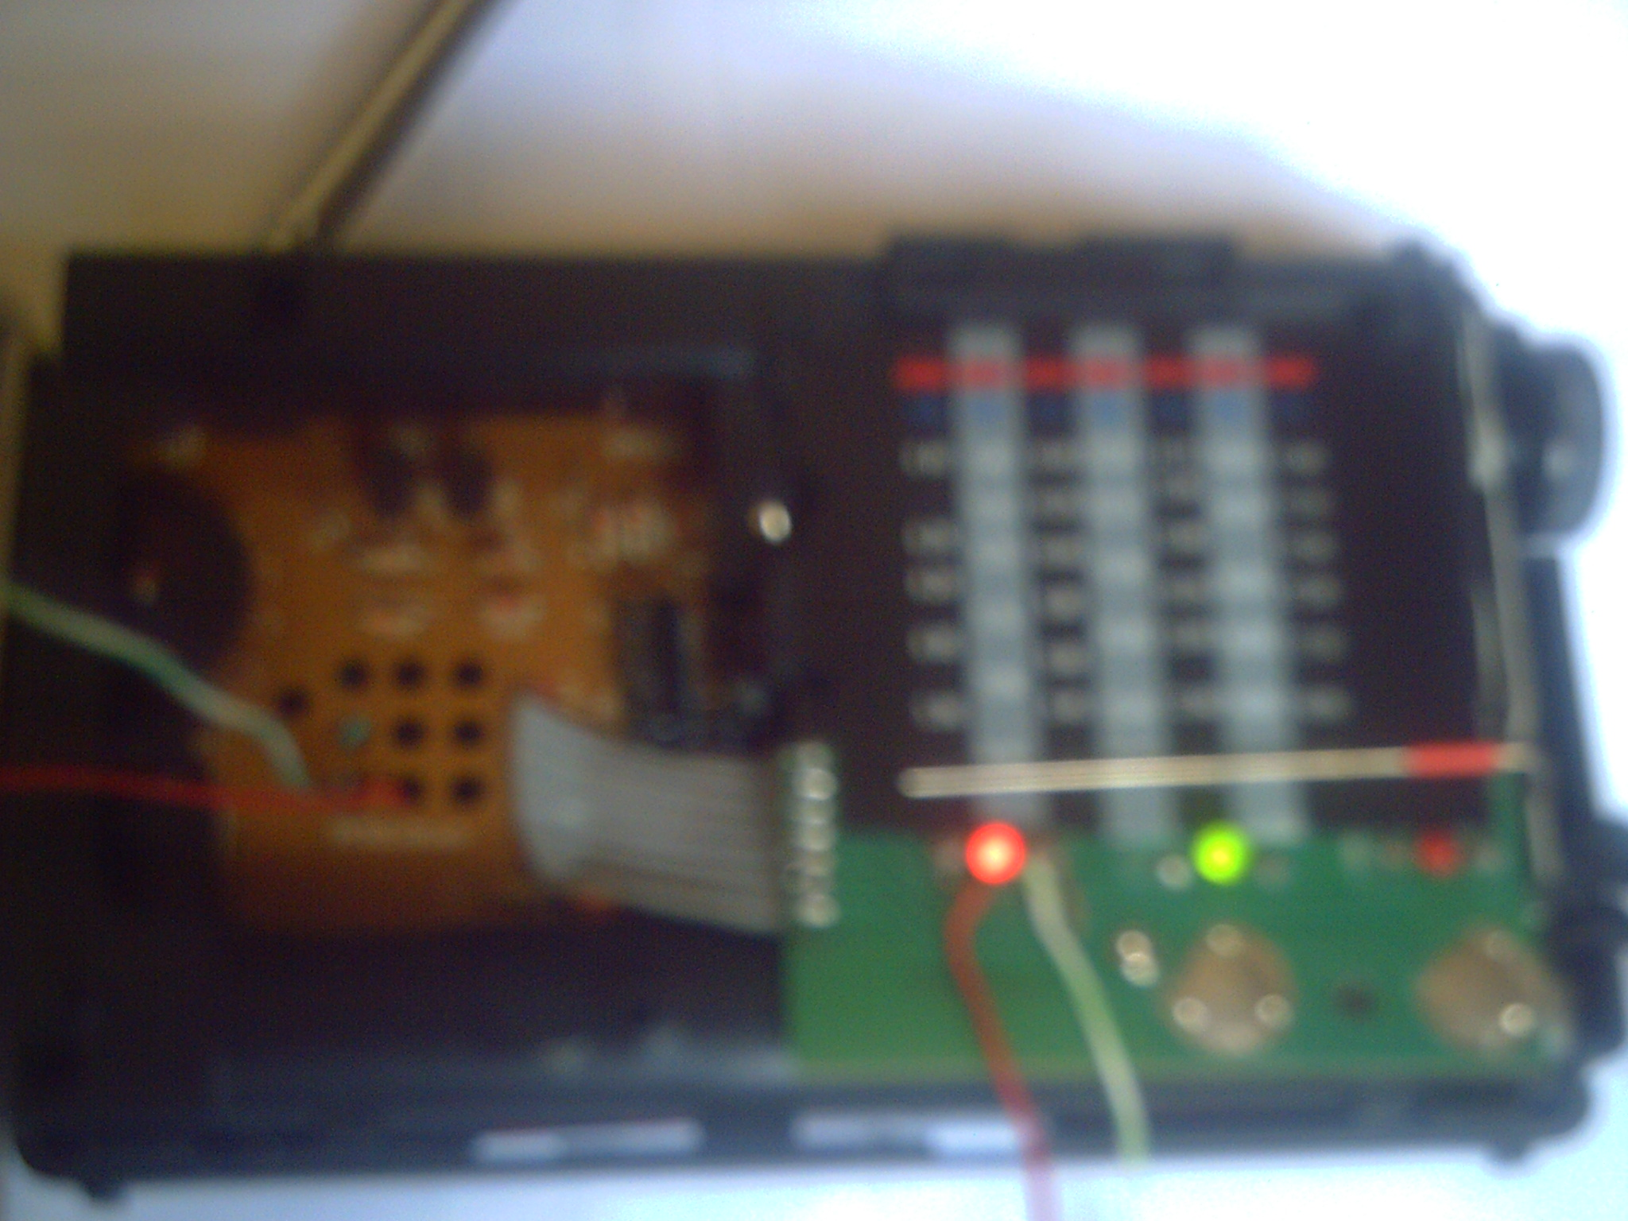
Fig 4.7: Tuning light of the mini-radio (the red light).
Car radio Feedbacks:
The PIC needs to know what is the status of the car radio to execute the program in a correct way, so we must take feedbacks from somewhere from the car radio.
While we are doing on the project we saw that two feedbacks must be taken from the car radio, one to give an induction if the radio is ON or OFF and the second to give an induction if it is radio or CD mode.
The first feedback from ON/OFF system point.
The second feedback from CD IC.
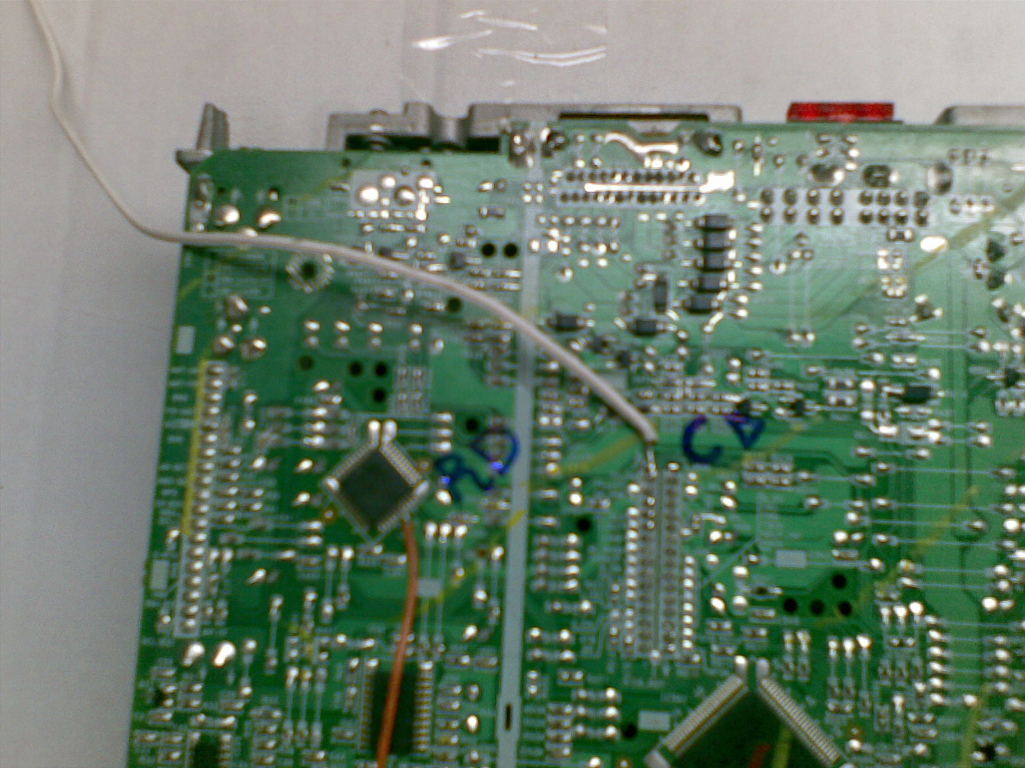
Fig 4.8: CD feedback from car-radio
The results that we take from the car-radio feedbacks are listed in the table below.
SYSTEM ON/OFF | RADIO/CD MODE | ON/OFF FEEDBACK VOLTS | CD FEEDBACK VOLTS
OFF | ---- | 0 | 1.5
ON | RARIO | 0 | 1.5
ON | CD | 5 | 5
Table- Car-radio feedbacks values

And the program algorithm can be described through the following flow chart:
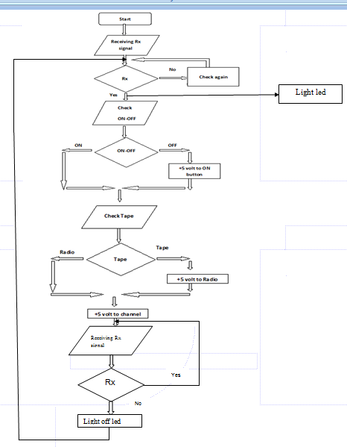
Figure 4.9: PIC Algorithm
Firstly, checking the radio status, if it’s off, it will be turned On, and if its On, then to the next step. Secondly, checking the Tape, if there is a CD inserted and played, it will go to radio mode, and if not then to the next step. Finally, the radio will be tuned to the required frequency, then the program is finished and the signal message will be heard.
Bipolar junction transistor
Bipolar junction transistor was the first type of transistor ,bipolar junctions are named because they conduct by using both majority and minority carriers ,they are three terminals of BJT are named emitter, base and collector, also BJT has two P-N junctions exist inside it: base/emitter junction and base/collector junction.
BJT is useful in amplifiers the current because the emitter and collector currents are controllable by the small base current.BJT used as an electronic switch, in grounded-emitter configuration

Types of transistor:
There are two types of standard transistors, NPN and PNP, with different circuit symbols. The letters refer to the layers of semiconductor material used to make the transistor. Most transistors used today are NPN because this is the easiest type to make from silicon.
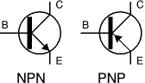
Figure 4.10 :Transistor circuit symbols

The transistor works as an amplifier; so it amplifies the incoming signal from the PIC to exceed a 5V to activate the diode.

The steps of testing the project:
Case 1: Car _radio is off and the last mode before turning it off is CD mode
The test: the transmitter is ON, so tune led get on (it gives > 1.5v), PIC starting to execute the program, a led will light it means that there is a guiding signal, then the PIC will read the value of ON/ OFF feedback which is 0v (car radio is OFF), it will give a pulse to the relay that is connected to ON/ OFF switch, the car radio will be ON, then the PIC will read the value of CD feedback which is 5v (CD mode), it will give a pulse to the relay that is connected to the CD/ Radio switch to change from CD to Radio mode, then it will give a pulse to the relay that is connected to channel 1 switch (police channel) at the last we can hear the guiding signal on car radio.
Case 2: Car _radio is off and the last mode before turning it off is Radio mode
The test: the transmitter is ON, so tune led get on (it gives > 1.5v), PIC starting to execute the program, a led will light it means that there is a guiding signal, then the PIC will read the value of ON/ OFF feedback which is 0v(car radio is OFF), it will give a pulse to the relay that is connected to ON/ OFF switch, the car radio will be ON, then the PIC will read the value of CD feedback which is 1.5v (Radio mode), it will give a pulse to the relay that is connected to channel 1 switch (police channel) at the last we can hear the guiding signal on car radio.
Case 3: Car _radio is ON and CD mode was playing
The test: the transmitter is ON, so tune led get on (it gives > 1.5v), PIC starting to execute the program, a led will light it means that there is a guiding signal, then the PIC will read the value of ON/ OFF feedback which is 5v (car Radio is ON), the PIC will read the value of CD feedback which is 5v (CD mode), it will give a pulse to the relay that is connected to the CD/ Radio switch to change from CD to Radio mode, then it will give a pulse to the relay that is connected to channel 1 switch (police channel) at the last we can hear the guiding signal on car radio.

Case 4: Car _radio is ON and radio is tuned on any other channel
The test: the transmitter is ON, so tune led get on (it gives > 1.5v), PIC starting to execute the program, a led will light it means that there is a guiding signal, then the PIC will read the value of ON/ OFF feedback which is 5v (car Radio is ON), the PIC will read the value of CD feedback which is 1.5v (Radio mode), it will give a pulse to the relay that is connected to channel 1 switch (police channel) at the last we can hear the guiding signal on car radio.

Problems

- While searching for a power feedback signal from the radio, we faced a problem from where we should take it.

- In this project we concerned on the Digital car radio which consists of buttons since they can be easily controlled, but it could be improved to be compatible with all kinds of radio such as analog and other types of radio

- There is no way to hold a specific BW for our FM transmission, this is because we will need permission from the telecommunication regulatory commission and a very specific components.

Solutions

After making some discussion with our supervisor and searching on the internet, we came out with some solutions for the above problems:
- Using a commercial wireless microphone that sends voice information or in our case street traffic information using FM radio freq range, the range of the used microphone is between (90-104)MHz, as a result there is no need for FM transmitter since the wireless microphone give the same function.

- A mini radio was used which is treated as FM MHz receiver. The main purpose of the receiver (mini radio) is to give a pulse for the PIC to start work. Mini radio is tuned to the same working channel of the wireless microphone.

3. Feedback: The first feedback from ON/OFF system point. And the second feedback from CD IC.

Future work
After the system has been analyzed, the following conclusion can be drawn:
- The system can help the countries from the traffics jam since it can organize the cars and guide the drivers to places away from these traffic jams. By this they can avoid accidents and dangers which can be faced in the emergency situations such as fires, snows and hard rains.
- The system is cheap and easy to be implemented in any car, so it can easily be used in countries without problems
- On the other hand, the system achieves a good synchronization between its parts (the user and the application). The use of the Microchip PIC microcontroller was appropriate because it provides a good control basis besides the ease of programming and using it.
Moreover, the FM modulation was efficient to the use in relatively to other range applications. Finally, the system has proved a good efficiency regarding all possible circumstances.

Conclusions

- The system can help the countries from the traffics jam since it can organize the cars and guide the drivers to places away from these traffic jams. By this they can avoid accidents and dangers which can be faced in the emergency situations such as fires, snows and hard rains.

- The system is cheap and easy to be implemented in any car, so it can easily be used in countries without problems

- On the other hand, the system achieves a good synchronization between its parts (the user and the application). The use of the Microchip PIC microcontroller was appropriate because it provides a good control basis besides the ease of programming and using it.

- Moreover, the FM modulation was efficient to the use in relatively to other range applications. Finally, the system has proved a good efficiency regarding all possible circumstances.

References

[1] Martin Bates, “Interfacing PIC Microcontrollers: Embedded Design by Interactive Simulation” Elsevier, 2006.
[2] Louis E. Frenzel, “Communication Electronics: principle and application” Macgraw – Hill, 2001.
[3] B. P. lathi “Modern digital and analog communication systems” Oxford University Press Inc., 1998.
[4] www.wikipedia.org.
[5] Ian A. Glover, Peter M. Grant, “Digital Communications”, Prentice Hall, 2nd edition, 2004.

Appendix: Program Code

#include "C:\Users\Admin\Desktop\u\u\NEW.h"
float cd=0;
float radio=0;
float mini_radio=0;
void main()
{
//setup_adc_ports(NO_ANALOGS);
// setup_adc(ADC_OFF);
setup_psp(PSP_DISABLED);
setup_spi(FALSE);
setup_timer_0(RTCC_INTERNAL|RTCC_DIV_1);
setup_timer_1(T1_DISABLED);
setup_timer_2(T2_DISABLED,0,1);
setup_comparator(NC_NC_NC_NC);
setup_vref(FALSE);
// TODO: USER CODE!!
set_tris_c(0x00);
setup_adc(ADC_CLOCK_INTERNAL);//enable module
setup_adc_ports(ALL_ANALOG);
xx:
set_adc_channel(2);
delay_ms(2000);
mini_radio=read_adc();
delay_ms(200);
while(1)
{
// mini_radio =mini_radio *5;
// mini_radio =mini_radio /255;
//check if it is on ....
if(mini_radio>=76)
{
//for led rc3
//turn on
output_high(PIN_c3);
//delay...
delay_ms(2000);
set_adc_channel(0);
delay_ms(200);
cd=read_adc();
//delay
delay_ms(1000);
set_adc_channel(1);
//delay
delay_ms(200);
radio=read_adc();
//delay
delay_ms(2000);
if(((radio>=0) && (radio<=10)) && ((cd>=60) && (cd<=88)))
{
//pulse
output_high(PIN_C1);
delay_ms(200);
output_low(PIN_C1);
//dealy
delay_ms(1000);
set_adc_channel(0);
delay_ms(200);
cd=read_adc();
delay_ms(1000);
//set_adc_channel(1);
//delay
delay_ms(200);
//radio=read_adc();
//delay
if((cd>=220) && (cd<=255))
{
//pulse
output_high(PIN_C1);
delay_ms(200);
output_low(PIN_C1);
delay_ms(1000);
//pulse
output_high(PIN_C2);
delay_ms(200);
output_low(PIN_C2);
delay_ms(1000);
}
else if ((cd>=60) && (cd<=88))
{

//pulse
output_high(PIN_C2);
delay_ms(200);
output_low(PIN_C2);
delay_ms(1000);
}
}
else if(((radio>=220) && (radio<=255)) && ((cd>=60) && (cd<=88)))
{
//pulse
output_high(PIN_C2);
delay_ms(200);
output_low(PIN_C2);
delay_ms(1000);
}
else if(((cd>=225) && (cd<=295)) && ((radio>=220) && (radio<=255)))
{
//pulse
output_high(PIN_C1);
delay_ms(200);
output_low(PIN_c1);
delay_ms(200);
//pulse
output_high(PIN_C2);
delay_ms(200);
output_low(PIN_C2);
delay_ms(1000);
}
}
restart_wdt();
while(1)
{
set_adc_channel(2);
//delay
mini_radio=read_adc();
if (mini_radio>=0 && mini_radio<=51)
{
output_low(PIN_C3);
goto xx;
}
restart_wdt();
}
}
}

